Year 10 Chemical Sciences

Week 2 – Elements and Metallic Bonding

Objectives:
- Describe trends in reactivity across periods and up and down groups
- Show an understanding of this idea by classifying elements as metallic or non metallic according to their valency
- Differentiate between metal and non-metal elements. Consider:
- Physical properties such as: appearance, conductivity, malleability, and ductility, position in the periodic table, ion charge, ie only metal elements form positive ions (exceptions H⁺, NH⁴⁺), non metal atoms form negative ions.
- Describe the metallic bond and explain the physical properties of metals conductivity and malleability in terms of their bonding

The Periodic Table is a chart of all of the elements known. They are arranged in 18 groups (columns) and several periods (rows). Most of the elements known are metals and exist as solids (except mercury). The remainder of the Periodic Table are non-metals and many of these exist as gases at room temperature. There are some non-metals such as silicon (Si) that are called metalloids and they are non-metals, however they have some properties which are metallic.

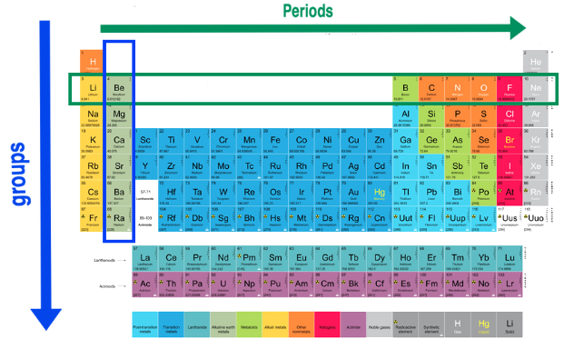

Elements in the same group have the same number of valence electrons in their outer shell. For example, metals in the alkali metals group (group 1) have 1 valence electron and form an ion with a +1 charge e.g. sodium, Na⁺. Valence electrons are the electrons involved in bonding and therefore elements in the same group have similar properties.

Elements in the same period have the same number of electron shells.
An element that has undergone oxidation has lost electrons. Elements that lose electrons easily are strong reductants and are highly reactive. Likewise, an element that has undergone reduction has gained electrons. Elements that gain electrons easily are strong oxidants and are also highly reactive.

As elements move across the periodic table from left to right, the reducing strength decreases as the atoms give up their valence electrons less readily and the oxidising strength of these elements increases as elements gain electrons more readily.

Going down a group, the elements release their electrons more readily, making them stronger reductants. For example, potassium is a stronger reductant than sodium and therefore more reactive. See the diagram below for a graphical representation of reactivity trends.
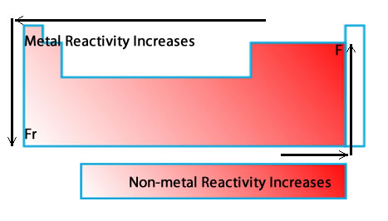
Ionisation energy is the energy required to remove an electron from the outer energy level of an atom. Ionisation energy increases from left to right and from bottom to top on the periodic table.

Electronegativity is the ability of an atom to gain electrons. Electronegativity increases from left to right and from bottom to top on the periodic table.

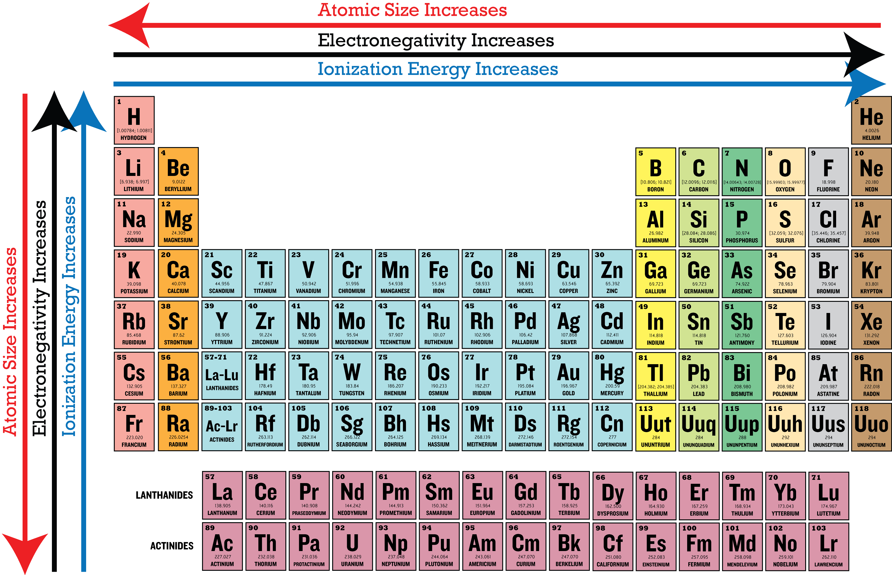
Ions are atoms with a charge and are formed by the loss or gain of valence electrons. Metals form positive ions with the loss of valence electrons to a non-metal that forms a negative ion. A polyatomic ion is an ion made up of more than one atom with a charge. For example carbonate is made up of carbon and 3 oxygen atoms with an overall charge of -2.
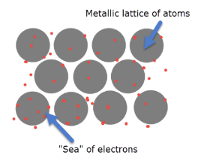
Metals have a lattice structure that is made up of positively charged cations, because the outermost or valence electrons are free to move away from the positively charged nucleus.

The delocalised electrons can carry a charge and therefore metals are great conductors of heat and electricity. The electrostatic attraction between the moving electrons and the cations holds the lattice structure together and means metals are very strong and apart from mercury (Hg), exist as solids. The delocalised forces of attraction in the lattice means that the metals if hit with a hammer will bend, without breaking.

The table below outlines the difference in properties of metals and non metals.

Property | Metal | Non-metal
Electrical and thermal conductivity | YES | NO
Hardness and strength | HARD | SOFT/ BRITTLE
Melting and boiling point | HIGH | LOW
Lustre | SHINY | DULL
Sound | SONOROUS | NON-SONOROUS
Malleable and ductile | YES | BRITTLE

The table below outlines the properties of metallic bonds and explains why each property exists.

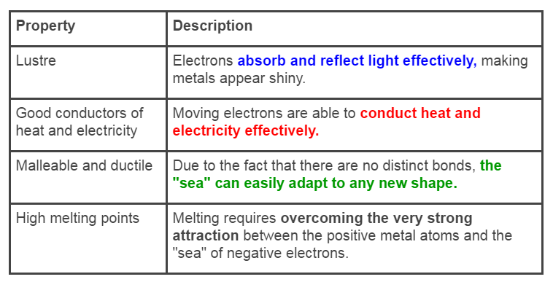
Week 2 Revision Questions

- In terms of bonding, explain why aluminium is malleable.

- In terms of bonding, explain why copper is a good conductor of electricity.

