Genetics Problems Practice

Name: ____________________________ Mark: _______/30 ___________%
- The Marvel family have a secret … some of them are superheroes with enormous strength. Super-strength (N) is dominant over normal strength (n). A heterozygous member of the Marvel family with super-strength mates with a homozygous member possessing normal strength.

  - Give the genotypes of the two marvel family members mentioned above.
(2 marks)

___________________ X __________________

  - Draw a punnett square showing the cross above to determine the genotype and phenotype probability (%) of the first generation (F1) offspring.
(3 marks)

- Two tongue rolling individuals have three children. One of these children cannot roll their tongue.

  - Explain how this can come about using the Punnet square below and a brief written explanation.
(3 marks)

Explanation
__________________________________________________________________________________________________________________________________________________________________________________________

  - If the couple were to have another child what would be the chance (%) that this child is:
(2 marks)
    - able to roll their tongue? ______________

    - unable to roll their tongue? ______________

- The blood of Vogons (an ugly space race that you can find in the distant galaxies) comes in three colours, blue, green and yellow. If a blue-blooded Vogon mates with a yellow-blooded Vogon then all their offspring are green-blooded. Use an appropriate key and a punnet square to calculate both the phenotype and genotype proportions for the offspring that you would expect to result from the crossing of two green-blooded Vogons.
(4 marks)

- Duchenne’s muscular dystrophy is an X-linked condition which is due to the inheritance of a recessive allele (d).
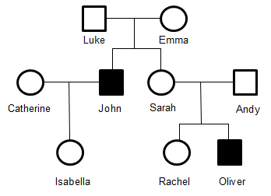
  - If John suffered from Duchenne’s muscular dystrophy and Catherine was not a carrier, what is Isabella’s genotype and phenotype?
(2 marks)

  - Give the genotypes for Catherine and John and draw a Punnett square to show how you determined your answer to the previous question.
(3 marks)

  - If Catherine and John were to have another child, what is the probability of them having a:
(2 marks)
    - Girl with the condition

    - Boy with the condition

  - Oliver’s parents (Sarah and Andy) are both unaffected by the condition. Give the genotypes of his parents and draw a Punnett square to show why Oliver is affected by the condition.
(3 marks)

- The autosomal pedigree below shows the Unibrow characteristic.

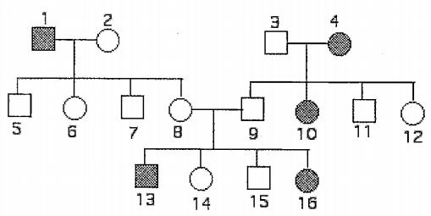
  - Determine if the condition (shaded individuals) is dominant or recessive and provide one piece of evidence from the pedigree that justifies your answer.
(2 marks)

  - How many family members have unibrows?
(1 mark)

  - What is the genotype of individual #4?
(1 mark)

  - Are individuals #8 and #9 homozygous or heterozygous?
(1 mark)

  - What is the genotype of individual #2?
(1 mark)

