HUMAN BIOLOGY

Unit 1

2015

Name: _______________________________________________________

Teacher: ___________________________________________________

TIME ALLOWED FOR THIS PAPER

Reading time before commencing work: Ten minutes
Working time for the paper: Two hours

MATERIALS REQUIRED/RECOMMENDED FOR THIS PAPER

To be provided by the supervisor:
- This Question/Answer Booklet
- Multiple Choice Answer Sheet

To be provided by the candidate:
- Standard items: Pens, pencils, eraser or correction fluid, ruler, highlighter, ruler.

- Special items: Calculators satisfying the conditions set by the Schools
Curriculum and standards authority for this subject.

IMPORTANT NOTE TO CANDIDATES

- No other items may be taken into the examination room. It is your responsibility to ensure that you do not have any unauthorised notes or other items of a non-personal nature in the examination room. If you have any unauthorised material with you, hand it to the supervisor before reading any further.

Structure of this paper

Section | Suggested working time | Number of questions available | Number of questions to be attempted | Marks
SECTION ONE:  Multiple-choice | 40 minutes | 30 | All | 60
SECTION TWO:  Short answers | 90 minutes | 6 | All | 100
SECTION THREE:  Extended answers | 50 minutes | 3 | 2 | 40
 |  |  | Total marks | 200

Instructions to candidates

1. The rules for the conduct of Western Australian external examinations are detailed in the Year 12 Information Handbook 2015. Sitting this examination implies that you agree to abide by these rules.

2. Answer the questions according to the following instructions.

Section One: Answer all questions on the separate Multiple-choice Answer Sheet provided. For each question shade the box to indicate your answer. Use only a blue or black pen to shade the boxes. If you make a mistake, place a cross through that square, do not erase or use correction fluid, and shade your new answer. Marks will not be deducted for incorrect answers. No marks will be given if more than one answer is completed for any question.

Sections Two and Three: Write your answers in this Question/Answer Booklet.

3. You must be careful to confine your responses to the specific questions asked and to follow any instructions that are specific to a particular question.

4. Spare pages are included at the end of this booklet. They can be used for planning your responses and/or as additional space if required to continue an answer.
- Planning: If you use the spare pages for planning, indicate this clearly at the top of the page.
- Continuing an answer: If you need to use the space to continue an answer, indicate in the original answer space where the answer is continued, i.e. give the page number. Fill in the number of the question(s) that you are continuing to answer at the top of the page.

Section One: Multiple-choice 30% (60 Marks)

This section has 30 questions. Answer all questions on the separate Multiple-choice Answer Sheet provided. For each question shade the box to indicate your answer. Use only a blue or black pen to shade the boxes. If you make a mistake, place a cross through that square, do not erase or use correction fluid, and shade your new answer. Marks will not be deducted for incorrect answers. No marks will be given if more than one answer is completed for any question.

Suggested working time: 40 minutes.

- The shaft of a long bone is called the

- epiphysis.
- trabecular.
- diaphysis.
- periosteum.

- The region at the back of the mouth which is a common pathway for both air and food is called the

- larynx.
- bronchus.
- pharynx.
- oesophagus.

- In which of the following would you expect blood pressure to be at its highest?

- The pulmonary artery
- The aortic arch
- The inferior vena cava
- A capillary in your finger

- Cartilage is more flexible than bone because it

- lacks mineral ions.
- lacks collagen.
- has more holes in the matrix.
- has extra calcium.

- The type of cartilage found covering the ends of bones at joints is

- hyaline cartilage.
- elastic cartilage.
- fibrocartilage.
- osteocartilage.

- Which of the statements concerning osteoporosis is INCORRECT?

- Taking dietary supplements such as calcium can help reduce the risk of developing osteoporosis.
- The risk of osteoporosis in women increases significantly after menopause.
- Smoking and high alcohol intake are both considered risk factors for osteoporosis.
- A very low body weight reduces the risk of developing osteoporosis.

- Pharmaceuticals such as Nurofen relieve pain for sufferers of osteoarthritis because they may be used to

- increase cartilage production.
- increase bone density.
- reduce joint inflammation.
- help heal fractures.

- Which of the following parts of the nephron would you expect to find in the renal medulla?

- renal corpuscle, proximal convoluted tubule and distal convoluted tubule
- Bowman’s (glomerular) capsule, distal convoluted tubule and collecting duct
- loop of Henlé and collecting duct
- proximal convoluted tubule, distal convoluted tubule and loop of Henlé

- During glomerular filtration, water moves from the glomerulus into the Bowman’s (glomerular) capsule. Which of the following contributes most to this movement of water?

- The efferent arteriole having a narrower diameter than the afferent arteriole.
- The filtrate having a lower water concentration than the plasma.
- The active transport performed by epithelial cells of the glomerular capillaries.
- The movement of salts into the Bowman’s (glomerular) capsule.

- In which of the following blood vessels would you expect to find the lowest urea concentration?

- efferent arteriole
- afferent arteriole
- renal vein
- inferior vena cava

Use the diagram below of a nephron and its associated blood supply to answer the following TWO questions.
B
C
D
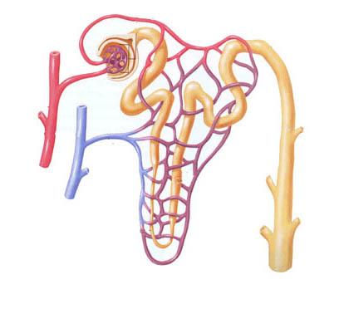
A

E

F

- The glomerulus is indicated by label

- A.
- B.
- E.
- F.

- The process of tubular secretion mostly occurs from structure

- A.
- C.
- D.
- F.

- Deamination occurs in the liver from the breakdown of amino acids, which come from protein metabolism. Which chemical is made during this process and what is it converted to?

- Deamination produces ammonia, which is converted into urea.
- Deamination produces uric acid, which is converted to urea.
- Deamination produces creatinine, which is converted to uric acid.
- Deamination produces bicarbonate, which is converted to ammonia.

- A student used a 10X ocular lens and a 40X objective lens to view a sample of tissue. A field of view of 300μm was measured. When the objective lens was changed to 10X, what would be the new FOV?

- 1.2 mm
- 7.5 mm
- 120 μm
- 75 μm
- In an experiment to test the effect of temperature on the action of the enzyme amylase in saliva, six test tubes containing saliva and starch were placed in water baths at the following temperatures: 0°C, 27°C, 37°C, 50°C, 70°C and 100°C.

The students tested their saliva with glucose sensitive tape before starting, When glucose is present the glucose sensitive tape turns green. Which student’s saliva should they have used in the test tubes?

- One which gave no reaction to the test tape.
- One which gave a strong reaction to the test tape.
- One which gave a mild reaction to the test tape.
- One which caused the test tape to turn green.

- Four microscopes were set up in the laboratory to observe cell movement.

Microscope number | Objective | Ocular
1  2  3  4 | X10  X40  X 20  X20 | X10  X5  X15  X10

Under which two microscopes would a cell appear to be moving at the same rate?

- 3 and 4
- 1 and 2
- 2 and 4
- 1 and 4

- An indicator solution which is coloured yellow in acid and blue in alkali or base would be

- blue in gastric juice and yellow in pancreatic juice.
- yellow in gastric juice and blue in pancreatic juice.
- yellow in both gastric and pancreatic juice.
- blue in both gastric and pancreatic juice.

- Which of the following is an INCORRECT pairing of “structure” and “function”?

- Large intestines - remove water from undigested food
- Liver receives - nutrients from the small intestine via the blood
- Small intestine - absorbs small food molecules
- Gall bladder - produces digestive enzymes

- ATP is essential to every living cell because it

- reacts with energy from glucose to form ADP.
- speeds up digestion of carbohydrates.
- stores energy in a form that is instantly available.
- stores energy released during the breakdown of ADP.
- The attachment of a muscle at its immovable end is the

- flexor.
- insertion.
- origin.
- tone.

- In the fluid mosaic model of membrane structure, phospholipid molecules form a bilayer. Which of the following correctly describes this bilayer?

 | Phosphate | Fatty acids
(a) | Hydrophilic, found on surface | Hydrophobic, found in centre
(b) | Hydrophilic, found in centre | Hydrophobic, found on surface
(c) | Hydrophobic, found on surface | Hydrophilic, found in centre
(d) | Hydrophobic, found in centre | Hydrophilic, found on surface

- Which of the following statements is CORRECT?

- The larger the cell, the greater its ability to take up nutrients from its surroundings.
- The increased surface area to volume ratio of a small cell means that it can remove its waste more efficiently.
- Smaller cells have a larger volume to surface area ratio to enable them to gain glucose by diffusion more readily.
- The size of the cell is irrelevant to diffusion because particles will always move randomly from areas of high to low concentration.

- Cells take in droplets of fluid from their surroundings. What is the transport mechanism involved?

- Pinocytosis
- Exocytosis
- Phagocytosis
- Carrier assisted transport

- In what state are the valves when the ventricles are relaxed?

 | Atrio-ventricular valves | Semilunar valves
(a) | open | open
(b) | open | closed
(c) | closed | open
(d) | closed | closed

- The graph below represents the results of a study on the relationship between sugar consumption and heart disease.

Comparison between the number of deaths from coronary heart disease per 100 000 men between the ages of 45 and 54 and the consumption of sugar in kilograms per person.

Based on the graph above, which of the following is CORRECT?

- The consumption of sugar per person in Canada is similar to that of the USA.
- There is some relationship between sugar consumption and death rate.
- A French person has a greater chance of dying from coronary disease than does an Italian.
- The death rate from coronary disease in Japan is approximately 1/6 that of Canada.

- In mouth to mouth resuscitation, the rescuer blows air from his respiratory system into that of the victim. Which of the following statements is CORRECT?

- Oxygen in the rescuer’s expired air soon enters the victim’s bloodstream and keeps the brain cells alive.
- During inflation of the lungs the intrapleural pressure would decrease.
- This technique wouldn’t work as the rescuer is breathing out carbon dioxide.
- Expansion of the victim’s lungs is brought about by blowing air in at a pressure lower than atmospheric pressure.

- Which of the following is NOT considered a risk factor for cardiovascular disease?

- Smoking
- High dietary intake of salt
- Lack of exercise
- Low dietary intake of calcium

- The structures A, B, C and D in the diagram below are respectively

D
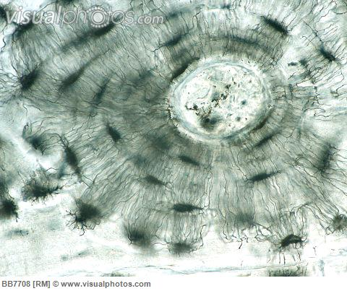
C
B
A
(Compact Ground Bone Bb7708 Stock Photos Royalty Free Picture, n.d.)

- lacunae, osteocyte, lamellae, canaliculi
- canaliculi, osteocyte, lacunae, lamellae
- lacunae, lamellae, canaliculi, Haversian canal
- haversian canal, lamellae, osteocyte, lacunae

- During one cardiac cycle the following events take place

i. atrial systole
ii. ventricular diastole
iii. ventricular systole

From when blood first enters the heart, in which order do these events take place?

- i, ii, iii
- ii, iii, i
- iii, i, ii
- i, iii, ii

- Cilia in the trachea move debris towards the

- alveoli
- bronchi
- pharynx
- bronchioles

End of Section One

Section Two: Short answer 50% (100 Marks)

This section has six (6) questions. Answer all questions. Write your answers in the spaces provided.

Spare pages are included at the end of this booklet. They can be used for planning your responses and/or as additional space if required to continue an answer.
  - Planning: If you use the spare pages for planning, indicate this clearly at the top of the page.
  - Continuing an answer: If you need to use the space to continue an answer, indicate in the original answer space where the answer is continued, i.e. give the page number. Fill in the number of the question(s) that you are continuing to answer at the top of the page.

Suggested working time: 90 minutes.

Question 31 (13 marks)

(a) (i) Draw a diagram of an erythrocyte.
(1 mark)

(ii) Explain two ways in which the structure of an erythrocyte is well suited to its function.
(2 marks) ____________________________________________________________________________________________________________________________________________________________________________________________________________________________________________________________________________________________________________________________________________________________________________________________________________

(b) Describe the main function of:
(i) leucocytes. ____________________________________________________________________________________________________________________________________

(ii) plasma proteins.
____________________________________________________________________________________________________________________________________
(2 marks)
Below is a table showing the normal concentrations of substances present in blood.

Component | Concentration (%)
Plasma  - Water  - Proteins  - Organic acids  - salts | 55  90  8  1  1
Blood cells  - leucocytes and platelets  - erythrocytes | 45  1  99

(c) Explain why it would be a problem for your body if the water levels of plasma increased to 95%.
(2 marks)
________________________________________________________________________________________________________________________________________________________________________________________________________________________________________________________________________________

(d) How does the composition of lymph differ from that of blood (as shown in the table)?
(1 mark)
________________________________________________________________________________________________________________________________________

(e) Describe TWO functions of the lymphatic system.
(2 marks)
________________________________________________________________________________________________________________________________________________________________________________________________________________________________________________________________________________

(f) Explain why it is important that blood type is known before receiving a blood transfusion. In your answer include what happens when blood types are mixed.
(3 marks)
________________________________________________________________________________________________________________________________________________________________________________________________________________________________________________________________________________________________________________________________________________________________________________________________________________________
Question 32 (19 marks)

The following diagram represents an unspecialized cell.
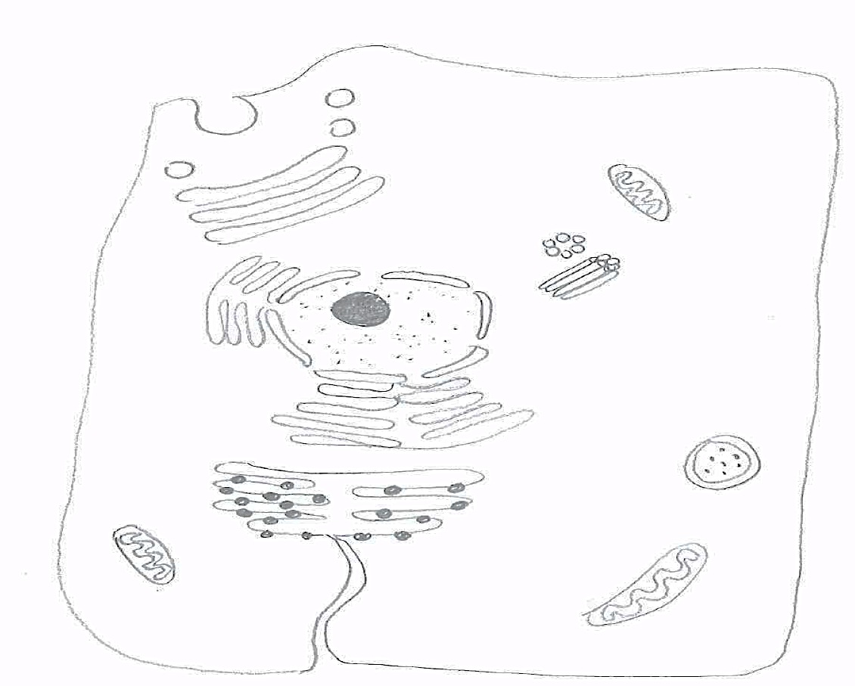
A
H
I
B
D
C
L
J
K
E
F
G

(a) State the function of the following structures:
(3 marks)
C. ________________________________________________________________
D. ________________________________________________________________
L. ________________________________________________________________

(b) Describe how proteins are arranged in a plasma membrane and the part they play in transporting substances into and out of cells.
(6 marks)
____________________________________________________________________________________________________________________________________________________________________________________________________________________________________________________________________________________________________________________________________________________________________________________________________________________________________________________________________________________________________________________________________________________________________________________________________________________________________________________________________________________
(c) Within organelles and in the cytoplasm of cells there are many different enzymes.

(i) Why are enzymes necessary for the survival of any cell?
(2 marks)
____________________________________________________________________________________________________________________________________

(ii) What lettered structure in the diagram of the unspecialised cell indicates where enzymes are made? (1 mark)

__________________________________________________________________

(iii) Why are many different enzymes needed in one cell?
(1 mark)
____________________________________________________________________________________________________________________________________

(d) Cellular respiration is the process whereby food molecules are broken down in a series of reactions to release energy in the form of ATP molecules.

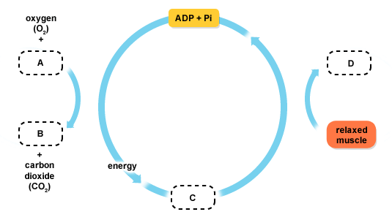

(i) State which letter in the diagram represents ATP.
(1 mark)
__________________________________________________________________

(ii) State TWO places in the cell where ATP molecules are produced.
(2 marks)
____________________________________________________________________________________________________________________________________

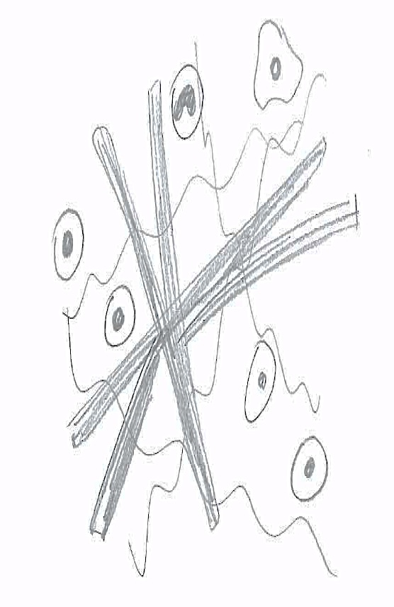
The figure below represents a sample of tissue viewed under high power of a monocular light microscope.

(e) (i) To which of the four main tissue types does it belong?
(1 mark)
__________________________________________________________________

(ii) Provide a reason for your answer in part (i).
(1 mark)
__________________________________________________________________
__________________________________________________________________

(iii) Describe one way in which the structure of this tissue is suited to its function.
(1 mark)
__________________________________________________________________
__________________________________________________________________

This page has been left blank intentionally

Question 33 (23 marks)
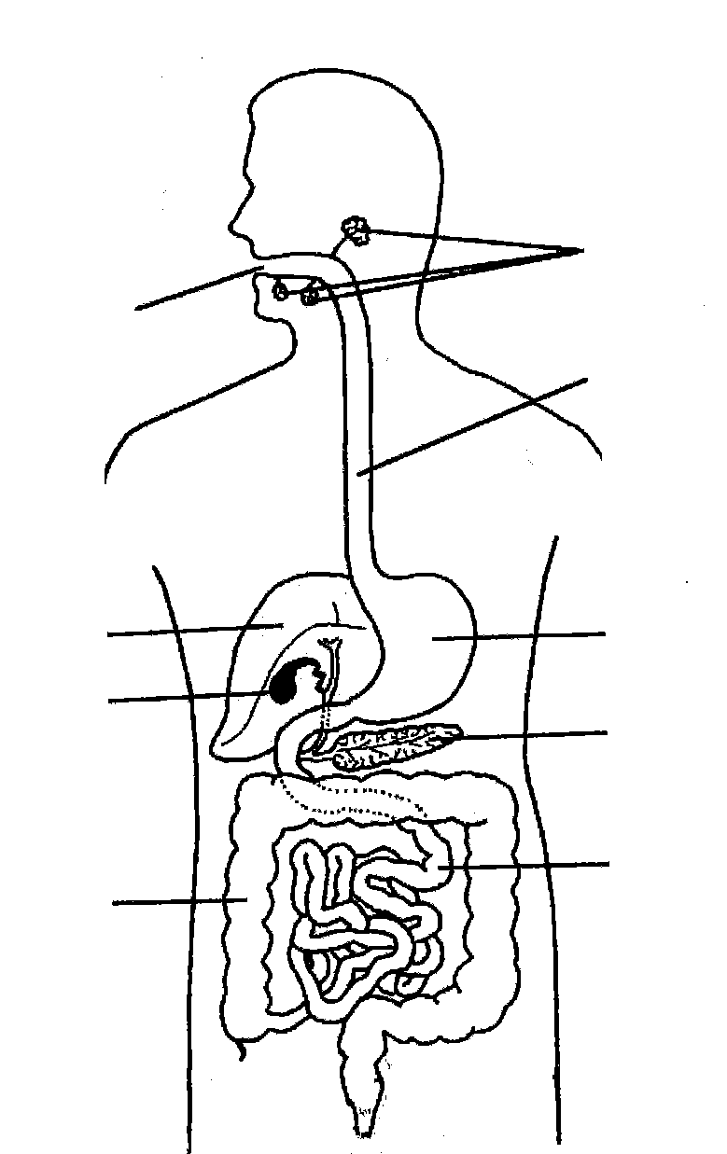

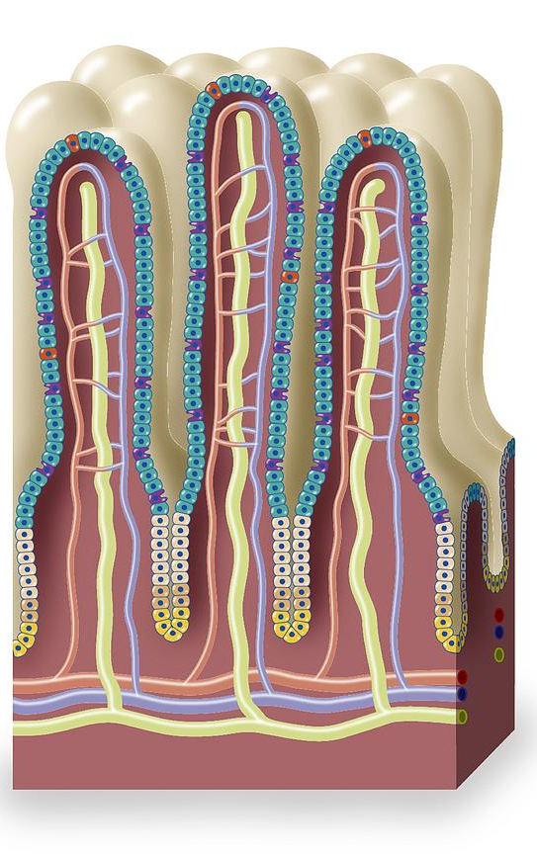

A

B

F
C
P. (Digestive Systems, n.d.)

D
G

E
H

(Digestive system worksheet 2, n.d.)

(a) Label the diagram of the human digestive system in the spaces provided. (4 marks)

A: ______________________________________________________
D: ______________________________________________________
E: ______________________________________________________
F: ______________________________________________________

(b) (i) Identify P. _______________________________
(1 mark)

(ii) In which region of the digestive tract is P found?
(1 mark) __________________________________________________________________

(iii) Name the major function of P and explain TWO reasons why it is suited to this function.
(3 marks)
________________________________________________________________________________________________________________________________________________________________________________________________________________________________________________________________________

(c) Name TWO substances produced by structure D, the substrate on which each of these substances acts and the product of each of these reactions.
(6 marks)

Substance Substrate Product

__________________ __________________ __________________

__________________ __________________ __________________

(d) Name the fluid stored in structure G. What is the function of this fluid?
(2 marks)
________________________________________________________________________________________________________________________________________________

(e) Complete the following table.
(6 marks)

 | Carbohydrates | Proteins | Lipids
Simple unit of which food group is composed
Major use in body of this unit

Question 34 (18 marks)

A knee joint is pictured below.

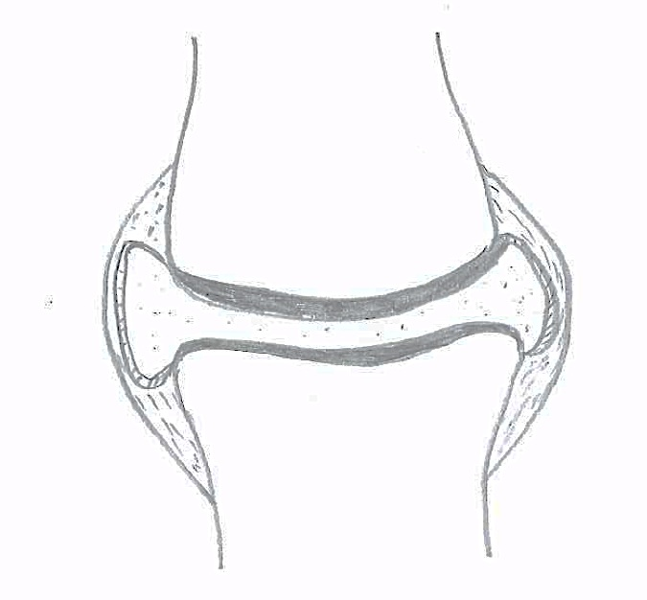
F
E
D
C
B
A

(a) Describe the functions of:
(3 marks)

B ______________________________________________________________________
________________________________________________________________________

E ______________________________________________________________________
________________________________________________________________________

F ______________________________________________________________________
________________________________________________________________________

(b) There are 3 main types of joints, one of which is shown above. Name the three types of joints and give an example of each.
(3 marks)

________________________________________________________________________________________________________________________________________________________________________________________________________________________

The diagram below shows the muscles and bones of a human arm.

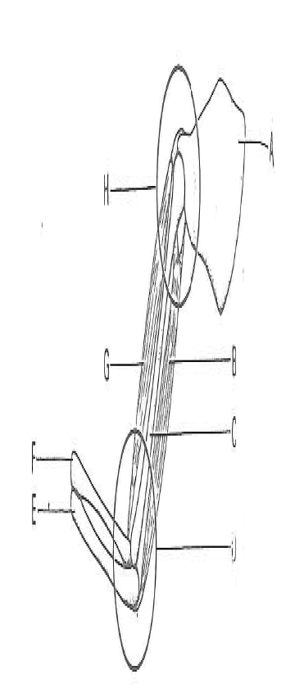
A
H

G
B
F
C
E
D

(c) Name the following bones:
(4 marks)

A: ______________________________________
C: ______________________________________
E: ______________________________________
F: ______________________________________

(d) Describe the type of movement possible at joint H.
(1 mark)
________________________________________________________________________________________________________________________________________________

(e) How is the shape of the bones at joint D related to the movement it can perform?
(1 mark)
________________________________________________________________________________________________________________________________________________

(f) Name the flexor and extensor muscles which move joint D.
(2 marks)
Flexor muscle _________________________
Extensor muscle _______________________

(g) Using your understanding of the sliding filament model, explain how the contraction of muscle G occurs.
(4 marks)
________________________________________________________________________________________________________________________________________________________________________________________________________________________________________________________________________________________________________________________________________________________________________________________________________________________________________________________________________________________________________________________

Question 35 (11 marks)

In 1912 Sir Frederick Gowland Hopkins published a paper titled “Feeding experiments illustrating the importance of accessory food factors in normal dietaries”. To investigate the importance of these “accessory food factors” he took rats from the same litter and divided them into two groups. The rats in Group A were fed a diet of purified cheese protein, glucose, starch, lard, minerals and water. Group B received exactly the same diet plus 3mL of milk per day. After 18 days Group A started receiving the milk supplement instead of Group B. The results are shown in the table below.

Time (days) | Average mass of rats in Group A (grams) | Average mass of rats in Group B (grams)
0  10  20  30  40  50 | 45  52  46  60  70  82 | 45  64  80  86  87  75

(a) Plot the results on the graph paper supplied. At day 18 insert a vertical dotted line to show where the diets were changed.
(5 marks)

(b) Name the
(i) Independent variable: __________________________________
(ii) Dependent variable: ____________________________________
(2 marks)

(c) Why did Gowland Hopkins use two groups of rats rather than two individuals?
(1 mark) ________________________________________________________________________

(d) Describe two variables that were controlled in this experiment.
(2 marks) ________________________________________________________________________________________________________________________________________________________________________________________________________________________________________________________________________________________________

(e) Based on these results, what was the accessory factor that Gowland Hopkins would conclude was needed in the rats diet?
(1 mark)
________________________________________________________________________

Question 36 (16 marks)

The diagram below shows part of the internal structure of the lung.
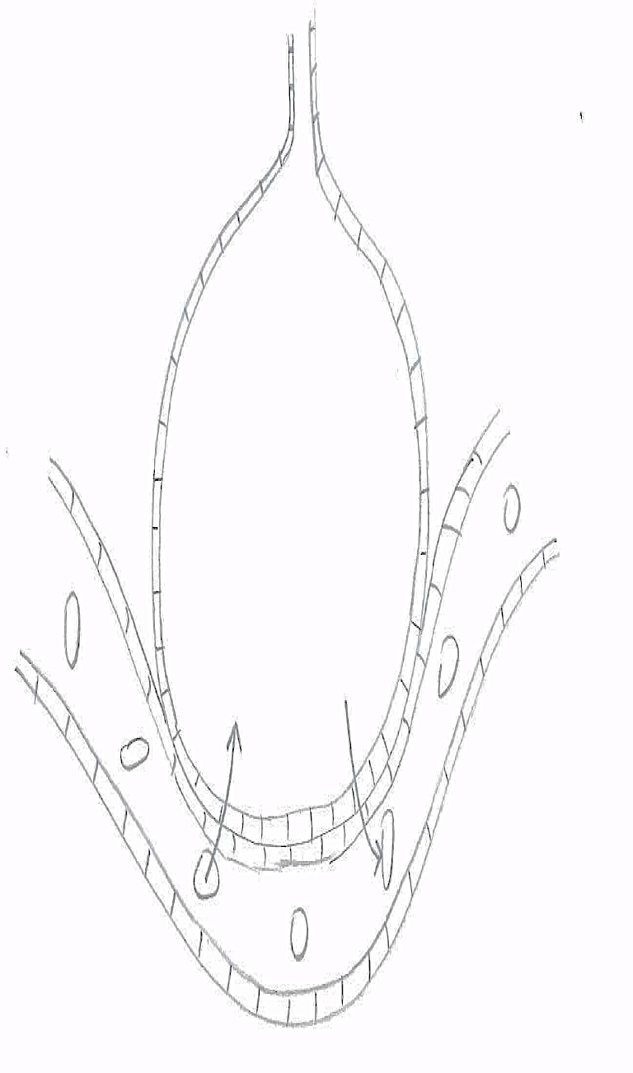

A
B

- What structure in the lungs is represented in the diagram above?
(1 mark)
________________________________________________________________________

(b) State four ways in which this structure is well suited to the function of gas exchange.
(4 marks)
________________________________________________________________________________________________________________________________________________________________________________________________________________________________________________________________________________________________

(c) (i) Name Gas A. _____________________________
(1 mark)

(ii) Explain what happens to Gas A once it has moved into the capillary.
(2 marks)
____________________________________________________________________________________________________________________________________

(iii) In what form(s) does Gas B get transported in blood?
(3 marks)
______________________________________________________________________________________________________________________________________________________________________________________________________

(d) Using your understanding of movement across a cell membrane, explain how the efficient exchange of gases A and B are maintained.
(2 marks)
________________________________________________________________________________________________________________________________________________________________________________________________________________________________________________________________________________________________________________________________________________________________________

(e) Smoking can cause the build up of irritating particles in the lungs. Name the disease that can result and describe TWO ways in which it will affect the normal functioning of the lungs.
(3 marks)
________________________________________________________________________________________________________________________________________________________________________________________________________________________________________________________________________________________________________________________________________________________________________________________________________________________________________________
End of Section Two
Section Three: Extended answer 20% (40 Marks)

This section contains three (3) questions. You must answer two (2) questions. You can choose Question 37 or Question 38 or Question 39. Write your answers in the space provided.

Spare pages are included at the end of this booklet. They can be used for planning your responses and/or as additional space if required to continue an answer.
  - Planning: If you use the spare pages for planning, indicate this clearly at the top of the page.
  - Continuing an answer: If you need to use more space to continue an answer, indicate in the original answer space where the answer is continued, i.e. give the page number. Write the number of the question(s) that you are continuing to answer at the top of the additional space page.

Responses could include clearly labelled diagrams with explanatory notes; lists of points with linking sentences; clearly labelled tables and graphs; and annotated flow diagrams with introductory notes.

Suggested working time: 50 minutes.

Question 37 (20 marks)

(a) Name and describe how the THREE types of muscle tissue involved in: peristalsis within the alimentary canal, the beating of heart muscle and the movement of your arms, differ.
(9 marks)

(b) Using your understanding of antagonistic muscles, explain how flexion of the arm is brought about.
(6 marks)

(c) Explain the differences in the ways energy is made available to the muscles of a sprinter and a marathon runner. Include a description of the form in which energy is supplied to the muscle fibres.
(5 marks)

Question 38 (20 marks)

(a) Describe the mechanism by which air is drawn into and forced out of the lungs during normal breathing.
(10 marks)

(b) The system of vessels which distributes blood around the body is made up of THREE different types of vessels: arteries, veins and capillaries. Explain the difference in structure and function of each of these vessels.
(10 marks)

Question 39 (20 marks)

(a) List the substances absorbed in the intestines and describe how and where this occurs.
(12 marks)

(b) Describe the factors that influence the activity of enzymes.
(8 marks)

End of questions

Question number: ________________
________________________________________________________________________________________________________________________________________________________________________________________________________________________________________________________________________________________________________________________________________________________________________________________________________________________________________________
________________________________________________________________________________________________________________________________________________________________________________________________________________________________________________________________________________________________________________________________________________________________________________________________________________________________________________
________________________________________________________________________________________________________________________________________________________________________________________________________________________________________________________________________________________________________________________________________________________________________________________________________________________________________________
________________________________________________________________________________________________________________________________________________________________________________________________________________________________________________________________________________________________________________________________________________________________________________________________________________________________________________
________________________________________________________________________________________________________________________________________________________________________________________________________________________________________________________________________________________________________________________________________________________________________________________________________________________________________________________________________________________________________________________________________________________________________________________________________________________________________________________________________________________________________________________________________________
Question number: ________________
________________________________________________________________________________________________________________________________________________________________________________________________________________________________________________________________________________________________________________________________________________________________________________________________________________________________________________________________________________________________________________________
________________________________________________________________________________________________________________________________________________________________________________________________________________________________________________________________________________________________________________________________________________________________________________________________________________________________________________
________________________________________________________________________________________________________________________________________________________________________________________________________________________________________________________________________________________________________________________________________________________________________________________________________________________________________________
________________________________________________________________________________________________________________________________________________________________________________________________________________________________________________________________________________________________________________________________________________________________________________________________________________________________________________
________________________________________________________________________________________________________________________________________________________________________________________________________________________________________________________________________________________________________________________________________________________________________________________________________________________________________________________________________________________________________________________________________________________________________________________________________________________________________________________________________
Question number: ________________
________________________________________________________________________________________________________________________________________________
________________________________________________________________________
________________________________________________________________________________________________________________________________________________________________________________________________________________________________________________________________________________________________________________________________________________________________________________________________________________________________________________
________________________________________________________________________________________________________________________________________________________________________________________________________________________________________________________________________________________________________________________________________________________________________________________________________________________________________________
________________________________________________________________________________________________________________________________________________________________________________________________________________________________________________________________________________________________________________________________________________________________________________________________________________________________________________
________________________________________________________________________________________________________________________________________________________________________________________________________________________________________________________________________________________________________________________________________________________________________________________________________________________________________________
________________________________________________________________________________________________________________________________________________________________________________________________________________________________________________________________________________________________________________________________________________________________________________________________________________________________________________________________________________________________________________________
Question number: ________________
________________________________________________________________________________________________________________________________________________________________________________________________________________________
________________________________________________________________________
________________________________________________________________________________________________________________________________________________________________________________________________________________________________________________________________________________________________________________________________________________________________________________________________________________________________________________
________________________________________________________________________________________________________________________________________________________________________________________________________________________________________________________________________________________________________________________________________________________________________________________________________________________________________________
________________________________________________________________________________________________________________________________________________________________________________________________________________________________________________________________________________________________________________________________________________________________________________________________________________________________________________
________________________________________________________________________________________________________________________________________________________________________________________________________________________________________________________________________________________________________________________________________________________________________________________________________________________________________________
________________________________________________________________________________________________________________________________________________________________________________________________________________________________________________________________________________________________________________________________________________________________________________________________________________________________________________
Question number: ________________
________________________________________________________________________________________________________________________________________________________________________________________________________________________________________________________________________________________________
________________________________________________________________________
________________________________________________________________________________________________________________________________________________________________________________________________________________________________________________________________________________________________________________________________________________________________________________________________________________________________________________
________________________________________________________________________________________________________________________________________________________________________________________________________________________________________________________________________________________________________________________________________________________________________________________________________________________________________________
________________________________________________________________________________________________________________________________________________________________________________________________________________________________________________________________________________________________________________________________________________________________________________________________________________________________________________
________________________________________________________________________________________________________________________________________________________________________________________________________________________________________________________________________________________________________________________________________________________________________________________________________________________________________________
________________________________________________________________________________________________________________________________________________________________________________________________________________________________________________________________________________________________________________________________________________________________________
Additional working space
Question number: ________________
________________________________________________________________________________________________________________________________________________________________________________________________________________________________________________________________________________________________________________________________________________________________________
________________________________________________________________________
________________________________________________________________________________________________________________________________________________________________________________________________________________________________________________________________________________________________________________________________________________________________________________________________________________________________________________
________________________________________________________________________________________________________________________________________________________________________________________________________________________________________________________________________________________________________________________________________________________________________________________________________________________________________________
________________________________________________________________________________________________________________________________________________________________________________________________________________________________________________________________________________________________________________________________________________________________________________________________________________________________________________
________________________________________________________________________________________________________________________________________________________________________________________________________________________________________________________________________________________________________________________________________________________________________________________________________________________________________________
________________________________________________________________________________________________________________________________________________________________________________________________________________________
Additional working space
Question number: ________________
________________________________________________________________________________________________________________________________________________________________________________________________________________________________________________________________________________________________________________________________________________________________________________________________________________________________________________________________________________________________________________________
________________________________________________________________________
________________________________________________________________________________________________________________________________________________________________________________________________________________________________________________________________________________________________________________________________________________________________________________________________________________________________________________
________________________________________________________________________________________________________________________________________________________________________________________________________________________________________________________________________________________________________________________________________________________________________________________________________________________________________________
________________________________________________________________________________________________________________________________________________________________________________________________________________________________________________________________________________________________________________________________________________________________________________________________________________________________________________
________________________________________________________________________________________________________________________________________________________________________________________________________________________________________________________________________________________________________________________________________________________________________________________________________________________________________________________________________________________________________________________
Additional working space
Question number: ________________
________________________________________________________________________________________________________________________________________________________________________________________________________________________________________________________________________________________________________________________________________________________________________________________________________________________________________________________________________________________________________________________________________________________________________________________________________________________________________________________________________________________________________________________________________________
________________________________________________________________________
________________________________________________________________________________________________________________________________________________________________________________________________________________________________________________________________________________________________________________________________________________________________________________________________________________________________________________
________________________________________________________________________________________________________________________________________________________________________________________________________________________________________________________________________________________________________________________________________________________________________________________________________________________________________________
________________________________________________________________________________________________________________________________________________________________________________________________________________________________________________________________________________________________________________________________________________________________________________________________________________________________________________
________________________________________________________________________________________________________________________________________________________________________________________________________________________________________________________________________________________________

Additional working space
Spare Grid for Question 35a.

References

Question 28
Compact Ground Bone Bb7708 Stock Photos Royalty Free Picture. (n.d.). Retrieved January 13, 2015, from http://www.picstopin.com/480/compact-ground-bone-bb7708--stock-photos-royalty-free/http:||www*visualphotos*com|photo|1x50657

Question 33
Digestive system worksheet 2. (n.d.). Retrieved January 13, 2015, from http://webpages.shepherd.edu/EWELLS01/ds worksheet 2.htm

Digestive Systems. (n.d.). Retrieved January 13, 2015, from http://philschatz.com/biology-book/contents/m44736.html

