Year 8 - Physics Revision
What does the Law of Conservation of Energy state?

______________________________________________________________________________________________________________________________________________________________________________________________________________________________________________________

Define Kinetic energy:

__________________________________________________________________________________________________________________________________________________________________________________________________________________________________________
Define Potential Energy:
________________________________________________________________________________________________________________________________________________________________________________________________________________________

What is Energy?
______________________________________________________________________________________________________________________________________________________________________________________________________________________________
What is the unit used to measure energy?
______________________________

Classify the following energy forms as either Potential energy (PE) or Kinetic Energy (KE)
Sound energy Gravitational Chemical
Heat energy Light Nuclear
Elastic Kinetic
Energy Unit Conversions

How many Joules are in 1 kilojoules (kJ)?

____________________________________

How many Joules are in 1 Mega joule (MJ)?

____________________________________

For the conversion calculations below – you MUST show working.

1. How many joules are in 5.5 kJ?
2. How many joules are in 650 kJ?
3. Convert 1578 J to kilojoules.
3. How many joules are in 6.7 MJ?
4. How many joules are in 0.55 MJ?
5. Convert 899,000 J to Mega joules.
6. Convert 0.082 MJ to Joules.

Where does all energy available on Earth come from?

_________________________________

Energy Types: Match the types of energy to their descriptions:
1. Kinetic Energy i. in vibrating air particles
2. Sound Energy ii. released from glow-worms
3. Elastic Potential Energy iii. Stored inside small particles that make up all matter
4. Gravitational Potential Energy iv. in a stretched or squashed spring
5. Light Energy v. stored in the bonds of chemical compounds/molecules
6. Chemical energy vi. in a moving object
7. Nuclear energy vii. in objects positioned above the ground

Energy transfers takes place according to the Law of constant energy. For example, as a diver performs a dive, potential energy changes into kinetic energy. The diver falls with increasing speed as more potential energy changes into kinetic energy. Due to friction (air resistance), a small amount of potential energy is converted into heat energy. However, the total energy remains constant. The potential energy at the start of the dive is equal to the kinetic energy at the end of the dive plus the heat energy that is lost.
State the energy transfers (also known as energy transformations or energy flow diagrams) taking place in the different situations below:
1. 2. 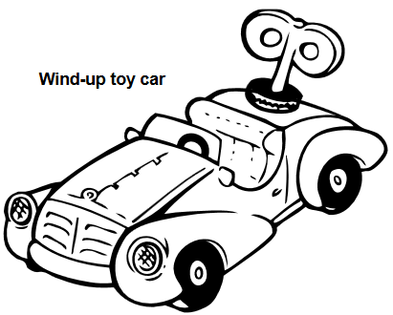3. 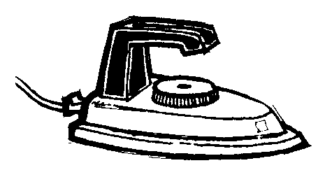
4. 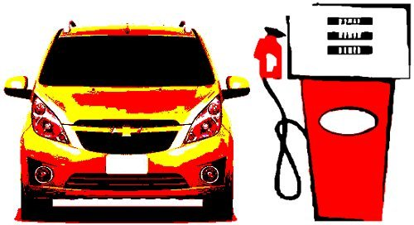 5. 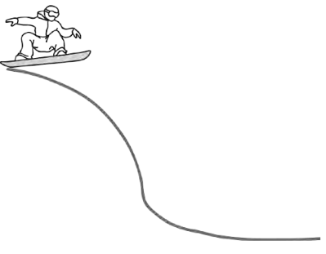

Question: Compare the efficiency of the two light bulbs shown below. Which is more energy efficient? Explain your reason using calculations.
Energy Efficiency Calculation: show all working

1. In 5 minutes, a gas heater used 2500 J of chemical energy. This input energy converted into 553 J of sound energy, 254 J of light energy and the remainder as heat energy. Calculate the energy efficiency of the Gas heater.
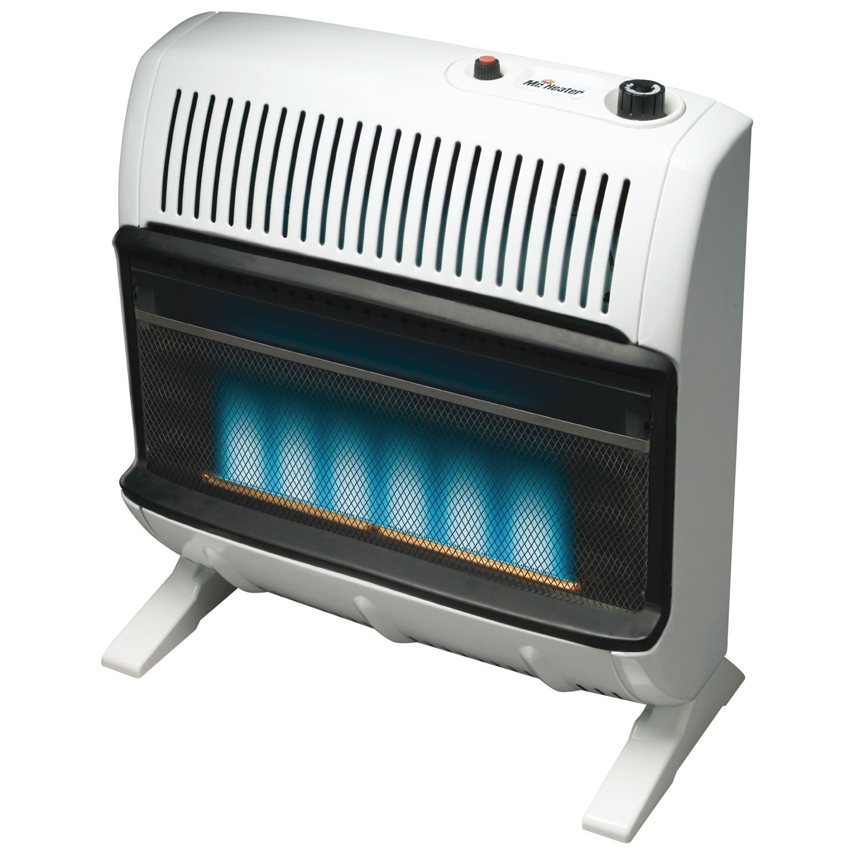

Energy Efficiency:

Energy efficiency is a measure of how much input energy is converted into useful output energy.

The greater proportion of useful output energy, the greater the energy efficiency of the device. (I.e. if most of the input energy is converted to useful energy output, then the device is energy efficient). If a lot of the input energy is wasted, then the device is inefficient.

Energy = useful energy output x 100
Efficiency total energy input
(%)
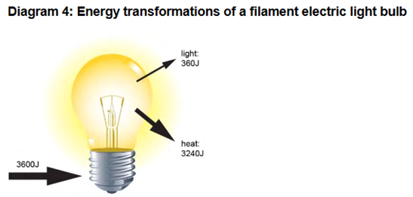
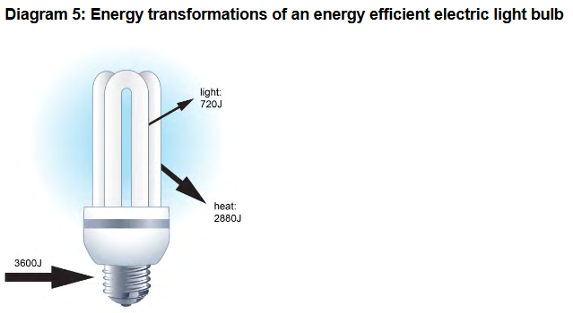

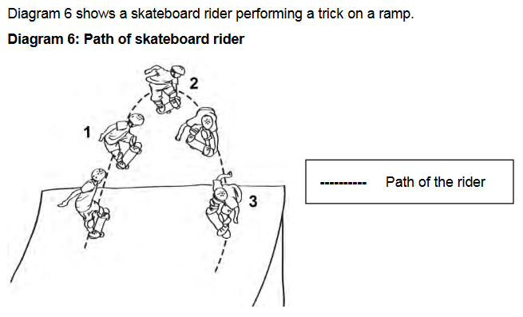
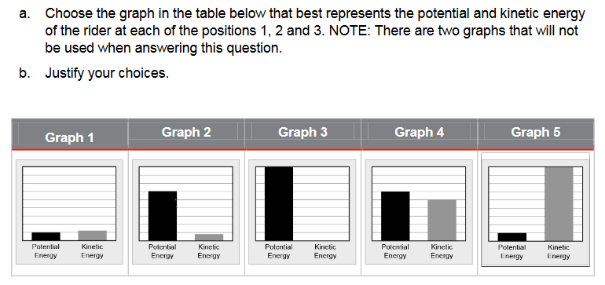

Kinetic Energy (KE)
The amount of Kinetic energy an object has is dependent on two factors. These are __________________ and __________________.
The greater the ___________/____________ an object has the ________________ the amount of Kinetic energy (and vice versa).
Kinetic Energy = ½ x m x v²

m = mass (kg), v = velocity/speed (m/s)
Examine the rollercoaster diagram below to answer the following questions.
Gravitational Potential Energy (GPE)
The amount of Gravitational Potential energy an object has is dependent on two factors. These are _______________________ and _________________________.
The greater the _______________________/____________ an object has the ________________ the amount of Gravitational Potential energy (and vice versa).

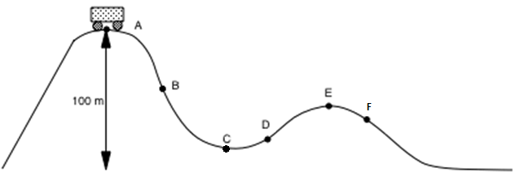
Using the letters A - F
1. When does the carriage have the greatest amount of gravitational PE? Justify your choice.
2. When does the carriage have the least amount of gravitational PE? Justify your choice.
3. When does the carriage have the greatest amount of Kinetic energy? Justify your choice.
4. When does the carriage have the least amount of Kinetic energy? Justify your choice.

Using the diagram below of how the Bounty Ship at Adventure World works, outline when it has the a) greatest amount of KE? b) Least amount of Kinetic energy? c) Greatest amount of GPE? D) Least amount of GPE?
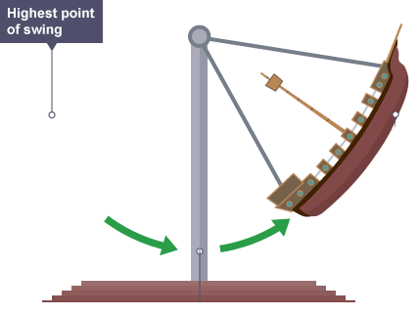

Kinetic Energy Calculation:
1. What is the kinetic energy of a 0.158 kg cricket ball travelling at 28 m/s? Select your answer and show your working.
a. 61936 J
b. 4.42 J
c. 247.74 J
d. 61.94 J

2. Calculate the Kinetic energy of an object with a mass of 5kg and moving at a speed of 3m/s.
3. Calculate the Kinetic energy of a motor vehicle that is 1000 kg and travelling at a speed of 6m/s.

Using the diagram to the left, outline which ball (A or B) has more GPE. ____________.
Explain your reason.
___________________________________________________________________________________________________________________________________________________________________________________________________________________________________________________________________
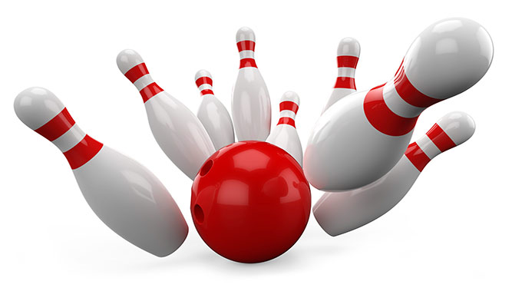
Two bowling balls (one with a mass of 5kg and one with a mass of 8kg) travelled at the same speed towards the ten pins. Which bowling ball as more Kinetic energy? Explain your reason.
When two 5kg bowling balls were thrown at different speeds, which would have more Kinetic energy? Explain your reason.

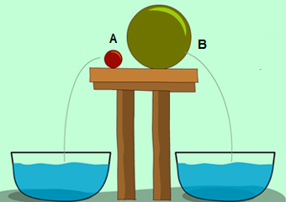

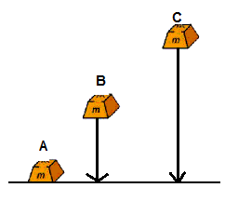
Chemical Energy is the energy stored in substances (held in the chemical bonds). Wood, paper, food (e.g. apples, cereal), petrol and barriers all contain (and are sources of) chemical energy. The energy held in their bonds can be released through applying them to electrical circuits, digestion, and combustion (burning). The chemical energy in petrol, coal and natural gases can do word when the fuels are burnt in engines. Dynamite and other explosives also contain chemical energy.
The foods that we eat originally obtained energy from the ________. Plants capture _____________ from the Sun and convert it into chemical energy in the form of simple sugars. This happens in a process called ________________________. Plants such as wheat make sugars and then concert them into starch for storage. When you eat the plants, their seeds, nuts or grains (or eat other animals that have eaten them), your body uses the chemical energy from these simple sugars and starch as your energy source.
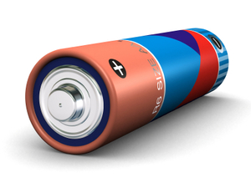

Heat Energy (also called thermal energy)
Heat energy is a form of energy because it can do work. Heat energy can come from the Sun, flames and chemical reactions, and is often given off from electrical devices and even people (which is why it is often a wasted or lost energy). In the engine of a motor car, hot gases are produced by burning petrol. The hot gases expand and cause the parts of the engine to move. As the hot gases do work, they lose most of their energy and cool down. Generally, the greater the temperature and mass of an object, the more heat energy is has.
Heat energy is the form of energy which is transferred from places of high temperature to places of low temperature. It is transferred in three ways, which are _________________, ____________________ and ________________________.
Question: List 4 uses of heat energy

Using the diagram to the right, outline which ball (A, B or C) has the most GPE. ____________.
Explain your reason.
___________________________________________________________________________________________________________________________________________________________________________________________________________________________________________________________________________________
Elastic Potential Energy
If you stretch a rubber band you will give it energy. When you shorten the band you will release its energy. Therefore the energy stored in the rubber band is elastic potential energy.

The potential energy of a stretch object depends on two factors: its elasticity and how much it is stretched. Elasticity is a measure of the stiffness of the stretched object.

The potential energy of a stretched spring can be used to close a door. The stronger the spring, the heavier the door it can swing shut. Stretching the spring more will also increase the amount of work it can do.
Explain using energy terms: a) what will happen if I increase the stretch of the rubber band b) change the angle of the stretch c) change the rubber band to a firm/rigid band
Draw an energy flow diagram to show the energy transformations taking place in a sling shot.
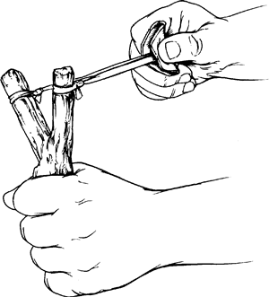

_____________________________________

Light globes:
What does wattage give us an indication of?
How do you calculate Brightness per watt? Cost per hour?
