Year 10 Biological Sciences

Week 5 to 7 – Genetics and Inheritance

Objectives:
Genetics and Inheritance:
- Recognise that inherited characteristics are the result of genetic information being passed from parent to offspring by meiosis and fertilisation
- Determination of male and female offspring in sexual reproduction. Mammals (XX female, XY male) Birds (ZW female, ZZ male)
- Define genetic terms: allele, genotype, phenotype, homozygous, heterozygous, hemizygous
- Use punnett square diagrams to determine the proportions of genotype and phenotype for monohybrid crosses
  - Examine similar characteristics between parents and offspring.
  - Predicting simple ratios of offspring genotypes and phenotypes in crosses involving dominant/recessive gene pairs and in genes that are sex-linked.
  - Examples of monohybrid dominant/recessive traits, co-dominant or incomplete dominance.
- Use punnett squares to predict likely outcomes of X-linked traits and recall examples (e.g. red-green colour blindness, haemophilia)
- Understand and be able to construct pedigrees to represent patterns of inheritance of a simple dominant/recessive characteristic through generations of a family
- Use pedigrees to determine genotypes and phenotypes of individuals. (Dominant/recessive and X-linked traits)

Inheritance of Characteristics

Eye colour, hair colour, tongue rolling and colour blindness are all characteristics that can be inherited through the genes provided to you by your parents. A gene is a part of a chromosome which controls a specific feature of an individual. Each characteristic (unless on the X chromosome) requires two copies of a gene in order to express a trait. One of these genes come from your mother (maternal) and the other one comes from your father (paternal).

The genes that you end up with depend on the gamete from your mother and the gamete from your father that fuse during fertilisation. As every gamete created during meiosis can be unique, this means that whilst you may have similar traits to your siblings and parents, you will not be identical.

Determining Gender

During meiosis, gametes are formed. Each gamete contains a haploid number of chromosomes and therefore only one sex chromosome. In females, each gamete will contain an X chromosome. In males, the gamete will contain either an X chromosome or a Y chromosome.

One gamete from a female fused with a gamete from a male during fertilisation to result in a new diploid cell called a zygote. The zygote now contains 46 chromosomes; two of these are sex chromosomes. If the sex chromosomes are XX then the offspring produced will be a girl. If the sex chromosomes are XY then the offspring produced will be a boy. The gender of the produced offspring is always determined by the sperm gamete that creates the zygote.

The below diagram shows the gender determination process.
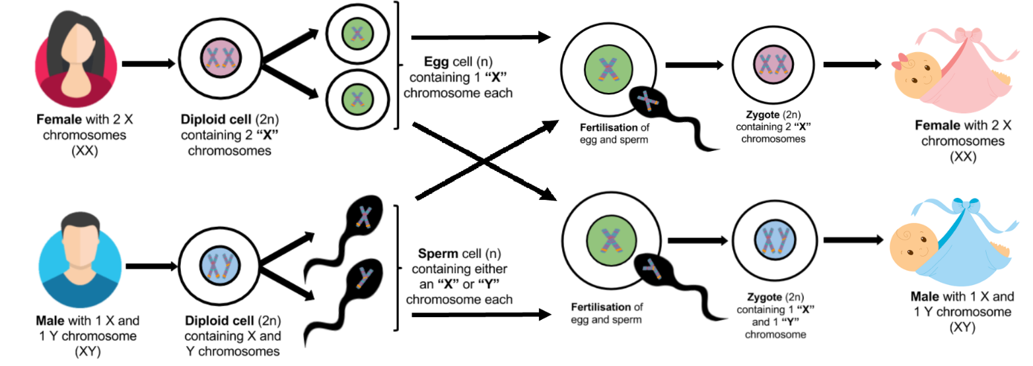

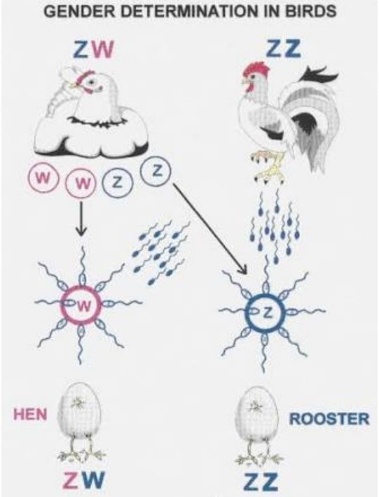
The way gender is inherited in birds is similar to humans. However, in birds it is the female’s gamete that determines the gender of the offspring. Male birds have two Z chromosomes and female birds have one Z and one W chromosome.

The egg from the female is fertilised with the sperm from the male. If the female’s egg contains a Z chromosome, then the Z chromosome from the sperm will result in a male bird. If the female’s egg contains a W chromosome, then the Z chromosome from the sperm will result in a female bird.

Genetics – Dominant/Recessive inheritance

How can two parents, both with brown eyes have a blue eyed child? A question like this can be answered when we examine the version of the genes for eye colour that each parent has and therefore the possible combination of genes that can be passed on to their offspring.

There can be many different forms of a gene, like eye colour, which codes for a particular characteristic or trait, like blue or brown eyes. Each of the different versions that a gene can take for each characteristic is called an allele (al-eel). For example, the gene for eye colour may include a blue eyed allele and a brown eyed allele.

Each allele is represented by a letter. If an allele is dominant, the trait it codes for will always be shown in the individual with that allele. Dominant alleles are represented with a capital letter, such as B for the brown eyed allele.

If an allele is recessive, the trait it codes for will be hidden unless both copies of the gene are recessive. Recessive alleles are represented by a lower case letter, such as b for the blue eyed allele.

It doesn’t matter what letter of the alphabet you choose to use but it is important to choose one where the uppercase letter is clearly distinguishable from the lower case letter. For example, using C and c could potentially cause issues if your writing is not clear, whereas using A and a or E and e, the different letters are very easily identified.

The combination of the allele obtained from the mother and the allele obtained from your father determines the trait that is expressed in the offspring. The written form of these two alleles is known as your genotype. Using eye colour as an example, if the offspring obtained a dominant allele from its mother and a recessive allele from its father, it would have the genotype Bb. The dominant allele is always written first because it is always expressed. In dominant/recessive inheritance there are three possible genotypes.
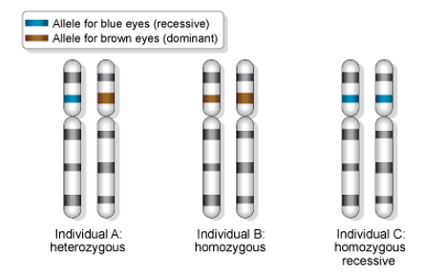
The colour of eyes you actually have is called your phenotype. In the case of an individual with the genotype Bb, the brown eyed allele is dominant over the blue eyed allele. This individual will therefore have brown eyes. Brown eyes is the phenotype represented by the genotype Bb. When an individual has a genotype containing two different alleles (Bb), the individual is said to be heterozygous or hybrid.

If an individual has two brown eyed alleles, the phenotype will be brown eyes and the genotype will be BB. The only time the recessive allele can be seen is when there are two copies of the allele. Therefore, blue eyes is the phenotype represented by the genotype bb. When an individual has a genotype containing two alleles that are the same, the individual is said to be homozygous or pure bred. An individual can be homozygous dominant (two dominant alleles - BB) or homozygous recessive (two recessive alleles - bb). In dominant/recessive inheritance there are only two possible phenotypes.

In some cases, there may only be one allele necessary to code for a trait. Individuals with just one allele coding for a trait is said to be hemizygous.

Using Punnett Squares

Punnett squares are a tool that can be used to quickly and easily predict the proportion of offspring of each type with a particular characteristic in any given cross.

To use a Punnett square
- Draw a 2 x 2 grid.
- Place one parent’s alleles (in their gametes) across the top of the Punnett square and the other parent’s down the left hand side.
- Then work out all four possible ways the genes can come together by combining the two alleles of each heading into each cell of the grid.
- Give the proportions of the four genotypes possible in the offspring. This can be expressed as a percentage or a ratio.
- Give the proportions of the phenotypes therefore possible in the offspring. This can be expressed as a percentage or a ratio.

Example: The diagram below shows a Punnett square of a father who is heterozygous for brown eyes crossed with a mother who is homozygous for blue eyes.

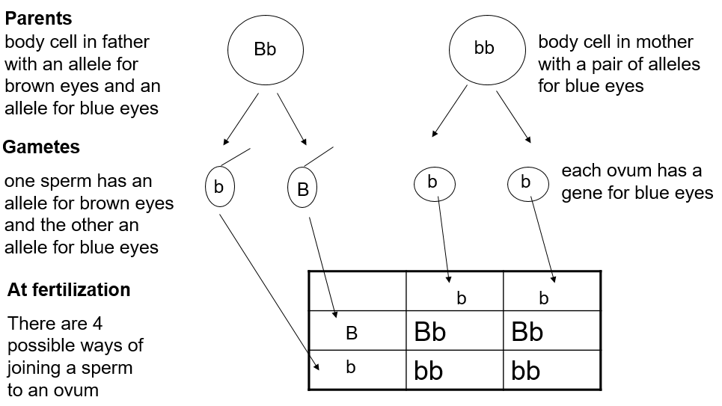

There are two possible genotypes produced by this cross, Bb and bb. There is a 50% chance that the offspring will have the genotype Bb and a 50% chance that the offspring will have the genotype bb.
As a genotypic ratio, this would be written as 1 Bb : 1 bb

There are also two possible phenotypes produced by this cross, brown eyes and blue eyes. There is a 50% chance that the offspring will have brown eyes and a 50% chance the offspring will have blue eyes.
As a phenotypic ratio, this would be written as 1 brown eyes : 1 blue eyes

Genetics – Co-dominance Inheritance

Some characteristics that are inherited are a result of two different alleles that are both dominant and expressed fully in some way. This type of inheritance is known as co-dominance.

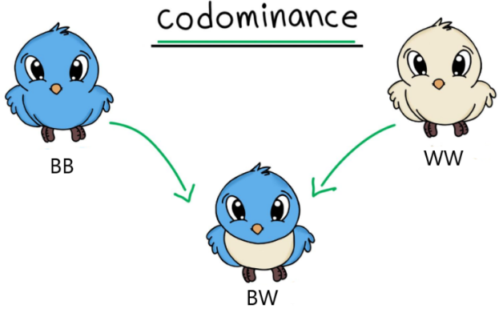
To show the genotype of co-dominant inheritance, each allele is represented by a different capital letter. For example, a cross between a blue feathered bird (BB) and a white feathered bird (WW) can produce a blue and white feathered bird (BW).

In co-dominant inheritance there are then three possible phenotypes, blue feathers, white feathers and blue and white feathers.

Genetics - Incomplete Dominance Inheritance

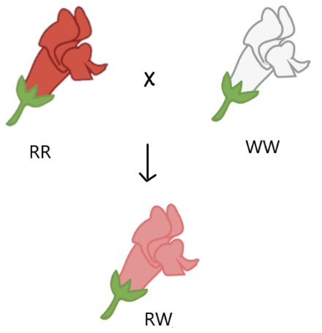
Some characteristics that are inherited are a result of two different alleles that are both dominant and expressed in a combined way. This type of inheritance is known as incomplete dominance.

To show the genotype of incomplete dominance inheritance, each allele is represented by a different capital letter. For example, a cross between a white rose (WW) and a red rose (RR) can produce a pink rose (RW).

In co-dominant inheritance there are then three possible phenotypes, white petals, red petals and pink petals.

The following picture shows the difference between dominant/recessive, co-dominance and incomplete dominance.

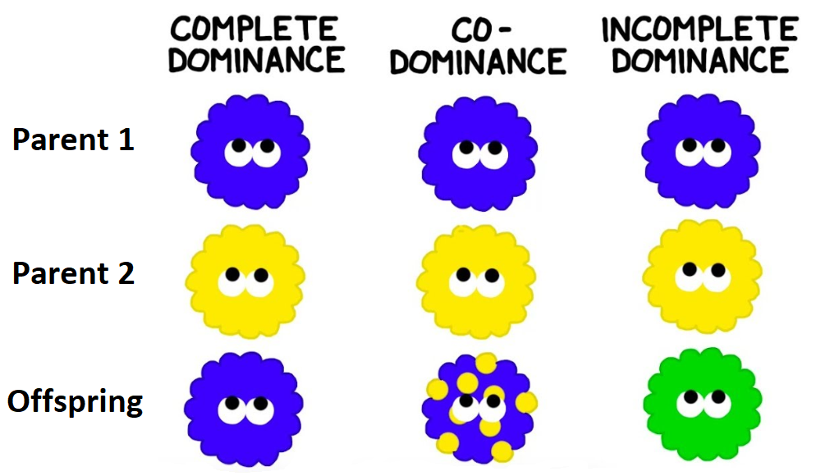

Genetics – X-linked Inheritance

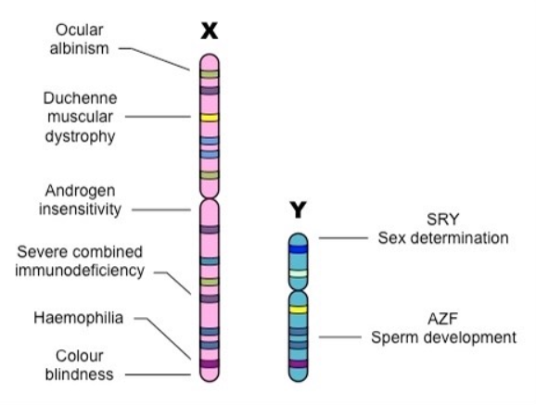
X-linked inheritance is the inheritance of a trait due to the controlling gene being located on an X chromosome. As seen in the picture on the right, the X chromosome is much longer than the Y chromosome and contains many genes not present on the Y chromosome.

As females have two X chromosomes, the combination of the two alleles will determine the trait that they inherit. Females can be either heterozygous or homozygous for the characteristic.
This means that for a recessive X-linked genetic disorder a female must have two copies of the recessive allele to present with the recessive trait. Females that are heterozygous for recessive X-linked disorders are known as carriers. The recessive gene is hidden by the dominant gene on the other X chromosome but can be passed to their offspring.

Males, however, only have one X chromosome and the allele on that chromosome will then determine the trait they inherit. They will always be hemizygous in X-linked inheritance. This means that for recessive X-linked genetic disorders males will either have the condition or not have the condition. Males can never be carriers for an X-linked condition. Also, as males transmit their Y chromosome to their sons, the sons will never inherit an X-linked recessive condition from their father.

When writing genotypes for X-linked inheritance, the alleles are written as superscripts on the X chromosome. The Y chromosome for males is also written but with no superscript added.

This table shows the genotype and phenotype for all possible allele combinations for the x-linked recessive genetic disorder Haemophilia.

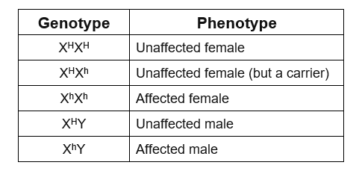

The diagram below shows two possible ways of inheriting haemophilia from one parent.
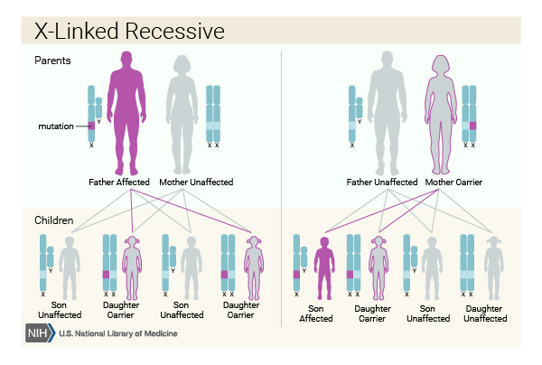
Punnett squares can also be used to determine the probability of offspring inheriting an X-linked genetic disorder. The Punnett square below shows the cross between an unaffected heterozygous female and an unaffected male for the X-linked genetic disorder, colour-blindness.

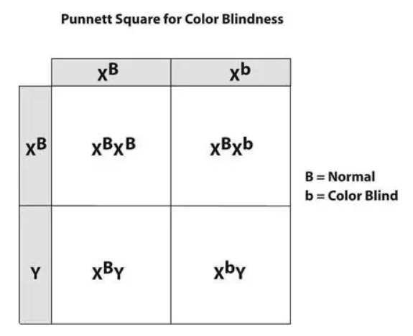
From this Punnett square we can see that no female offspring will be affected by colour-blindness, but that there is a 50% chance that a male offspring will have colour-blindness

Pedigrees

A pedigree is a diagram of family tree that uses symbols to represent gender and lines to represent genetic relationships. Pedigrees are often used to determine the mode of inheritance (dominant, recessive, etc.) of genetic diseases.

In a pedigree, squares represent males and circles represent females. Horizontal lines connecting a male and female represent mating. Vertical lines extending downward from a couple represent their offspring. Subsequent generations are therefore written underneath the parental generations and the oldest individuals are found at the top of the pedigree. A sample pedigree is below.

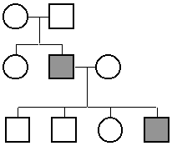

If the purpose of a pedigree is to analyse the pattern of inheritance of a particular trait, it is customary to colour in the symbol of all individuals that possess this trait.
In the pedigree above, the parents had two children, a son and a daughter. The son had the trait in question. One of his four children also had the trait.
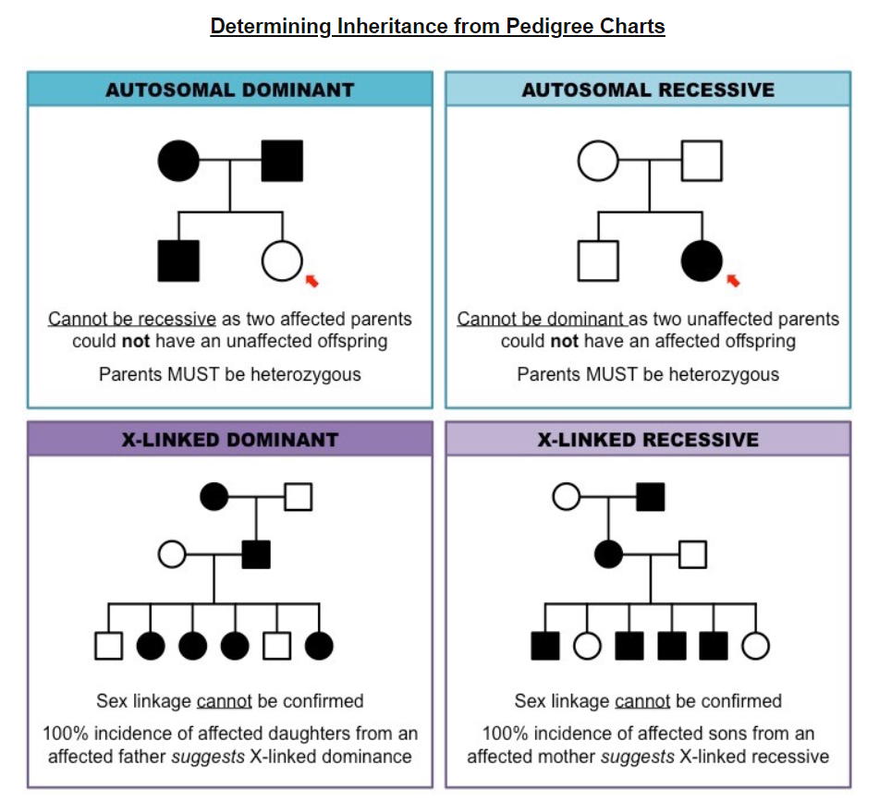
This picture shows how pedigrees can be analysed to determine the type of inheritance that led to the traits that appeared in the offspring.

Pedigrees can also be used to determine unknown genotypes and phenotypes of individuals by examining the traits in parents, offspring and previous generations.

The pedigree chart below shows the autosomal recessive trait for albinism.

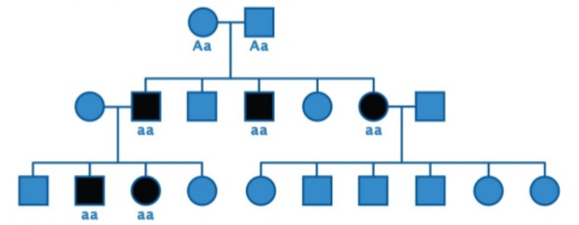

When trying to assign genotypes always start with the affected individuals. In this case, the genotype for affected individuals is aa. You can then work backwards from there. Unaffected parents of affected individuals must be heterozygous as they have to have one copy of the recessive allele to pass on to their child.

Bibliography

Gender determination process
https://www.educationperfect.com/controlpanel/#/content/manage/search/2565460/Unit-2---Reproduction-and-Inheritance%7C2-Cell-Reproduction/1930283?base=english&target=science&term=determination
Gender determination in birds
http://www.soc.hawaii.edu/ws350/spr05/birdsex.gif
Incomplete dominance diagram
https://www.khanacademy.org/science/high-school-biology/hs-classical-genetics/hs-non-mendelian-inheritance/a/multiple-alleles-incomplete-dominance-and-codominance
Difference between dominant/recessive, incomplete and codominance diagram
https://www.youtube.com/watch?v=FXc5F9AMAiQ
X chromosome vs Y chromosome diagram
https://ib.bioninja.com.au/standard-level/topic-3-genetics/34-inheritance/sex-linked-genes.html
Colour blindness punnett square
https://www.quora.com/How-can-a-Punnett-square-for-color-blindness-be-created
Determining Inheritance from pedigree charts
https://www.humanlongevity.com/x-linked-recessive-inheritance
Albanism pedigree chart
https://www.slideshare.net/jamilner/pedigree-examples

Questions

- Complete the following table by writing a definition for each term.

Term | Definition
Gene
Allele
Genotype
Phenotype
Homozygous
Heterozygous
Hemizygous

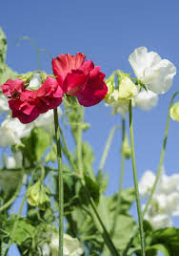
- The gene for red flowers in pea plants is dominant over the gene for white flowers. A homozygous red-flowered plant is crossed with a homozygous white-flowered plant to produce 200 offspring. These are allowed to self-pollinate and produce a second generation of 10,000 offspring.

How many white-flowered plants should occur in:

  - the first generation of 200 flowers?

  - the second generation of 10000 flowers?

- A cross between a blue blahblah bird and a white blahblah bird produces offspring that are silver. The colour of blahblah birds is determined by just two alleles.
  - What are the genotypes of the parent blahblah birds in the original cross?

  - What is the genotype of the silver offspring?

  - What would be the phenotypic ratios of offspring produced by a silver blahblah bird mated with a blue blahblah bird?

- Haemophilia is an X-linked condition which is due to the inheritance of a recessive allele (h). In a given family Dan is a haemophiliac. His parents were normal. Dan has a brother Dick who is normal and a sister Sally who is also normal. Dan marries a normal woman and they have three children. Two of their children, a boy and a girl are normal, but their third child, a girl called Sonia is a haemophiliac. Dan’s sister, Sally, marries a normal man called Roger. Unfortunately, they have an only child called Albert who has the disease.

  - Draw a family tree to show all individuals described in the passage above.

  - On the diagram include the genotypes of all the family members.

  - If Sally and Roger were to have another child, what is the probability that their child would be a Haemophiliac?

- The following pedigree chart shows the inheritance of sickle cell anaemia.
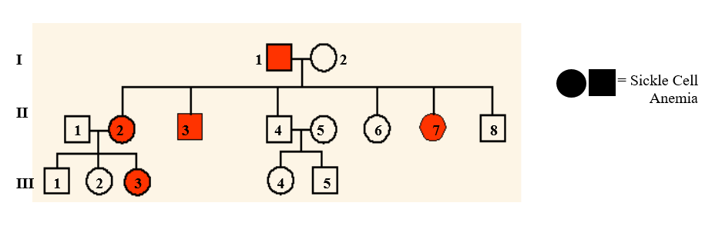

  - Is sickle cell anaemia a dominant or recessive condition? Explain how you determined your answer.

  - Label the possible genotypes for all individuals in the pedigree. One person can have more than one possible genotype.

  - If individuals II 1 and II 2 had another child, what is the probability of them having a child without sickle cell anaemia?

