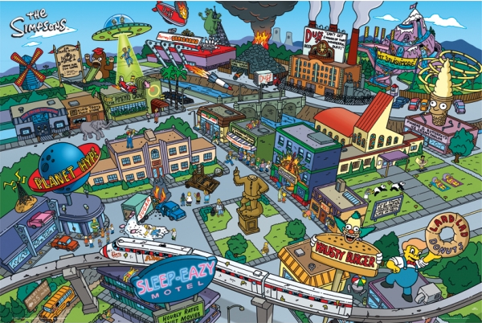
Find as many different forms of energy around Springfield as you can! Add to your list then check with other students to add even more.
My list...

Other examples found by my fellow students...

