Human Perspectives ATAR Units 3 & 4

Worksheet 3.1 Neurons
1 a Label the structures of a neuron on the image below.
b Annotate the image with the function of each structure.
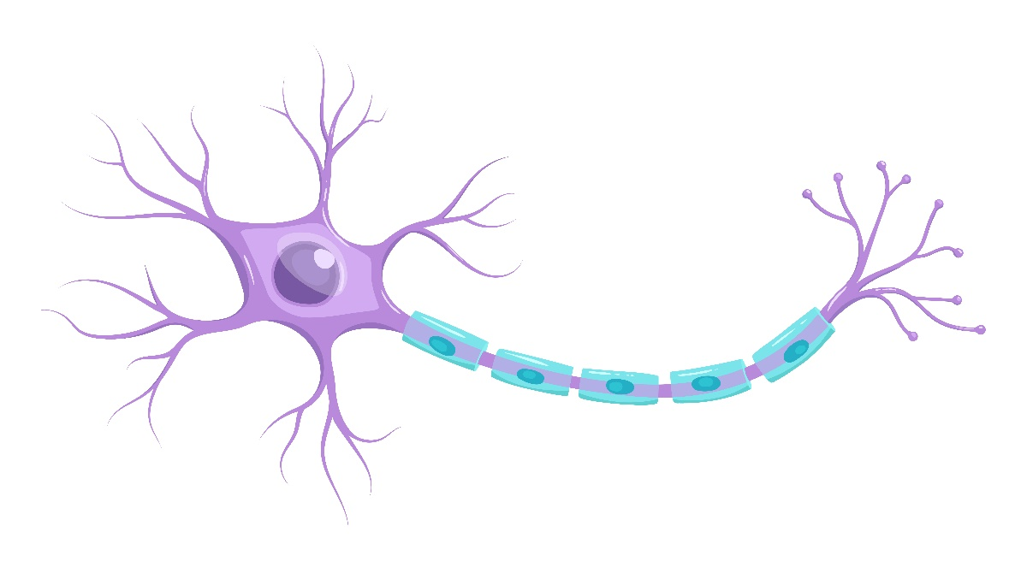
2 a Label the synapse in the image below.
b Annotate the image to show how messages travel from one neuron to the next.

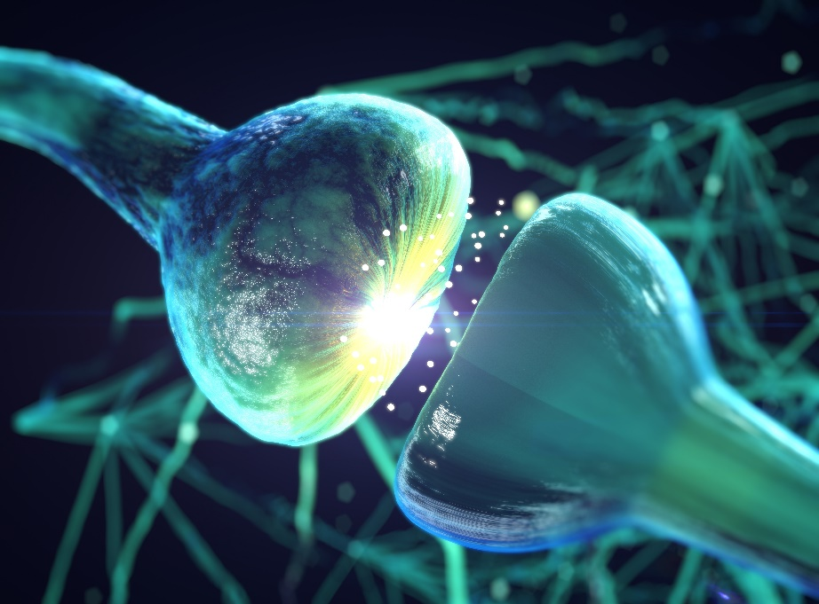
3 Make a list of key terms regarding a neurons and synapses. Organise these into a glossary and add definitions for each.

Photo credits: Top: Shutterstock.com/Ldarin; bottom: Shutterstock.com/Anatomy Image

