Science Inquiry in ATAR Human Biology
Skills and Concepts

Outcome 1 – Science Inquiry Skills
Students investigate questions in human biology, evaluate the impacts of advancements in human biology and communicate scientific understandings.
In achieving this outcome, students:
- plan and conduct investigations
- analyse data, draw conclusions, evaluate investigation design and findings
- evaluate the impact of advancements in human biology on individuals and society
- communicate understandings of human biology.

Science Inquiry Skills
Science inquiry involves identifying and posing questions; planning, conducting and reflecting on investigations; processing, analysing and interpreting data; and communicating findings. This strand is concerned with evaluating claims, investigating ideas, solving problems, reasoning, drawing valid conclusions, and developing evidence-based arguments.
Science investigations are activities in which ideas, predictions or hypotheses are tested and conclusions are drawn in response to a question or problem. Investigations can involve a range of activities, including experimental testing, field work, locating and using information sources, conducting surveys, and using modelling and simulations.
In science investigations, the collection and analysis of data to provide evidence play a major role. This can involve collecting or extracting information and reorganising data in the form of tables, graphs, flow charts, diagrams, text, keys, spread sheets and databases. The analysis of data to identify and select evidence, and the communication of findings, involve the selection, construction and use of specific representations, including mathematical relationships, symbols and diagrams.
Through the Human Biology ATAR course, students will continue to develop their science inquiry skills, building on the skills acquired in the Year 7–10 Science curriculum. Each unit provides specific skills to be taught. These specific skills align with the Science Understanding and Science as a Human Endeavour content of the unit.

Part a) Experimental Design (Chapter 1 Pages 3 – 10)
- identify, research and construct questions for investigation; propose hypotheses; and predict possible outcomes
- design investigations, including the procedure(s) to be followed, the materials required, and the type and amount of primary and/or secondary data to be collected; conduct risk assessments; and consider research ethics, including animal ethics
- conduct investigations; use microscopy techniques; and perform real or virtual dissection, safely, competently and methodically for the collection of valid and reliable data

Some key concepts to revise:
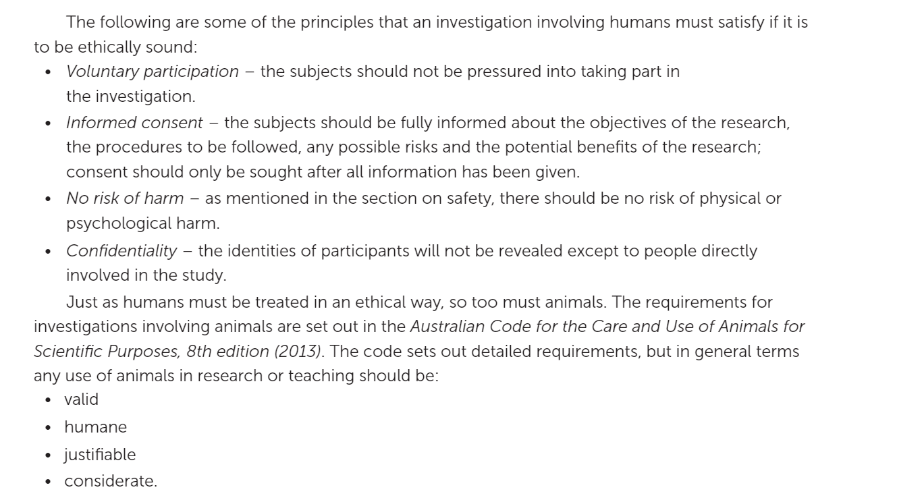www.ebooks.netsonnet.com.au
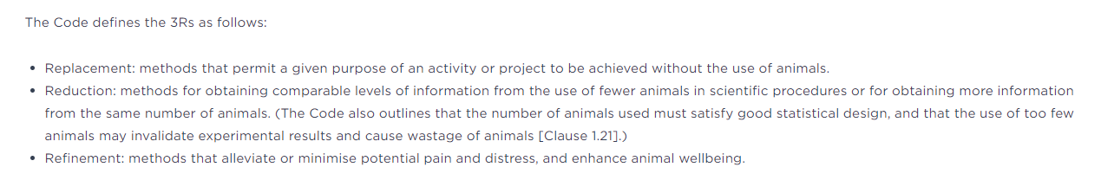
https://www.nhmrc.gov.au/research-policy/ethics/animal-ethics/3rs - for more information access this link

Past Exam Questions:
2015 Question 36
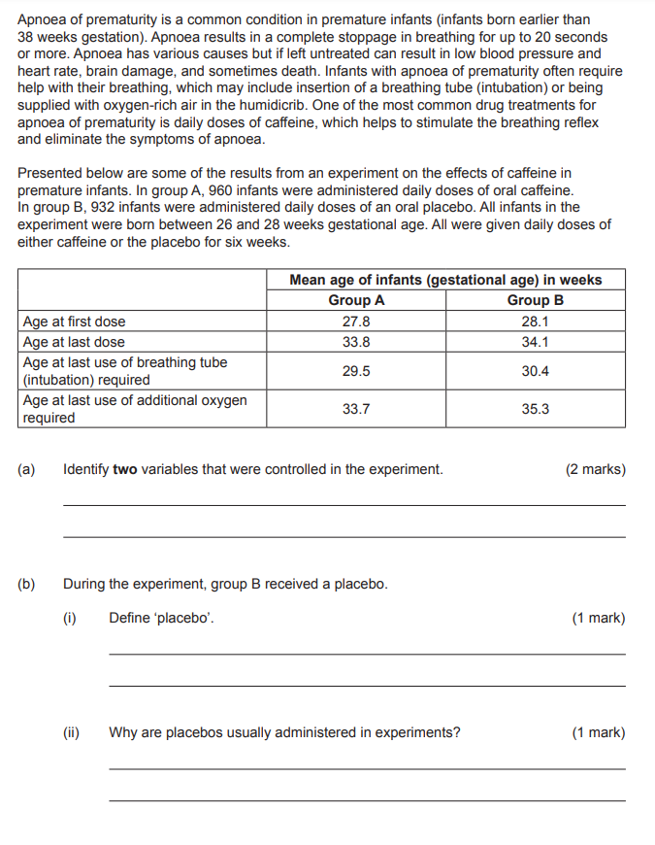
2018 Question 38
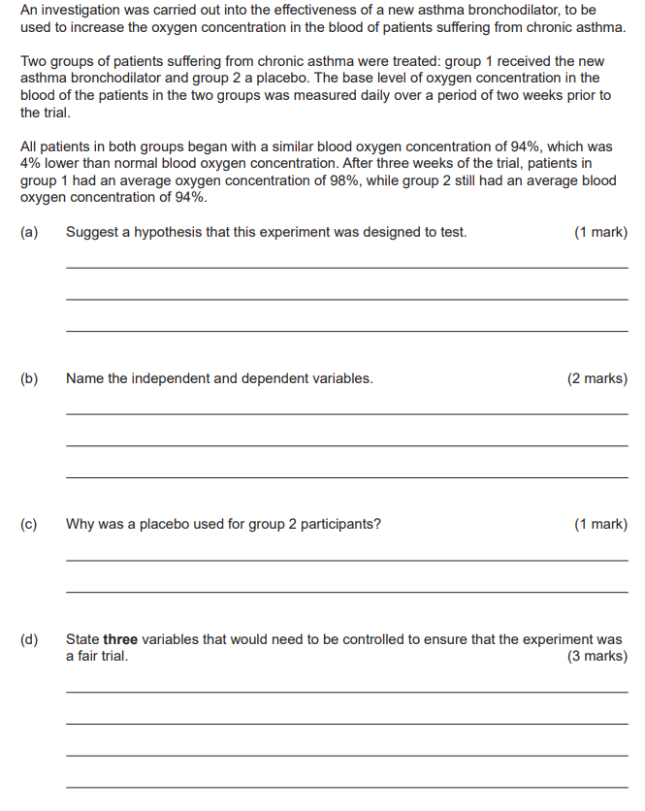

2020 Question 9

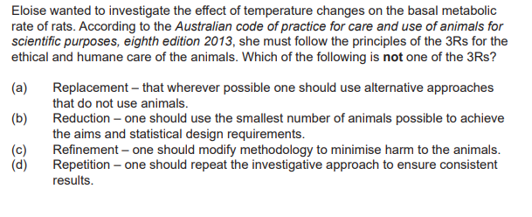

Part b) Representing Data (Chapter 1 Pages 11 – 16)
- represent data in meaningful and useful ways; organise and analyse data to identify trends, patterns and relationships; qualitatively describe sources of measurement error, and uncertainty and limitations in data; and select, synthesise and use evidence to make and justify conclusions
- represent data in meaningful and useful ways, including the use of mean, median, range and probability; organise and analyse data to identify trends, patterns and relationships; discuss the ways in which measurement error, instrumental accuracy, the nature of the procedure and the sample size may influence uncertainty and limitations in data; and select, synthesise and use evidence to make and justify conclusions

Past Exam Questions:
2013 Question 36
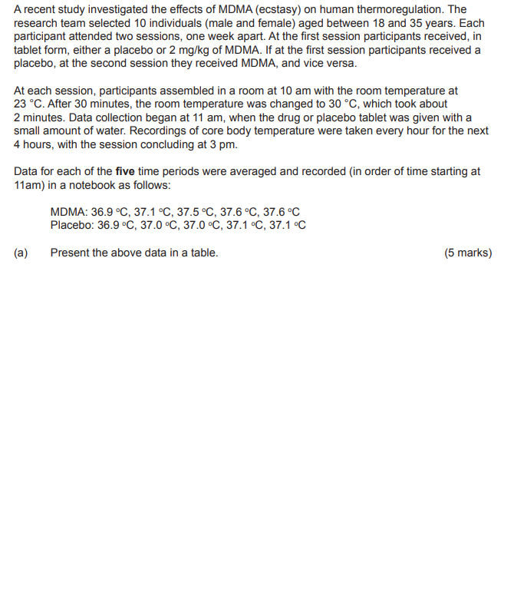
2017 Question 33
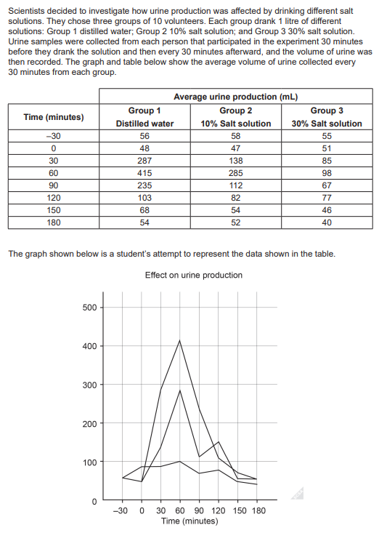
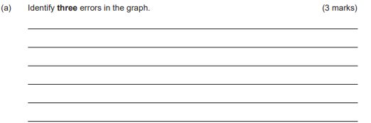
2019 RSHS Sem II Exam Question 33
A year 12 Human Biology student was interested to find out whether or not reaction times were affected by the use of the dominant or non-dominant hand. To test this the student found a reaction time test on the internet where you had to click the mouse when a coloured dot changed, and the computer would display the reaction time in seconds after every attempt. She did the test five times with each hand.

With the non-dominant hand, she scored 0.483, 0.212, 0.357, 0.29 and 0.455; whereas, with the other hand, she scored 0.470, 0.612, 0.417, 0.320 and 0.280.

- Draw a table of results based on the information given above. (3 marks)

The student decided to conduct the same test on 10 of her class mates. Each participant had to complete the same test 5 times with each hand and then record the average.
The results are shown below.

Participant number | Average dominant hand (sec) | Average non-dominant hand (sec)
1 | 0.361 | 0.384
2 | 0.411 | 0.521
3 | 0.172 | 0.169
4 | 0.223 | 0.256
5 | 0.311 | 0.320
6 | 1.100 | 1.421
7 | 0.228 | 0.308
8 | 0.201 | 0.212
9 | 0.199 | 0.212
10 | 0.318 | 0.310
Average | ? | ?

- Use these results to create a graph showing the combined average time for the dominant hand and combined average time for the non-dominant hand. Graph this on the grid paper below. (6 marks)

Part c) Mathematical Skills (Chapter 1 Pages 12 – 14)

Mathematical skills expected of students studying the Human Biology ATAR course
The Human Biology ATAR course requires students to use the mathematical skills they have developed through the Year 7–10 Mathematics curriculum, in addition to the numeracy skills they have developed through the Science Inquiry Skills strand of the Year 7–10 Science curriculum.
Within the Science Inquiry Skills strand, students are required to gather, represent and analyse numerical data to identify the evidence that forms the basis of scientific arguments, claims or conclusions. In gathering and recording numerical data, students are required to make measurements using appropriate units to an appropriate degree of accuracy.
Students may need to be taught when it is appropriate to join points on a graph and when it is appropriate to use a line of best fit. They may also need to be taught how to construct a straight line that will serve as the line of best fit for a set of data presented graphically.
It is assumed that students will be able to competently:
- perform calculations involving addition, subtraction, multiplication and division of quantities
- perform approximate evaluations of numerical expressions
- express fractions as percentages, and percentages as fractions
- calculate percentages
- recognise and use ratios
- transform decimal notation to power of ten notation
- comprehend and use the symbols/notations <, >, Δ, ≈
- translate information between graphical, numerical and algebraic forms
- distinguish between discrete and continuous data and then select appropriate forms, variables and scales for constructing graphs
- construct and interpret frequency tables and diagrams, pie charts and histograms
- describe and compare data sets using mean, median and inter-quartile range
- interpret the slope of a linear graph.
Some key concepts to revise:
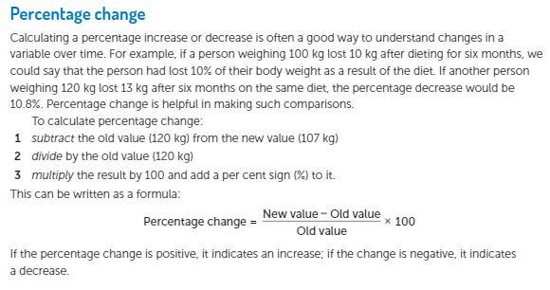
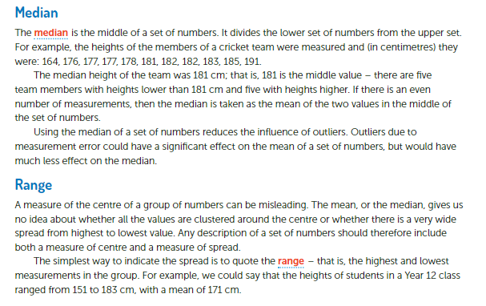www.ebooks.netsonnet.com.au

Past Exam Questions:
2020 RSHS Sem I Exam Question 31
The average systolic blood pressure results for 9 of the Group 1 participants for the two-week medication trial were.

Participant | 1 | 2 | 3 | 4 | 5 | 6 | 7 | 8 | 9
Average Systolic Blood pressure (mmHg) | 140 | 135 | 134 | 150 | 130 | 127 | 125 | 135 | 128

- State the median blood pressure (arranged by systolic pressure). (1 mark)

___________________________________________________________________

- State the mean systolic blood pressure for this group of participants. (1 mark)

___________________________________________________________________

Nelson Chapter 1 Review Question 18
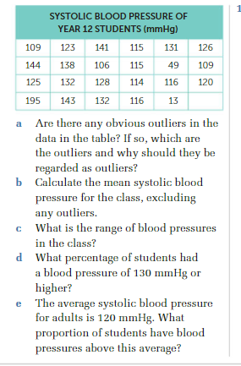
www.ebooks.netsonnet.com.au

Nelson Chapter 1 Apply your Knowledge Question 9
During an investigation about the effect of different types of exercise, the following pulse rates, in beats per minute were recorded prior to exercise.
54 65 62 58 60 66 84 57 61 65 59 63

- Calculate the mean for this data

- Identify any outliers in the data

- State the median pulse rate

- State the age range for the data

- During exercise, the mean pulse rate was 96 beats per minute. Calculate the percentage increase in pulse rate due to exercise

