Rossmoyne Senior High School
Year 10 Science
Biotechnology Research Project

Name: ________________________

Rossmoyne Senior High School is conducting a Biotechnology and Ethics Conference. You have been invited to make a presentation at the conference. Your presentation should be unbiased and inform people about the facts of an issue so they can be better informed to make decisions. It should not be designed to make an ethical statement.

You will be allocated one of the following major biotechnology issues to do your presentation on:

- Genetically modified foods
- Genetically modified organisms
- Cloning
- DNA fingerprinting (profiling)
- In-vitro Fertilisation (IVF)
- Human Genome Project
- Human Stem Cell Research
- Gene Therapy
- Herbicide Tolerant Crops
- Prenatal Testing (harmony test)
- Reviving Extinct Species
- Designer Babies

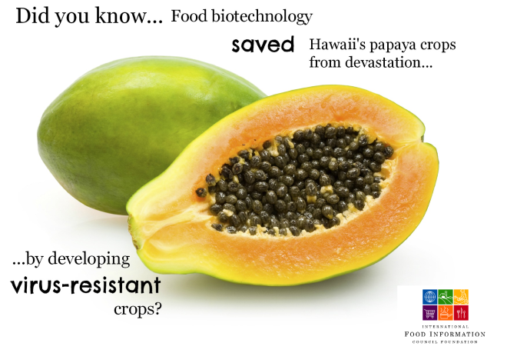

My Topic is:

Use the planning sheet to help you make notes from relevant resources on your topic.

Present your information in a Power Point/keynote presentation that you will exhibit to the class in a gallery walk on Friday 28th July 2017

