Year 10 Chemical Sciences

Week 8 – Rates of Reaction
Objectives:
- Describe the Collision Theory
- Describe the following factors that affect reaction rates:
  - Nature of reactants
  - Surface area of reactants
  - Action of a catalyst
  - Temperature of reactants
  - Concentration of reactants
- Basic awareness of nanotechnology

Collision Theory

The collision theory states that for a reaction to take place the particles in the reaction must:

- collide with sufficient energy to break bonds and form new ones

- collide with correct orientation to allow particles to rearrange themselves into new compounds

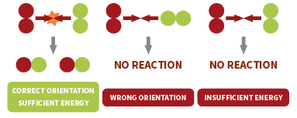

Factors That Affect Reaction Rates

There are five main factors that affect the speed of a reaction. They are:
- Nature of reactants
- Surface area of reactants (or state of subdivision)
- Action of a catalyst
- Temperature of reactants
- Concentration of reactants

We will now examine each factor more closely.
Nature of reactants

The type of bonding can affect the speed of a reaction as some bonding types require more energy to break them than others.
- If a reaction involves breaking of covalent bonds the reaction will often be slow.
- The reaction of ions in solution (e.g. precipitation reactions) will be fast.

Surface area of reactants (State of subdivision)

The greater the surface area exposed in a reaction the greater the number of collisions. More collisions means there is a greater likelihood of collisions being successful which leads to a faster reaction rate.

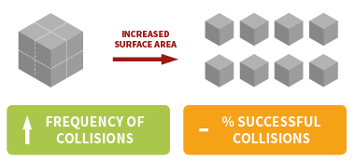

For example, it is a lot quicker to cook potatoes if you cut them into smaller pieces than if you kept them as whole potatoes.

Action of a catalyst

A catalyst is a substance that increases the reaction rate of a reaction but is not consumed in the reaction.
A catalyst provides the reactants with an alternative reaction pathway that requires less energy. As a result more collisions will be successful as a greater proportion of them will have sufficient energy.

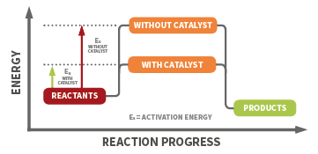

For example hydrogen peroxide will decompose into water and oxygen gas. Two molecules of hydrogen peroxide will produce two molecules of water and one molecule of oxygen.

A catalyst of potassium permanganate can be used to speed up this process. This chemical reaction is known as Elephant’s Toothpaste.

Temperature of reactants

An increase in temperature causes an increase in the average kinetic energy of the particles which means more particles will have sufficient energy to break bonds. Therefore, if the same number of collisions occurred a greater number of them would be successful.
More collisions also occur because the reactants are moving faster which also helps to increase the reaction rate.

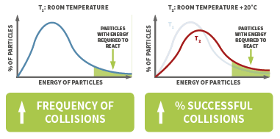
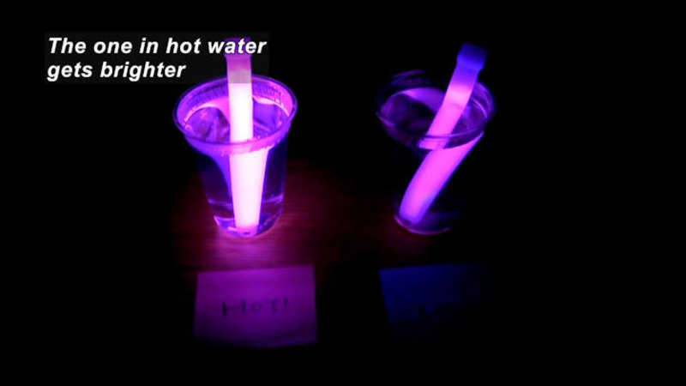
An example of where this is evident is in glowsticks. If you were to place one glowstick in hot water and another of the same type of glowstick in cold water the one in hot water would glow more. This is because the reaction that is producing the photons of light has been sped up.

The reverse is also true, the lower the temperature the lower the reaction rate. For example, refrigeration slows the rate of growth of bacteria in foods by decreasing the reaction rates of biochemical reactions that enable bacteria to reproduce.

Concentration of reactants

If the concentration of reactants is increased then this means there will be a higher frequency of collisions between particles. Since the percentage of successful collisions remains the same this means that there will be a greater likelihood of successful collisions which therefore increases the reaction rate.

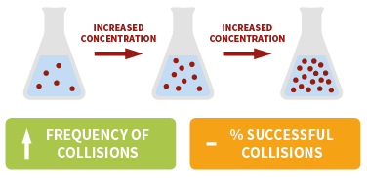

A decrease in concentration of the reactants leads to a decrease in reaction rate due to the number of collisions between particles being reduced.

For example, the reaction of hydrochloric acid and magnesium produces hydrogen gas. A low concentration of hydrochloric acid takes a lot longer to produce the same quantity of hydrogen gas compared to a higher concentration of hydrochloric acid.

Nanotechnology

Nanotechnology is the science of manipulating materials on an atomic or molecular scale. Nanotechnology operates at the scale of one nanometre which is approximately equivalent to one ten thousandth (1/10000) of the width of a human hair.

If you wish to know more about nanotechnology, read chapter 3.8 from Oxford Science 10.

References:

http://www.compoundchem.com/wp-content/uploads/2016/02/Factors-Affecting-Rate-of-Reaction.png

Questions

- List the factors that affect the rate of reaction in a heterogeneous system.

- Explain the following observations:
  - If a lump of iron is placed in a flame it simply gets hot. If powdered iron is sprinkled into the same flame it burns and iron oxides are formed.

  - The reaction Ag⁺ + Cl⁻ → AgCl is faster than the reaction
C₂H₆ + Br₂ → C₂H₅Br + HBr

- To make some carbon dioxide a chemist puts some large pieces of marble in a 0.10 M solution of hydrochloric acid. The rate of production of carbon dioxide is too slow. List 4 ways in which the chemist could alter the conditions so that the carbon dioxide is produced more rapidly and briefly explain each using the Collision Theory.

Method 1
Explanation

Method 2
Explanation

Method 3
Explanation

Method 4
Explanation

