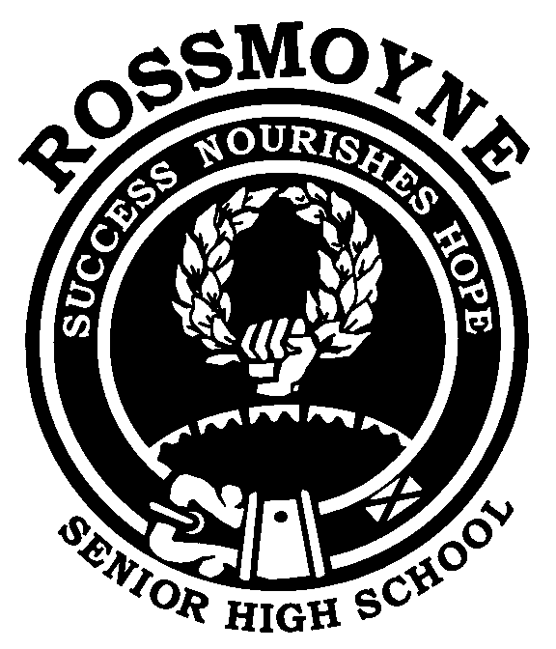
Humanities and
Social Sciences

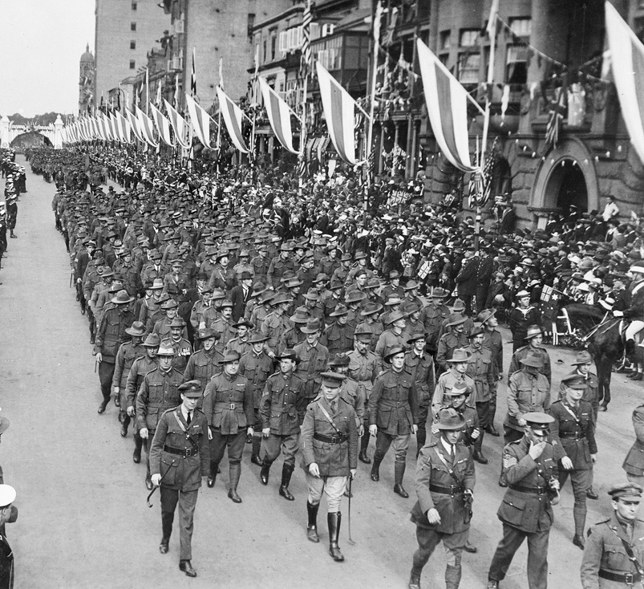

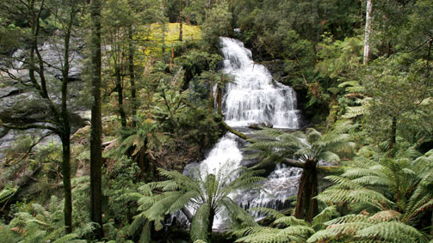
Year 9 Parent and Student Information Booklet 2017
Also available at http://www.rossmoyne.wa.edu.au/programs/learning-areas/humanities-and-social-sciences/

Student’s Name __________________________________

Teacher’s Name __________________________________

Developing Active Citizens for the Future

Acknowledgements Cover Page Images

A March past of Australian ANZAC soldiers during Peace Celebrations in Sydney
Date: 1919 Photographer: Sydney Morning Herald and Sydney Mail; Id number: H16146 ights Info: No known copyright restrictions. This photograph is from the Australian War Memorial's collection www.awm.gov.au Persistent URL: cas.awm.gov.au/item/H16146 accessed 29/11/2013

The words outside the Supreme Court House
Photo released into the public domain by Source: by John Kwan File Number 33956442 Stock Photo Graphical Resources Free Photographs and Graphs for Education https://stock.adobe.com/au

Report Cards
Photo released into the public domain by Petr Ciz at Stock Photo Graphical Resources Free Photographs and Graphs for Education https://stock.adobe.com/au

Country Alpine Mountain Stream
Kathie Nichols, Stock Photo Graphical Resources Free Photographs and Graphs for Education
https://www.dreamtime.commountain-stream-victoria-australia-country-alpine-country-42284219.jpg accessed 17/12/2014

Dear Parent/Guardian and Student

The Humanities and Social Sciences Learning Area provides opportunities for students to acquire the knowledge, skills and values to become active citizens in a rapidly changing world. During the course of the Lower School Humanities and Social Sciences Program, students will develop an understanding of how and why individuals and groups live together and interact with their environment. This will involve developing a respect for our cultural heritage, a commitment to social justice, the democratic process and ecological sustainability.

Monitoring Progress
Students are encouraged to record their Humanities and Social Sciences results in the Student Record of Achievement on page 9 of this document. This provides parents with the opportunity to monitor their child’s progress and contact the classroom teacher if there are any issues of concern that need addressing. Teachers will likewise contact parents when necessary.

Upper School Courses of Study
The knowledge, skills and values acquired during the Lower School Program will equip students to successfully complete studies in the following Upper School Courses of Study:
- History ● Geography
- Politics & Law ● Economics
- Accounting and Finance ● Certificate II Business
- Psychology

Please read the remainder of the booklet to familiarise yourself with the whole program being offered by the Humanities and Social Sciences Learning Area.

Please sign below to indicate you have read through the Parent and Student Booklet and please feel free to contact us for any further information that you may require.

Student’s Name: _______________________ Signature: ____________________________

Parent’s Name: ________________________ Signature: ____________________________

Following our Sustainability Priority – the whole booklet is available on
http://www.rossmoyne.wa.edu.au/programs/learning-areas/humanities-and-social-sciences/

COURSE OUTLINE SCHEDULE FOR YEARS 9 AND 10

The structure of the Humanities and Social Sciences’ courses are currently undergoing considerable changes with the implementation of the Western Australian Curriculum. The each semester grade will be based on the courses below.

Research skills will be included in all courses and not be reported separately.

 | Year 9 – 2017 | Year 10 - 2018
Semester 1 | Term 1
 | History  - The Industrial Revolution (1750 – 1914)  - World War I (1914 – 1918) | Geography  - Environmental Change and Management  - Geographies of Human Wellbeing
 | Term 2
 | Civics & Citizenship  - Our Democratic Rights | Economics & Business  - Economic Performance and Standards of Living
Semester 2 | Term 3
 | Geography  - Biomes and Food Security  - Geographies of Interconnection | History  - World War II (1939 – 1945)  - Rights and Freedoms (1945 – present)
 | Term 4
 | Economics & Business  - Australia and the Global Economy | Civics & Citizenship  - Justice at Home and Overseas

HUMANITIES AND SOCIAL SCIENCES YEAR 9 COURSE OUTLINE CONTENT

Semester 1  Term 1 - History  Making the Modern  - The important features of the modern period (1750–1918)  The Industrial Revolution (1750-1914)  - The technological innovations that led to the Industrial Revolution, and other conditions that influenced the industrialisation of Britain and of Australia  - The population movements and changing settlement patterns during the Industrial Revolution  - The experiences of men, women and children during the Industrial Revolution, and their changing way of life  - The short-term and long-term impacts of the Industrial Revolution, including global changes in landscapes, transport and communication  World War I (1914–1918)  - The causes of World War I and the reasons that men enlisted to fight in the war  - The places where Australians fought and the nature of warfare during World War I  - The impact of World War I, with a particular emphasis on Australia  - The commemoration of World War I |  | Semester 2  Term 3 - Geography  Biomes and Food Security  - The distribution and characteristics of biomes as regions with distinctive climates, soils, vegetation and productivity  - The ways that humans in the production of food and fibre have altered some biomes  - The environmental, economic and technological factors that influence crop yields in Australia and across the world  - The challenges to food production  - The effects of anticipated future population growth on global food production and security; the capacity for Australia and the world to achieve food security; the implications for agriculture, agricultural innovation and environmental sustainability  Geographies of Interconnection  - The perceptions people have of place, and how this influences their connections to different places  - The way transportation, and information and communication technologies are used to connect people to services, information and people in other places  - The ways that places and people are interconnected with other places through trade in goods and services, at all scales  - The effects of people's travel, recreational, cultural or leisure choices on places, and the implications for the future of these places
Term 2 - Civics & Citizenship  - The role of political parties, and independent representatives in Australia’s system of government,  - How citizens’ choices are shaped at election time  - How social media is used to influence people’s understanding of issues  - The key features of Australia’s court system and the role of a particular court and the types of cases different courts hear  - How courts apply and interpret the law, resolve disputes, and make law through judgements  - The key principles of Australia’s justice system, including equality before the law, independent judiciary, and right of appeal  - The factors that can undermine the application of the principles of justice |  | Term 4 - Economics & Business  - The role of the key participants in the Australian economy  - Australia’s interdependence with other economies  - Why and how participants in the global economy are dependent on each other  - Why and how people manage financial risks and rewards in the current Australian and global financial landscape  - The ways consumers can protect themselves from risks  - The nature of innovation and how businesses seek to create and maintain a competitive advantage in a market, including the global market  - The way the work environment is changing in contemporary Australia and the implication for current and future work
HUMANITIES AND SOCIAL SCIENCES: - YEAR 9 COURSE OUTLINE
SKILLS TO BE DEVELOPED DURING THE YEAR
General
Research and Questioning | - Identify current understandings to consider possible gaps and/or misconceptions, new knowledge needed and challenges to personal perspectives  - Construct a range of questions, propositions and/or hypotheses  - Use a variety of methods to collect relevant information and/or data from a range of appropriate sources, such as print, digital, audio, visual and fieldwork  - Select the best method for recording selected information and/or data  - Identify differences in terms of origin and purpose between primary sources and secondary sources  - Use appropriate ethical protocols to plan and conduct an inquiry
Analysing | - Use criteria to select relevant information and/or data such as accuracy, reliability, currency and usefulness to the question  - Interpret information and/or data to identify key relationships and/or trends displayed in various formats  - Identify points of view/perspectives, attitudes and/or values in information and/or data  - Translate information and/or data from one format to another  - Apply subject-specific skills and concepts in familiar and new situations
Evaluating | - Draw evidence-based conclusions by evaluating information and/or data to generate a range of alternatives and plan for action in response to contemporary events, challenges, developments, issues, problems and/or phenomena; make comparisons; evaluate costs (disadvantages) and benefits (advantages); and infer relationships
Communicating and Reflecting | - Represent information and/or data using appropriate formats to suit audience and purpose  - Develop texts, particularly descriptions and explanations, using appropriate subject-specific terminology and concepts that use evidence to support findings, conclusions and/or arguments, from a range of sources.  - Reflect on learning to review original understandings and/or determine actions in response to events, challenges, developments, issues, problems and/or phenomena
Subject specific
Geography | - Application of the 7 key concepts of Geography  - Data interpretation  - Short answer responses  - Topographical and Image mapping skills  Research skills
Economics & Business | - Data interpretation  - Short answer responses  - Extended answer responses  - Research skills
History | - Timelines  - Source analysis (message, perspective, compare and contrast, purpose, context)  - Research skills  - Extended answer responses
Civics & Citizenship | - Short answer responses  - Extended answer responses  - Research skills

The main process/methodology of learning in Humanities and Social Sciences is through research.
There are four stages involved in research tasks:

1. PLANNING RESEARCH
Students plan ways to organise and gather information:
- Identify factors to be considered
- Devise questions
- Identify possible sources of information
- Make simple predictions
- Negotiate how to use the information
- Formulate hypotheses

2. CONDUCTING RESEARCH
Students, conduct the investigation by determining where sources of information are located then organising and evaluating the information:
- Use a range of social science techniques to make observations
- Refer to more than one source and type of sources e.g. interviews, DVDs, internet
- Use a variety of techniques to record information e.g. tables
- Identify a range of perspectives
- Identify the most appropriate sources of information

3. PROCESSING & TRANSLATING INFORMATION
Students process and translate information to make findings/judgements:
- Select, categorise and compare information gathered
- Transform the information into structured forms of display
- Identify, select and combine information
- Connect similar ideas
- Make generalisations and draw conclusions
- Present a particular point of view

4. APPLYING & COMMUNICATING FINDINGS
Students evaluate data, apply and communicate findings according to purpose and audience:
- Present findings
- Present evidence for findings
- Communicate findings effectively
- Demonstrate consideration of facts, opinions and motives of a particular point of view

Students will have numerous opportunities to work on developing their proficiency in the above skills.
PLAGIARISM
Plagiarism is presenting work that is not your own. To avoid this situation, students need to ensure that they:
- Take key points from sources rather than ‘cut and paste’
- Label notes with the references used
- Maintain a detailed bibliography
- Develop their own findings regarding the topic based on research

Students who plagiarise may have marks deducted or be asked to write the task again.

ASSESSMENT TASKS

Throughout each semester, students will have the opportunity to demonstrate their understanding of the course knowledge and skills through different types of assessments such as:
- research tasks
- in-class essays or extended answer questions
- common assessment tasks
- class participation in discussions and other activities

Students are encouraged to record their results on the Student Record of Achievement below.

ASSESSMENT STRUCTURE AND WEIGHTING

SEMESTER 1 | SEMESTER 2
History  - Common Assessment Task  - Other Formative Tasks | Geography  - Common Assessment Task  - Other Formative Tasks
Civics & Citizenship  - Common Assessment Task  - Other Formative Tasks | Economics & Business  - Common Assessment Task  - Other Formative Tasks

STUDENT RECORD OF ACHIEVEMENT

Semester 1 |  |  |  | Semester 2
Date | Assessment | Result |  | Date | Assessment | Result

COMPLETING ASSESSMENT TASKS

All assessment tasks need to be completed. Failure to complete an assessment task will jeopardise your chances of being awarded a higher grade.

ABSENT FOR AN ASSESSMENT

If a student misses an in-class assessment OR a due date for handing in a piece of work as a result of being away on the day, a parent note will need to be presented to the teacher on the day they return to school. Alternatively, a telephone call (or email) can be made to the teacher.

Please refer to the Assessment Policy in the School Handbook or Rossmoyne Senior High School’s website for more information.
http://www.rossmoyne.wa.edu.au/about-us/policies/assessment-and-reporting-policy/

HOMEWORK AND STUDY

Students will need to spend time working on their Humanities and Social Sciences learning out of school hours.
This may take one of the following forms:
- A set task to be completed by a certain date
- General review of material covered in class
- Revision for an in class assessment
- Conducting research
- Completing tasks which cannot be completed in class e.g. local area study

The amount of time students should be spending on their Humanities and Social Sciences learning should fit within the parameters set by the school for each year group for all subjects.

MONITORING AND REPORTING PROGESS

Teachers will monitor student progress and report in the following ways:
- Marking of assessment tasks
- Parent Evening
- Semester 1 and 2 reports
- Letters of Commendation and Concern
- Telephone calls and/or e-mails

ACHIEVEMENT TARGETS

Students aiming to successfully proceed into History, Economics, Geography, Accounting & Finance, Psychology and Politics & Law courses should be achieving B grades or better.

The Humanities and Social Sciences Learning Area has a strong focus in providing students with opportunities to participate in a wide range of competitions and activities. Some examples are:

Premier's Anzac Tour
Students prepare a five minute oral presentation on an ANZAC related topic to a panel of RSHS Humanities and Social Sciences teachers. One student from each age category continues to a district level and a possibility of being selected for a remarkable trip to a World War I or a World War II location with the other state winners.

National History Challenge
The National History Challenge encourages inquiry-based learning, the use of primary and secondary sources and offers a variety of presentation styles that can cater to individual learning preferences. Students are the historians, they can investigate their community, explore their family’s past, major events, new ideas or historical theories.

Australian Geography Competition
Students complete a multiple-choice test which can lead all the way to an interstate or international competition. All entrants will receive a certificate informing them of the level they have achieved.

Sir Charles Court Young Leaders Program Year 10
Students are nominated for a four day camp where leadership skills are sharpened and students participate in collaborative activities that enhance their learning.

ASX School Share-Market Game
Students participate in an online virtual share market game. Students develop a range of skills including decision making in an ever-changing environment.

Cultural Day Year 9
Students will be given the opportunity to experience the different arts and traditions of world cultures in a fun, educative and engaging way.

Each semester, student achievement in the Humanities and Social Sciences Learning Area will be acknowledged in the following ways:

- The most outstanding Humanities and Social Sciences students will receive Outstanding Student Awards in each year group

- The top student in each class will receive a Certificate of Acknowledgement

- Up to 5 students in each class will be awarded Certificates of Endeavour

End of Year Awards
The most outstanding student in Year 7, 8, 9 and 10 will receive one of the following Humanities and Social Sciences medals:

- Year 7 - C. Y. O’Connor Medal

- Year 8 - Yagan Medal

- Year 9 - Dorothy Tangney Medal

- Year 10 - John Curtin Medal

The Selection Process for Outstanding Student and Medal Awardees:
Teachers will invite students who have performed at the highest level in their Humanities and Social Sciences studies to submit a portfolio reflecting their progress.

The portfolio should contain:

- A short summary of how they have performed in their Humanities and Social Sciences studies
- ONE extended answer (essay)
- ONE investigation (research assignment)
- Documentation that reflects active citizenship in the school environment and beyond in accordance with the principles and values associated with the democratic process, social justice and ecological sustainability

Students can use the following guidelines to ensure they maximise their achievement.

ARRIVING TO CLASS ON TIME
It is your responsibility to be in class on time.

ABSENT FROM CLASS
If you know you are going to miss class ensure you inform your teacher at the earliest opportunity so the necessary arrangements can be made. If you have an unscheduled absence check with your classmates and teacher to ensure you catch up on all work missed.

BEING ORGANISED
Students need to use their diary to ensure they are fully aware of their Humanities and Social Sciences responsibilities. This will include using their diary effectively, always having the appropriate equipment, completing homework, meeting deadlines and being involved in class activities.

EQUIPMENT NEEDED
Students will need a file with their Humanities and Social Sciences section clearly labelled, pens, pencils, ruler, eraser, sheet protectors, plenty of paper, a USB and earphones. Students should have their exercise book for Cornell Note taking with them every day. The bringing of a laptop computer every day is highly recommended.

ORGANISING YOUR INFORMATION
All work needs to be correctly titled, dated and completed neatly. It is important to be able to keep sections of work together – particularly when working on a research assignment . All Humanities and Social Sciences work completed on computers should be kept in an Humanities and Social Sciences folder with sub-folders for separate topics such as Research Assignments, History, Politics etc.

COMPLETING TASKS IN CLASS
It is important for students to participate in all aspects of their Humanities and Social Sciences learning. This involves being able to discuss ideas, ask questions and complete a variety of tasks which will include researching, writing, using a variety of information sources such as texts, atlases and the internet.

WORKING IN THE LIBRARY AND ON COMPUTERS
Students need to ensure they gain maximum benefit from being in the library or using computers.
This will involve identifying a clear task for you to complete, identifying the source of information you wish to use quickly and using appropriate note taking skills to record the information needed. Use Moodle to access information to upload your work, download tasks and for collaborative learning activities.

Year 9
- Financial Management

Year 10
- Accounting & Entrepreneurship | - Criminal Investigation | - Psychology
- Law and Commerce | - Certificate II/III Business | - Philosophy
- International Tourism

Successful completion of the Year 7 – 10 Program will provide an excellent platform for selecting the following upper school courses.

Economics
The Economics course provides the knowledge and develops the skills of reasoning, logical thinking and interpretation that are demanded by business and government. Topics are taught within the real world context of the retail market, stock market, labour market and international markets. Macroeconomics and the government’s role in the economy are explored. Issues such as economic growth, inflation, unemployment, income distribution, business strategy, and international relations, global markets and economic policy are considered and financial literacy skills are developed.

Students learn the language of economics and the use of theories and models to explain and interpret economic events and issues.

Geography
Some of the areas studied in upper school include natural hazards, resources, urban planning and climate change. By exploring their impact and proposed solutions for sustainable development whilst meeting environmental, economic and community needs, students should develop knowledge, skills and understandings that enables them to live and work in a rapidly changing world.

History
The Modern History course fosters students’ skills through analysing information and using evidence to develop a strong coherent argument. Students are encouraged to question and evaluate historical sources, representations, interpretations and versions of history. Historical studies help students to use critical thinking skills as they compare and contrast information, detect inconsistencies in details, recognise manipulation of evidence, note one-sided presentation of material and evaluate degrees of accuracy in sources.

Politics & Law
Democracy requires involvement. An essential part of life in the 21st century is an understanding of the framework of politics and law in this society so that students will be able to participate in the processes which will, in turn, empower them to make informed choices.

The knowledge, skills and values examined by the course allow students to become informed, active participants in the political and legal decisions that affect their lives and the future of their communities.

Psychology
Psychology is the scientific study of how people think, feel and act. It aims to answer important questions such as what factors influence human development. Students will look at a range of psychological concepts including biological bases of psychology, personality theory, intelligence theory, social psychology, ethics, scientific investigation, developmental psychology and communication. ​

Accounting and Finance
Accounting provides students with an understanding of concepts and procedures needed to process the financial records of a small business. The course includes some computerised accounting. The knowledge and skills gained in this course are useful for careers in accounting, marketing, management and finance.

Certificate II/III in Business
The Business course covers a range of business subjects including word processing, spread sheets, designing organisational documents, mail procedures, preparing and processing accounts and processing and maintaining workplace information.

Students develop relevant technical skills, vocational and interpersonal competencies suitable to employment and further training in business as well as skills, knowledge and experiences that are transferable to other industry areas.

Answering essay questions is a skill that can be acquired with a combination of practice and applied technique.

The technique of essay writing:

- PLANNING THE ANSWER
- Planning is the key to success
- All good essays are well constructed, follow a sound ‘line of argument’ and answer the question clearly
- To plan successfully, you must have a clear understanding what the question is asking. Underline key words and know what these key words are asking you to do e.g. evaluate.

- WRITING THE ESSAY ANSWER
Essays should have an introduction, a body of several paragraphs and a conclusion

INTRODUCTION:
- State the central argument/theme/thesis that you are presenting
- Outline the structure of your essay, what major points you are going to make?
- Identify the limits/parameters of your essay
- Where appropriate define any terms
- Relate the topic to the keywords of the question e.g. describe, compare.

BODY:
- ‘Say it’
- Use paragraphs
- Put one main point in each paragraph
- For each paragraph provide a topic sentence, explain the point, give evidence and examples to support your explanation, conclude the paragraph by connecting it to your thesis/question
- Try, if possible, to link each paragraph to the one before or to the question.

CONCLUSION:
- ‘Say that you’ve said it’
- Keep the conclusion crisp, strong and clear
- Make a direct reference to the question, re-iterate key words of the question if you can and show that you have answered the question.

The purpose of your conclusion is to draw all the major points of your answer into one or two strong, powerful statements.

3. CHECKLIST FOR ESSAYS

Ask yourself the following questions when editing your essay:

1. Does the essay answer the question?
2. Have I followed the instruction words i.e. discuss, analyse, compare?
3. Does the essay have an introduction that outlines the main points?
4. Does the essay present relevant information and details appropriate to the question?
5. Is there a logical sequencing of ideas and facts?
6. Is the essay coherent with correct use of grammar, spelling, sentence and paragraph structure?

Account for | To give reasons for something.
Analyse | To separate or break up a whole into its parts so that you may study how each part relates to the whole question/event/topic, etc. It is important to make some comment about the main idea or concept of the question/event/topic.
Assess | To estimate the importance, quality, significance of something. Look carefully at the situation/aspect you are being asked to assess. In general, you should point to strengths and weaknesses and/or similarities and differences.
Compare | To look for similar and different qualities or characteristics of events/ ideas, etc.
Contrast | To stress dissimilarities/differences of qualities, events or problems.
Criticise | To judge the merit or truth of factors or views mentioned. Give the results of your analysis of these factors, discussing their limitations and good points.
Debate | To present an argument. To argue a particular point of view, using evidence to support the argument. You must present a proposition.
Define | To give short, clear and authoritative meanings. Do not give details but keep to the limits of the definition by staying on the point.
Describe | To narrate or write a detailed account of the particular event or factor.
Develop | Put forward your ideas in a logical and detailed manner.
Discuss | To critically examine and give reasons for and against. Present your views in detail using examples or illustrations. This may require the student to combine definition, description, explanation, drawing conclusions etc. The answer should be comprehensive and detailed.
Evaluate | To present a judgement of an issue by stressing both strengths/advantages and weaknesses/limitations. Conclude with your own opinion (not using first person) or evaluation supported by available evidence.
Examine | To carefully inspect the known facts about a particular situation/aspect and present the findings in a balanced way.
Explain | To make clear with detailed information. To provide reasons for -
Identify | To recognise or establish something e.g. reasons for a particular event/aspect or concept through an examination of the known facts.
Illustrate | To use example/s to explain a particular topic or proposition.
Interpret | To make sense of something, often a table of data or a graph.
Justify | Give an explanation why a particular course of action has been or should be followed. Justify means make a reasoned choice.
List | To write an itemised series of concise/accurate statements using prose (complete sentences). Do not use note-making format in Humanities and Social Sciences subjects.
Outline | Summarise by mentioning important points only. Provide a short discussion to demonstrate a good overall knowledge of the topic or concept.
Relate | (a) Show how events are related to one another or  (b) to explain the link between cause and effect – understand a relationship.
State | To narrate or write main points in a brief, clear and logical sequence.
Suggest | Identify possible reasons why an event has occurred. The question might also be asking for a prediction – suggest what might happen if…?
Summarise | To give the main points or facts in a condensed/shortened form omitting details and illustrations. Do not use note-making format.
Trace | To describe in narrative form the progress, development or sequence of historical events from the point of origin.

