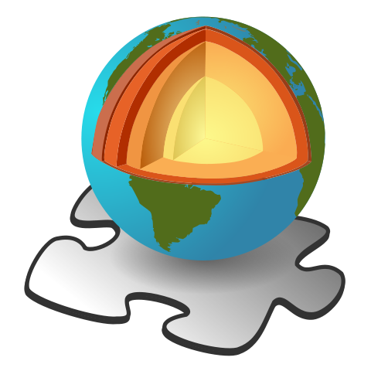
Name: ______________________________
Earth Science - Pushing and Shoving
Before viewing
Define the following terms:
Tectonic plate

Continent

Continental drift

Crust

Mantle

Watch the video Our Earth – Pushing and Shoving
During/after viewing
Answer the following questions in the space provided:
What causes natural disasters like earthquakes and volcanic eruptions to occur?

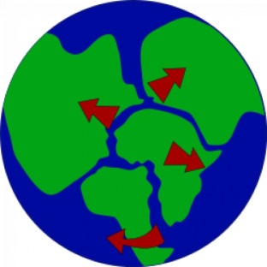
What evidence is there for the super continent of pangea?

Draw a diagram of a convection current:

At what rate do the continents move?

What is the difference between a divergent and convergent boundary?

What is the name given to the place where the sea floor converges into a continental plate?

What process causes mountain ranges?

Why is New Zealand tectonically active, yet Australia is not?

What is erosion?

What causes a fault?

Draw a picture of diverging and converging plates. Include labels of subducting zones, mountain ranges, ocean trenches and convection currents.

