Working as a Scientist
TEST REVISION
- Read the following statement and tick the box that it belongs to:
 | OBSERVATION | INFERENCE | PREDICTION
The woman is on the telephone | X
Jason is not at school today, he must be sick |  | X
Sally’s mums car is green | X
Everybody is packing up, I think the bell will go soon |  |  | X
I think Ms Johansen will give us lollies tomorrow |  |  | X
It must be cold outside |  | X
Everyone is wearing jumpers | X

- Johnny wants to light a Bunsen burner. In the space below list the 10 steps he must take to do so correctly:

Here is the equation for working out averages:
$$Average=\frac{measurement 1+measurement 2+measurement 3+…last measurement}{how many measurements were made}$$
You can also work out averages like this:
0 | 1 | 2 | 3 | 4 | 5 | 6 | 7 | 8 | 9
Measurement 1
Measurement 2
Average

The average is the number that is in the ‘centre’ of all the other numbers you have in a set of data.
- Using the equation above, find the average of the following:
Time | Temperature measurement 1⁰C | Temperature measurement 2 ⁰C | Temperature measurement 3 ⁰C | Average ⁰C
Start | 26 | 28 | 26 | 26.6
5 min | 29 | 30 | 30 | 29.6
10 min | 31 | 33 | 32.5 | 32.16
15 min | 33 | 34 | 33.5 | 33.5

- Write a hypothesis for each aim:
To determine if washing hands with soap is better than using hand sanitiser
If hands are washed using soap then they will be cleaner than if they were washed with hand sanitiser

To determine if bribing the teacher reduces the amount of homework set
If the teacher is bribed then the amount of homework set will reduce

- Name the following equipment:

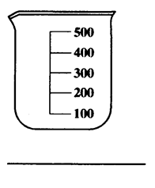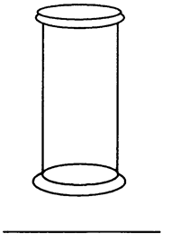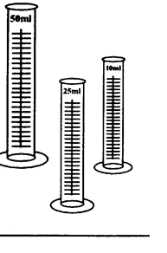
Measuring Cylinder
Gas Jar
Beaker

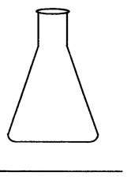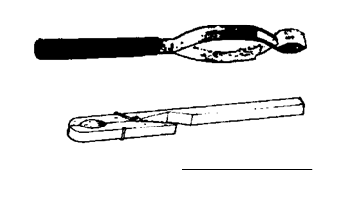
Test Tube Holder
Conical Flask

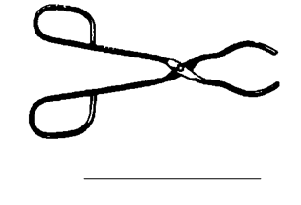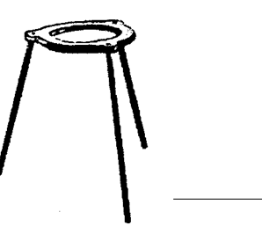
Tripod Stand
Tongs

