METALS ASSIGNMENT

DUE DATE: TUESDAY 20TH OF SEPTEMBER

Select a metal from the table below:

Aluminum | Copper | Gold | Silver
Iron | Lead | Nickel | Zinc

Create a poster (strictly A4 in size) about the element that you have chosen. Make sure to answer the following questions on your poster.

- Where is the element mined? (If the element is widely mined all over the world, then give the major locations it is mined in Western Australia or Australia). (2 marks)

- What is the name of the ore of the metal that is mined? (2 marks)

- What processing happens to the ore before the element is in a useable form? (6 marks)

- Give uses of the element and explain the properties that make it suitable for that use. (5 marks)

- What are three properties that the chosen element shares with most metals? (3 marks)

- Describe one property of the chosen element that makes it different to other metals.
(2 marks)
Total: 20 Marks

Make sure to include a bibliography (minimum of 2 references). The bibliography can be written on a separate piece of paper or on the back of your poster.

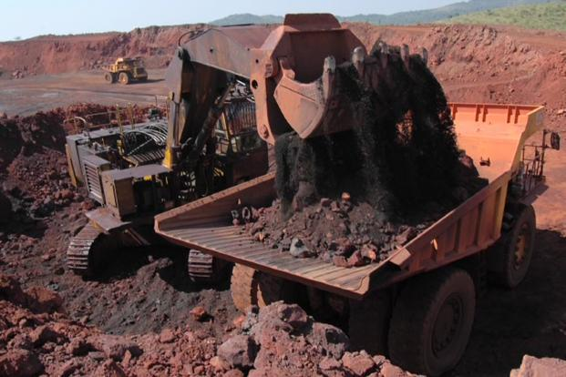
Posters will be displayed in class on Tuesday the 20th of September

