SELECTING THE APPROPRIATE BUSINESS STRUCTURE
One of the first decisions you need to make when starting a business is to select an appropriate business structure.

Comparison of sole trader Partnership and Company (SBDC website https://www.smallbusiness.wa.gov.au/business-topics/planning-structures/business-structures/)
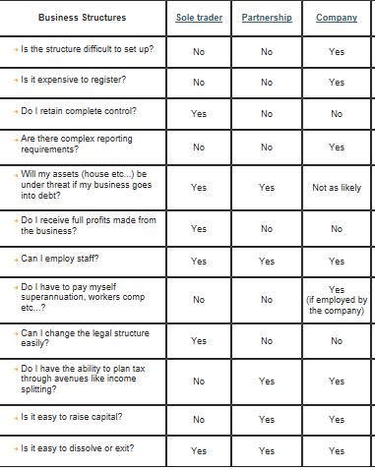

STUDENT ACTIVITY

- Complete the following table:

Structure | Definition | Advantages | Disadvantages
Sole Trader

Partnership

Company

- Decide what form of business ownership is most appropriate for each of the following:

Scenario | Most Appropriate Ownership Structure | Reason
A small bicycle shop that offers personal service and advice by the owner

A national retail chain that would require $589 million dollars to establish

A suburban hairdressing salon

A medical clinic

- Complete the table below to show the ownership structure of each of the listed businesses. The first one has been completed for you as an example:
Pinters Pty Ltd Tom Brooks Plumbing
Mark & Mark Communications CGM Ltd
Top Ten Pty Ltd Spencer & Kelly
Grants Catering Wesfarmers Ltd

Sole Trader | Partnership | Private Company | Public Company
 |  | Pinters Pty Ltd

- Define unlimited liability.

- What is ‘incorporation’?

