Year 10 Earth and Space Science Week 1

Big Bang Theory and the Universe

Objectives:
- Recall the Big Bang hypothesis for how the universe began.
- Identify the evidence for the Big Bang Theory e.g. the red and blue shifts (movement and location of galaxies) and background radiation.
- Features of the Universe E.g. Galaxies, Stars, Solar Systems, Planets, satellites, comets, moons.

Big Bang Theory

The Big Bang Theory describes what the universe was like in the beginning and what is happening to the universe today.

This theory states three things:
- In the beginning, the universe was very small, hot, and dense. All matter was crammed into a space smaller than the size of an atom.
- An unknown event (the “bang”) triggered a rapid expansion of the universe. The universe is still expanding and has always been expanding since it began.
- As the universe expands it is cooling down.

No one knows what caused the big bang but there is a lot of evidence that supports the theory.

Evidence supporting the Big Bang Theory

There are three main pieces of evidence that supports the Big Bang Theory.
- The existence of Cosmic microwave background radiation
- Red and Blue shift of stars and galaxies.
- The abundance of light elements.

- Cosmic Microwave Background Radiation

If the universe was initially as hot as the Big Bang theory suggests then we should be able to find some remnant of this heat. It is thought that Cosmic Microwave Background (CMB) radiation is this remnant we were looking for.

The Big Bang created a lot of high-energy radiation. Then as the universe expanded and reduced in temperature, the high energy photons lost most of their original energy and is now in the microwave part of the electromagnetic spectrum. (See diagram of the Electromagnetic Spectrum on the next page.) CMB radiation is in the microwave part of the electromagnetic spectrum and comes from all directions in outer space. It is the oldest electromagnetic signal that we can detect.

Arno Penzias and Robert Wilson first detected the CMB radiation in 1964 and received a Nobel Prize in Physics in 1978 for the discovery as the existence of CMB radiation is important evidence that the Big Bang theory is true.

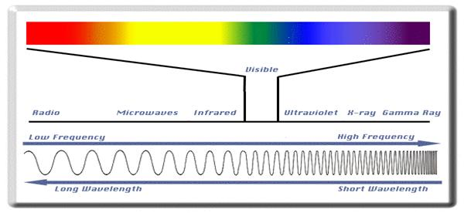
(https://www.aph.gov.au/About_Parliament/Parliamentary_Departments/Parliamentary_Library/pubs/rp/rp0809/09rp18)

It is difficult to observe CMB radiation with ground-based instruments so many air and space-borne research was conducted. The Cosmic Background Explorer (COBE) satellite that was flown in 1989-1996 is probably the most famous and which made the first detection of the large scale fluctuations in CMB radiation. In June 2001, NASA launched a second CMB radiation space mission, WMAP, to make more accurate measurements. The picture below shows an all-sky map of the CMB radiation, created from 9 years of WMAP data

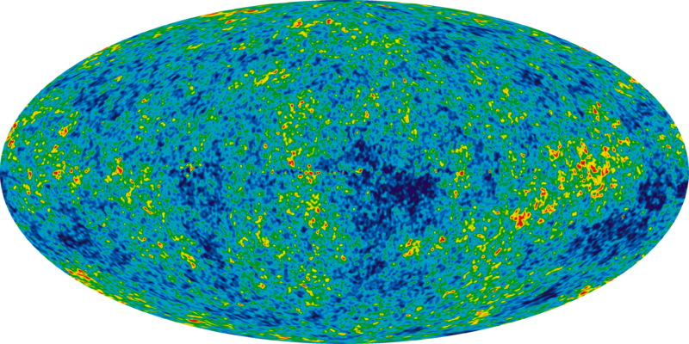
(http://map.gsfc.nasa.gov/media/121238/index.html)

More recent data has been obtained from the Planck spacecraft, launched in 2007 as a joint effort between the European Space Agency (ESA) and NASA. The purpose of the mission was to observe differences in the cosmic microwave background at microwave and infra-red frequencies, with high sensitivity and small angular resolution. Data from the mission is still being analysed.

- Red and Blue shift of stars and galaxies

Have you ever observed that when an ambulance or police car drives past you, its siren is high-pitched as it comes towards you and then becomes low-pitched as it moves away from you?

This effect is called the Doppler effect and can be defined as “the apparent change in the frequency of a wave caused by relative motion between the source of the wave and the observer.”

It is important to note that the effect does not result because of an actual change in the frequency of the source. Looking at the diagram below, you can see the effect is only observed because the distance between observer B and the ambulance is decreasing and the distance between observer A and the ambulance is increasing. As a result, it appears to the observer whom the ambulance is approaching that the disturbances are being produced at a higher frequency.
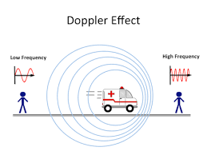
(https://www.quora.com/Why-does-the-Doppler-effect-happen)

This video is a good representation of the Doppler effect as seen above. https://www.youtube.com/watch?v=Y5KaeCZ_AaY

The Doppler effect can be observed for any type of wave source (water, sound, light etc.) As a result, the Doppler effect is of intense interest to astronomers as it can be applied to the movement of stars and galaxies.

The belief that the universe is expanding is based in part upon observations of electromagnetic waves emitted by stars in distant galaxies. Electromagnetic radiation emitted by such stars in a distant galaxy would appear to be shifted downward in frequency (a red shift) if the star is moving in a direction that is away from the Earth. On the other hand, there is an upward shift in frequency (a blue shift) of such observed radiation if the star is moving in a direction that is towards the Earth. This can be seen in the following diagram.

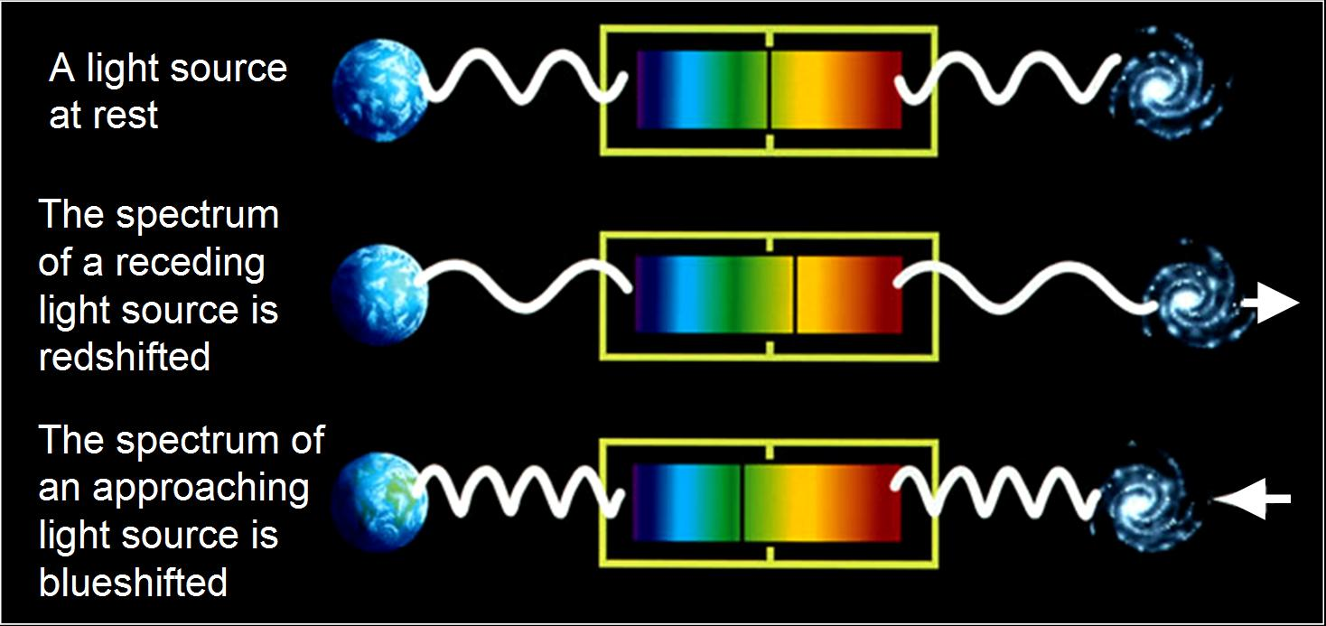
(https://briankoberlein.com/2013/11/18/color-in-the-lines/)

Astronomers have found that the further from us a star is the more its light is red-shifted. This tells us that distant galaxies are moving away from us, and that the further a galaxy is the faster it is moving away.

- Abundance of light elements

Hydrogen and helium account for nearly all of all the nuclear matter in today's universe. This is consistent with the standard or "big bang" model. The process of forming the hydrogen and helium and other trace constituents is often called "big bang nucleosynthesis".

The relative abundance of helium is about 25% by mass and the relative abundance of hydrogen is about 73%, with all other elements constituting less than 2%. This high percentage of helium argues strongly for the big bang model, since other models gave very small percentages of helium. The hydrogen-helium abundance helps us to model the expansion rate of the early universe. If the expansion rate had been faster, there would be more neutrons and more helium. If the expansion rate had been slower, more of the free neutrons would have decayed before the deuterium stability point and there would be less helium abundance.

Features of the universe

The Universe is comprised of many features from galaxies, to black holes, stars and planets. Below is a table of the main features and their definitions.

Feature | Definition
Galaxy | A system of millions or billions of stars, together with gas and dust, held together by gravitational attraction. There are four main types of galaxies.
Star | A celestial body that generates light and other radiant energy and consists of a mass of gas held together by its own gravity.
Solar System | A system of planets or other bodies orbiting a star.
Planet | A celestial body larger than an asteroid or comet, illuminated by light from a star, such as the sun, around which it revolves.
Satellite | Natural satellites are celestial bodies orbiting around a planet or star. Artificial satellites are man-made devices orbiting around the Earth, moon, or another planet transmitting to Earth scientific information or used for communication.
Comet | A celestial body with a central solid mass and a tail of dust and gas, that orbits the Sun along an elongated course.
Moon | A natural satellite revolving around a planet.

Types of galaxies

Galaxies can be classified into four major types: spiral, barred spiral, elliptical,
and irregular. Most galaxies are spiral, barred spiral, or elliptical.

Spiral | are made up of a flattened disk containing spiral (pinwheel-shaped) arms, a bulge at its centre, and a halo. Spiral galaxies have a variety of shapes and are classified according to the size of the bulge and the tightness and appearance of the arms. | 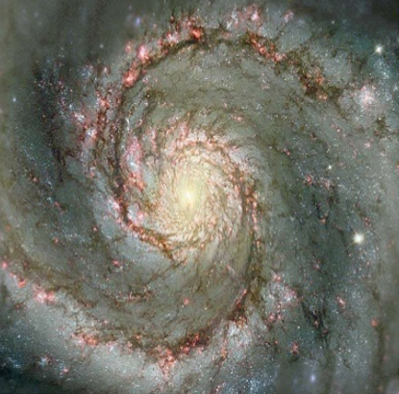
Barred | are spirals that have a bar running across the centre of the galaxy. | 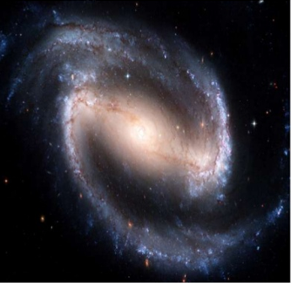
Elliptical | do not have a disk or arms. Instead, they are characterized by a smooth, ball-shaped appearance. Ellipticals contain old stars, and possess little gas or dust. They are classified by the shape of the ball, which can range from round to oval (baseball-shaped to football-shaped). | 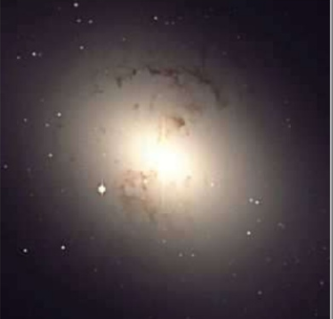
Irregular | are galaxies that are neither spiral nor elliptical. They tend to be smaller objects that are without definite shape and tend to have very hot newer stars mixed in with lots of gas and dust. | 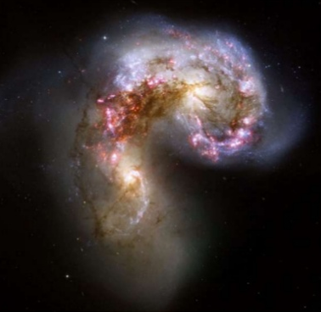

Questions:

  - What is the Big Bang Theory?

  - Describe two sources of evidence that support the Big Bang theory.

  - What is the Doppler effect?

  - Explain how “redshift” supports the expansion of the universe.

  - Compare and contrast the four types of galaxies

