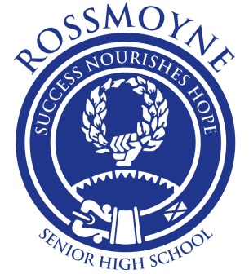

ROSSMOYNE SENIOR HIGH SCHOOL
Humanities and Social Sciences
– Year 9 Gifted and Talented Education and Extension–

NATIONAL HISTORY CHALLENGE 2015

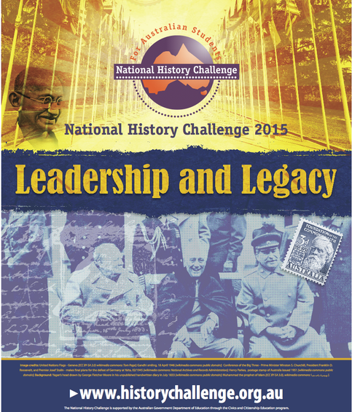

Student Name: __________________________________________
Hand out date: Friday the 27th of March (Term 1 week 4)
Due date part one: Tuesday 28th April (Term 2 week 2)
Due date part two: Monday the 15th of June (Term 2 week 7)
Instructions:
- Read through this booklet carefully
- Complete all required activities
- Make sure you keep an additional display folder containing all your notes, research and bibliographic details
- Hand in booklet, plus all your drafts, notes and evidence of research
This assessment goes towards your grade for Semester 1

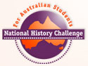
The National History Challenge:

The National History Challenge (from now on referred to as the NHC) is an exciting contest that encourages students to use research and inquiry based learning to discover more about the past. Students are the historians. They can investigate their community, explore their own and their family’s past and explore ideas throughout history. The NHC encourages inquiry based learning, the use of primary and secondary sources and offers a variety of presentation styles that can cater to individual learning styles. It rewards winning students with generous cash prizes and travel opportunities.
Source: http://historychallenge.org.au/about/about-the-nhc/

Your Task
As part of your historical investigations for this semester you will be conducting an in-depth research and investigation task on a person, or group that fits into the theme “Leadership and Legacy”. This assessment can be completed as individuals or in groups of up to 4 students.
Your task has been divided into two parts:

1) Research: (This section needs to be completed individually)
- You need to complete in-depth research based on your chosen Historical figure or group by initially filling out the attached booklet
- This booklet provides a beginning for your research needed. You will also need to attach a display folder/file that showcases the depth of your investigation such as: 1) well organised notes from secondary sources, 2) printed evidence of annotated primary sources (such as photos of tapestries, buildings, artefacts, written documents, etc), 3) developed inquiry questions and researched answers, and 4) any other evidence of research you may wish to include.
- You will need to include a Bibliography listing all the sources you have used in your investigation. You need to include a minimum of 4 primary sources and 5 secondary sources in your research. All of these should feature in your bibliography. (Instructions for your bibliography are included in this booklet). Details on writing a bibliography is also featured on pages 9 & 10 in your student diaries.
- Finally you need to include a draft of your final presentation. Your final presentation will be an essay

The research aspect of this booklet is worth 30% of your semester 1 mark
It is due on Tuesday 28th April (Term 2 week 2)

2) Presentation: (Done as a group or individual)
Whilst the ‘research’ part of your project is being assessed by your teacher you will need to commence work (if you have not done so already) on the second part of your project.
- Your final product needs to take on the form of one of the following, and adhere to the guidelines of that presentation format:

Presentation form | Details
Essay | -This format MUST be an individual (one participant) entry  - LENGTH one thousand (1000) words to two thousand five hundred (2500) (using computer word count), not including the bibliography or fifty (50) word descriptor. An annotated bibliography must be included.  *The total word count includes quotations but not footnotes.
Other Formats | - This category could include presentations such as:  Multimedia  Performance  Website  Other forms of creative representation (not a model)  - 500 word (maximum) explanation of how the research was carried out to create and develop the display must be included. It must conclude with a strong statement about the relationship of the model to the theme.

- Every Presentation needs to:
Include an annotated bibliography (including both primary and secondary sources) and acknowledge the use of these sources on the presentation where needed
Be historically accurate and correct
Show an understanding of the period being researched and the attitudes and values of the people at the time, and relate your findings to the theme
Be original and not use the words or ideas of other people without acknowledgement
- Most importantly BE CREATIVE AND HAVE FUN!!! Be inspired by the history you are studying and come up with an engaging way to present your findings!

The presentation aspect of this assessment is worth 10% of your semester 2 mark
It is due on Monday the 8th of June (Term 2 week 6)

The Theme:
What is the theme for 2015?
The theme for 2015 is “Leadership and Legacy”. All entries must incorporate a response to the theme.
How important is the theme
The theme is very important and it is the theme upon which all entries must be focused. Students can apply the theme to a variety of contexts. This theme offers students the opportunity to explore various topics in history. This exploration can be approached at a number of levels such as:
- How leaders determined their legacy.
- How changing interpretations of legacies influenced opinions of leaders
- How historians change legacies by re-interpreting evidence
- How changing attitudes to leaders impact on their legacies
Students may like to consider leaders as individuals or groups in various fields, for example, fashion, medicine, social movements in different eras.
Source: http://historychallenge.org.au/about/about-the-theme/

Thematic categories:

- Australian Wartime Experiences
- Australian Democracy
- The Life and Times of John Curtin
- Women’s History
- Australia’s Heritage
- Asia and Australia
- Using Primary Sources from the National Archives
- Museum Exhibit

INSPIRATION PAGE:
Napoleon Bonaparte (1769 - 1821) - One of the greatest military leaders in history and emperor of France, he conquered much of Europe
Florence Nightingale (1820 - 1910) - Famous for her work in the military hospitals of the Crimea, Nightingale established nursing as a respectable profession for women.
Martin Luther King - Martin Luther King was an American clergyman and winner of the Nobel Peace Prize. One of the leading figures in the civil rights movement, he has had a defining influence on the recent history of the United States. His assassination in 1968 was met with shock around the world.
Alexander the Great (356 - 323 BC) - Alexander III of Macedon, better known as Alexander the Great, single-handedly changed the nature of the ancient world in little more than a decade.
Kemal Atatürk (1881-1938) - Atatürk was a Turkish nationalist leader and founder and first president of the republic of Turkey.
Augustus (63 BC - AD 14) – Augustus was the first emperor of Rome. He replaced the Roman republic with an effective monarchy and during his long reign brought peace and stability.
Julius Caesar (100BC - 44BC) - Caesar was a politician and general of the late Roman republic, who greatly extended the Roman empire before seizing power and making himself dictator of Rome, paving the way for the imperial system.
Neville Chamberlain (1869 - 1940) - Chamberlain was British prime minister between 1937 and 1940, and is closely associated with the policy of appeasement towards Nazi Germany.
Winston Churchill - On 8 May 1945 Winston Churchill stood on a Whitehall balcony and addressed the excited crowd below. "In all our long history," he said, "we have never seen a greater day than this." Churchill had stood against Hitler and won – the day was his.
Cleopatra (c.69 BC - 30 BC) - Cleopatra VII was the last ruler of the Ptolemaic dynasty, ruling Egypt from 51 BC - 30 BC. She is celebrated for her beauty and her love affairs with the Roman warlords Julius Caesar and Mark Antony
Benjamin Franklin (1706-1790) - Franklin was a statesman, diplomat, writer, scientist and inventor, one of the most versatile and talented men in colonial America and a leading figure in the American struggle for independence.
Mohandas Gandhi (1869 - 1948) - Known as 'Mahatma' (great soul), Gandhi was the leader of the Indian nationalist movement against British rule, and is widely considered the father of his country. His doctrine of non-violent protest to achieve political and social progress has been hugely influential.
Stephen Hawking - Stephen Hawking is known for his significant contribution to our understanding of black holes and his efforts to popularise science. He accomplished these achievements while being almost totally paralysed by a form of motor neurone disease.
Adolf Hitler - Adolf Hitler, military and political leader of Germany 1933 - 1945, launched World War Two and bears responsibility for the deaths of millions, including six million Jewish people in the Nazi genocide.
Attila the Hun (c.410-c.453 AD) - Leader of the Hunnic empire, he led the Huns and their massed subject peoples in four massive assaults, attacking the east and west of the Roman empire twice each.
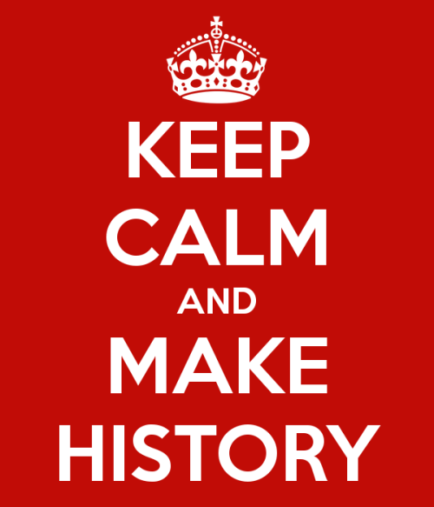
John F Kennedy - John F Kennedy (known as JFK) was the 35th president of the United States, an immensely popular leader who was assassinated before he completed his third year in office.
Abraham Lincoln (1809-1865) - Lincoln was the 16th president of the United States and one of the great American leaders. His presidency was dominated by the American Civil War.
Nelson Mandela (1918-2013) - Nelson Mandela led the struggle to replace the apartheid regime of South Africa with a multi-racial democracy. Imprisoned for 27 years, in 1994 he went on to become his country's first black president.
Emmeline Pankhurst (1858 - 1928) - leader of the suffragette campaign to win the vote
Margaret Thatcher (1925 - 2013) - 20th century Conservative prime minister
Tiberius (42 BC - 37 AD) - second emperor of Rome
Titus (39 AD - 81 AD) - Roman emperor when Pompeii was destroyed by Vesuvius
Harry S Truman (1884-1972) - World War Two US president, ordered atomic bombings of Japan
Victoria (1819 - 1901) - queen of Great Britain, the longest reigning British monarch
Joan of Arc - Nicknamed "The Maid of Orléans", is considered a heroine of France and a Roman Catholic saint
Edith Cowan – was an Australian politician, social campaigner and the first woman elected to an Australian parliament.
Fiona Stanley – is an Australian epidemiologist noted for her public health work, and her research into child and maternal health, and birth disorders such as cerebral palsy.

Planning

Suggestion 1) – If you already have an idea of who/m you would like to investigate:
- Try using http://www.instagrok.com/ to create a base brainstorm about your chosen person or group.
- After searching up more about them you may be even more inspired to research them, or you may wish to choose someone else.
- If you login to instagrok you can save your findings. Follow the links and sources to find more information and begin your notes and in-depth investigation.
Suggestion 2) – If you are not sure who you would like to do:
- Research a topic you are passionate about and look for leaders in that field. For example:

  - Fashion
  - Human Rights
  - Slavery
  - Sport
  - Science
  - Medicine
  - Politics
  - Women’s Rights
  - Education

- By doing this you may find a leader within this field and you can further research the impact and legacy they have had on that field of study.
Suggestion 3) Still unsure:
- Go through the list of suggestions on the previous pages and do a little further reading of who interests you.
- You could always then use instagrok to find out a little more information about them.

Top Tips:

- Before you definitely choose your person, make sure they fit into the theme “Leadership and Legacy”; after all this is the key priority and theme of the assessment
- Make sure you are recording all the sources you read through and take information from. Maybe have one specific piece of paper you record the source information on – including access dates of internet sites
- Start now! Research and having a deeper understanding is imperative (vitally important) to this assessment. Though the due date may seem in the distant future there is much work to be done!

Useful resources
- ALPHABETICAL LIST OF POSSIBLE PEOPLE: http://www.bbc.co.uk/history/historic_figures/d.shtml
- INSTAGROK – RESEARCHING RESOURCE: http://www.instagrok.com/
- NATIONAL HISTORY CHALLENGE MAIN WEBSITE: http://historychallenge.org.au/

Inquiry questions

Inquiry questions are used to help guide your research in its initial stages. You need to write down five questions you hop to investigate that align the theme to your chosen research topic.
For example:
What long lasting impacts did Julius Caesar’s reign have on the Roman Empire?
(Incorporates legacy with Caesar)
Record your Inquiry Questions below:
- __________________________________________________________________________________________________________________________________________________________________________________________

- __________________________________________________________________________________________________________________________________________________________________________________________

- __________________________________________________________________________________________________________________________________________________________________________________________

- __________________________________________________________________________________________________________________________________________________________________________________________

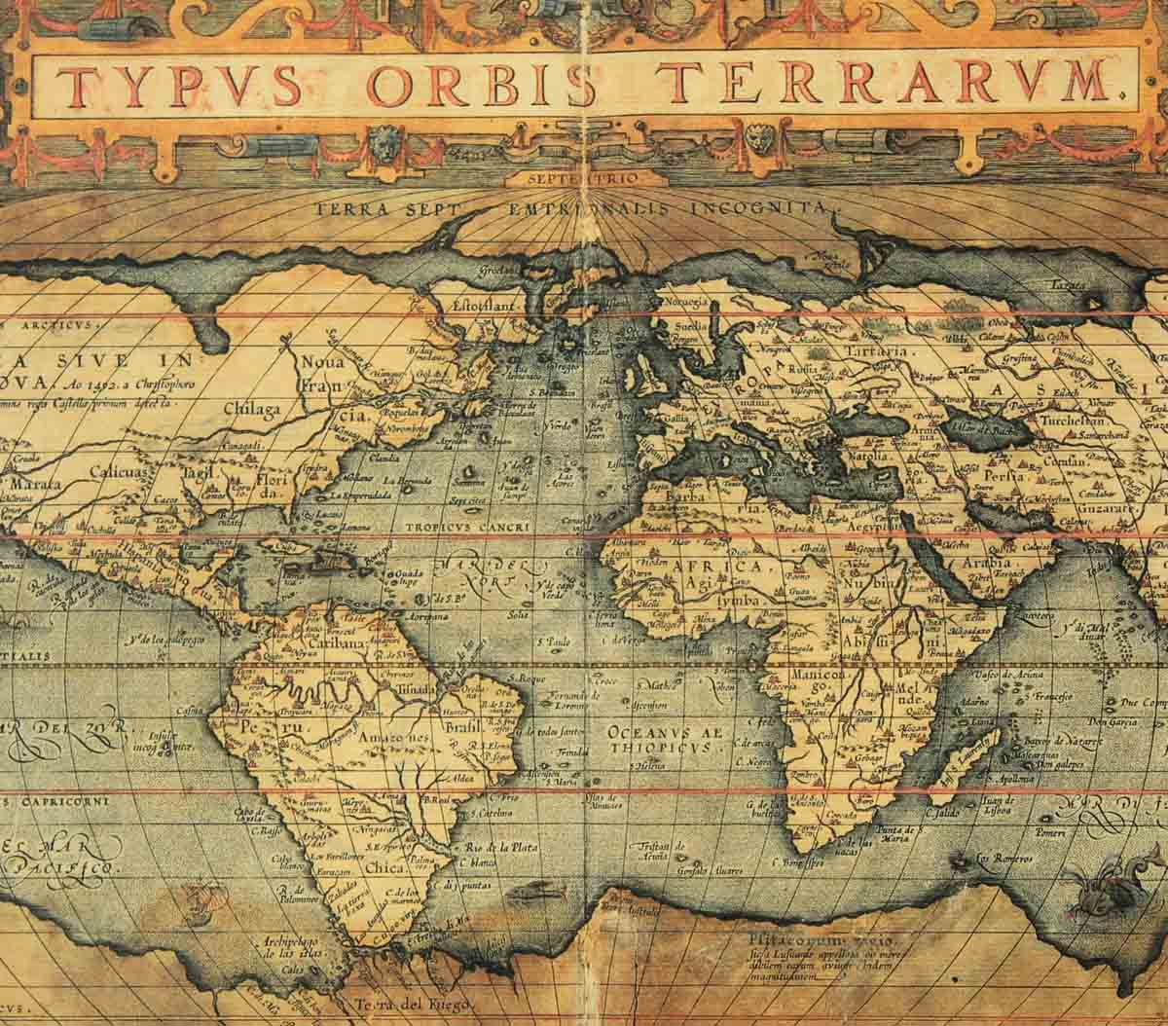
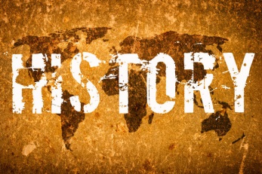
- __________________________________________________________________________________________________________________________________________________________________________________________

NOTE-TAKING SHEET (Your Working Notes)

Focus Question / Sub Heading
Source used: 1
2
3

Research notes use keywords, dot points and phrases

-Key Concepts-Key Questions

NOTE-TAKING SHEET (Your Working Notes)

Focus Question / Sub Heading
Source used: 1
2
3

Research notes use keywords, dot points and phrases

-Key Concepts-Key Questions

NOTE-TAKING SHEET (Your Working Notes)

Focus Question / Sub Heading
Source used:

Research notes use keywords, dot points and phrases

-Source &

Page No.

-Key Concepts-Key Questions
Important: You need to keep a display folder or plastic sleeve with all your additional notes, research, printouts of primary resources, etc – to be submitted with this assessment on the due date as evidence of your investigation. Try to keep your notes well organised. For example – you may like to colour code; everything about Art could be pink, everything about religion could be blue, etc.
Or – Use headings to categorise your research.

