Meiosis Stages
Division 1
Stage | Picture | Description
Interphase |  | - DNA replication occurs
Prophase 1 |  | - Spindle fibres begin to appear  - Nuclear membrane begins to disappear  - Chromosomes (X) pair up with other chromosomes (X) of the same size – HOMOLOGOUS CHROMOSOMES
Metaphase 1 |  | - Homologous chromosomes line up at the centre (equator) of the cell.  - Each homologous pair of chromosomes is attached to a spindle
Anaphase 1 |  | - Homologous chromosomes are pulled apart to opposite poles of the cell
Telophase 1 |  | - Nuclear membrane begins to form around the chromosomes (X)  - The cell begins to separate  - 2 new cells have formed. Each cell contains one chromosome from each homologous pair.
Division 2
No DNA Replication occurs!
Stage | Picture | Description
Prophase 2 |  | - Spindle fibres begin to appear  - Nuclear membrane begins to disappear
Metaphase 2 |  | - Chromosomes line up at the centre (equator) of the cell.  - Each chromosome is attached to a spindle
Anaphase 2 |  | - Chromosomes are pulled apart to opposite poles of the cell
Telophase 2 |  | - Nuclear membrane begins to form around the chromosomes  - The cell begins to separate  - 4 new cells have formed. Each cell contains half the number of chromosomes as the parent cell

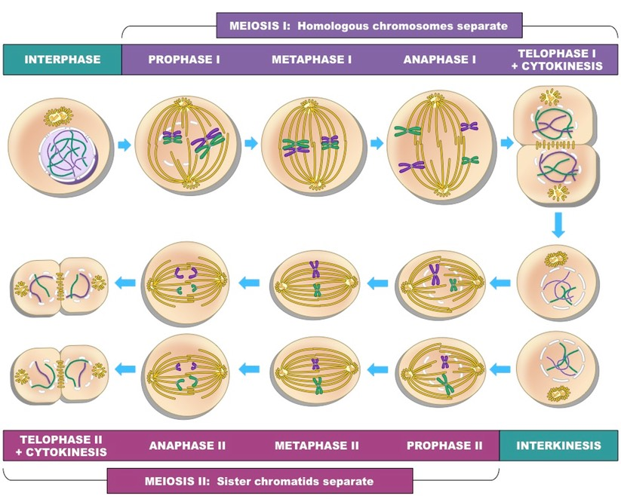

Genes - Recap
We receive information for each trait (gene) from both our mother and our father. Alleles are alternate forms of a gene. For each gene we receive one allele from our mother (contained in the egg) and one from our father (contained in the sperm).
Alleles from our mother = Maternal
Alleles from our father = Paternal
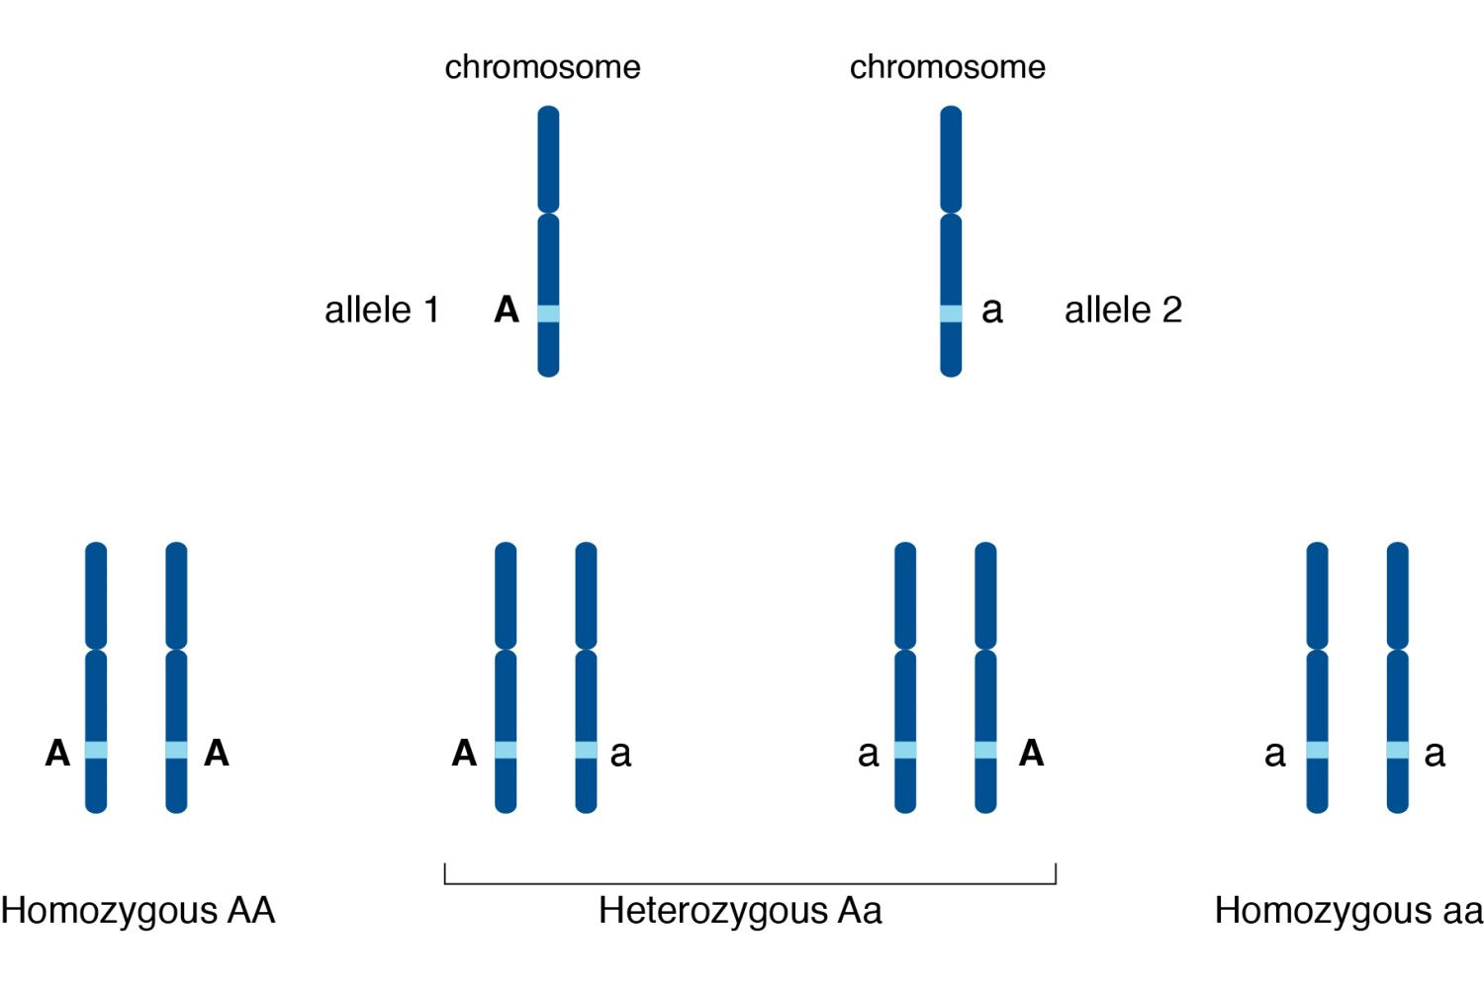

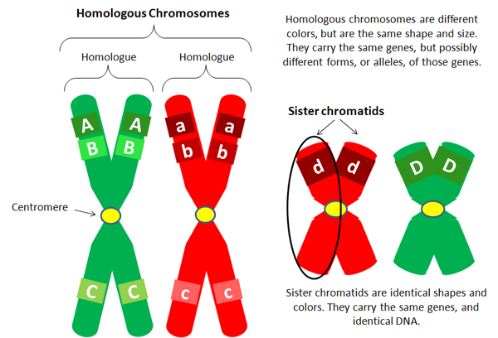
Homologous Chromosomes
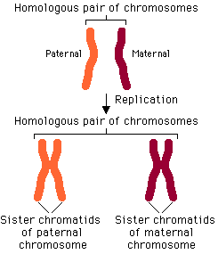
Crossing Over
Occurs between prophase 1 and metaphase 1 - Homologous chromosomes exchange alleles (codes for particular genes) causing a recombination of genetic information on each homologous chromosome.
After the second division the sister chromatids separate and 4 recombinant chromosomes result. This increases genetic variation as a different combination of alleles for each gene is represented in each gamete.

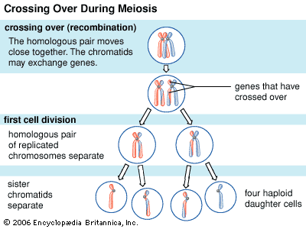
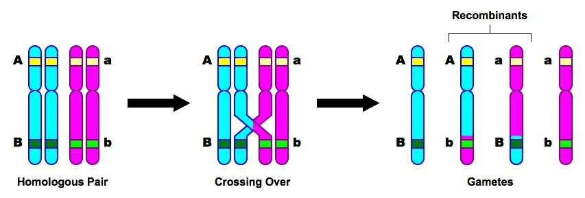

Random assortment of chromosomes
Occurs when homologous chromosomes are paired up and separated (metaphase and anaphase 1) to form two haploid cells. The separation is random – meaning that not all maternal and paternal chromosomes are separated into the same cell.
This increases genetic variation as a different combination of alleles for each gene is represented in each gamete.

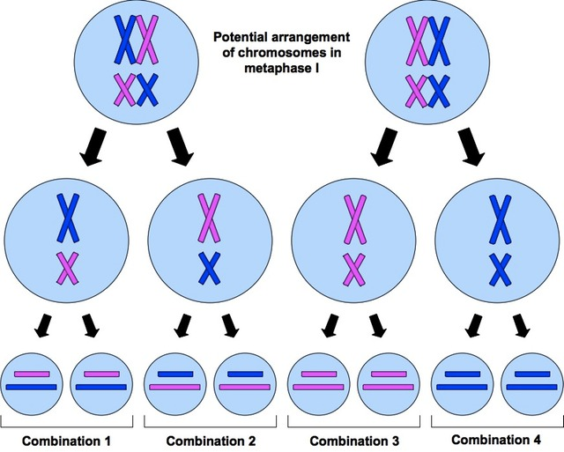

Random fusion of gametes
When fertilisation occurs one sperm is responsible for fertilising an egg. Semen contains millions of sperm. Each sperm (gamete) contains a random assortment of chromosomes (as does each egg that is released). Once the sperm are deposited inside the female, each sperm has an equal chance of fertilising the egg (the race is on!!). This is known as random fusion of gametes and is responsible for increasing genetic variation.
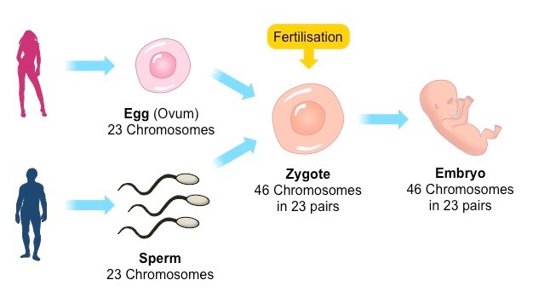

When meiosis goes wrong….
Non disjunction is the failure of homologous chromosomes or sister chromatids to separate correctly during anaphase 1 or 2. This results in an abnormal amount of chromosomes in the resulting daughter cells.
A daughter cell (gamete) can either have too many or too few chromosomes…
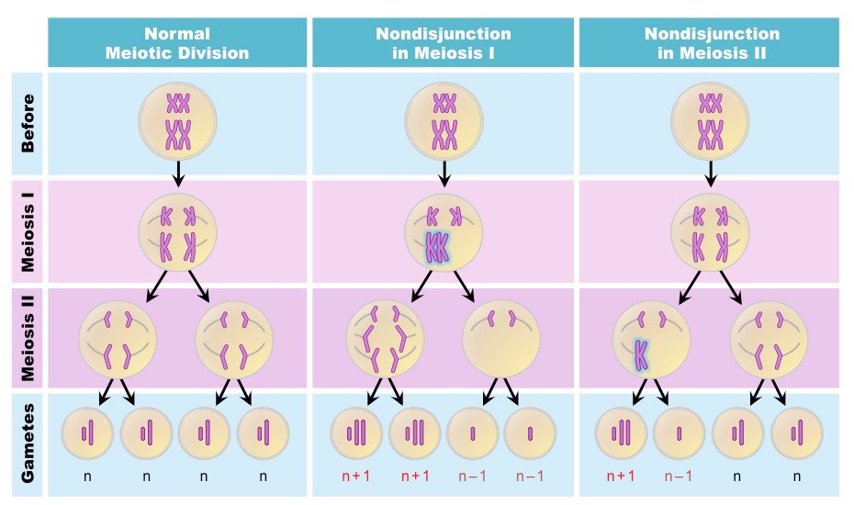
Non disjunction can be seen in karyotypes…
