Year 8 Ring of Fire Research Task
This content will be tested in the Mid-Topic Test on Tuesday 5th November.
Use this website https://kids.kiddle.co/Pacific_Ring_of_Fire to answer the questions below. You may need to click on the blue hyperlinks to navigate the page.
- The ring of fire is an arc around the Pacific Ocean where many volcanoes and earthquakes are formed.
- The ring of fire is _________________________kms long.
- There are ________________________volcanoes in the ring of fire.
- The ring of fire is a direct result of plate tectonics. Click on the blue ‘plate tectonics’ hyperlink and answer the following questions:
- Describe the theory of continental drift (click on the hyperlink):

- Describe three (3) pieces of evidence for the theory of continental drift:

- Return to the plate tectonics page. Describe seafloor spreading (click on the hyperlink) and give an example of where this occurs:

- Return to the homepage. The Ring of Fire is a result of subduction of tectonic plates. Describe the process of subduction (click on the hyperlink) and indicate which events occur as a result of subduction:

- Name three (3) places around the world where subduction zones exist:

- Use the table below to plot the Ring of Fire on the map provide:
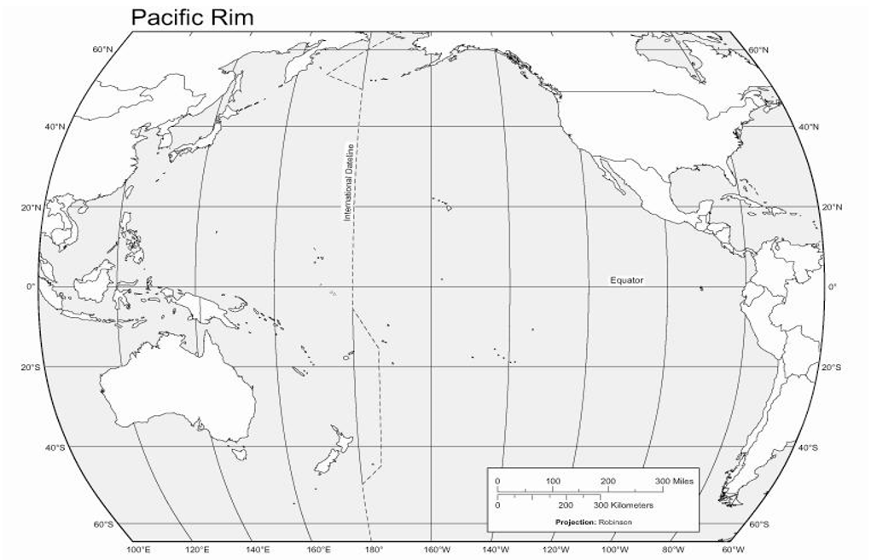
Longitude | Latitude
150° W | 60° N
70° W | 35° S
120° W | 45° N
61° W | 15° N
105° W | 20° N
75° W | 0°
122° W | 40° N
160° E | 55° N
145° E | 40° N
120° E | 10° S
105° E | 5° S
70° W | 30° S
175° E | 39° S
123° E | 38° N

