Student worksheet answers

1.8 Alleles on the sex chromosomes produce sex-linked traits
Pages 18–21

Sex-linked traits
1 What are autosomes?
Non-sex chromosomes. In humans, chromosomes 1–22 are autosomes.
2 What are sex chromosomes?
The chromosomes that determine the sex of an organism.
3 What sex chromosomes does a human male have?
X and Y
4 Does a human male’s Y chromosomes come from his mother or his father? Why?
His father. A female has 2 X chromosomes. Therefore, she can only give her offspring an X chromosome. A male can give either an X (to his daughter), or a Y (to his son).
5 Fill in the blanks.
In humans, the genotype of a female is XX and the genotype of a male is XY.
6 Identify which is the X chromosome and which is the Y chromosome in the image below:
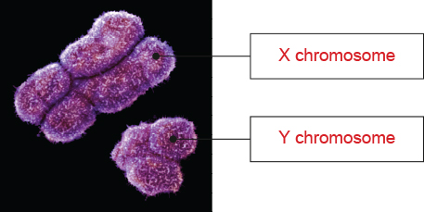
7 Name the term used to describe traits and genes that are carried on the sex chromosomes.
Sex-linked
8 Give ONE example of a non-sexual trait that is carried on the human X chromosome.
Answers may vary. Examples include red–green colour vision and blood clotting.

9 Explain why there is a greater percentage of males than females that have red–green colour blindness.
Red–green colour blindness is an X-linked recessive trait. This means the gene is located on the X chromosome. Because males only have one X chromosome, it means if this allele is present they will have the trait. They cannot be carriers.
10 Match the patterns of inheritance with the correct example.
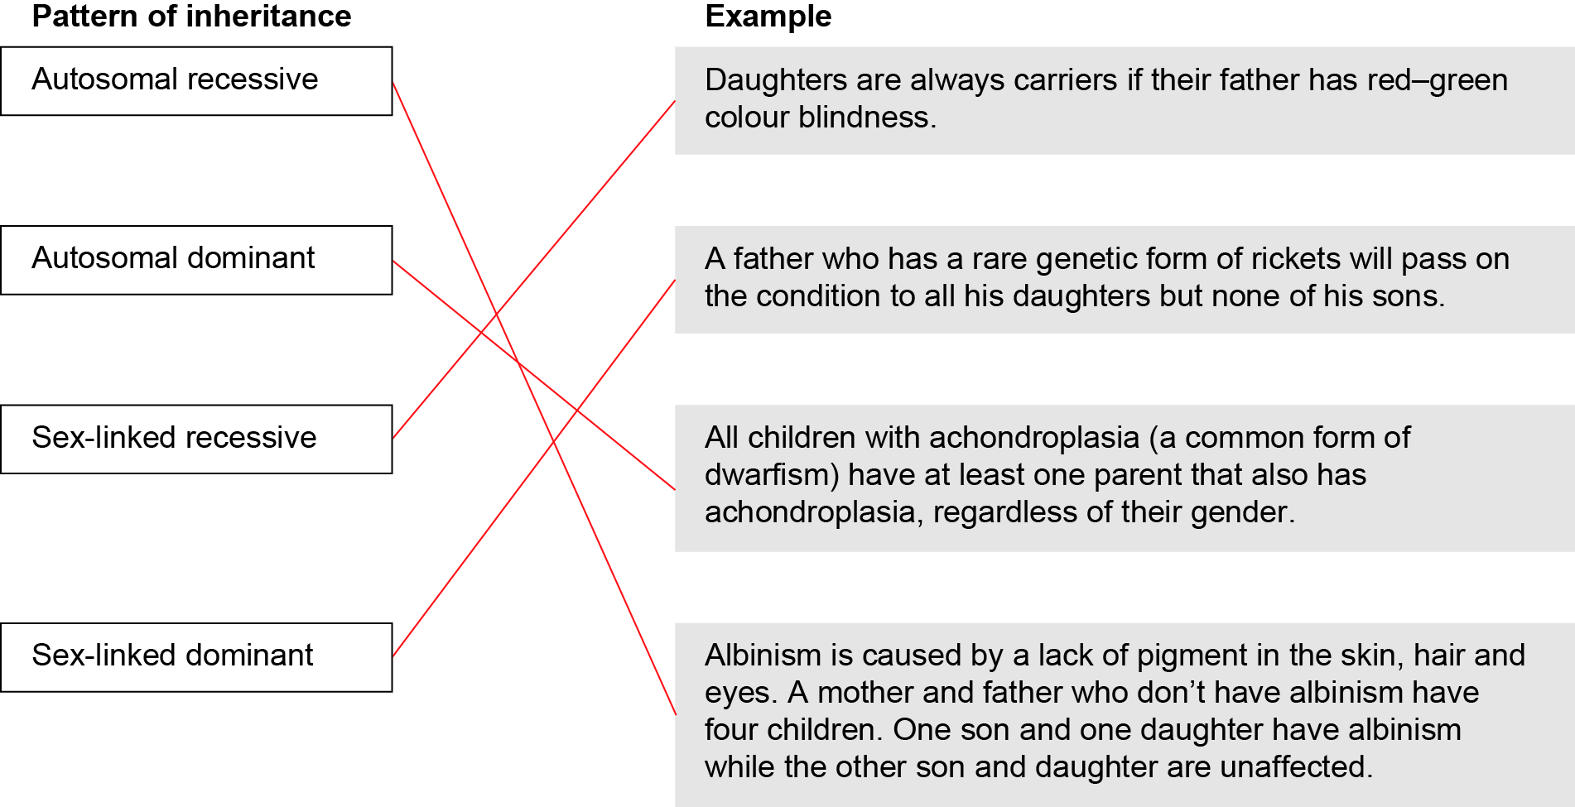
11 Suggest how a man and woman, both with normal sight, could have children that have red–green colour blindness. Include a Punnett square in your answer.
The woman must be a carrier with the genotype X^{c}X. The male has normal sight so must have the genotype XY. This means they could have daughters with normal sight (X^{c}X and XX) and sons both normal (XY) and affected (X^{c}Y).

Extend your understanding
12 Suggest why sex-linked traits are more frequently found on the X chromosome than on the Y chromosome, and explain how this affects the inheritance of these traits differently in males and females.
The X chromosome is much larger than the Y chromosomes and contains many more genes, therefore more sex-linked traits are found on the X chromosome. Females can be heterozygous for any traits found on the X chromosome while males only have one allele for these genes located on their single X chromosome.

