7.4 Electrons are arranged in shells

Student worksheet answers (pages 140–141)

Arranging electrons
1 How are the electrons of Atoms arranged?
Into orbits surrounding the atom’s nucleus called electron shells
2 How many electrons can fill the following shells?
a first
2
b second
8
c third
8 up to Calcium, 18 if elements are bigger than calcium
d fourth
32
3 How should electrons be arranged in electron shell diagrams?
in pairs
4 What is the valence shell of an atom?
the outermost occupied shell
5 Why is the valence shell so important?
It determines the chemical properties of the element and affects how it will bond to other elements
6 Draw electron shell diagrams for the following atoms and fill in the information beneath (this has been completed for you for the first atom, carbon).

a Draw the electron configuration of nitrogen and state what its electron configuration is.
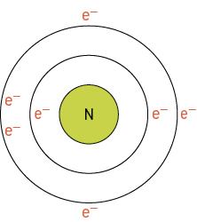
Nitrogen will have 2 electrons in the first shell and the remaining 5 in the second.
Therefore Nitrogen has an electron configuration of: 2, 5
b Draw the electron configuration of lithium and state what its electron configuration is.
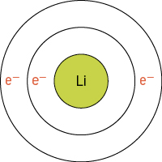
Lithium will have 2 electrons in the first shell and the remaining 1 in the second.
Therefore Lithium has an electron configuration of: 2, 1
c Draw the electron configuration of beryllium and state what its electron configuration is.
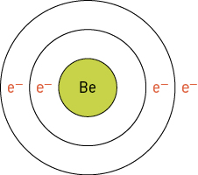
Beryllium will have 2 electrons in the first shell and the remaining 2 in the second.
Therefore Beryllium has an electron configuration of: 2, 2

d Draw the electron configuration of boron and state what its electron configuration is.
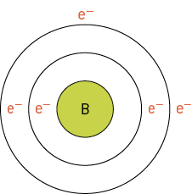
Boron will have 2 electrons in the first shell and the remaining 3 in the second.
Therefore Boron has an electron configuration of: 2, 3
e Draw the electron configuration of oxygen and state what its electron configuration is.
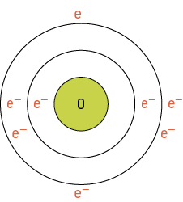
Oxygen will have 2 electrons in the first shell and the remaining 6 in the second.
Therefore Oxygen has an electron configuration of: 2, 6
f Draw the electron configuration of fluorine and state what its electron configuration is.
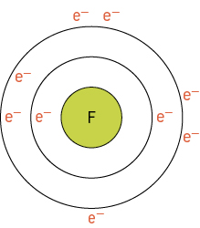
Fluorine will have 2 electrons in the first shell and the remaining 5 in the second.
Therefore Fluorine has an electron configuration of: 2, 7

EXTEND YOUR UNDERSTANDING
The periodic table contains groups and periods. Groups are the columns of the periodic table and periods are the rows. The following snapshots have been taken of groups and periods in the periodic table.
7 Draw the electron configuration and determine what pattern is produced by elements in the same group of the periodic table.
Group 8 elements | Electron Shell Diagram and Electron Configuration:
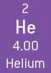 | 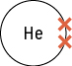  Electron Configuration: 2
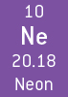 | 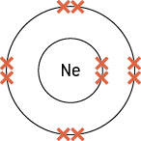  Electron Configuration: 2, 8
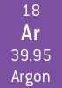 | 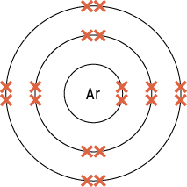  Electron Configuration: 2, 8, 8

8 What happens to the electron shell diagram and electron configuration as you move down groups in the periodic table?
As you move down a group, the electron shell diagrams gain an electron shell, but the valence shell hase the same number of electrons. So all elements in group 8 have 8 valence electrons.
9 Draw the electron configuration and determine what pattern is produced by elements in the same group of the periodic table.
a Boron electron shell diagram:  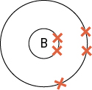  Electron configuration: 2, 3 | b Carbon electron shell diagram:  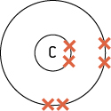  Electron configuration: 2, 4 | c Nitrogen electron shell diagram:  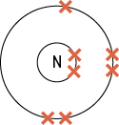  Electron configuration: 2, 5
d Aluminium electron shell diagram:  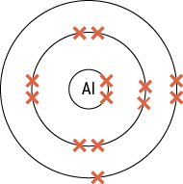  Electron configuration: 2, 8, 3 | e Silicon electron shell diagram:  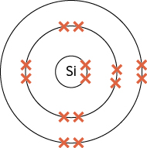  Electron configuration: 2, 8, 4 | f Phosphorous electron shell diagram:  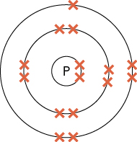  Electron configuration: 2, 8, 5
10 What happens to the electron shell diagram and electron configuration as you move across periods in the periodic table?
As you move across a period, the electron shell diagrams have the same number of electron shells, but the valence shell changes its number of electrons. So all elements in period 2 have 2 electron shells.
11 How could you use the periodic table as a cheat sheet for determining electron configuration?
The group number is the number of valence shell electrons that the element has.
The period number is the number of electron shell that an element has.

