YEAR 9 FINANCIAL MANAGEMENT

CREATING A BUSINESS
Semester 2, 2016

Name: ______________________

Group members: ____________________________________________________

Due date: _______________________

This assessment piece is worth 50% of your semester grade

Overview
Are you ready to create a small business concept?

In this assignment, you will form into groups of a maximum of 4 and create a concept for a small business. You will then get an opportunity to sell your product and/or service during a break period later this term. Businesses may not be food based.

This assignment will comprise of two parts:
• Workbook
• Market day participation

Before you start, make sure you:
• Have advised your teacher of your group members
• Have read the entire assignment including the instructions and the marking criteria
• Have decided if you will have any specific roles in your group

Are you ready? Let’s go!

Your Resources
A resource assessment is important because:
1. It helps to identify what resources you already have and can use for free!
2. It can give you ideas for your business!
3. The results can help you to keep your business start-up costs low (and therefore help you to make a bigger profit!)

Resource Assessment Table
Resources/Skills | How will this benefit a business?

After finishing the resource assessment, it is important to analyse the results.
What resources do you have available that you could you use to start a business and how will this help you?

How could you use your existing skills to start a business?

Brainstorming
It’s important that businesses meet one or more of one of the following criteria - People, Planet, Profit.
People – Making your business a ‘social’ enterprise.
A social enterprise is a business that has a positive impact on its local community.

Planet – Making your business a ‘green’ enterprise
A green enterprise is a business that has a positive impact on the local environment.
Profit – Making a profitable enterprise
The main aim of any business is to make a profit. How will you generate the greatest profit?

Now that you have discussed the resources available AND understood the People, Profit, Planet criteria, it’s time to come up with a great business idea!

Step 1:
Think about the following:
How could you use your business to solve current problems?
What could you make that people would like to buy?
Who are your customers and how can you reach them?
Could you update or modernise a traditional business idea?
Are there any gaps for goods and services?
Could you combine existing products and services to make something new?

Step 2:
Brainstorm five business ideas.

Step 3:
Select three business ideas and list the advantages and disadvantages of each.

Business One
_________________________________________________________________________

Advantages | Disadvantages

Business Two
_________________________________________________________________________

Advantages | Disadvantages

Business Three
_________________________________________________________________________

Advantages | Disadvantages

Feasibility Study
Once you have come up with some ideas, choose one and perform a feasibility study. A feasibility study is designed to help you decide whether a business idea could realistically work.

Product Feasibility Study
 | Yes | No | If no, how can you overcome it?
Would most customers consider the product useful or attractive?
Is the product easy to store and transport?

Does the product have a long lifespan (i.e. it won’t go off, wear out or go out of fashion)?

Is the product safe for customers to use?

Is the product easy to make?

Do you have access to the necessary materials?

Will the product be in demand all year round?

Is the product easily packaged and transportable?

Will you be able to sell this product at a price that will cover the costs of making it and still generate a profit?

Does this product have a low start-up cost?

Service Feasibility Study
 | Yes | No | If no, how can you overcome it?
Would most consumers consider the service useful, (i.e. can a large number of people use it)?

Would the service have a repeat demand, (i.e. could people buy it more than once)?

Will this service be in demand all year round?

Would the service be risk free for you and the consumer?

Do you have easy access to the necessary materials for the service?

Is the service quick and easy to supply?

Will you be able to sell this service at a price that will cover the costs of providing it and still generate a profit?

Does this service have a low start-up cost?

Analysing the results
If you answered YES to all the questions in the feasibility study, then your business idea is feasible and you can move onto the next stage.
If you answered NO to any of the questions, decide if you are able to overcome these barriers by changing your business idea slightly or compensating in other ways, or if the business idea is simply not viable and a new one must be thought about. If you need to think through a new idea, don’t worry, you can return to the list of brainstormed ideas you came up with and test one of those in the feasibility study.

By working through the feasibility questions one by one you will ensure that your business idea works in reality because you have thought about all the problems it may face before they even happen!

Which of your ideas did you choose as your final business idea and why? Please give 3 reasons why you chose this idea.

How does your final business idea meet the People, Profit, Planet criteria?

Market Research
Market research will help you understand both your customers and the market you are operating in. This will help you find out whether there is a market for your product or service (i.e. whether there are people who will buy your product or service), who those people are and how much people will be willing to pay for your product or service.
The fastest and simplest way to conduct market research is through a survey. When planning your own survey keep these guidelines in mind:
- 1. Try to ask no more than 10 to 15 questions.
- 2. Try to ask at least 20 people.
- 3. Check that your questions are clear, unbiased and lead to useful information.
- 4. Ask a realistic sample of people.

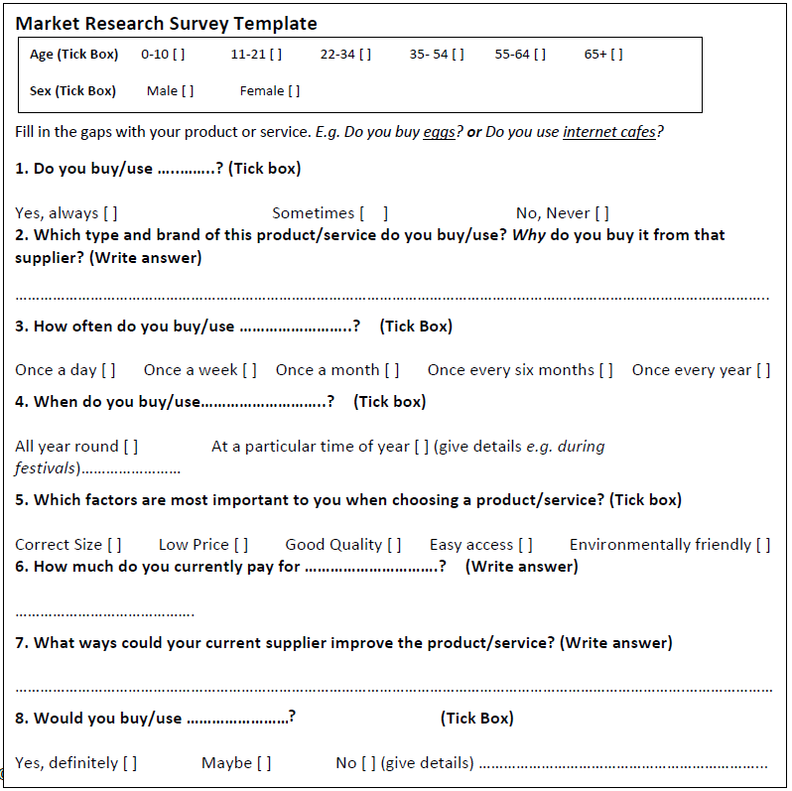
You can use the following survey template to help you write your own survey, but you should also think of a few additional questions that are relevant to your business! Don’t forget to keep track of how many people you have surveyed as you will need this information.

What Market Research did you do? Please include how you did your market research and how many people you spoke to.

What were the results of your Market research? Please include who is going to buy your product or service (Target Market) and why they will buy it.

Conducting a competitor analysis
Competitors are the people who sell the same or a similar product or service as you. Look back at the answers you got to Question 2 on your market research survey – These are your competitors!
Doing a competitor analysis will help you find out the strengths and weaknesses of your competitors. It will also help you decide on how to make your product/service different or special from others already on sale. There are a number of types of data that you can collect for competitor analysis:
- Recorded data is data that is available in published form. This may be annual reports or product brochures (it is likely that only large businesses will have these).
- Observable data is data that you actually go out and look for! It is data that your competitors make obvious, such as pricing, advertising and promotions.
- Opportunistic data: This data usually comes from discussions you have with people who are connected to both you and your competitor, for example customers.
Use the template to conduct your own competitor analysis.
Competitor Analysis
 | My Business  (In this column answer the questions about your business– this will help you to compare your business with your competitors! | Competitor
Where is the competitor located? Think about how close they are to your business and why they have chosen that location (i.e. They can attract more customers).
What product/service do they sell?
Is their product / service the same as yours? If so, what can you do to be different?
What are the competitor’s prices?
How can you go cheaper and still make a profit?
Who are their customers?
Are you aiming for the same customers or is there something about your product that attracts different customers?
What methods of marketing do they use?
Do your competitors have adverts, events or run promotions?
How are they trying to develop or expand?
This information is helpful to know how to remain different from you competitor.
Do they have a good reputation locally?
Why or why not? What could you learn from their business?
Do they offer any extra services?
Are these things you should consider for your business?
What are their strengths?
Can you learn from these without copying them too closely?
What are their weaknesses?
Your competitors’ weaknesses can become your strengths!
What is their Unique Selling Point? What is unique about their business?

Who is your main competitor and what is their strengths and weaknesses?
Competitor | Strengths | Weaknesses

How are you going to be better than your competitor?

Conducting a SWOT analysis
A SWOT Analysis is a way to assess the Strengths and Weaknesses of your business. It also allows you to identify Opportunities you have and the Threats you might face. Strengths and weaknesses are internal to your business and in the present, whereas opportunities and threats are external and in the future.
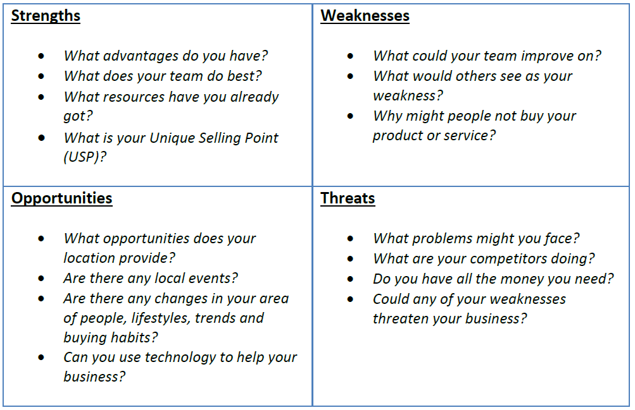
You can use the following questions to help you carry out a SWOT analysis for your business. A SWOT Analysis Template is also provided for you to complete.
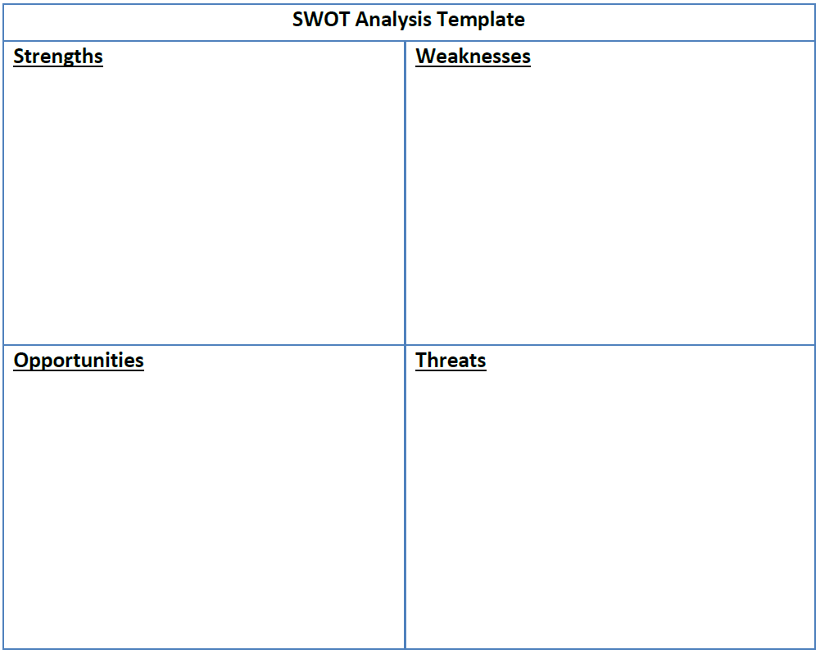
Operational Plan
1. Designing your product or service. Provide images and descriptions of the products/services that you will be selling.

2. Supplies & Equipment. List the supplies and equipment your business will require and where you will source them from.

5. Company Name. It should be something clever, cute or quirky. Grab your audience’s attention! You want them interested right from the very start. Name should be relevant to your product/service and should have a positive connotation to it.
Brainstorm three potential names.

The name we have chosen is… because

4. Mission Statement. A mission statement is a short summary of your business’ values and goals. Creating your mission statement can be a great way to galvanise your team and make sure that you are working towards a common goal.
When writing your mission statement, here are some things to consider:
- Who is your market and how are you serving them?
- What are you are producing and what is special about it?
- What values underpin your business?
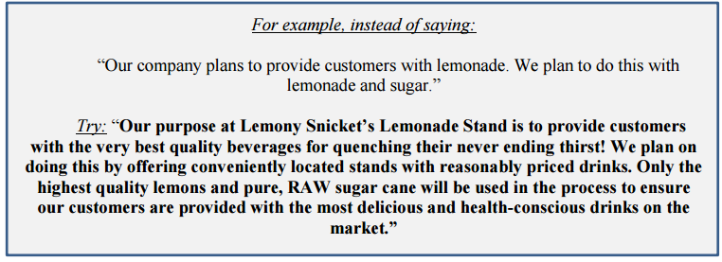
Write down your mission statement.

5. Company Advertisement. This is where your creative juices get to run wild! One of the most important aspects of any small business is marketing/advertising. HOW are you going to attract customers to your product/service if they’ve never heard of you? Why chose you if they already have a brand they like? You have to market your product JUST RIGHT to make potential customers want to try your product. Companies do this through advertising. Some of the more simple aspects of advertising include having a slogan and logo.

Slogan (A catchy motto for your product) Like: “I’m Lovin’ It” by McDonalds or “Just Do It” by Nike. Make sure the slogan is RELEVANT to your product. A sports motto for a lemonade stand, for example, would make no sense. You also can not steal (or borrow) a motto that another company already uses. (That would be trademark infringement, and your company would get shut down before it even got started!)

Brainstorm three potential slogans.

The slogan we have chosen is… because

Logo. Having some sort of graphic/logo that represents the company. (ie. McDonalds also does a very good job of this with its giant “M” golden arches).

Brainstorm three potential logos.

The logo we have chosen is… because

6. Production Plan. This is where you demonstrate your understanding of all the ongoing tasks needed to run your business. For example a cycle of activities for a jam business.

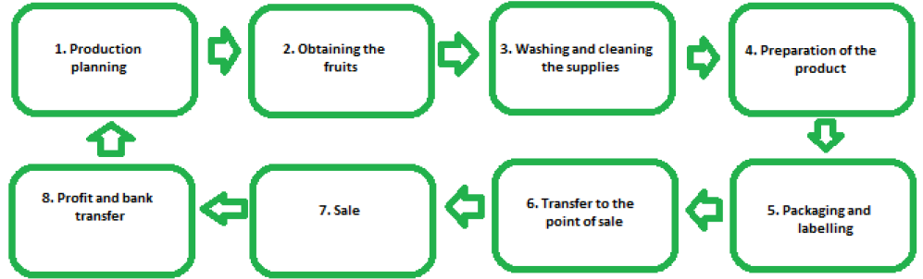

Outline your production plan below.

7. Business Team Structure. Any successful company depends on the talents and skills of its members - and yours is no different! You will need to decide how to structure your business and who will work in which roles. A great way to show how your business is organised is by using an Organogram – a diagram showing a company structure.
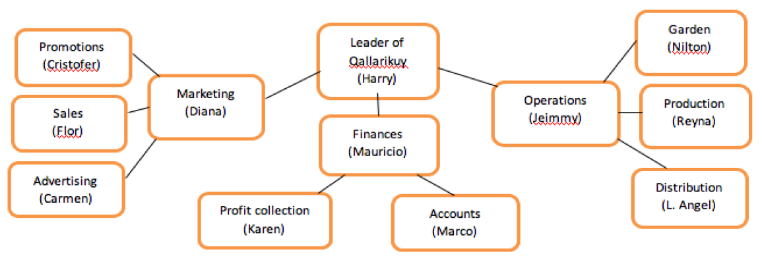
Example of an organogram.

How is your business structured?

Draw your business structure below.

Marketing
In this section you will need to think about how much you will sell your product or service for, to ensure that you make enough profit. You will also need to decide how you are going to reach the people you are selling to so as to ensure you sell as much as possible. These considerations make up your Marketing plan.

1. Establishing a sales price
Before you can begin to sell anything, you need to establish how much you will sell your product or service for. When establishing prices it is important to ensure that they are set at a level which:
1. The customer is prepared to pay - You will need to do some basic market research to estimate a price for the product. Compare the price and the quality of your product or service to others already in the market.
2. Allows you to make a profit - Use Steps 1-7 to help you determine at what level you should set your prices.

7 Steps to help you work out what price you should sell at.
Step 1:
What are your variable costs?
Variable costs are costs which vary with the amount of product you produce. Your variable costs will increase at the amount your produce increases.
Step 2:
What are your fixed costs?
Fixed costs are those which stay the same no matter how much of a product you sell.
Step 3:
What are your total costs?
Add together your variable costs and your fixed costs.
Step 4:
What are your revenues?
Revenue is the total amount of money earned by your enterprise.
Step 5:
What is your contribution margin?
This is how much your revenue contributes to the payment of your fixed costs. Revenue ([per item) – variable cost (per item) = contribution margin.
Step 6:
What is your breakeven point?
Your breakeven point tells you how many products you need to sell to cover your costs: Fixed costs / contribution margin = breakeven point
Step 7:
How much do you need to sell in order to reach your target profit?
(Target Profit / Contribution Margin) + Breakeven point = number of items required to be sold.

Marketing
Marketing is what you need to do to make the leap between identifying your customers and actually selling your product or service. It is the method through which you reach your customers and then persuade them to buy your product or service. Even the best business idea will not succeed unless people know about it. That’s where marketing comes in. Promoting your business will generate sales and boost your bottom line. But marketing is about more than attracting customers, it is also about making sure that they keep coming back.

The Four P’s of Marketing
1. Product (or service)
• What is your product?
• Is the product in demand, is it desired, and is it attractive?
• In what way does it satisfy the customers’ needs?
• How will you distinguish your product from those of the competition?
• How can you improve your product to maximise sales?

2. Price
• Is the price too high/too low?
• Is the price covering costs?
• Will selling at this price give you sufficient profit?
• Explain your pricing strategy and why your customers will pay this price.

3. Place
• Where will your business be located?
• Is this close to your customers?
• If not, how will you attract customers to the business?
• Will you offer delivery services?

4. Promotion
It is crucial to inform people about your business and product, the best product cannot sell if no one knows about it! How will you publicise your business?

Product/Service | Price | Place | Promotion

Example of Marketing Advert

Financial Strategy

Start-up Capital
Some businesses will require little or no start-up capital. Indeed many of the wealthiest and most successful entrepreneurs in the world started with no money at all! Some though will need to raise some start-up capital. Do you have access to anything cheap that you could reuse, recycle, and re-sell perhaps?

Does your business need start up capital (money)? Please circle one: Yes /No

If yes, how much and how are you planning to raise the start-up capital?

If no, why do you not require start up capital?

Your Start-Up Costs or Business Development Costs are the costs of the Equipment and Supplies that you used to start your business. If you already had the products that you needed to start up your business please list them here and put 0 as the Unit cost.
- List all your actual Start Up OR Business Development Costs
Start Up OR Business Development Equipment | Quantity | Unit Cost | Total Costs of your Equipment (Quantity x Unit Cost)

Start Up OR Business Development Supplies | Quantity | Unit Costs |  | Total Costs of your Supplies/Expenses (Quantity x Unit Costs)
Total Start Up Costs OR Business Development Costs  (Add all your costs together) |  | $
Income (Actual)
- List all the products or services that your business sold. List the amount you sold and the price at which you sold your products/service for.
Name of Product or Service | Quantity | Sales Price |  | Sales Income (Quantity x Sales Price)
Total Income  (Add all the ‘Sales Income’ together) |  | $
Profit
Calculation |  |  | $
Total Sales Income
Total Costs
Profit
(Total Sales Income – Total Costs)

Marking Rubric

Booklet
 | 30 | 25 | 20 | 15
 | Student fully completes the booklet neatly in depth and detail with clear, coherent expression providing examples and free of grammatical errors. Shows a clear and well developed understanding of businesses and associated topics. | Student fully completes the booklet neatly with adequate explanation that is free of grammatical error. Shows a good understanding of businesses and associated topics. | Student completes most of the booklet with some explanation and mostly free of grammatical errors. Shows a fair understanding of businesses and associated topics. | Booklet is minimally completed and responses lack detail and attention to grammar is required. Shows a very minimal understanding of businesses and associated topics.
Market Day
 | 4 | 3 | 2 | 1
Participation | Student shows to be an active and enthusiastic participant in market day. | Student participated well in market day in setting up/maintaining their stall to run a business. | Student participated in market day in stall provision and general effort to run a business. | Student had little to no involvement in market day.
Business | Business makes a profit. | Business breaks even. | Business makes a loss. | No business activities undertaken.
Stall | Student creates a very attractive and engaging stall which entices customers to purchase their product/service. | Student creates a well-resourced stall that is visually appealing. | Student creates a stall that is satisfactorily in meeting customer needs. | Student makes minimal to no effort in the creation/maintenance of the stall.
Team Work | Student works well, shares the workload and collaborates together as a group to run a business. | Student shares the workload and works well to run a business. | Student generally works well with the group. | Student shows inconsistency in ability to work together.
Reflection | Student provides a high level of reflection on performance in depth with detailed examples. | Student reflects well on performance. | Student provides some reflection on performance. | Student provides a minimal attempt at reflection on performance.

Comments:

