Evidence for Evolution

Q1. Fill in this table using appropriate sentences provided to you on the second page.

Technique/Study | Definitions/Description | How does it support evolution?
Fossils and the Fossil Record | 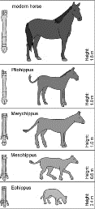
Comparative Anatomy: Homologous Structures |  | 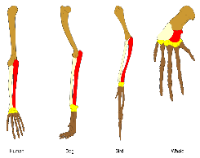
Comparative Anatomy: Vestigial Structures | 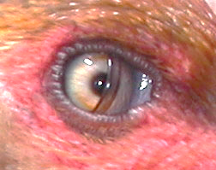
Comparative Embryology of vertebrates |  | 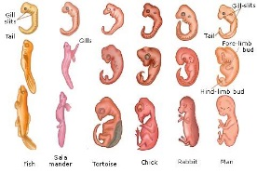
Comparative Biochemistry: DNA

Comparative Biochemistry: Proteins (Amino acid sequences) |  | 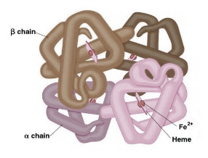
Geographical Distribution – Biogeography | 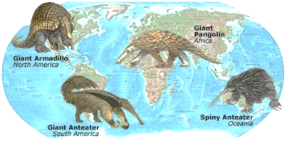

- Looking at the sequence of amino acids in a ubiquitous protein such as haemoglobin between different species.

- Fossils are remains of dead organisms and include bones, teeth, footprints and impressions.
Fossil record is a collection of fossils across many geological periods.

- The greater the similarity of the sequence of nitrogenous bases between two organisms, the closer these organisms are related to a common ancestor. E.g. chimpanzee and human.

- Geographic distribution of organisms on earth in combination with movement of tectonic plates.

- A study concerned with physical features that are similar in many organisms but serve different function. E.g. limb bones in whale is used for swimming, whereas limb bones in bats are used to fly.

- Comparing and contrasting embryos of different species.

- The fossil record shows that over time changes have occurred in the features of living organisms. It links an ancestor to its descendants.

- The closer the species are related to a common ancestor, the greater the similarity of their amino acid sequence of their ubiquitous protein.

- Animals that evolved before the breakup of Pangea are distributed worldwide; but, those who evolved after Pangea’s breakup tend to appear in uniquely smaller regions on earth.

- Comparing the sequence of nitrogenous bases in DNA of different species.

- Structures that are present in some organisms that have lost all or most of their function in others.

- If organisms have similar body parts but use it in a different way, this implies they have all acquired it from a common ancestor and it has been modified to serve a different function.

- The presence of these structures establishes a link between an ancestor and its descendants.

- It links many organisms to a common ancestor by looking at the similarity between their embryonic development.

Q2. Match the following statements with their correct terms.

 | Vestigial organ | A | A collection of fossils belonging to different geological times.
 | Ubiquitous protein | B | This animal is a proof that two species have descended recently from a common ancestor.
 | Fossil | C | Is used as an evidence for evolution by linking animals to their distribution on earth.
 | Comparative DNA | D | A structure that has lost all of most of its function.
 | Fossil record | E | This can have an impact on fossil record.
 | Homologous structures | F | A preserved remain of a once living organism.
 | Haemoglobin | G | The sequence of amino acids of this object is used to determine evolutionary links.
 | Liger | H | Looks at the similarity of the sequence of nitrogenous bases
 | Ancestor | I | A type of fossil.
 | Biogeography | J | Body parts that are similar in structure but serve a different function.
 | Coccyx | K | An organism that gives rise to a descendant that shares some of its features.
 | Footprint | L | Is an example of a ubiquitous protein.
 | Human activity | M | An example of a structure that has lost its function in some organisms.

