Student worksheet answers

7.1 Displacement is change in position with direction
Pages 156–157

Distance and displacement
1 Complete the second column of the table below, showing your understanding of the key terms on the left. Once you have finished, discuss with a peer, recording their understanding in the third column. Finally, check your answers with your teacher or the Student book by using the glossary at the end.
Key term | My understanding of this word | My peer’s understanding of this word | Actual definition
Distance | Students’ answers will vary. | Students’ answers will vary. | How far an object travels over a certain period of time
Displacement | Students’ answers will vary. | Students’ answers will vary. | A vector quantity that measures the change in position of an object and its direction over a certain period of time
Scalar quantity | Students’ answers will vary. | Students’ answers will vary. | A quantity that only has size (or magnitude) and no direction (e.g. distance)
Vector quantity | Students’ answers will vary. | Students’ answers will vary. | A quantity that has size and direction (e.g. velocity, displacement)
A girl riding her skateboard completed the journey shown by the graph below.
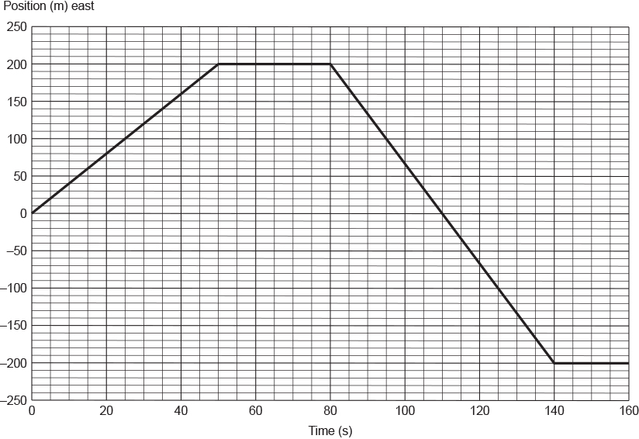
2 Describe the girl's motion as indicated by each of the different sections on the graph.
From t = 0 s to t = 50 s, the girl travelled a distance of 200 m at a constant speed.
From t = 50 s to t = 80 s, the girl is stationary.
From t = 80 s to t = 140 s, the girl travelled at a constant speed but in the opposite direction to that of her initial motion. At t = 110 s, she passed her starting point. She travelled a total distance of 400 m during this time interval.
From t = 140 s to t = 160 s, the girl was stationary.3 How far did the girl travel in 160 seconds? Give your answer in metres.
In 160 s, the girl travelled a total distance of 200 + 400 = 600 m.
4 What was the girl’s displacement at each of the following times?
a t = 50 seconds
200 m
b t = 110 seconds
0 m
c t = 150 seconds
–200 m
5 What does the shape of the graph between t = 0 and t = 50 seconds suggest about the girl’s motion? Explain your answer.
Between t = 0 s and t = 50 s, the distance travelled increases by the same amount each second. This indicates that she was travelling at a constant speed.
A brother and sister arrived with their parents at a hotel that, below the foyer on the ground floor, had three levels of underground car parking. Above the foyer were 12 floors of guest rooms. While their parents were checking the family into the hotel, the two siblings snuck off to ‘ride’ in one of the lifts. From the hotel foyer, they rode the lift up 9 floors, then down 11 floors, up 5 floors and finally down 5 floors.
6 On which floor did the two siblings finish their elevator ride?
The brother and sister finished their elevator ride back on the second car park level, two floors below the ground floor.
7 How many floors did they pass through on their journey?
On their journey, the two siblings passed through 30 floors.

Extend your understanding
From a campsite, a hiker walked 12 kilometres north and 5 kilometres west. She then walked 4 kilometres south and 20 kilometres east.
8 In the space provided below, carefully draw the journey taken by the hiker. Use a scale of 0.5 centimetre = 1.0 kilometre. Draw a line from the hiker’s campsite to where her journey finished.
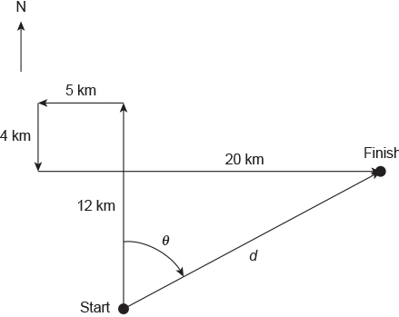

9 Without using a ruler or protractor, determine the hiker’s final displacement.

$$c^{2}=a^{2}+b^{2}$$
$$d^{2}=8^{2}+{15}^{2}$$
$$d^{2}=64+225$$
$$d^{2}=289$$
$$d=\sqrt{289}$$
$$d=17 km$$

$$tanθ=\frac{15}{8}$$
$$θ=\tan^{-1}\left(\frac{15}{8}\right)$$
$$θ={61.9}^{o}={62}^{0}$$

Answer:
17 km N 62º E
17 km 62º T

