Year 10 Chemical Sciences

Week 3 – Ionic Compounds
Objectives:
- Show an understanding that ionic compounds consist of a combination of metal elements (or NH⁴⁺⁾ and non metal elements, ie identify ionic compounds from their chemical formula.
- Show an understanding of the electron transfer between metal and non metal elements during the formation of ionic compounds.
- Describe the lattice structure of ionic compounds and relate this to their properties including: hardness, strength, conductivity, melting point, and boiling point
- Show an understanding that ionic compounds will be more stable than the elements from which they form because of the attraction between the opposite charged ions in the ionic lattice.
- Explain the properties of ionic compounds brittle, non conductors as solids, conductors in solution in terms of the ionic bonding
- Draw representations of ionic compounds using electron dot diagrams.
- Write balanced formula for ionic compounds using the following valencies:
H⁺, Na⁺, Mg²⁺, Al³⁺, K⁺, Ca²⁺, Cu²⁺, Zn²⁺, Ag⁺, Pb²⁺, Br⁻, I ⁻, S ²⁻, Cl ⁻, O ²⁻,F ⁻, OH ⁻, NO₃⁻, CO₃²⁻, SO₄²⁻, NH₄⁺, Fe²⁺, Fe³⁺, Ba²⁺, HCO₃⁻, PO₄³⁻, CH₃COO⁻
Ionic substances are made up of positive (usually metal) and negative (non-metal) ions chemically bonded. In the below diagram you can see that the sodium atom has donated its electron to the chlorine atom making the sodium atom become positively charged forming a sodium ion and the chlorine atom becomes negatively charged forming a chloride ion.

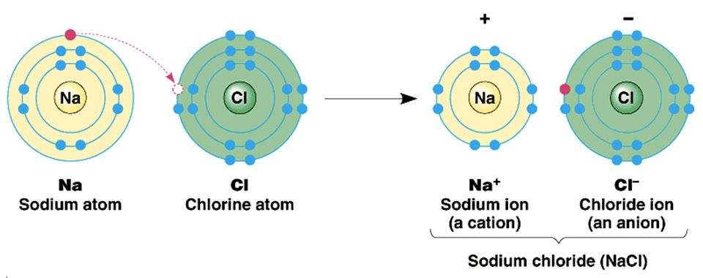

Electron dot diagrams (Lewis dot) show the electrons involved in bonding. It only shows the element symbol and its outer most shell of electrons. Transfer of electrons is involved in ionic bonding and brackets are drawn around the ions. The diagram below shows the process to creating the electron dot diagram for an ionic compound.

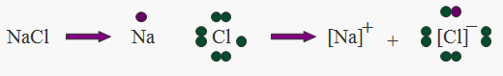
Electron dot diagrams of individual atoms

Formula of ionic compound
Electron dot diagram of ionic compound

The diagram below shows another example of the process to creating the electron dot diagram for an ionic compound.

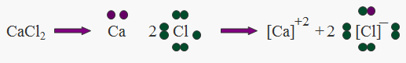

When drawing electron dot diagrams remember to:
- to only show outer shell electrons
- to put ion in brackets and show charge on the ion
- that metals lose electrons to form positive ions, so dot diagrams show no valence electrons and a positive charge
- that non-metals gain electrons to form positive ions, so dot diagrams have full outer shell and a negative charge

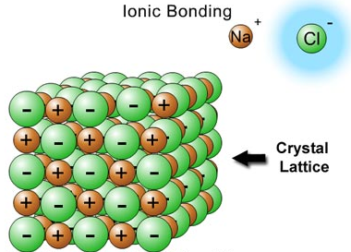
Ionic substances have a lattice structure made up of alternating positive and negative ions, with the chemical formula indicating the smallest ratio of ions in the lattice. That is, for sodium chloride the smallest ratio of ions in the lattice is one sodium ion to one chloride ion as seen in the diagram on the right.

Ionic compounds are hard because of the strong electrostatic attraction between the negative and positive ions in the lattice. They are brittle because when pressure is applied to the lattice, ions of like-charge are forced to come close together. The repulsion force of like-charges is enough to break the lattice as seen in the diagrams below.
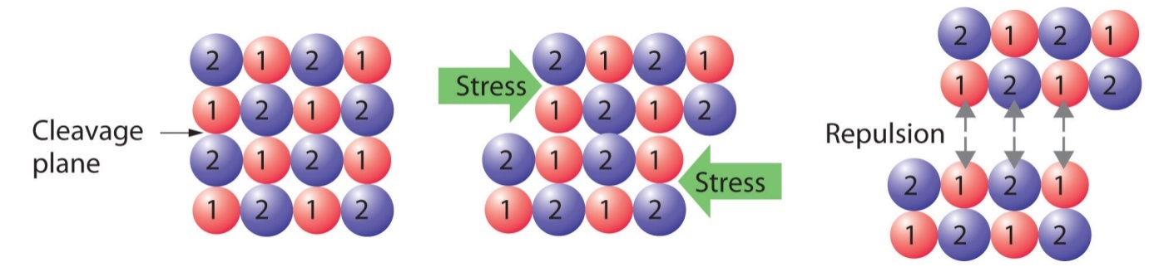

Ionic substances in their solid state cannot conduct electricity as the electrons are in fixed positions but if the ionic substances are dissolved in water (form electrolytes) or if molten, the ions are free to move and can conduct electricity.
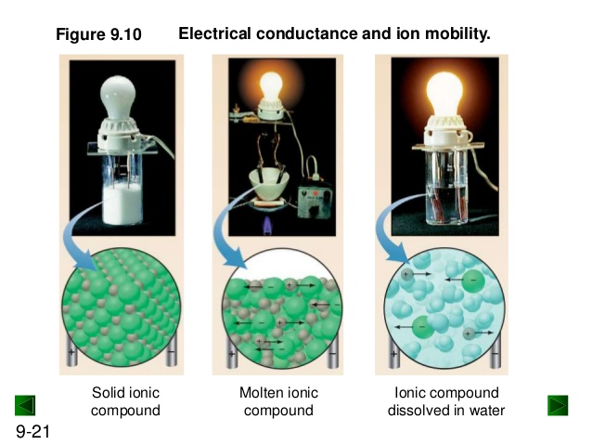

The bonding in ionic substances is formed by the transfer of valence electrons. This electrostatic force of attraction is very strong and means these substances generally have high melting and boiling points.

Ionic compounds are neutrally (zero) charged. That means when writing chemical formula for an ionic compound the amount of positive charge from the ions must equal the amount of negative charge from the ions.

When writing chemical formula the positive ion (cation) is always written first and the negative ion (anion) is always written second. The charges on the ions are NOT written in the chemical formula.

For example the compound formed from Na⁺¹ and F⁻¹ ions is called sodium fluoride and has the chemical formula NaF.

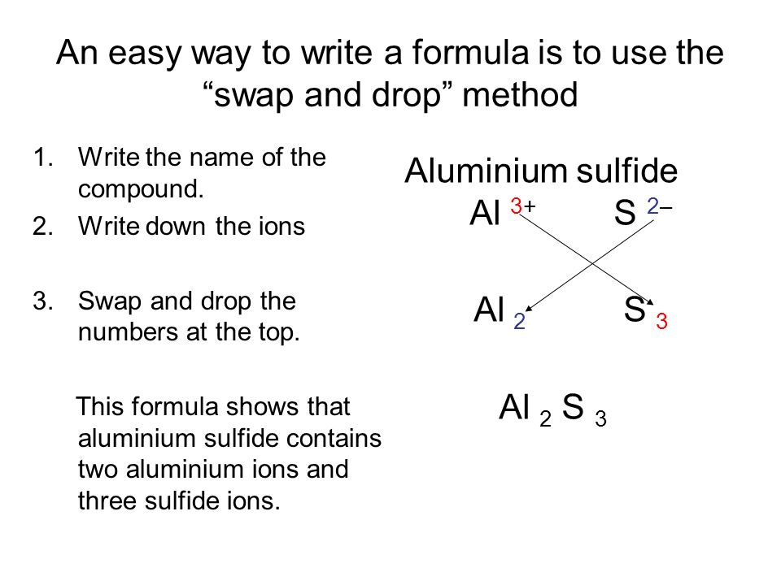
There are some simple rules to follow for naming of ionic formula
- The positive ion is named first, then the anion (negative ion)
- The positive ion, usually a metal, keeps its normal name
- If the positive ion has several valencies possible, indicate its valency using roman numerals.
- The negative ion,
  - if it is monatomic (one type of atom) has the end of its name written as –ide (e.g. chloride)
  - if it is polyatomic (more than one type of atom) keeps its polyatomic name (e.g. sulfate)

Examples:

Chemical Formula | Name of Compound
NaF | sodium fluoride
Al₂O₃ | aluminium oxide
Mg(NO₃)₂ | magnesium nitrate
CuCl₂ | copper (II) chloride
CuCl | copper (I) chloride
Fe₂(SO₄)₃ | iron (III) sulfate

Week 3 Revision Questions

- Draw electron dot diagrams for the following ionic compounds.

3. Calcium oxide, CaO
2. Potassium chloride, KCl
1. Sodium fluoride, NaF

6. Magnesium oxide, _________
4. Lithium bromide, LiBr
5. Barium chloride, BaCl₂

8. Aluminium fluoride, _______
7. Beryllium chloride, _______
9. Gallium chloride, _______

12. Caesium iodide, __________
10. Aluminium oxide, _________
11. Strontium chloride, _______

- Complete the following word close using the terms provided in the box
bonding react electrons configuration bond compound stability shell
group shared outermost (valence) accepted
18 8 metal non-metal

Ionic ___________ involves electrons being donated or ___________ between _______ and ___________atoms.
___________ will be given and taken so that each ion in the ___________ ends up with ___________ electrons in its ___________ electron ___________.
We know there is special chemical ___________ attached to 8 electrons in the outermost (valence) e⁻ shell because all Group _________ have this electron ___________ and do not ___________.
The only exception is He which only has 2 electrons in its outer (valence) shell.

- Complete the following table by writing the correct ionic chemical formula.

 | chloride | oxide | sulfate | sulfide | carbonate
Sodium
Potassium
Magnesium
Calcium
Hydrogen
Lead(II)
Silver
Ammonium
Copper(II)
Zinc

- Complete the following table by naming the ionic compounds formed

Part 2 | OH⁻¹ | SO₄²⁻ | PO₄³⁻ | NO₃⁻¹ | N⁻³
Na¹⁺
Mn²⁺
H¹⁺
Fe³⁺
Zn²⁺
Al³⁺
Mg²⁺
Cr³⁺
K¹⁺
NH₄¹⁺

- In terms of bonding explain why Aluminium chloride is not malleable when Aluminium is.

- Explain why sodium chloride does not conduct electricity in solid form but does conduct electricity when dissolved in water.

