YEAR 8 PHYSICS REVISION
ENERGY
Fill in the blanks below:
Energy lets us do _______________. Energy comes in many different forms. The unit used to measure energy is a ______________________. There are ___________joules in a kilojoule and __________________kilojoules in a mega joule.
Energy cannot be __________________ or destroyed. It can only be _______________________ to another object or __________________________ to a different type of energy.
In the table below list some different forms of kinetic and potential energy:
KINETIC ENERGY | POTENTIAL ENERGY

Energy flow diagrams show the transformation of energy in simple systems. Show the energy transformations that occur when you do the following:
- Turn on a light switch

- Turn on a car and begin the drive down the street

Energy transformations can often produce useful sources of energy and non – useful sources of energy. Energy efficiency measures how much useful energy is produced from the input source of energy. What is the equation we can use to find energy efficiency?

Use the above equation to measure the efficiency of the laptop. You will first need to identify the useful source/s of energy:
500 MJ 100MJ 250MJ 150M
Electricity Heat + Light + sound

Kinetic energy is the energy of _____________________________. The ______________ kinetic energy an object has the more work that can be done.
Circle to object that has the most kinetic energy in each scenario:
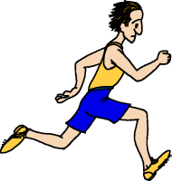 50kg man running at 2m/s 80kg Big bird riding at 10m/s

50 kg man running at 4m/s 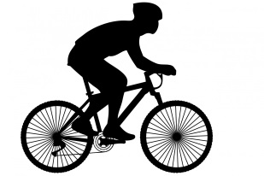70kg man riding at 10m/s

Potential energy is ______________________ energy. Gravitational potential energy is affected by the mass of the object and the ____________________ above sea level.
When an object is dropped it transforms ______________________________ into _____________________________________.
Below is a picture of a ramp. Put an X at the spot where the ball has the greatest G.P.E

If each of these balls was released from the track which one (circle your answer) would have the most G.P.E? Explain your answer.
5g
50g
7g
15g

Chemical energy is a type of _______________________ energy. This energy is ______________ in objects. When this energy is accessed it is transferred into other forms of energy.
Complete the table below:
Source of Chemical Potential Energy | How can the chemical potential energy be accessed?
Battery

Food

Fuel

Chemical energy can be released as _________________ in chemical reactions. There are 2 types of chemical reactions where heat is exchanged. They are called exothermic and endothermic. The table below summarises these reactions:
Exothermic | Endothermic
The objects lose heat energy  The surroundings gain heat energy (feel warmer)  Examples:  Combustion – Burning wood on a bon fire. The air around the fire becomes warm.  Draw a diagram to show the flow of heat in an exothermic reaction: | The objects gain heat energy  The surroundings lose heat energy (feel cooler)  Examples:  Ice melting – When we hold ice in our hand it makes our hands cold because the ice block is taking the heat out of our hands.  Draw a diagram to show the flow of heat in an endothermic reaction:

Elastic potential energy is stored in objects that are either _________________________ or __________________________________.
What are some sources of elastic potential energy?

What are some sources of heat energy?

What types of energy do the following objects have?
- A cyclist riding a bike on flat ground _________________________________________
- A cyclist stopped on the road half way up a hill________________________________
- A battery being used in your phone _________________________________
- A battery not being used ___________________________________
- A bungee jumper who has jumped off the platform and the bungee cord is fully stretched ___________________________________
- A toasted sandwich ____________________________
- A compressed spring _______________________________

