IT’S IN OUR GENES - REPRODUCTION
In this activity we will look at the different ways organisms reproduce.
Reproductive processes may be of two kinds, asexual or sexual.
Asexual Reproduction
In asexual reproduction identical offspring are formed from the one parent.
Asexual reproduction can occur in several ways:
Bacteria reproduce by fission. (fission = splitting) When conditions are ideal, a bacterium simply splits into two. About fifteen minutes later these two split so that four cells have formed. After another twenty minutes each cell splits again.

Hydra is a stinging-celled animal that lives in freshwater. At certain times of the year a hydra can form a little bud-like growth that eventually separates and grows as a new individual. This is known as budding.

Starfish can reproduce by regeneration. In regeneration or fragmentation, small pieces of the organism break off and develop into a new organism. A whole starfish can regenerate from a single arm.

Vegetative reproduction is a term that refers to asexual methods of reproduction by plants.

Some examples:
Spores:
Moulds, mushrooms and toadstools all form tiny spores. These can form a new plant when they land on a suitable food source.
Ferns also make spores. These grow into a small plant, later forming male and female cells that join and grow into a new fern.

Runners:
Some plants send out shoots, which grow roots and then develop into new plants.

Bulbs:
Some plants grow from bulbs or corms like a daffodil.

Tubers:
Some plants grow from underground stems called tubers like potatoes.

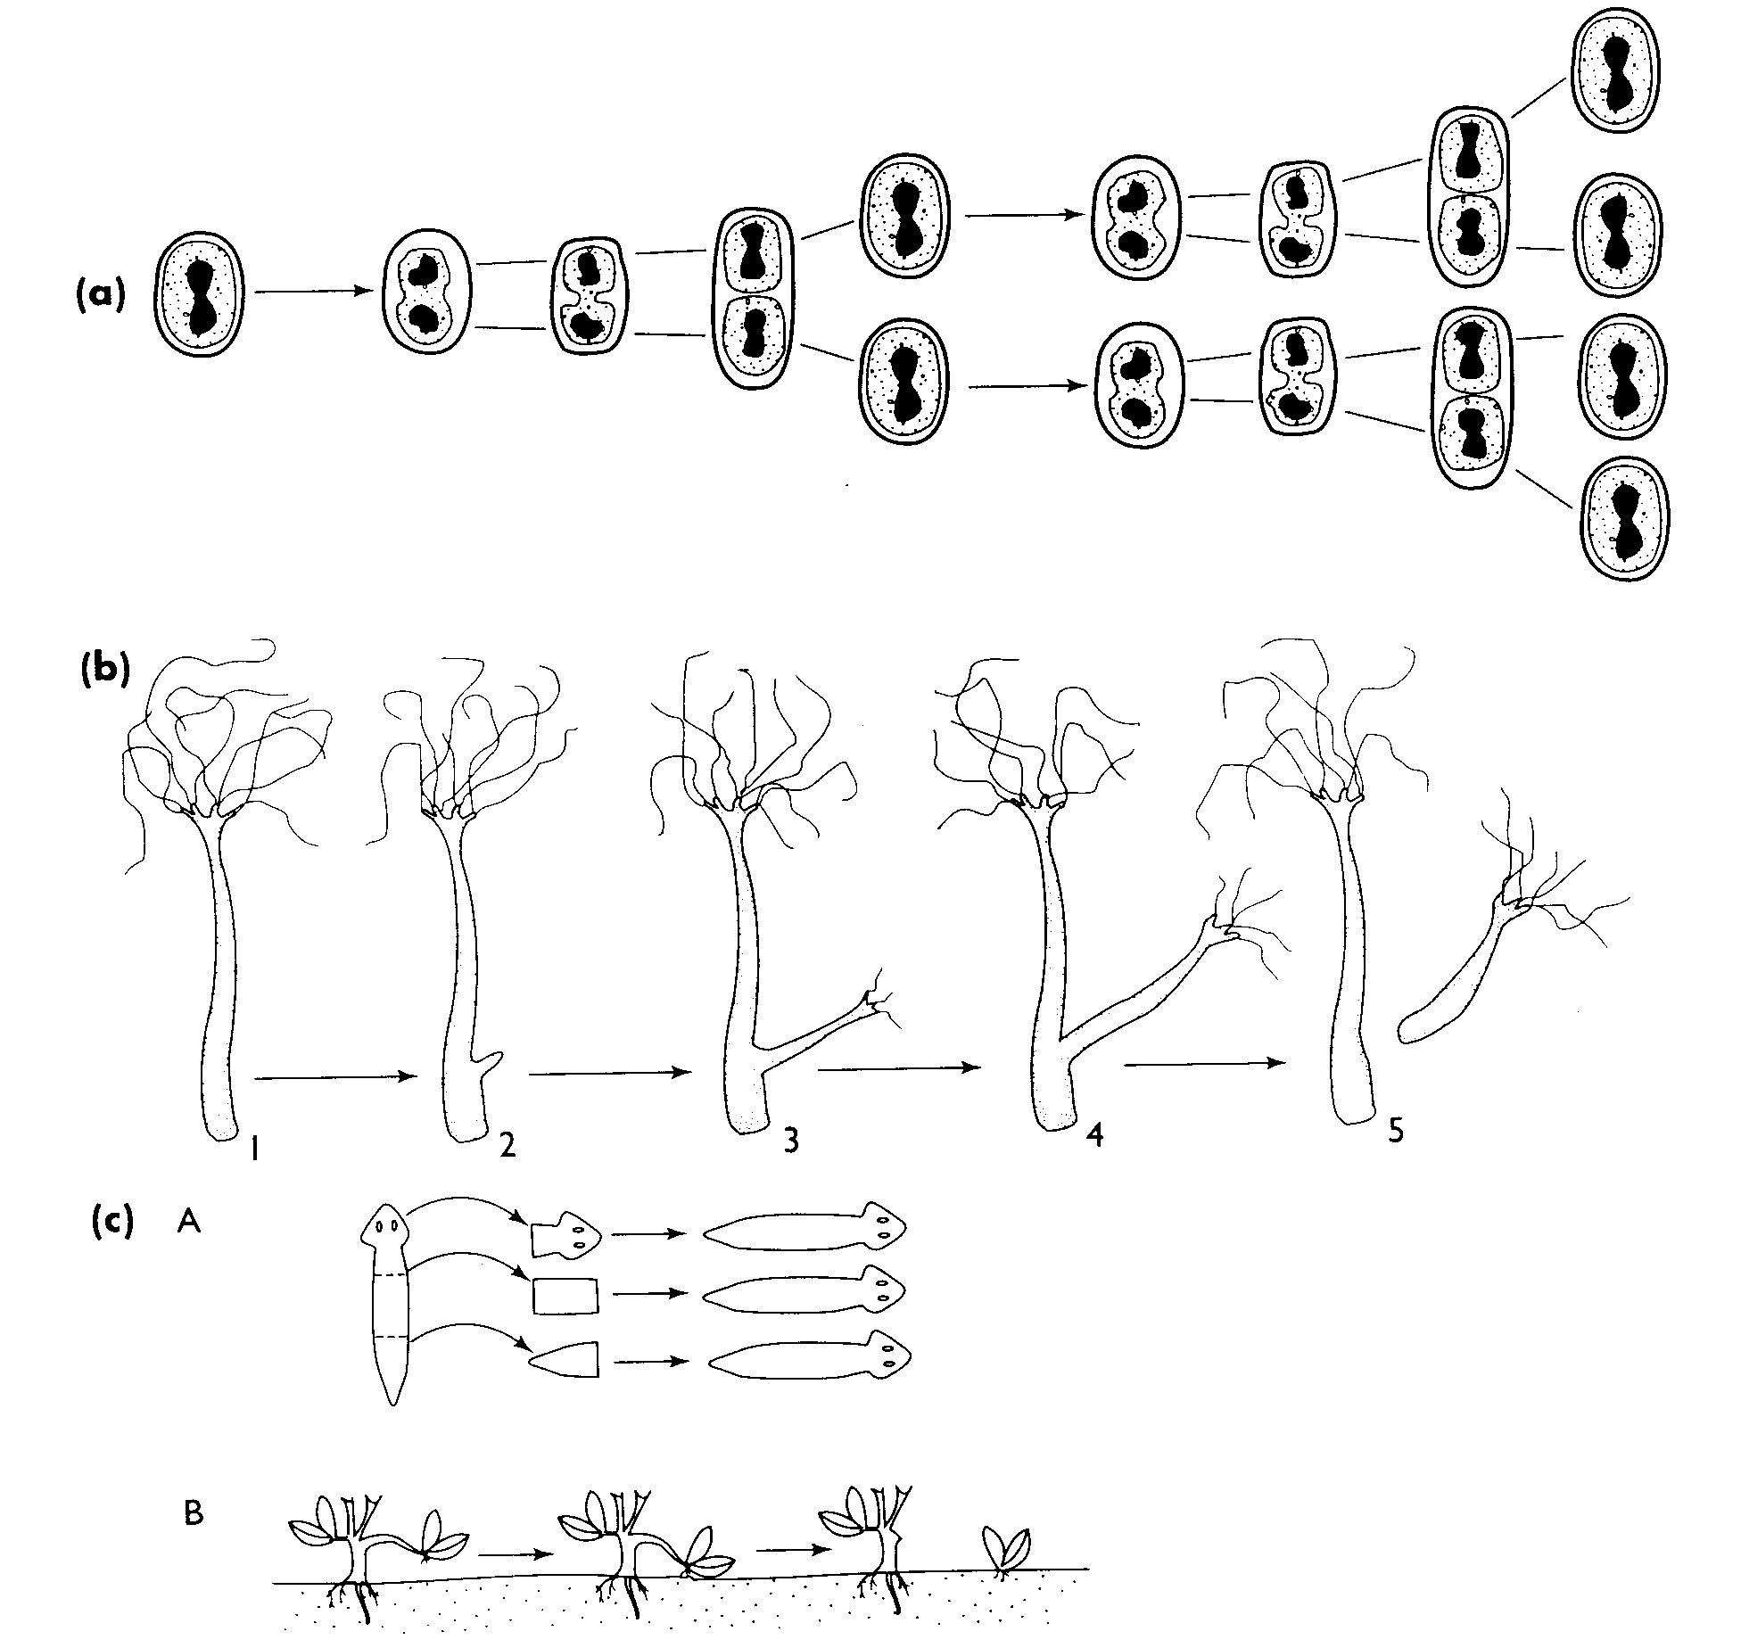
Some examples of asexual reproduction in plants and animals:

(a) a bacterium reproducing by binary fission.
(b) a small freshwater animals called a Hydra. It reproduces asexually by budding.
(c) Some different forms of asexual reproduction
A. regeneration in a flatworm
B. layering in a flowering plant.

QUESTIONS:
Write definitions for
- Asexual reproduction
- Fission
- Budding
- Regeneration

Sexual reproduction
- In animals, male sex cells called sperm are formed in testes.
- In female animals the sex cells are formed in ovaries and are known as eggs or ova (singular – ovum).
- Both sperm and egg cells are called gametes.
- During sexual reproduction, the gametes (sperm and ovum) fuse together to form a cell called a zygote.

The fusing process where the two gametes join is called fertilization.
In many animals, especially those living in water (like fish), eggs and sperm are released into the water and fertilization takes place outside the bodies of the animals. The sperm and eggs simply float around in the water until they collide. This form of fertilisation is called external fertilization. External fertilization is common in animals living in water.

In other organisms, like humans, the sperm are deposited in the female during sexual intercourse. The sperm cells swim upwards until one eventually meets an ovum inside the female’s reproductive tract.
This form of fertilization is called internal fertilization.
Fertilized egg (zygote) divides many times

Fertilized ovum (zygote)
Male and female gametes fuse

Embryo

1. Match each of the words or phrases with the meanings:
a. Asexual reproduction 1. Zygote
b. Sexual reproduction 2. Internal fertilization
c. Asexual reproduction method used by bacteria 3. Testes
d. Asexual reproduction method used by Hydra 4. Fertilization
e. Mushrooms and other fungi form these 5. Ovaries
f. Sperm form in these 6. Fusion of two cells
g. Eggs are formed in these 7. Spores
h. The fusion of two sex cells 8. Budding
i. The cell resulting from this fusion 9. No fusion occurs
j. Fusion within the body of the female 10. Budding
Variation
An important result of sexual reproduction is that the offspring look different to the parents. Any difference is known as variation. For example, a calf born to a bull and cow may have a different coat colour to its parents. There will be many other differences too.
Perhaps you can spot some.
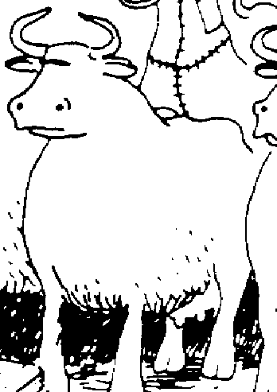

This is not the case for asexual reproduction where the offspring are very similar to the parent.

QUESTIONS:
1. How alike are you and your brothers and/or sisters? List some similarities and differences.
2. Why is an offspring of sexually reproducing parents often different to its parents?
- Why do you think variation might be important to a species of organisms?

