Student worksheet answers

7.2 Velocity is speed with direction
Pages 158–159

Speed and velocity
1 Explain in your own words, the difference between speed and velocity.
Speed is a scalar quantity that measures the distance travelled in a set time. Velocity, however, is a vector quantity and it measures the charge in displacement over time.
2 Use the formula triangle to identify the following formulas.
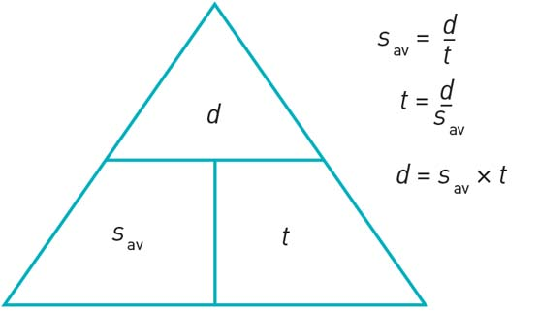
a Distance
Average speed multiplied by time
b Time
Distance divided by average speed
c Average speed
Distance divided by time
3 Use the formula triangle to identify the following formulas.
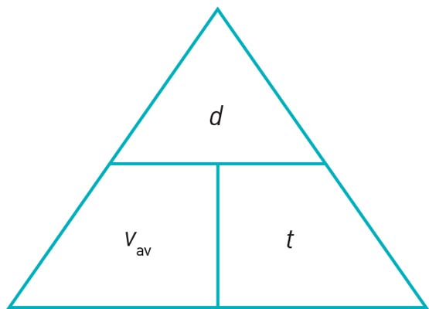

a Displacement
Average speed multiplied by time
b Time
Displacement divided by average velocity
c Average velocity
Displacement divided by time
4 In 2009 Usain Bolt set a new world record time of 9.58 seconds for the men’s 100 metres. What was his average speed for the race? Give your answer in metres per second.
s_{av} = d/t
= 100/9.58
= 10.4 m s^{–1}
5 Kenyan athlete Daniel Komen holds the world record for the men’s 3000 metres. If his average speed for the race was 6.81 m s^{–1}, what is his world record time? Give your answer in minutes and seconds.
t = d/s_{av}
= 3000/6.81
= 440.53 s
= 7 min 20.53 s
6 What was the total distance travelled by an object whose velocity–time graph is shown below? Give your answer in metres.
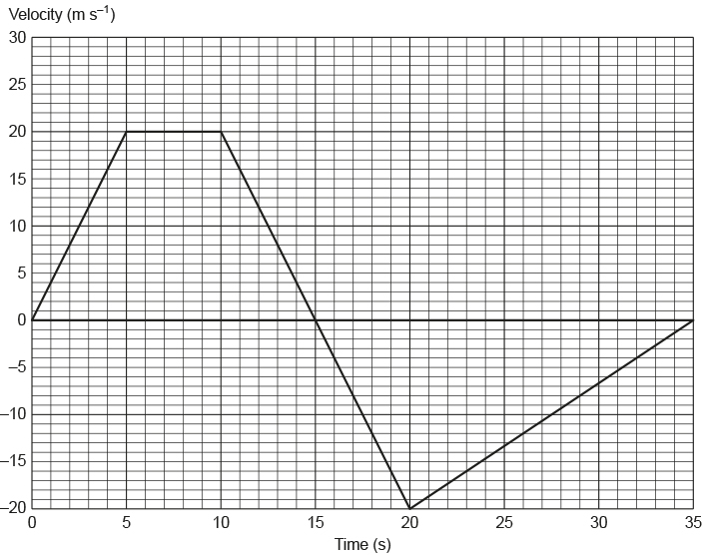
The total distance travelled by the object in 35 s will be equal to the ‘unsigned’ area underneath its velocity against time graph.
In this instance, that will be equal to the sum of the area of the trapezium outlined from t = 0 s to t = 15 s with that of the triangle formed from t = 15 s to t = 35 s.
$$d=\frac{1}{2}\left(15+5\right)×20+\frac{1}{2}×20×20$$
$$=200+200$$
$$=400 \text{m}$$
7 What was the average speed of an object whose velocity–time graph is shown in Figure 3? Give your answer in metres per second.
s_{av} = d/t
= 400/35
= 11.4 m s^{–1}
8 What was the final displacement of the object after 35 seconds? Give your answer in metres.
The object’s final displacement after 35 s will be equal to the ‘signed’ area underneath its velocity against time graph.
In this instance, that will be equal to the signed sum of the area of the trapezium outlined from t = 0 s to t = 15 s with that of the triangle formed from t = 15 s to t = 35 s.
$$d=\frac{1}{2}\left(15+5\right)×20-\frac{1}{2}×20×20$$
$$=200-200$$
$$=0 \text{m}$$
9 What was the object's average velocity during the 35 seconds?
v_{av} = d/t
= 0/35
= 0 m s^{–1}

Extend your understanding
This graph shows the motion of a man riding on a Segway along straight pathway.
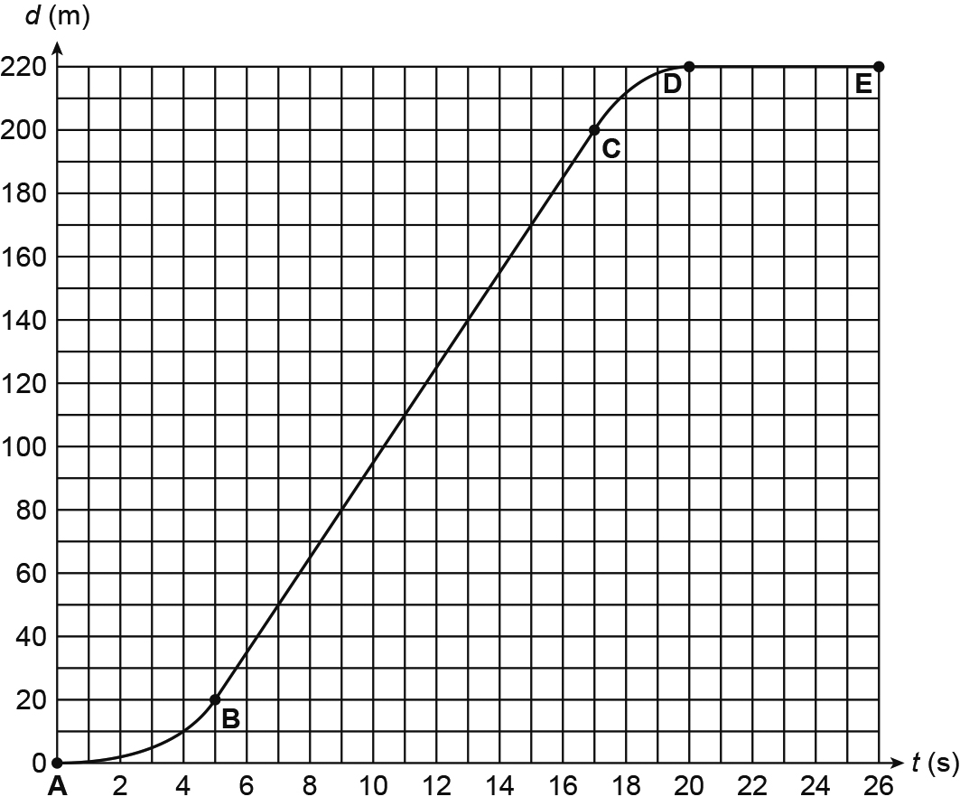
10 Which of the options, P–S, correctly describes the man’s motion in each of the stages AB, BC, CD and DE, as shown by the graph?
 | AB | BC | CD | DE
P | Decelerating | Constant speed | Accelerating | Stationary
Q | Accelerating | Stationary | Constant speed | Decelerating
R | Accelerating | Constant speed | Decelerating | Stationary
S | Decelerating | Stationary | Constant speed | Accelerating
In section AB the gradient of the graph is increasing. This means that the Segway’s velocity is increasing – this means that it is accelerating.
In section BC the gradient of the graph is constant. This means that the Segway is travelling with a constant speed.
In section CD the gradient of the graph is decreasing. This means that the Segway’s velocity is decreasing – this means that it is decelerating.
In section DE the gradient of the graph is zero. This means that the Segway's velocity is zero – this means that it is stationary.
Option R correctly describes the Segway’s motion.

11 What was the man’s average speed during section AB? Give your answer in metres per second.
s_{av} = d/t
= 20/4
= 5.0 m s^{–1}
12 What was the man’s speed during section BC? Give your answer in metres per second.
s_{av} = (200 – 20)/(17 – 5)
= 1800/12
= 15 m s^{–1}

