Year 10 Biological Sciences

Week 1 and 2 – Genetics: DNA

Objectives:
- Describe the role of DNA (Deoxyribonucleic acid) as the blueprint for controlling the characteristics of organisms
- Review cells structures: Cell membrane, Cell Wall, Nucleus, Nucleolus, Ribosomes, Cytoplasm, Mitochondria, Chloroplast and Centrioles
- Describe the structure of DNA
  - Nucleotides
  - Nitrogen base pair rule (A-T, G-C)
- History and impact of developments in genetic knowledge: Gregor Mendel, James Watson, Francis Crick and Rosalind Franklin
- Relationships between DNA, Chromosomes and Genes
- DNA vs. RNA structure
- Understand that genes make proteins (which is brought about through the process of protein synthesis, and involves RNA)
- Define the term ‘mutation’ and understand how they arise
  - Understand mutations can be classified as: gene vs. chromosomal

Cell: Organelles and their function

Organelle | Function
Cell Wall | Maintains the rigid shape of the cell and protects it from damage
Cell Membrane | Surrounds the cell and allows material to pass in and out of the cell
Nucleus | The control centre of the cell that contains DNA
Nucleolus | Makes the ribosomes
Mitochondria | Provides energy for the cell by carrying out cellular respiration
Ribosomes | Involved in protein formation
Chloroplasts | Carry out photosynthesis
Cytoplasm | Allows ions to diffuse through it as it is mostly made up of the cytosol which is comprised of water.
Centrioles | Forms spindles during cell division in animal cells

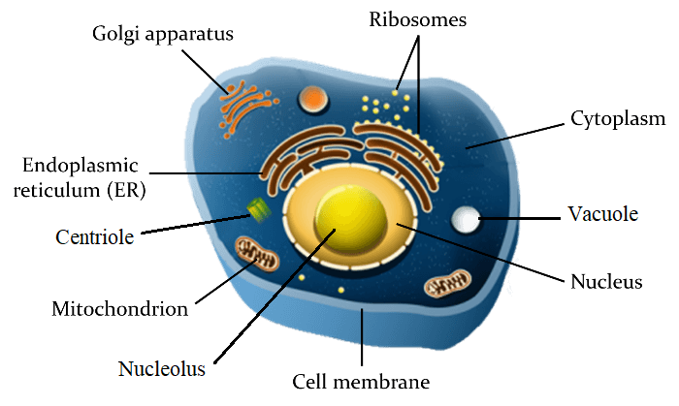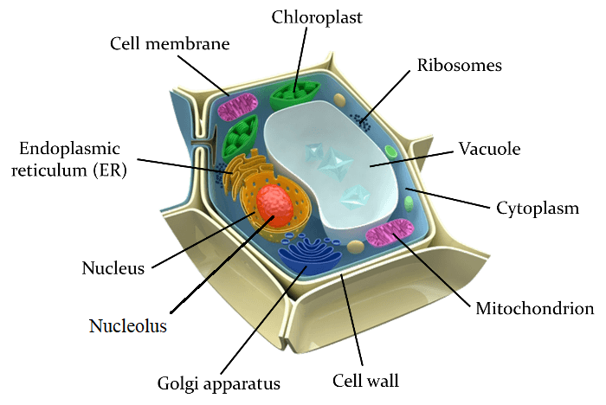

Animal Cell | Plant Cell
DNA

DNA stands for Deoxyribose Nucleic Acid. DNA is found in the nucleus in all living cells (except red blood cells) and is important for controlling the functions of the cell. DNA is in the shape of a double helix with a sugar phosphate backbone. This structure allows for large amounts of genetic information to be stored in a small space.
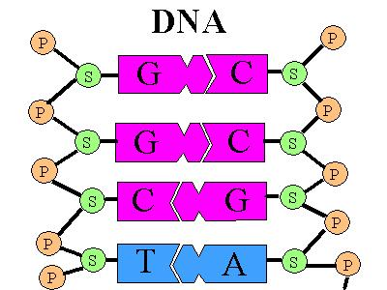
DNA is made up of subunits called nucleotides. Each nucleotide consists of a sugar, phosphate and a nitrogenous base. There are four different nitrogenous bases: Adenine, Cytosine, Guanine and Thymine.

Each nitrogenous base pairs with a complementary base. Adenine pairs with Thymine and Cytosine pairs with Guanine.

The history of DNA

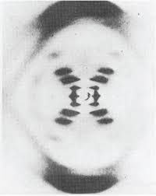
DNA’s double helix was discovered in 1953 by James Watson and Francis Crick. This resulted in them winning a Nobel Prize in 1962 with Maurice Wilkins.

The information that assisted in this discovery came from an x-ray crystallography taken by Rosalind Franklin prior to her death. This x-ray crystallography picture was shown to Watson and Crick by Franklin’s colleague Maurice Wilkins which confirmed to them that the shape of DNA was in fact a double helix.

Relationship between DNA, Chromosomes and Genes

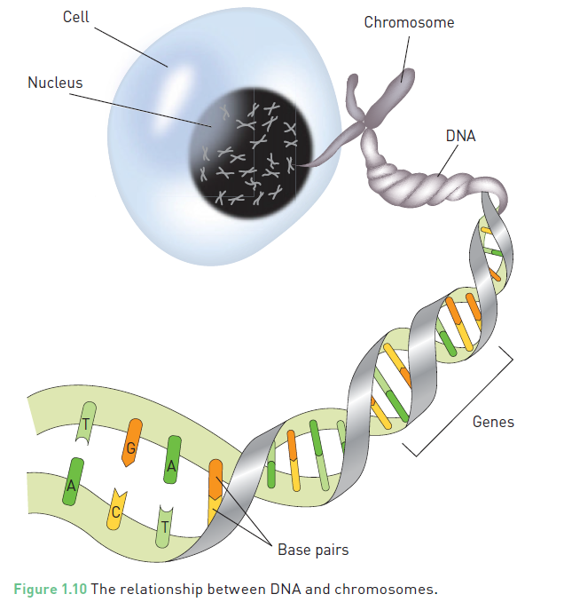
Human cells have between 2 – 3 metres of DNA in their nucleus. In order to fit this much genetic material in a small space the DNA is in the form of a double helix. The DNA strands are coiled around proteins called histones. This coiled DNA is called chromatin.

Chromosomes are DNA molecules carrying genetic information in the form of genes. Chromosomes are condensed ‘super coiled’ structures which become visible during cell division.
Humans have 23 pairs of chromosomes (46) in total. The first 22 pairs (44) of chromosomes are called autosomal chromosomes. These are also called body/non-sex chromosomes. The last pair of chromosomes (2) are called sex chromosomes. These determine the sex of the individual. A Karyotype is a picture which shows all the chromosome pairs matched up from largest to smallest.

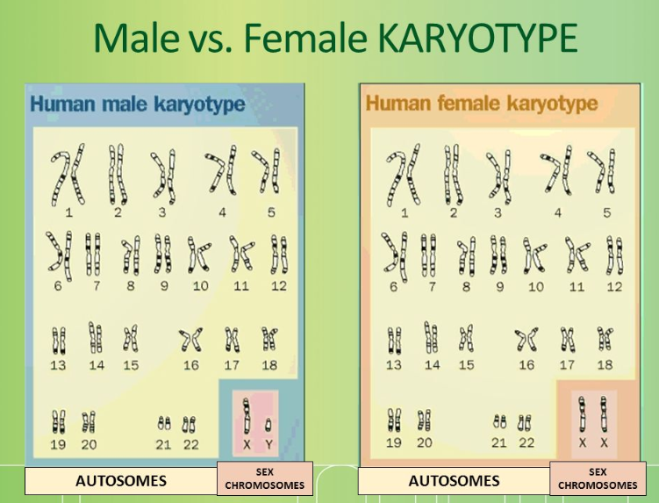

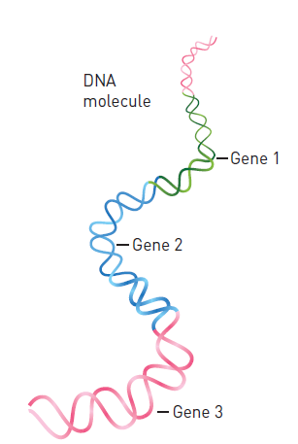
Sections of chromosomes (or DNA) contain specific instructions (genetic code) for structure and activities coordinated by the cell. These sections are called genes. We all have genes which code for the same traits, however our specific genetic codes vary. For example: We all have the gene for eye colour, however people have blue, brown or green eyes. These differences in genes of a population contribute to genetic variation.
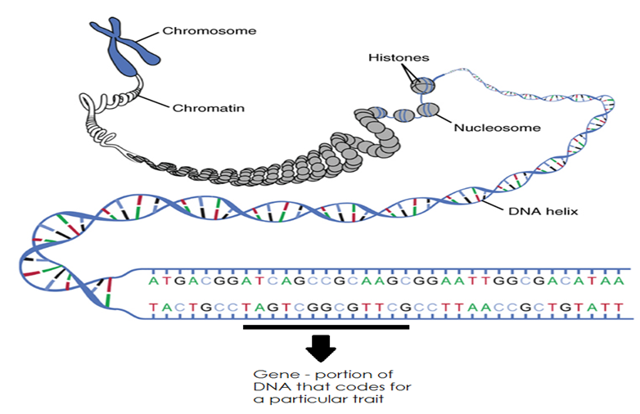

DNA Replication

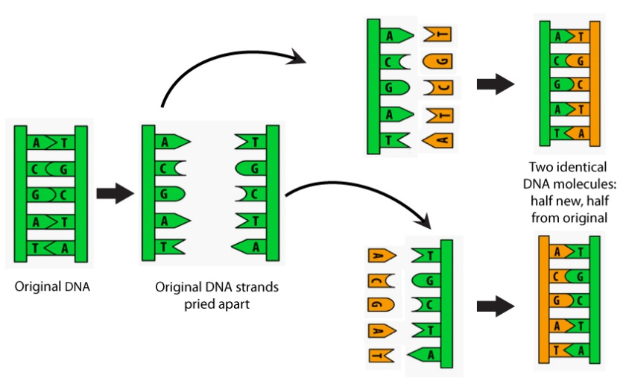
In order for our body to grow and repair damaged cells we need to undergo DNA replication. DNA replication is required for mitosis to occur. In Mitosis we need an identical copy of the original DNA so that the new cell (daughter) can be exactly the same as the original (parent).

The complimentary base pairs make this process easy. The DNA first unzips (separates at the nucleotides) by breaking the weak hydrogen bonds between the bases. Each strand is then matched with complimentary bases to make a new double stranded DNA molecule.

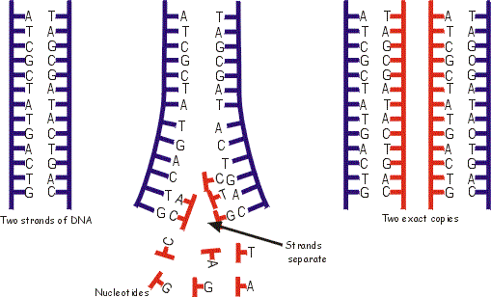

History of Genetics

Gregor Mendel is famous for his pea plant experiments. He spent many years studying their traits and noticed that their traits did not blend over generations. For instance, tall pea plants didn’t blend with short pea plants to produce medium sized pea plants. Instead, he noticed that the offspring all came out tall. When he then bred two of these offspring he noticed that one of the offspring was short and the others were tall. This lead him to discover that each gene in DNA had multiple alleles. Two of these alleles together then determined the traits presented. He also discovered that some of these alleles were dominant over other ones resulting in traits being “hidden”

DNA vs RNA

Proteins are chemical substances that play a vital role in the functioning of the body. Enzymes, hormones and antibodies are all types of proteins. To make proteins the body needs to reads the genetic code found on genes of the DNA. This genetic code is like a recipe for making the correct proteins.

Proteins are made in the cytoplasm of the cell by ribosomes. DNA is found in the nucleus and is too large to fit through the pores in the nuclear membrane. The cell makes templates of sections of the DNA needed to make the proteins which is capable of leaving the nucleus and finding its way to the ribosome. This template is called RNA (Ribonucleic acid).

To make RNA, a section of the DNA is unzipped and the RNA is made with bases that are complimentary to one side of the DNA stand (template strand) that was unzipped. This RNA molecule can then leave the nucleus and enter the cytoplasm where it will find a ribosome.

DNA RNA PROTEIN

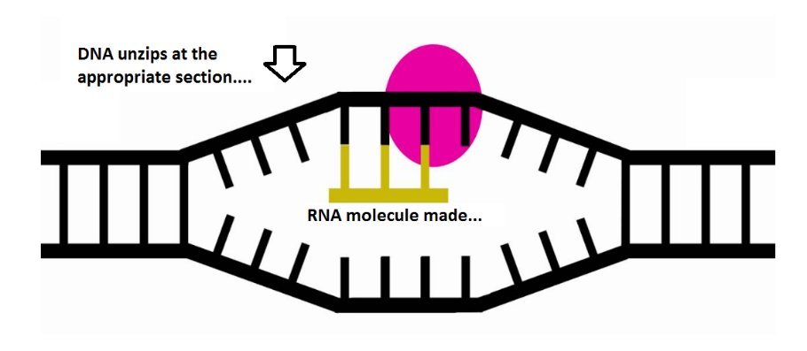
RNA is similar to DNA but there are some key differences.
- DNA is double stranded but RNA only has a single strand
- The sugar in DNA is deoxyribose. In RNA the sugar is ribose.
- The base uracil (U) is used in RNA instead of the base Thymine (T) which is found in DNA. Uracil bonds to Adenine.
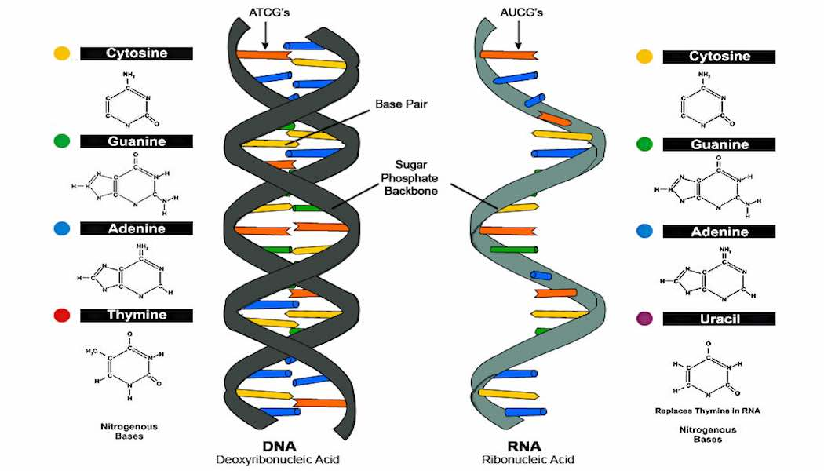
Protein Synthesis

Each gene in the DNA in the cell nucleus carries the code for making a protein from amino acids. There are two processes that must occur for a protein to be made, transcription and translation.

In transcription, the 2 strands of the DNA in a gene separate. Messenger RNA (mRNA) forms with bases that are complementary to those on the template strand of the DNA. This mRNA then travels from the nucleus into the cytoplasm.

In translation the mRNA attaches to a ribosome. The ribosome moves along the mRNA reading the code. At the start codon it begins making the protein. A codon is a sequence of 3 bases in the mRNA molecule that form the code for an amino acid. The bases of the codon are complementary to those in the template strand and the same as those in the coding strand of DNA.

For each codon on the mRNA a transfer RNA (tRNA) with a matching anticodon brings the correct amino acid. The amino acids are bonded together to form the protein. The tRNA is then released back into the cytoplasm to pick up another amino acid.

Mutations

There are two types of mutations that occur, gene mutations and chromosomal mutations.

Gene mutations occur when mistakes are made during DNA replication. This causes a permanent change in the nucleotide sequence which changes the information stored in the DNA that codes for specific traits.

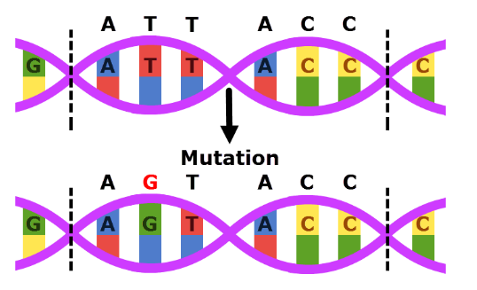

Chromosomal mutations are mutations that affect the entire chromosome, not just one gene. For example, an individual could end up with more than 46 chromosomes due to non-disjunction. This is where an unequal separation of chromosomes occurs during meiosis which results in a gamete having more chromosomes than it should. More about the types of chromosomal mutations will be discussed in week 4 notes.

Bibliography

Some material paraphrased and pictures sourced from https://www.educationperfect.com/controlpanel/#/content/manage/science in various sections.

Questions

- Label the three structures as shown, of a typical animal cell (in the boxes below):
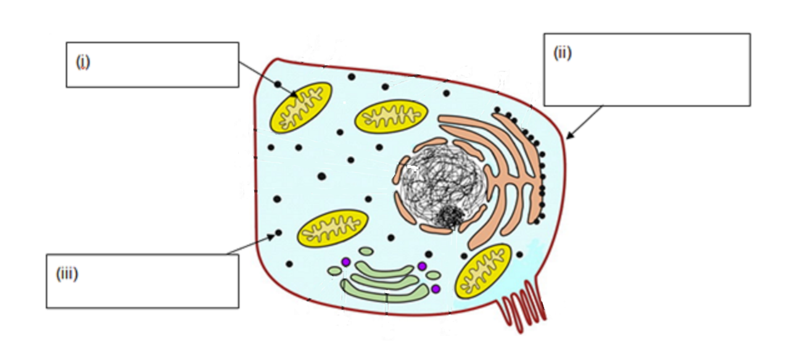

- Briefly state the function of each of the structures labelled in the above diagram.

Structure | Function
(i)
(ii)
(iii)

- Where is DNA found and why is it important?

- Draw a nucleotide.

- Complete the DNA strand below by adding in the complementary bases.

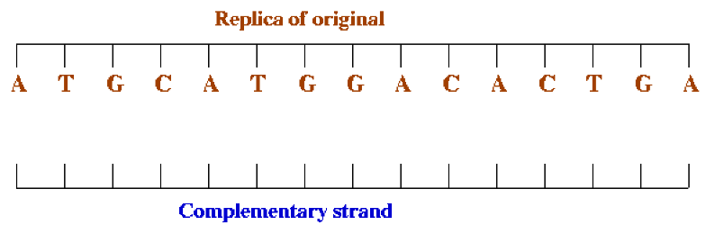
- Explain how DNA, Chromosomes and Genes are interrelated.

- Complete the following table to compare DNA and RNA.

 | DNA | RNA
Double/Single Stranded?
Bases Present
(appropriate partners identified)
Type of Sugar on Backbone
Function
Location in the Cell
- The diagram below shows the sequence of events taking place in the cytoplasm of a cell during the process of protein synthesis.
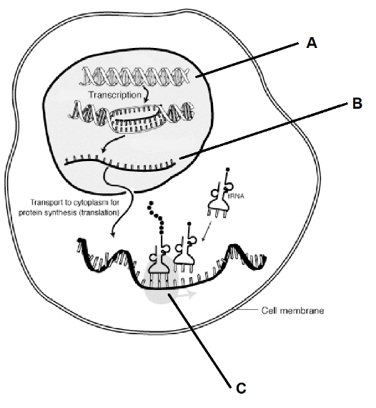
  - Identify each of the following structures labelled on the diagram.

A __________________ B__________________

  - If a DNA coding strand reads CCG ATC, then how will this strand read when copied to structure B?

  - What is a three base sequence on structure B called?

  - Describe what is happening at C in the diagram above.

- What is a mutation?

- What is the difference between a gene mutation and a chromosomal mutation?

