Year 8 Body Works

What you will learning about?
By the end of the topic you should be able to;

In this unit you will be leaning the skills required to use a microscope. You will have the opportunity to observe and draw a variety of different cells. You will learn about the organised hierarchy that multicellular organisms have and you will look closely at the main systems these organisms have to help them function. Comparisons between different groups of organisms will be made, showing how structures can vary to perform specialised functions. You will also have the opportunity to complete dissections of various organs present in the systems you have learnt about.

By the end of the topic you should be able to spell and apply the following terms:
Cell | Mitochondria | Respiration
Microscope | Chloroplast | Circulation
Objective Lens | Ribosome | Reproduction
Ocular Lens | Mitosis | Observation
Magnification | Tissue | Variables
Nucleus | Organ | Hypothesis
Cytoplasm | Organism | Valid
Cell Membrane | Digestion | Reliable
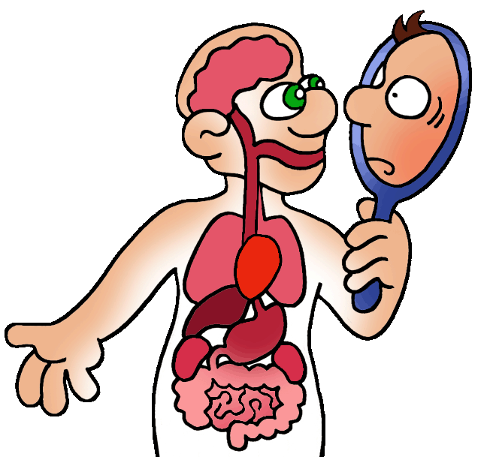
How will you be assessed?

Quiz
Mid Topic Test
Animal Comparison Research Task
Investigation
Final Topic Test

Homework Activities
In class work
Self/Peer/Teacher Evaluation
Note: See Assessment details in SEQTA

Week of Program/  Term | Content Covered
1 | - Recall that cells are the basic units of living things  - Recall the parts of a light microscope  - Calculate the magnification of a microscope  = ocular x objective magnification  - Define the field of view of a microscope  - Use a light microscope to examine a variety of cells
2 | - Distinguish plant cells from animal cells or fungal cells  - Identify the main structures within cells and describe their functions (nucleus, cell membrane, cytoplasm, ribosomes. Mitochondria, chloroplast)  - recognising that some organisms consist of a single cell  - Recall some examples of specialised animal and plant cells  - Recognise that cells reproduce via cell division (mitosis only)  - Describe the purposes of Mitosis
3 | - Understand that multicellular organisms have an organised hierarchy:  - Cells tissues organs systems  - Examining the specialised cells and tissues involved in the structure and function of particular organism  - Recall the main organs in the digestive system
4 | - Recall the main organs in the digestive system  - Describe the structure of these organs, relating their functions to the overall function of the system  - Compare the digestive system in different organisms (herbivores and carnivores)
5 | - Recall the main organs in the respiratory system  - Describe the structure of these organs, relating their functions to the overall function of the system  - Compare the respiratory system in different organisms (respiratory system in fish and mammals)
6 | - Recall the main organs in the cardiovascular system  - Describe the structure of these organs, relating their functions to the overall function of the system  - Can name chambers of heart, blood vessels attached to heart and order of blood flow  - Summarise how the three systems (digestion, respiratory and cardiovascular) are related and important in terms of survival:  - Glucose, Oxygen (respiration) ATP  - Transport to cells
7 | - Distinguish between sexual and asexual Reproduction  - Recall the types of asexual reproduction  - Define the terms: Life cycle, development, growth, metamorphosis, fertilisation, copulation, parental care  - Be able to label a life cycle (incomplete vs. complete)  - Be able to label the reproduction parts of a flowering plant  - Describe the process of pollination
8 | - Conducting investigations  - Identifying independent, dependant and controlled variables  - Writing a hypothesis  - Calculating an average  - Making observations  - Recording data in tables and graphs  - Analysing data  - Evaluating experiments (validity and reliability)
9 | - Revision of program content  - Final test preparation

Note: Teachers lesson schedules may vary due to school activities. Please check on SEQTA.

