Yr 9 Biology Worksheet – Maintaining balance - Coordination

- Identify which area of the brain is indicated by the star and state its function.

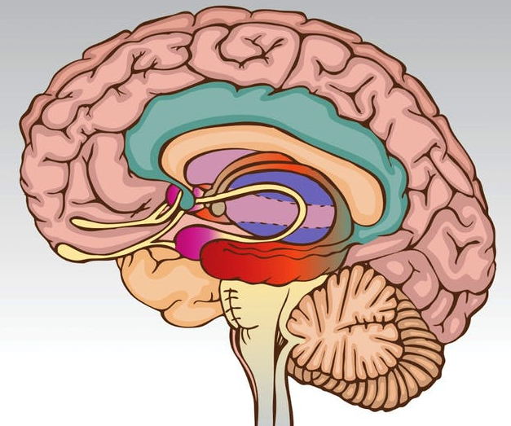

- Label the following neuron parts.

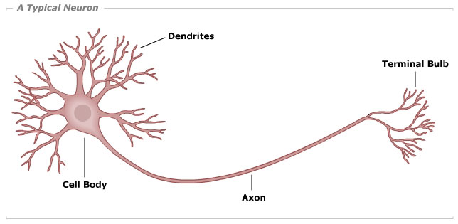

- What are three types of neurons?

- Label the following diagram of a stimulus-response model.

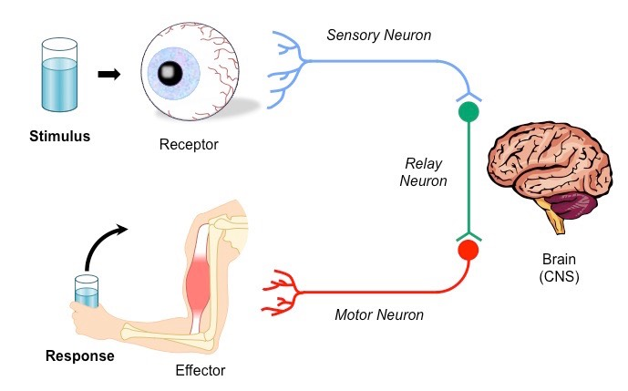
C

A
B
D

E

F
G
H

