REVISION PZ – DNA & INHERITANCE
1. INVESTIGATING SCIENTIFICALLY QUESTION (© VCAA 2017 – February 2017 BIOLOGY Written examination)
Question 9 The enzyme lactate dehydrogenase is found in a wide variety of organisms. It catalyses the conversion of both pyruvate to lactate and lactate to pyruvate. The bacterium Thermoanaerobacter ethanolicus lives in geothermal (hot) springs. The river buffalo (Bubalus bubalis) is a domestic animal common in Pakistan. Scientists studying the enzyme lactate dehydrogenase from these two organisms produced the following graphs.
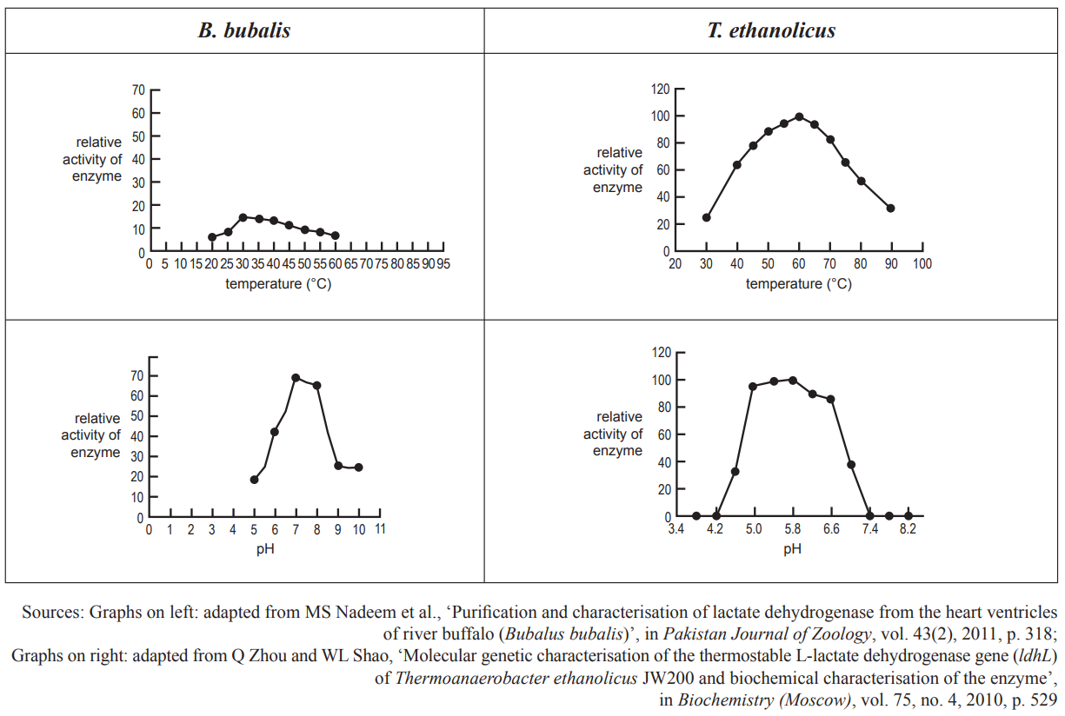
From the graphs, it is reasonable to conclude that the
A. optimum temperature at which the enzyme operates is higher in the bacteria than in the river buffalo
B. bacterial form of the enzyme would denature at temperatures below 60 °C
C. bacterial form of the enzyme has an optimum pH of 7.4
D. body temperature of a river buffalo is 40 °C

2. INVESTIGATING SCIENTIFICALLY QUESTION (© VCAA 2017 – February 2017 BIOLOGY Written examination)
Question 11 (9 marks)
Laura wanted to investigate the effectiveness of an antibiotic against the bacterium Escherichia coli. She
prepared five different concentrations of the antibiotic.
She wrote the following method:
1. Collect five agar plates containing nutrient agar.
2. Label each agar plate with the five different concentrations of the antibiotic.
3. Collect a sample of E. coli in a broth culture.
4. Put on a pair of disposable gloves.
5. Measure 0.5 mL of broth in a pipette and place in the centre of the first agar plate.
6. Spread the bacteria evenly over the agar plate with the spreader provided.
7. Place a drop of the antibiotic in the centre of the agar plate.
8. Close the lid of the agar plate and tape the lid to the bottom of the agar plate with sticky tape.
9. Repeat steps 6 to 8 with the other four concentrations of the antibiotic.
10. Place the agar plates on the side bench and leave overnight.
11. Wash your hands and dispose of the gloves.
a. What hypothesis is Laura testing with this experiment? 1 mark
b. Name the independent variable in this experiment. Justify your answer. 2 marks
c. Identify two sources of experimental errors in this investigation and suggest how the experimental
design could be changed to reduce the effect of these errors. 4 marks
d. Laura wanted to repeat the experiment to test the effectiveness of an antiviral drug against E.coli. She prepared five different concentrations of the antiviral drug and followed the same steps that she used for the antibiotic.
Explain the results that Laura would be expected to obtain.
3. (© VCAA 2017 – February 2017 BIOLOGY Written examination)
Question 1 The genetic code specifies 20 different amino acids that can form proteins. Which one of the following explains the functional diversity of proteins?
A. Protein denaturation may be reversible or irreversible.
B. Proteins have structural, enzymatic and signalling functions.
C. Numerous combinations of amino acids can form a variety of polypeptide chains.
D. Codons correspond to a specific amino acid or stop signal during protein synthesis.
Question 2 Which of the following correctly describes a difference between DNA and rRNA?

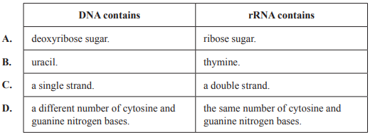
4. (© VCAA 2017 – February 2017 BIOLOGY Written examination)
Question 37 During a fight between a number of people, one was seriously injured. Blood samples were taken from the victim, the crime scene and four suspects. DNA was extracted from white blood cells in each of the blood samples and electrophoresis of the samples was carried out. The results are shown in the following diagram.
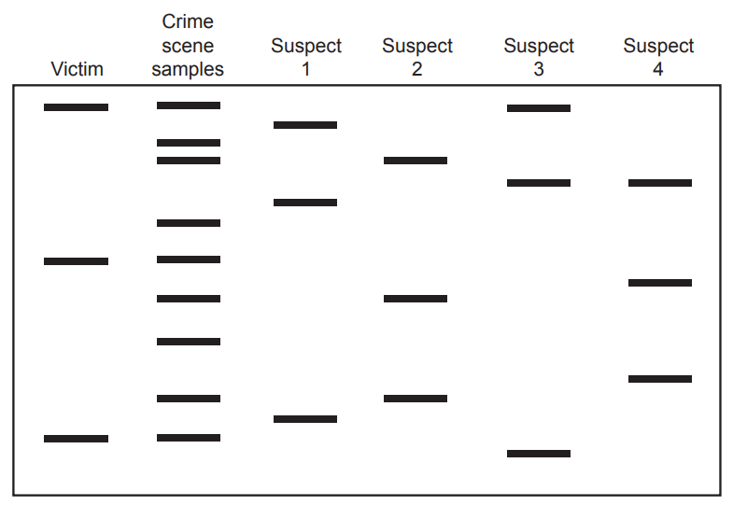
The person most likely to have been at the crime scene is
A. Suspect 1.
B. Suspect 2.
C. Suspect 3.
D. Suspect 4.

5. © VCAA 2017 – February 2017 BIOLOGY Written examination
Question 6 (12 marks) The prostate is a gland found in the male reproductive system. Prostate cancer represents the second most frequent type of tumour in men worldwide. The BRCA1 and BRCA2 genes that have been linked to breast cancer have also been linked to an increased risk of prostate cancer. A section of the normal BRCA2 gene and a section of a mutated BRCA2 gene are shown below
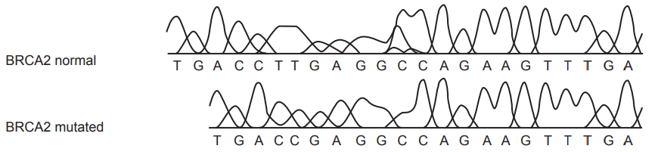

a. Transcribe both DNA sequences into mRNA. 1 mark
mRNA BRCA2 normal
mRNA BRCA2 mutated
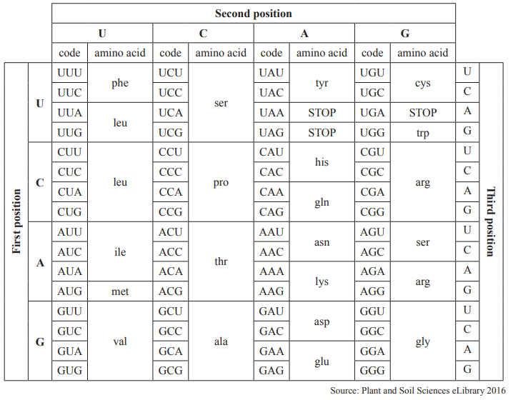
b. Using your answer to part a. and the codon table provided above, determine the amino acid sequence
coded by the nucleotide sequence on each segment of the mRNA strands. 2 marks
BRCA2 normal (amino acid chain)
BRCA2 mutated (amino acid chain)

c. Consider the mutation in the BRCA2 gene.
Explain any changes that may affect the function of the transcribed protein. 2 marks

Scientists have investigated prostate cells and mapped the interaction between the proteins expressed by
those cells in the hope of developing a quick and more accurate blood test to detect prostate cancer.
The scientists investigated the expression pattern in both healthy and cancerous prostate cells from more
than 100 individuals.
d. Explain the significance of using both healthy and cancerous prostate cells in the scientific study.
e. Why did the scientists collect healthy and cancerous prostate cells from more than 100 individuals? 2 marks
f. What is a neoplasm? Are malignant and benign tissues types neoplasms? If so, how are they the,
i. same?
ii different?
6. 2019 HSC Examination
Mod 5 – Question 2 A student constructed a model of meiosis as shown. However, there is an error in the model.
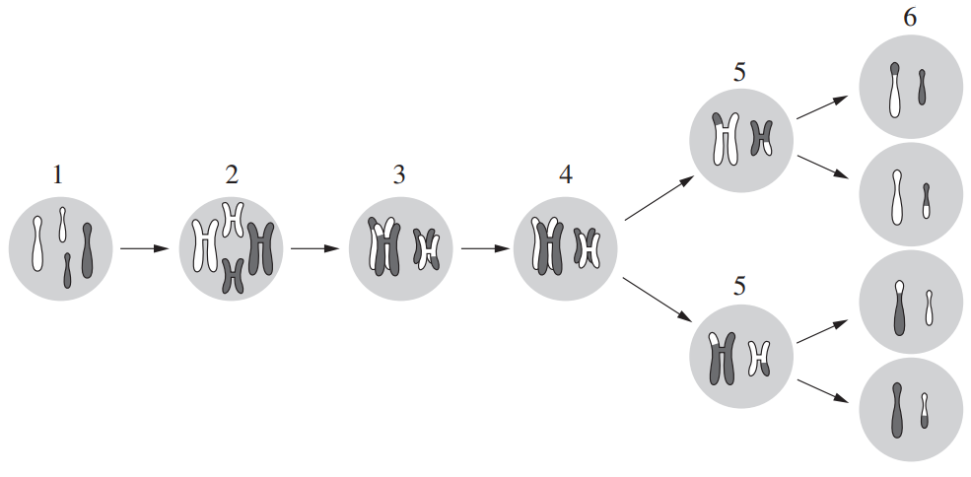
Which aspect of this model does NOT fit with observations of meiosis?
A. Separation of chromatids has not been shown in the model.
B. The chromosomes have not independently assorted in stage 2.
C. The chromosomes in stage 4 should have duplicated before stage 5.
D. The chromosomes have undergone crossing over before sister chromosome alignment in
stage 3.

7. Mod 5 – Question 4 The table shows the base triplets in mRNA for amino acids. From the table, the amino acid Tryptophan (Trp) can be coded for by the base triplet UGG.

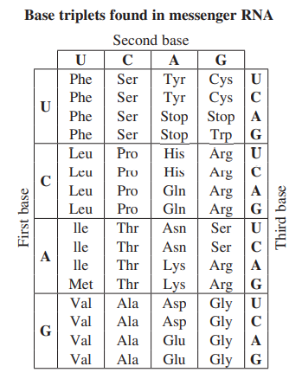
Which base triplet could code for the amino acid Arginine (Arg)?
A. AAU
B. GAC
C. GCC
D. CGG

8. Mod 5 – Question 5 A student completed a genetics exercise by preparing a Punnett square. T represents a dominant allele and t represents a recessive allele.
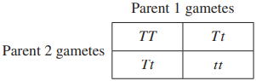
What were the likely genotypes of these parents?
A. Both parents were homozygous.
B. Both parents were heterozygous.
C. Parent 1 was homozygous, Parent 2 was heterozygous.
D. Parent 1 was heterozygous, Parent 2 was homozygous.

9. Mod 5 – Question 7
Colour blindness is a sex-linked recessive trait.
Susan is not colour-blind but her father is. Susan is married to James who is also not colour-blind.
Susan and James are expecting twins, a boy and a girl.
Which row in the table shows the probability of colour-blindness in the boy and the girl?
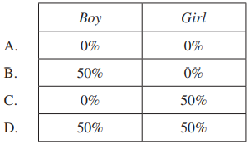
10. Mod 5 – Question 8 Haemophilia A is a blood clotting disorder that arises from a defect in the gene which is carried on the X chromosome. A couple is considering starting a family. However, the father suffers from Haemophilia A. The mother is healthy with no family history of the disease. What is the probability that a potential grandson will have Haemophilia A if they have a daughter who partners with an unaffected man?
A. 0%
B. 25%
C. 50%
D. 100%

11. Mod 5 – Question 9
It is suspected that a child has a recessive, sex-linked condition. An initial pedigree was
developed.
Which of the following is most likely to depict this initial pedigree?
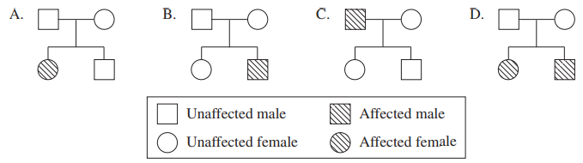

12. Mod 5 – Question 14 (5 marks) (a) Complete the following diagram to show the process by which gametes are formed.
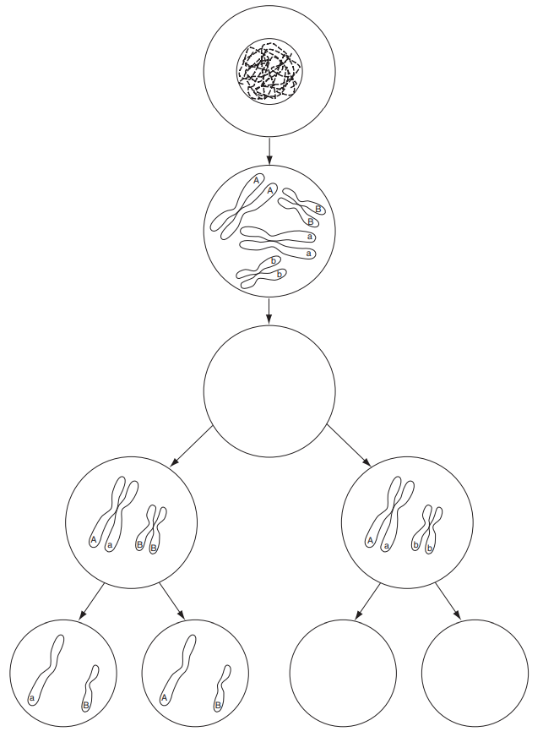

2019 HSC Examination
Question 14 (continued)
(b) How does the segregation of chromosomes during meiosis lead to a wide variety
of gametes being produced?

Complete the following image of the cell cycle
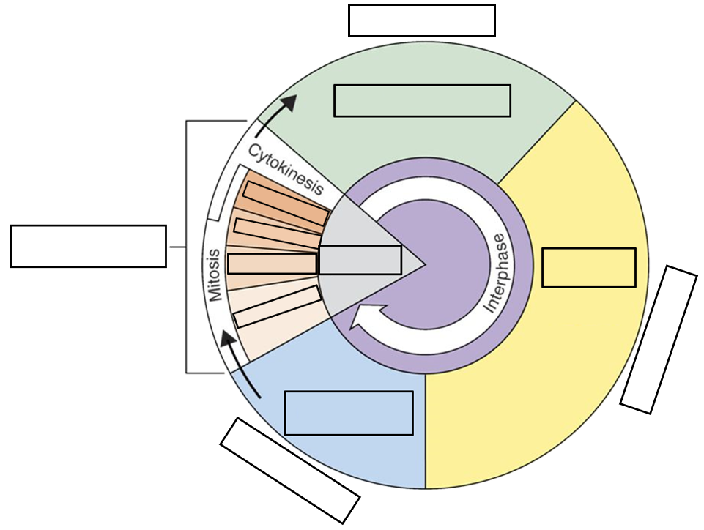
13. Mod 5 – Question 16 (5 marks)
A non-infectious disease was observed in a mother and her four sons who live with her. She has no daughters. The father of these children does not have the disease and does not live with them. The woman’s parents and her two sisters who live overseas do not have the disease.
A geneticist suspects that the disease is inherited.
(a) Draw the family pedigree for this disease.

(b) From the evidence, what indicates that the disease could be the result of a recessive allele and not be sex-linked?
14. complete each of the following word cloze sentences.
i. Commonly, _________ of histones leads to the silencing of genes.
Possible Answers:
acetylation, methylation, phosphorylation, All of these would silence the gene
ii. Which of the following best describes the mechanism by which histone acetylation results in increased transcription of a given chromosomal segment?
Possible Answers:
Acetylation removes methyl groups from the DNA sequence, thus relieving the repression that they induce on transcription.
Acetylation increases the interaction between the histones and the DNA strand; this conformation permits increased activation of polymerases.
Acetylation reduces the interaction between the histones and the DNA strand; this relaxed conformation permits increased interaction with transcriptional machinery.
Acetylation activates transcription factors near the histone; this permits increased transcriptional activity at a given locus.
Acetylation increases phosphorylation at crucial enhancer sites on the DNA sequence, thereby increasing transcription at those loci.
iii. Histones are proteins that bind to and order the DNA into tight clusters, making it inaccessible to transcription machinery. How does the cells loosen the interaction of the histone and DNA.
Possible Answers:
By adding acetyl groups to the DNA, By methylating the DNA, By adding acetyl groups to the histone,
By removing acyl groups from the histone, By adding methyl groups to the histone
15.
i. Say if the following variations are inherited or acquired.
(a) freckles _____________________________________
(b) the production of an enzyme _____________________________________
(c) the ability to play a musical instrument _____________________________________
(d) the ability to form a blood clot _____________________________________
(e) the ability to read _____________________________________
ii. Heredity is the passing on of features from one generation to another by means of ___________________.
iii. Genes are sections of ____________________________ on a _____________________, hich carry the code for the production of a protein.
iv. Gene _____________________________ is the way in which a gene produces a protein in a cell.

v. Characteristics are the result of the interaction of our __________________________ with our genes.
vi. All humans are members of the same ___________________, despite having many visible ______________.
vii. Non-coding DNA makes up about ________% of a chromosome and does not cause the production of a ____________________.
viii. Chimpanzees and gorillas form two different ______________________________ because they cannot successfully _________________________________ with each other.
ix. (a) Name the four bases found in DNA. ____________________, _________________,________________ and ____________________.
x. One strand of DNA has the base sequence ATTGC. Give the sequence of bases on the complementary strand of DNA. ___________________________________
xi. A _______________________________ is a sequence of three DNA bases that carries the code for a single ______ ___________________________.
xii. A section of a chromosome that causes the production of a protein is called a
___________________________. Sections of a chromosome that do not cause the production of any known product contain so-called _____________________ DNA.
16. Explain the three ways in meiosis and fertilization that produce variation in the offspring. (6 marks)
17. Use the following information to answer Questions 8 and 9.
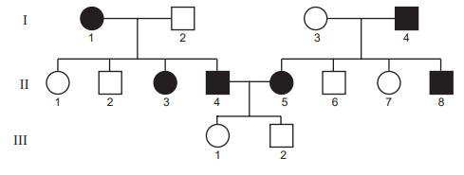

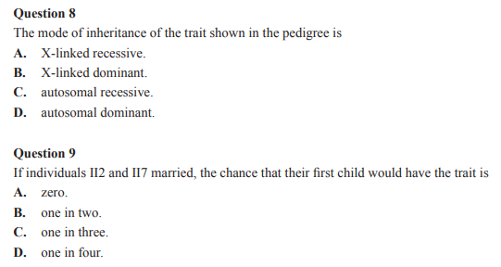
18.
Epigenetics - During Reading:
- Explain the relationship between genes, chromosomes and DNA.
- Do your genes determine everything about you? Name a few things about yourself that your genes don’t determine. (Hint: Think about where you live and who you spend time with and how these influence your life.)
- Do you know any identical twins? Are they exactly alike, or do they have some differences?
- What are methyl groups? How do they affect genes? How are they related to epigenetic changes?
- How did Jirtle’s team turn the Agouti gene on and off in the mice?
- List two differences between the baby mice with the Agouti gene switched on and the baby mice with the Agouti gene switched off.
- Describe the epigenetic changes that the daughters of fat rat dads inherited.
- List five things that can cause epigenetic changes.

19. What is epigenetics? Name three different epigenetic marks found in eukaryotic genomes and how each affects gene expression. And finally, explain why should epigenetics be of interest to you if you have a poor diet or if you smoke?
20. Fill in the following sentences.
i. __________ only occur(s) in the gonads to produce gametes. (Mitosis, Meiosis, Mitosis and meiosis, Sporogony, Schizogony)
ii. Which of the following is mitosis not used for? (Repair (of a wound) in multicellular organisms, Asexual reproduction in unicellular organisms, Development (e.g., baby in mother's womb), Production of gametes, All of the above use mitosis)
iii. During which stage of mitosis do the centromeres split? (Prophase, Interphase, Anaphase, Telophase, Synthesis stage)
iv. During which stage of mitosis does cytokinesis usually occur in animals? (Prophase, Metaphase, Anaphase, Telophase, Interphase)

v. What is the correct order of the stages of mitosis? 1-Metaphase 2-Telophase 3-Anaphase 4-Prophase
4,1,2,3
2,3,1,4
1,2,3,4
1,3,2,4
4,1,3,2
vi. During which stage of meiosis do the sister chromatids begin to move toward the poles? Prophase I, Telophase I, Anaphase II, Anaphase I, Telophase II
vii. During which stage of meiosis do tetrads line up at the equator? Metaphase I, Telophase I, Metaphase II, Anaphase II, Anaphase I
viii. In both mitosis and meiosis, sister chromatids seperate during anaphase, but there are _____ haploid daughter nuclei produced by meiosis compared to ______ diploid nuclei by mitosis. 6,3, 4,2 2,4 3,6 9,1
ix. During which stage of mitosis does the nuclear envelope begin to disappear? Metaphase I, Telophase I, Anaphase II, Prophase I, Metaphase II
x. When _______________ occurs between nonsister chromatids genetic exchange between chromosomes provides new combination of genes that are different from either parent. Cytokinesis, crossing-over, mitosis, cell division, centromeres splitting
21. Draw and fully label the steps in mitosis.
22. Complete the following table comparing mitosis and meiosis

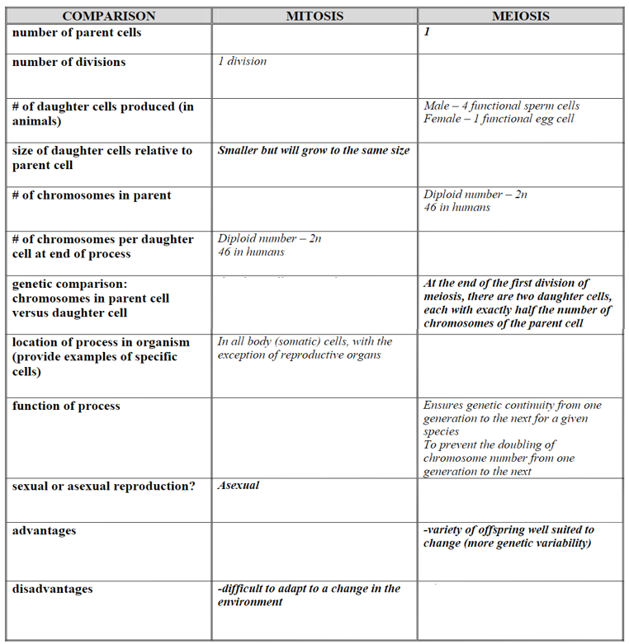

23.
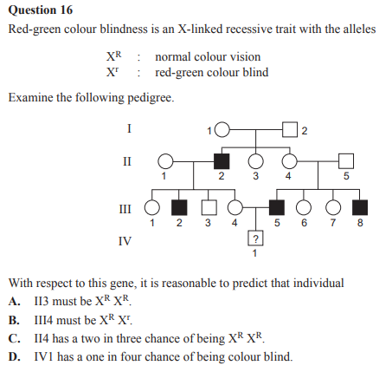
24. Practice questions for ABO blood types
i. In the ABO blood system, you normally can be type:
a) A
b) B
c) ABO
d) A, B, AB, or O
e) all of the above

ii. Which of the following statements is true regarding the ABO blood system?
a) People who have the A antigen normally would not produce the anti-A antibody.
b) People who are type AB normally produce both anti-A and anti-B antibodies.
c) The only ABO type blood that normally does not have either A or B antigens is AB.
iii. The universal blood donors for the ABO system are type:
a) A
b) B
c) O
d) AB

iv. Which of the following statements is true about the ABO blood system?
a) It was discovered in the 1950's.
b) It was discovered by Karl Landsteiner
c) Few people are actually typed for this system because of the difficulty of the procedure and high cost.
d) a and b

v. An individual's ABO blood type is normally determined by:
a) Genetic inheritance and environmental influences during life
b) Environmental influences alone
c) The inheritance of 1 of 3 possible alleles (A, B, or O) from each parent
vi. In determining the phenotype for the ABO blood system:
a) O is dominant over A
b) B is dominant over A
c) O is recessive
d) all of the above
vii. If one of your parents is blood type A and the other is type B, which of the following blood types would you likely be?
a) A
b) B
c) O
d) AB
e) any of the above
viii. Which of the following would be least likely to be accepted as legal proof of paternity?
a) ABO blood type evidence
b) HLA type evidence
c) DNA sequence evidence
d) all are equally likely to be accepted
ix. Which of the following statements is true?
a) Specific ABO blood types are known to be linked with increased or decreased susceptibility to particular diseases.
b) Antibodies to alien antigens in the ABO group may be present in one's body prior to the first contact with blood of a different ABO type.
c) When our blood comes in contact with blood of a different type, our bodies can develop long-term immunity to the alien blood type.
d) All of the above are correct.

x. Remember that pedigrees are diagrams of family relationships that illustrate how a particular trait is passed from person to person. Review the structure of pedigrees and then construct one from the following.
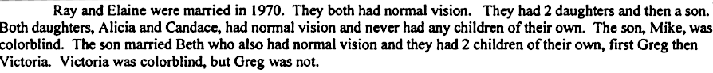

25. Work with your partner to analyze your pedigree and to determine blood type for John and Mona. You did not test their blood, but the pedigree will give you many clues. You may be able to narrow it down to just one blood type or you may find that there is more than one possibility. That is OK – take it as far as you can.
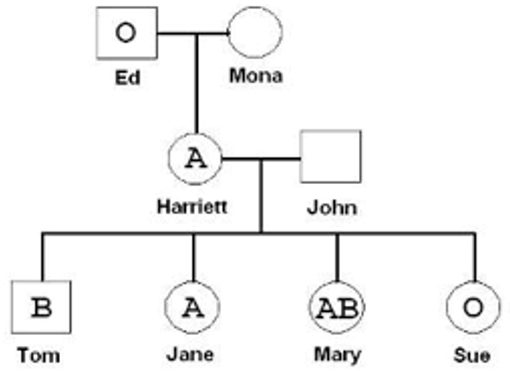
Questions
- Explain why a person who has AB blood is considered the universal recipient. Why can this person receive any other blood type?

- Explain why Jane cannot receive blood from her sister Mary but Mary can receive blood in an emergency from Jane.

- What happens when an antigen on a red blood cell comes in contact with the antibody designed to seek it out? Why would this be a bad thing?

- Explain how you were able to determine John’s blood type (phenotype.) What is John’s genotype?

- Explain why blood is classified as a type of connective tissue.

26. Explain how each of the following words relate to the picture below.
- Trisome
- Monosome
- Karyotype
- Homologous pairs
- Autosomes
- Sex-determining chromosomes
- Histones

