- Arrhenius acids and bases

Key points
- An Arrhenius acid is any species that increases the concentration of H⁺ in aqueous solution.
- An Arrhenius base is any species that increases the concentration of OH⁻ in aqueous solution.
- In aqueous solution, H⁺ ions immediately react with water molecules to form hydronium ions, H3​O⁺
- In an acid-base or neutralization reaction, an Arrhenius acid and base usually react to form water and a salt.

Introduction
From the vinegar in your kitchen cabinet to the soap in your shower, acids and bases are everywhere! But what does it mean to say that something is acidic or basic? In order to answer this question, we need to examine some of the theories describing acids and bases. In this article, we will focus on the Arrhenius theory.

Arrhenius acids
The Arrhenius theory of acids and bases was originally proposed by the Swedish chemist Svante Arrhenius in 1884. He suggested classifying certain compounds as acids or bases based on what kind of ions formed when the compound was added to water.

An Arrhenius acid is any species that increases the concentration of H⁺ ions—or protons—in aqueous solution. For example, let's consider the dissociation reaction for hydrochloric acid, in water:
HCl_{(aq)} → H⁺_{(aq)} + Cl⁻_{(aq)}
When we make an aqueous solution of hydrochloric acid, HCl dissociates into H⁺ and Cl⁻ ions. Since this results in an increase in the concentration of H⁺ ions in solution, hydrochloric acid is an Arrhenius acid.

Hydrogen or hydronium ions?
Let's say we made a 2 M aqueous solution of hydrobromic acid, HBr which is an Arrhenius acid. Does that mean we have 2 M of H⁺ ions in our solution?
Actually, no. In practice, the positively charged protons react with the surrounding water molecules to form hydronium ions, H3​O⁺. This reaction can be written as follows:
H⁺_{(aq)} + H2​O_{(l)} → H3​O⁺ _{(aq)}
Even though we often write acid dissociation reactions showing the formation of H⁺(aq) there are no free H⁺ ions floating around in an aqueous solution. Instead, there are primarily H3​O⁺ ions, which form immediately when an acid dissociates in water. The following picture illustrates the formation of hydronium from water and hydrogen ions using molecular models:
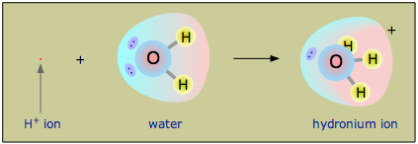
In practice, most chemists talk about the concentration of H⁺ and the concentration of H3​O⁺ interchangeably. When we want to be more accurate—and less lazy!—we can write the dissociation of hydrobromic acid to explicitly show the formation of hydronium instead of protons:
HBr _{(aq)} + H₂O_{(l)} → H₃O⁺ _{(aq)} + Br ⁻ _{(aq)}
In general, either description is acceptable for showing the dissociation of an Arrhenius acid.

Arrhenius bases
An Arrhenius base is defined as any species that increases the concentration of hydroxide ions, OH⁻ in aqueous solution. An example of an Arrhenius base is the highly soluble sodium hydroxide, NaOH. Sodium hydroxide dissociates in water as follows:
NaOH(aq)→Na+(aq)+OH−(aq)
In water, sodium hydroxide fully dissociates to form OH⁻ and Na⁺ ions resulting in an increase in the concentration of hydroxide ions. Therefore, NaOH is an Arrhenius base. Common Arrhenius bases include other Group 1 and Group 2 hydroxides such as LiOH and Ba(OH)₂.
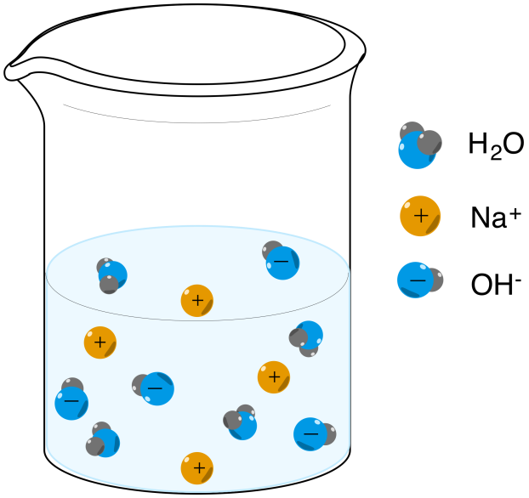
Note that depending on your class—or textbook or teacher—non-hydroxide-containing bases may or may not be classified as Arrhenius bases. Some textbooks define an Arrhenius base more narrowly: a substance that increases the concentration of OH⁻ in aqueous solution and also contains at least one unit of OH⁻ in the chemical formula. While that doesn't change the classification of the Group 1 and 2 hydroxides, it can get a little confusing with compounds such as methylamine, CH3NH2.
When methylamine is added to water, the following reaction occurs:
CH3​NH2​(aq)+H2​O(l)⇋CH3​NH3+​(aq)+OH−(aq)
Based on our first definition, methylamine would be an Arrhenius base since the OH⁻ ion concentration increases in the solution. By the second definition, however, it would not count as an Arrhenius base since the chemical formula does not include hydroxide.

Acid-base reactions: Arrhenius acid + Arrhenius base = water + salt
When an Arrhenius acid reacts with an Arrhenius base, the products are usually water plus a salt. These reactions are also sometimes called neutralization reactions. For example, what happens when we combine aqueous solutions of hydrofluoric acid HF and lithium hydroxide LiOH?
If we think about the acid solution and base solution separately, we know the following:
- An Arrhenius acid increases the concentration of H⁺_{(aq)}:
HF_{(aq)} ⇋ H+_{(aq)} + F⁻_{(aq)}
- An Arrhenius base increases the concentration of OH⁻ (aq):
LiOH_{(aq)} → Li⁺_{(aq)} + OH−_{(aq)}
When the acid and base combine in solution, H₂O is produced from the reaction between hydrogen ions and hydroxide ions, while the other ions form the salt LiF _{(aq)}:
H⁺_{(aq)} + OH⁻_{(aq)} → H2​O_{(l)} Formation of water
Li⁺_{(aq)} + F⁻_{(aq)} → LiF_{(aq)} Formation of salt
If we add the reactions for the formation of water and the formation of salt, we get our overall neutralization reaction between hydrofluoric acid and lithium hydroxide:
HF_{(aq)} + LiOH_{(aq)} → H2​O_{(l)} + LiF_{(aq)}

Limitations of the Arrhenius definition
The Arrhenius theory is limited in that it can only describe acid-base chemistry in aqueous solutions. Similar reactions can also occur in non-aqueous solvents, however, as well as between molecules in the gas phase. As a result, modern chemists usually prefer the Brønsted-Lowry theory, which is useful in a broader range of chemical reactions. The Brønsted-Lowry theory of acids and bases will be discussed in a separate article!

2. Brønsted-Lowry acid base theory

Key points
- A Brønsted-Lowry acid is any species that is capable of donating a proton—H⁺
- A Brønsted-Lowry base is any species that is capable of accepting a proton, which requires a lone pair of electrons to bond to the H⁺.
- Water is amphoteric, which means it can act as both a Brønsted-Lowry acid and a Brønsted-Lowry base.
- Strong acids and bases ionize completely in aqueous solution, while weak acids and bases ionize only partially.
- The conjugate base of a Brønsted-Lowry acid is the species formed after an acid donates a proton. The conjugate acid of a Brønsted-Lowry base is the species formed after a base accepts a proton.
- The two species in a conjugate acid-base pair have the same molecular formula except the acid has an extra H⁺ compared to the conjugate base.

Brønsted-Lowry theory of acids and bases
The Brønsted-Lowry theory describes acid-base interactions in terms of proton transfer between chemical species. A Brønsted-Lowry acid is any species that can donate a proton, H⁺ and a base is any species that can accept a proton. In terms of chemical structure, this means that any Brønsted-Lowry acid must contain a hydrogen that can dissociate as H⁺. In order to accept a proton, a Brønsted-Lowry base must have at least one lone pair of electrons to form a new bond with a proton.

Using the Brønsted-Lowry definition, an acid-base reaction is any reaction in which a proton is transferred from an acid to a base. We can use the Brønsted-Lowry definitions to discuss acid-base reactions in any solvent, as well as those that occur in the gas phase. For example, consider the reaction of ammonia gas, NH₃(g) with hydrogen chloride gas, HCl(g) to form solid ammonium chloride, NH4​Cl(s):
NH3​_{(g)} + HCl_{(g)} → NH4​Cl_{(s)}
This reaction can also be represented using the Lewis structures of the reactants and products, as seen below:
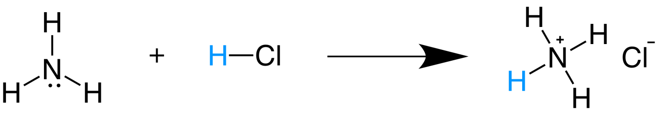
In this reaction, HCl donates its proton—shown in blue—to NH3. Therefore, HCl is acting as a Brønsted-Lowry acid. Since NH3 has a lone pair which it uses to accept a proton, NH3 is a Brønsted-Lowry base.
Note that according to the Arrhenius theory, the above reaction would not be an acid-base reaction because neither species is forming H⁺ or OH⁻ in water. However, the chemistry involved- a proton transfer from HCl to NH₃ to form NH₄Cl is very similar to what would occur in the aqueous phase.
To get more familiar with these definitions, let's examine some more examples.

Identifying Brønsted-Lowry acids and bases
In the reaction between nitric acid and water, nitric acid, HNO3 donates a proton—shown in blue—to water, thereby acting as a Brønsted-Lowry acid.
HNO3_{​(aq)} + H2​O_{(l)} → H3​O⁺_{(aq)} + NO3⁻_{​(aq)}
Since water accepts the proton from nitric acid to form H₃O, water acts as a Brønsted-Lowry base. This reaction highly favors the formation of products, so the reaction arrow is drawn only to the right.
Let's now look at a reaction involving ammonia, NH3 in water:
NH3​_{(aq)} + H2​O_{(l)} ⇌ NH4⁺_{​(aq)} + OH⁻_{(aq)}
In this reaction, water is donating one of its protons to ammonia. After losing a proton, water becomes hydroxide, OH⁻. Since water is a proton donor in this reaction, it is acting as a Brønsted-Lowry acid. Ammonia accepts a proton from water to form an ammonium ion, NH4⁺. Therefore, ammonia is acting as a Brønsted-Lowry base.

Strong and weak acids: to dissociate, or not to dissociate?
A strong acid is a species that dissociates completely into its constituent ions in aqueous solution. Nitric acid is an example of a strong acid. It dissociates completely in water to form hydronium, H3​O⁺ and nitrate, NO3⁻ ions. After the reaction occurs, there are no undissociated HNO3 molecules in solution.

By contrast, a weak acid does not dissociate completely into its constituent ions. An example of a weak acid is acetic CH3​COOH, which is present in vinegar. Acetic acid dissociates partially in water to form hydronium and acetate ions, CH3​COO⁻:
CH3​COOH_{(aq)} + H2​O_{(l)} ⇌ H3​O⁺_{(aq)} + CH3​COO⁻_{(aq)}
Notice that in this reaction, we have arrows pointing in both directions ⇋. This indicates that dissociation of acetic acid is a dynamic equilibrium where there will be a significant concentration of acetic acid molecules that are present as neutral CH3​COOH molecules as well as in the form of the dissociated ions, H⁺ and CH3​COO⁻.
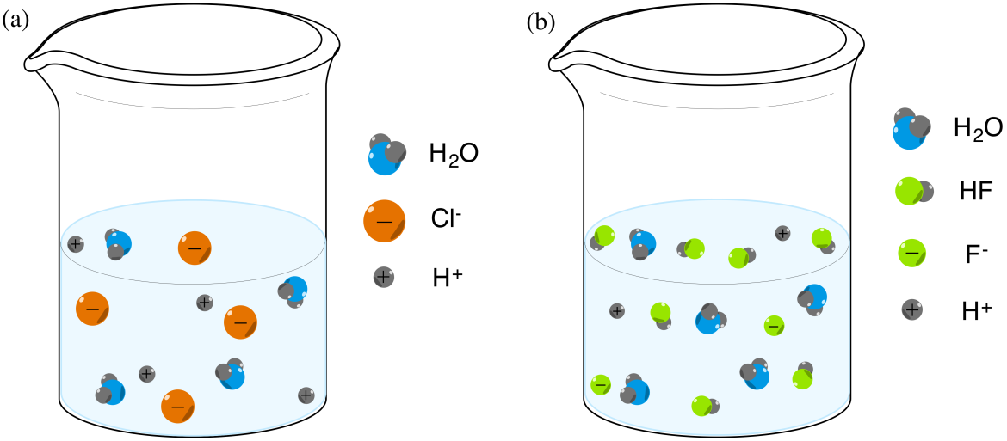

A common question is, “When do you know when something is a strong or a weak acid?” That is an excellent question! The short answer is that there are only a handful of strong acids, and everything else is considered a weak acid. Once we are familiar with the common strong acids, we can easily identify both weak and strong acids in chemistry problems.
The following table lists some examples of common strong acids.

Strong and weak bases
A strong base is a base that ionizes completely in aqueous solution. An example of a strong base is sodium hydroxide, NaOH. In water, sodium hydroxide dissociates completely to give sodium ions and hydroxide ions:
NaOH(aq) → Na+(aq) + OH−(aq)
Thus, if we make a solution of sodium hydroxide in water, only Na⁺ and OH⁻ are present in our final solution. We don't expect any undissociated NaOH.
Let's now look at ammonia, NH₃ in water. Ammonia is a weak base, so it will become partially ionized in water:
NH3​(aq) + H2​O(l) ⇌ NH4+​(aq) + OH−(aq)
Some of the ammonia molecules accept a proton from water to form ammonium ions and hydroxide ions. A dynamic equilibrium results, in which ammonia molecules are continually exchanging protons with water, and ammonium ions are continually donating the protons back to hydroxide. The major species in solution is non-ionized ammonia, NH3​ because ammonia will only deprotonate water to a small extent.
Common strong bases include Group 1 and Group 2 hydroxides.

