Energy Revision
Gravitational Potential Energy:

This is the energy an object has because of its mass, height above the ground and the force of gravity.

E_{p} = m x g x h
m = mass of object (kg)
g = acceleration due to gravity( g=10 m/s² on earth)
h = height above the ground(m)

Q1. 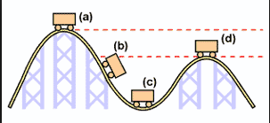

In which position will the potential energy of the rollercoaster

- be the greatest_____________________

- be the least____________________

Q2. In which position will the kinetic energy of the rollercoaster

- be the greatest_____________________

- be the least____________________

Q3. Explain why the rollercoaster track has to be the highest at the start of the ride.
______________________________________________________________
Q4. Write down the energy transfers that occur from {a d}
{a c } ________________ _______________
{c d } ________________ _______________
What forms of energy will the object possess at b?___________________
Q5. List two ways of increasing the potential energy of the rollercoaster.
a)
b)

Q6. Calculate the potential energy of a passenger in the rollercoaster at the
start of the ride, if the passenger has a mass of 50 kg and he is 10 m above the ground.(Extension question#)

Kinetic Energy
Kinetic energy is the energy an object has because of it’s mass and velocity(speed).
E_{k}= ½ mv²
E_{k} = kinetic energy(J)
m= mass (kg)
v= velocity (m/s)

Q7. Calculate the kinetic energy of a 2 kg rock that has fallen off a ledge and is travelling
at 20 m/s.
Q8.
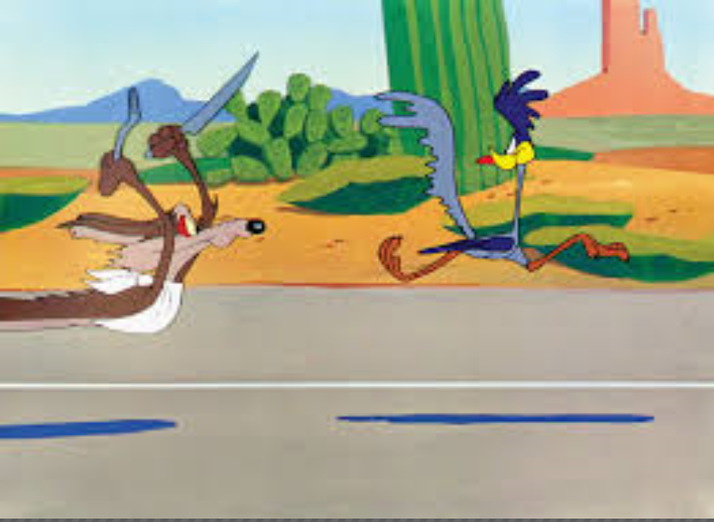
Which has more kinetic energy, the Road Runner or the Coyote?
Explain why.
Energy Revision

- What is Energy?
_______________________________________________________________________________________________________
- What is another name for stored energy? ________________________________.

- There are 3 main types of stored energy:
(a) ______________________ eg. a stretched rubber band, windup toy.
(b) ________________________ eg. candle (wax) is burning to give out light and heat
(c) Gravitational Potential energy. ________________________________________________________

- What is the unit for energy? ____________________________________________________________________

- How many joules in a kilojoule?

__________________________________________________
- Convert:
  - 6 kJ to J____________________
  - 40 kJ to J___________________
  - 0.04 kJ to J__________________
Convert
  - 30,000 J to kJ____________________
  - 400 J to kJ___________________

- How many joules in a mega joule?

____________
- Convert:
  - 3 MJ to J____________________
  - 16 MJ to J___________________

- How many kilojoules in a mega joule?

- Convert:
  - 12 MJ to kJ____________________
  - 20 MJ to kJ___________________
  - 14 000 kJ to MJ____________________
  - 7000 kJ to MJ___________________
Efficiency

Efficiency = Useful Energy Output x 100
Energy Input

11 (a) Calculate the efficiency of a torch that uses 600 J of chemical potential energy to produce 40 J of light energy.

(b) How much wasted energy is produced?

(c) What is the main form of wasted energy produced?

12. If a petrol engine of a car is 25 %, how much kinetic energy will it produce when it uses
a litre of fuel that contains 20 MJ of energy.

Energy Transformations

13. State the changing energy:
a) flashlight’s batteries
C __ __ __ __ __ __ __ energy
L __ __ __ __ energy
H __ __ __ energy

) b) talking on the phone
H __ __ __ __ energy
S __ __ __ __ energy
E __ __ __ __ __ __ __ __ __ energy

c) green plants undergo photosynthesis

S __ __ __ __ energy
C __ __ __ __ __ __ __ energy

d) Eating high energy food and drink, so that you can run faster.

