ELECTRON DOT DIAGRAMS – COVALENT BONDING

- no brackets are shown
- all valence electrons are shown to indicate the sharing of electrons between the non-metal atoms. The example below shows the electron dot diagram for an atom of fluorine and the electron dot diagram for two atoms of fluorine bonding together.

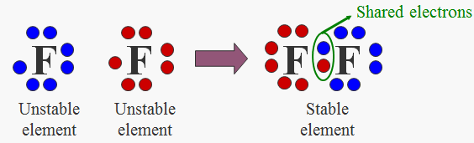

Rules for drawing electron dot diagrams of covalent compounds

- Find valence electrons in all atoms involved. Add them together.
- Find the octet electrons for each atom. Add them together.
- Subtract step 1 from step 2. This will give you the bonding electrons.
- Divide the number from step 3 by 2 (each bond is made up of 2e⁻).
- Subtract step 3 from step 1. This will give you the non-bonding or lone electrons.

Example 1 – draw the electron dot diagram for CCl₄.
- 4 +(7 × 4) = 32.
- 8 × 5 = 40.
- 40 – 32 = 8
- 8 ÷ 2 = 4 (4 bonds)
- 32 – 8 = 24 (12 non-bonding pairs of e⁻).
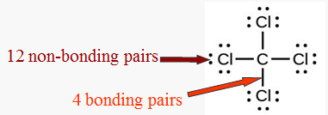

Example 2 – draw the electron dot diagram for SO₃
- 6 +(6 × 3) = 24.
- 8 × 4 = 32.
- 32 – 24 = 8
- 8 ÷ 2 = 4 (4 bonds)
- 24 – 8 = 16 (8 non-bonding pairs of e⁻).

There are actually 3 different ways of drawing SO₃. All are correct.

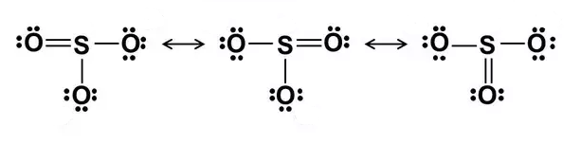

Your turn!

Draw the electron dot diagrams for the following covalent compounds

a. Br₂ | b. CO₂
c. H₂S | d. NCl₃
e. SiF₄  g. CH₄ | f. PH₃  h. C₂H₂

ELECTRON DOT DIAGRAMS – IONIC BONDING

- only show the valance electrons (electrons involved in bonding)
- Transfer of electrons is involved in ionic bonding.
- Brackets are drawn around the ions with charges shown.
- The example below shows the electron dot diagram for: an atom of sodium, an atom of chlorine and then the electron dot diagram for the two atoms bonded together forming sodium chloride.

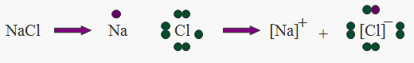
Electron dot diagrams of individual atoms

Formula of ionic compound
Electron dot diagram of ionic compound

Rules for drawing electron dot diagrams of simple ionic compounds

- Only show valence (outer shell) electrons
- Put ion in brackets and show charge on the ion
- Metals lose electrons to form positive ions, so dot diagrams show no valence electrons and a positive charge
- Non-metals gain electrons to form positive ions, so dot diagrams have full outer shell and a negative charge

Example 3 - draw the electron dot diagram for CaCl₂.

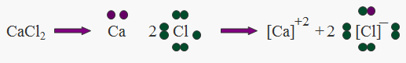

Rules for drawing electron dot diagrams of polyatomic ionic compounds

- For the polyatomic ion: Determine the number of valence electrons for each atom in the molecule and draw the dot diagram as if it were covalent BUT
  - SUBTRACT one electron (usually from the central atom) for each positive charge
  - ADD one electron (usually to the central atom) for each negative charge.
- Complete the remainder of the electron dot diagram as per a simple ionic.

Example 4 – draw the electron dot diagram for NaOH
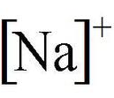
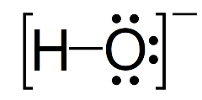
+
Your turn!

Draw the electron dot diagrams for the following simple ionic compounds

a. NaBr₂ | b. MgO
c. K₂S | d. AlCl₃
e. Fe₂O₃  g. Na₂CO₃ | f. MgF₂  h. Al₂(SO₄)₃

