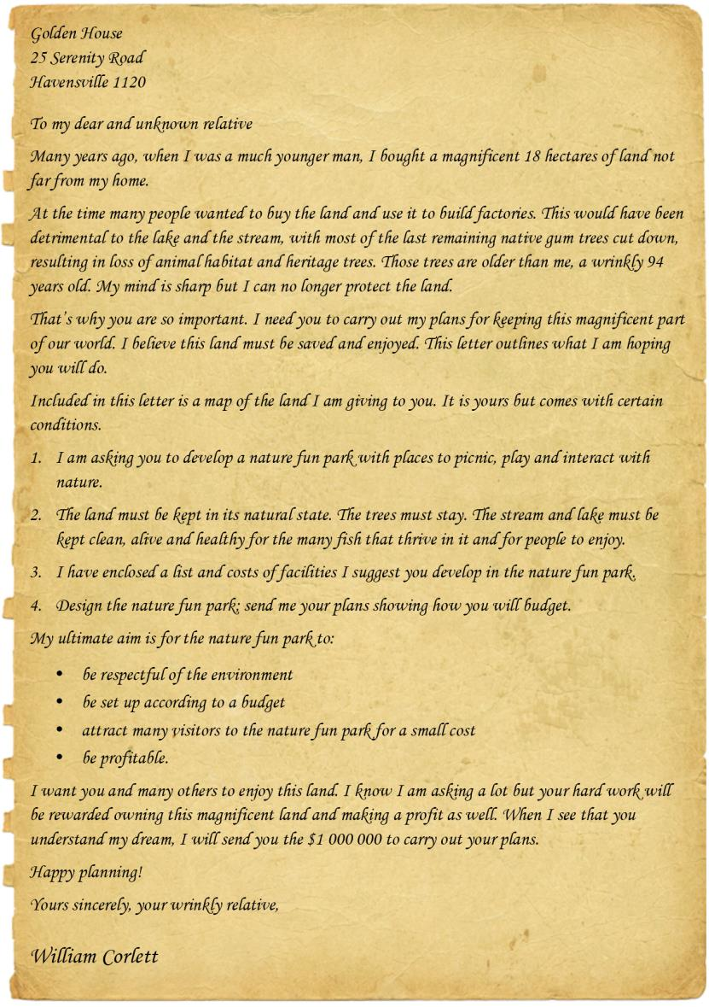
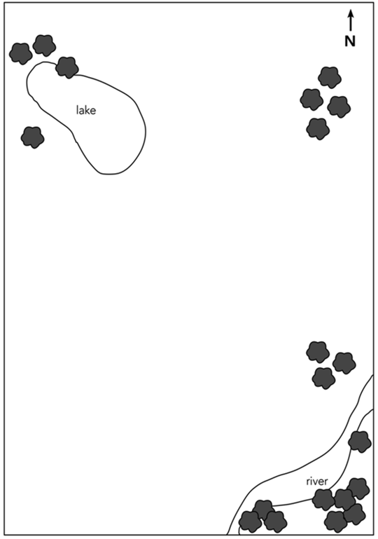

Facilities and costs
Suggested features of your nature fun park. You have a budget of
$1 000 000. You may also research your own costs of items to be built in the park.
Facility | Cost per item
Drinking fountain | $2 000
Bike rack (for 10 bikes) | $2 200
Bikes | $500
Seat | $750
Table (seats 8) | $3 000
Paddle boats | $2 500
Toilet block | $50 000
Covered picnic area with tables and seats | $9 950
Walking/bike trail | $350 per metre
Cafe/ticket office | $200 000
Parking area for 50 cars | $100 000
Playground | $200 000
Nature attraction (flying fox, maze, etc.) | $250 000
Other:
Other:
Other:
Other:

Budget sheet
Use this budget sheet to plan how much it will cost to include all the facilities in the nature fun park. You have a budget of $1 000 000.
Facility | Cost  per item | Number  of items | Total  cost
Drinking fountain | $2 000
Bike rack (for 10 bikes) | $2 200
Bikes | $500
Seats | $750
Table (seats 8) | $3 000
Paddle boats | $2 500
Toilet block | $50 000
Covered picnic area with tables and seats | $9 950
Walking/bike trail | $350  per metre
Cafe/ticket office | $200 000
Parking area for 50 cars | $100 000
Playground | $200 000
Nature attraction (flying fox, maze, etc.) | $250 000
Other:
Other:
Other:
Other:
Grand total
Check your calculations and whether all the facilities requested by William Corlett are included in the budget.

Income calculator
After you have designed your park you are going to work out how much income you can make if 100 people (in 25 family groups) – 40 adults and 60 children under 12 – visit on one day. They are all going to use all of the facilities. Extension - Include upkeep/running costs and accounting for them when working out income.
Attractions | Charge | Working-out column | Total for the 100 people
Basic entrance fee | $3 per adult  Children aged 12 and under free
1 x paddle boats | $2 per hour
1 x bike | $2 per hour
Use of covered picnic area | $5 per family
Use of walking/bike trail | $2 per family
Use of playground | $5 per family
The major environmental attraction | $5 per family
Total income

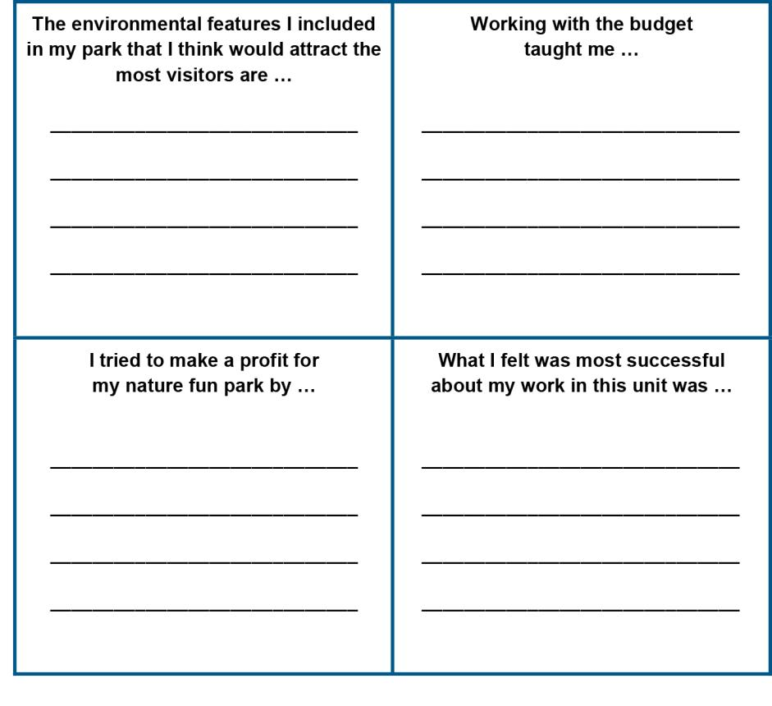
Reflection

