Year 10 Biological Sciences

Week 3 and 4 – Variation and Reproduction

Objectives:
Variation:
- Explain the importance of reproduction
- Distinguish between sexual and asexual reproduction and provide some examples of each
  - Difference between the number and variation of offspring produced.
  - Ability to cope with a changing environment.
- Outline advantages and disadvantages of asexual and sexual reproduction
Cellular Reproduction Process:
- Explain the general process, products and site of mitosis in plants and animals
  - Describe growth as an increase in cell size and number.
  - Describe asexual reproduction as result of mitosis. E.g. cloning of parent, identical genetic information.
  - Describe the stages of mitosis. (interphase, prophase, metaphase, anaphase, telophase and cytokinesis)
  - Outline the role of cell centrioles
- Recognise genetic information passed on to offspring is from both parents by meiosis and fertilisation
  - Explain the general process, products and site of meiosis in animals
  - Describe the role of gametes in sexual reproduction.
  - Distinguish between diploid and haploid number of chromosomes in somatic (body) cells and gametes.
  - Understand sexual reproduction requires the fusion of a male gamete and a female gamete (fertilisation), each containing genetic information that influences the offspring’s characteristics
  - Explain that meiosis produces greater variation due to random assortment of chromosomes, crossing over and random fusion of gametes.
  - Understand how non-disjunction results
    - Define ‘karyotype’ and understand they can be useful to identify possible genetic problems, e.g. down syndrome

Reproduction

Reproduction is essential to the continuation of a species. All living things reproduce to ensure that there are offspring to continue the species when the parents die. (nothing lives forever!)

Asexual reproduction involves a single organism that makes an exact copy of itself. There are different ways that organisms can reproduce via asexual reproduction.

- Binary Fission: Fission means splitting. A lot of unicellular organisms reproduce using this method. When conditions are appropriate the organism, such as Bacteria, simply splits into two. This then occurs again and again to create more and more cells. The cell division process of Mitosis is used for binary fission.
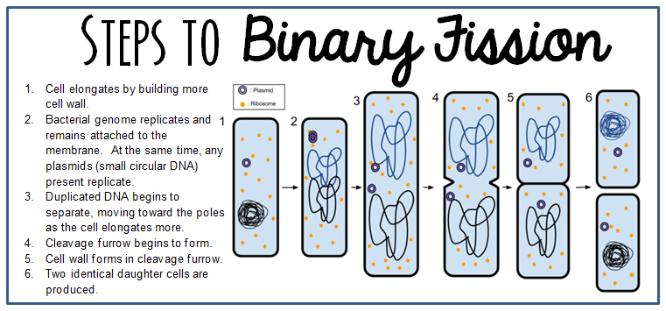

- Budding: This occurs when an organism grows a small bud-like growth which eventually separates and becomes a new individual. Hydra reproduce using this method.

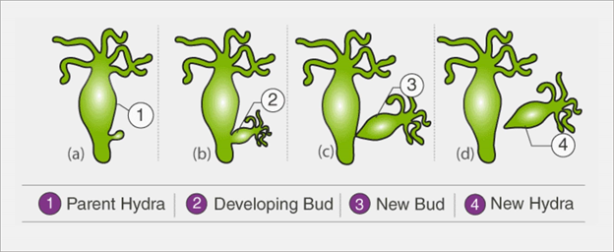

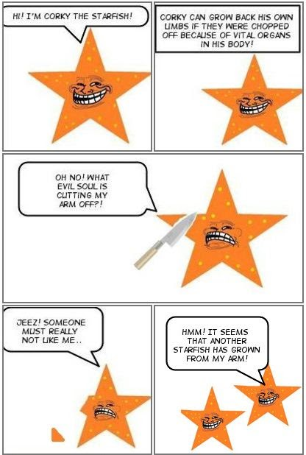
- Regeneration or Fragmentation: This is where a small piece of the organism breaks off and develops into a new organism. For example, a starfish can regenerate from a single arm! Cool hey!

- Vegetative Reproduction: is a term that refers to asexual reproduction by plants. There are a variety of different methods that plants use:
  - Spores: Mushrooms, moulds and ferns form tiny spores which can form a new plant if they land in a suitable environment.
  - Runners: Some plants such as grasses and strawberries send out shoots which grow roots which then develop into new plants.
  - Bulbs: Some plants grow from bulbs like daffodils and tulips.
  - Tubers: Some plants, like potatoes, grow from underground stems called tubers
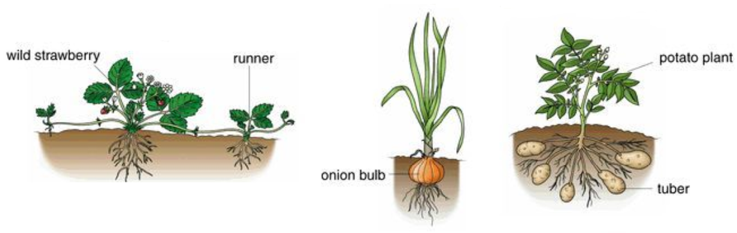
Sexual reproduction requires the fusing of two gametes or sex cells to make a fertilised cell called a zygote. In humans, the gametes are the ova from a female and sperm from a male. In flowers, the gametes are the pollen from the anther and the ova in the ovule of the flower.

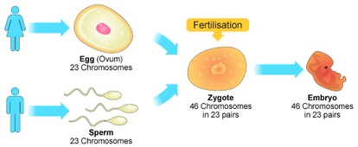

The following table outlines the advantages and disadvantages of asexual and sexual reproduction.

 | Asexual  Reproduction | Sexual  Reproduction
Advantages | - Only one organism required for reproduction  - Process requires less energy and is quick  - Large amounts of offspring may be produced in suitable conditions. | - Variation in species as a result of crossing over and random assortment during meiosis  - Has a greater chance of survival if environmental changes occur.
Disadvantages | - No genetic diversity – identical to parent cell  - Less chance of population survival if non suitable environmental changes occur | - Requires two sex cells in order for reproduction to take place  - Uses more energy and takes longer for the process to occur.  - Fewer offspring are produced

Mitosis

Mitosis is a cell division process where one somatic parent cell divides to form two genetically identical daughter cells. Mitosis occurs in every living cell of the body except for the sex cells and red blood cells.

Mitosis is an important process as it is used for:
- Growth
- Repair of damaged cells
- Replacement of old or dead cells
- Binary fission in simple organisms

The stages of Mitosis are as follows:

Stage | Picture | Description
Interphase |  | - The nucleolus and the nuclear membrane are clearly visible.  - The chromosomes duplicate and the copies remain attached to the original chromatid at the centromere.
Prophase | 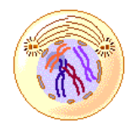 | - The chromosomes condense and become visible.  - The nuclear membrane begins to break down.  - The spindle begins to form which is produced from the centrioles in the cytoplasm.
Metaphase | 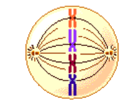 | - The chromosomes line up in the middle of the cell.  - Each chromosome is attached to the spindle at its centromere.
Anaphase | 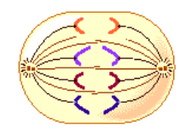 | - The chromatids of each chromosome are separated at the centromere.  - The spindle fibres pull each chromatid away to the opposite pole of the cell.
Telophase | 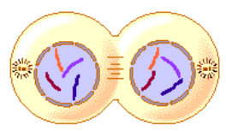 | - The nuclear membrane reappears around each set of chromosomes.  - The chromosomes spread out (become diffuse).  - The spindle begins to break down.
Cytokinesis | 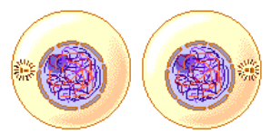 | - The cytoplasm divides the cell entirely into two identical daughter cells.

The process of mitosis results in two identical diploid cells (normal amount of chromosomes) forming from one identical diploid parent cell.
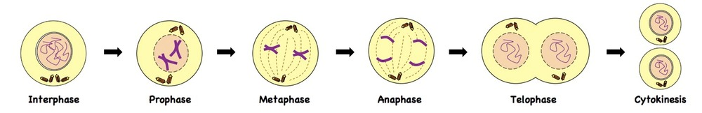

Meiosis

Meiosis is a cell division process which results in the formation of gametes (sex cells) and occurs in the sex organs (ovaries and testes in humans). Gametes in humans (sperm and egg cells) contain 23 chromosomes. This is half the number of chromosomes of a somatic cell and as a result gametes are referred to as haploid cells.

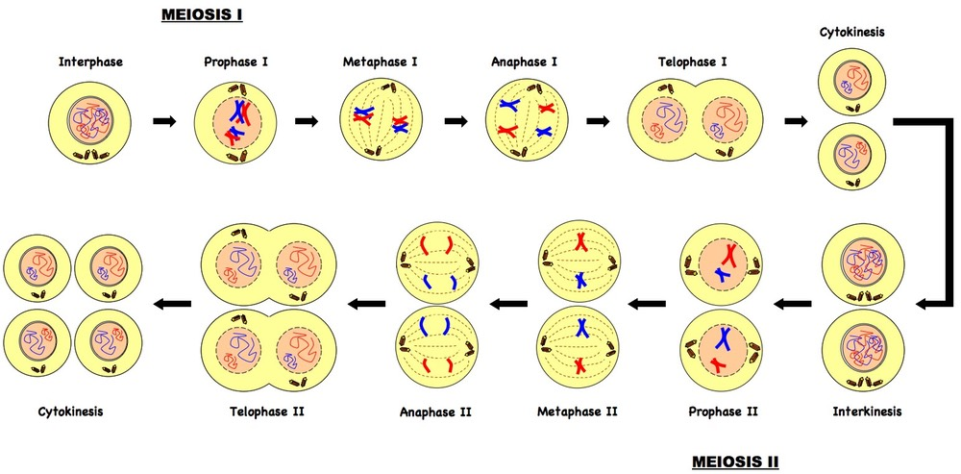

One male and one female sex cell then combine during fertilisation to create a zygote (fertilised cell). This results in a new somatic cell containing varied genetic information to both parent cells. We receive information for each trait (gene) from both our mother and our father. Alleles are alternate forms of a gene. For each gene we receive one allele from our mother (contained in the egg) and one from our father (contained in the sperm).

Alleles from our mother are known as Maternal alleles and alleles from our father are known as Paternal alleles.

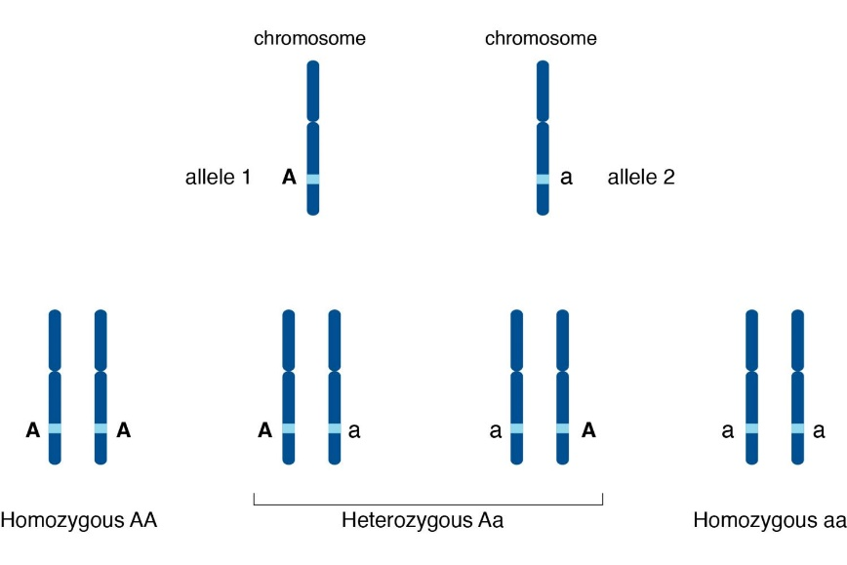

Meiosis increases variation in a species in a number of ways:
- Crossing over
- Random assortment
- Random fusion of gametes
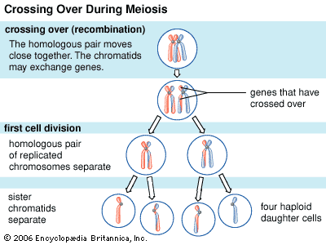
Crossing over occurs between prophase 1 and metaphase 1 in meiosis where homologous chromosomes exchange alleles (codes for particular genes) causing a recombination (rearrangement) of genetic information on each homologous chromosome.

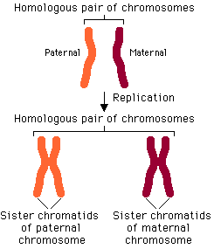
Homologous chromosomes are a matching pair of chromosomes Each chromosome in a homologous pair is of similar length and has similar gene position and centromere location.
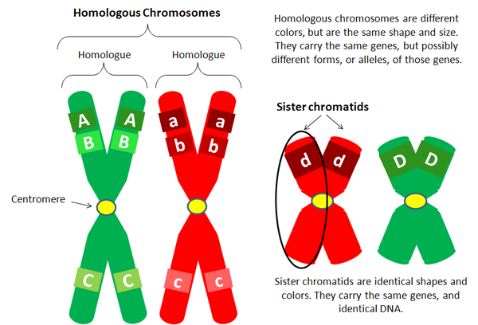

After the second division in meiosis, the sister chromatids separate and 4 recombinant chromosomes result. This increases genetic variation as a different combination of alleles for each gene is represented in each gamete.

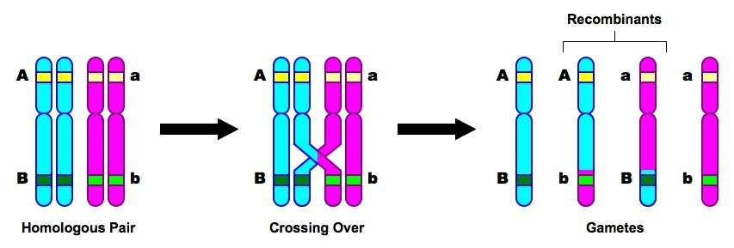

Random assortment of chromosomes occurs when homologous chromosomes are paired up and separated (metaphase and anaphase 1) to form two haploid cells. The separation is random – meaning that not all maternal and paternal chromosomes are separated into the same cell.
This increases genetic variation as a different combination of alleles for each gene is represented in each gamete.

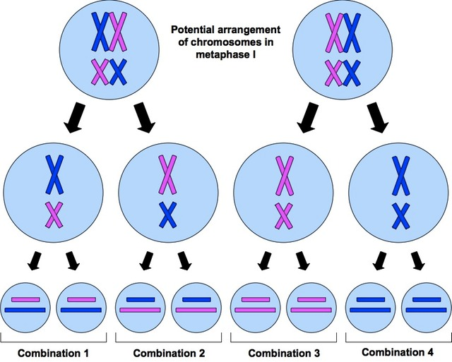

When fertilisation occurs one sperm is responsible for fertilising an egg. Semen contains millions of sperm. Each sperm (gamete) contains a random assortment of chromosomes (as does each egg that is released). Once the sperm are deposited inside the female, each sperm has an equal chance of fertilising the egg (the race is on!!). This is known as random fusion of gametes and is responsible for increasing genetic variation.

When meiosis goes wrong….

Non disjunction is the failure of homologous chromosomes or sister chromatids to separate correctly during anaphase 1 or 2. This results in an abnormal amount of chromosomes in the resulting daughter cells. A daughter cell (gamete) can either have too many or too few chromosomes.
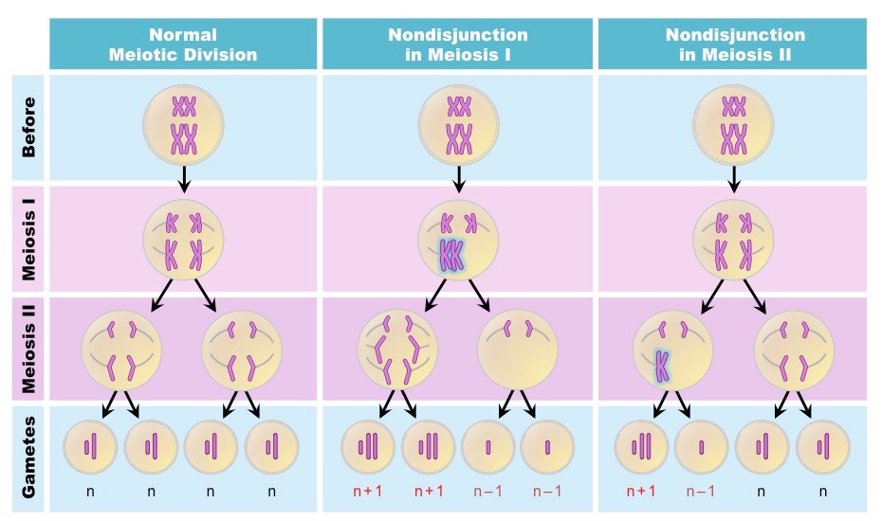

Non disjunction can be seen in karyotypes. A karyotype is a picture showing the number, size and shape of chromosomes in an organism. The karyotype below shows Trisomy 21. This is where nondisjunction has occurred to produce a third 21st chromosome which results in the genetic disorder Down Syndrome.

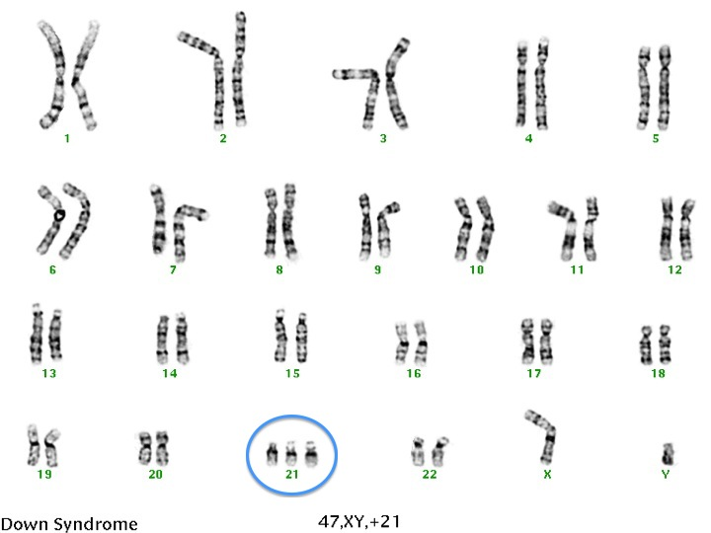

Bibliography

Binary Fission image https://www.pinterest.com.au/pin/825636544158691874/?autologin=true
Budding image
https://www.vedantu.com/biology/budding
Regeneration image
http://mitosisdhoffmann.blogspot.com/2011/10/starfish-regeneration-comic.html
Asexual Reproduction image
https://www.pinterest.com.au/pin/488077678340392805/?lp=true
Mitosis images
https://www.pinterest.com.au/pin/413486809512696842/?lp=true
http://www.vce.bioninja.com.au/aos-3-heredity/cell-reproduction/mitosis.html

Questions

- Why is reproduction important?

- Compare and contrast asexual and sexual reproduction with the use of examples.

- Describe the process of Mitosis

- How does Meiosis differ to Mitosis? (You might like to draw a table outlining the key differences)

- Describe the different ways that sexual reproduction can increase the variation in a species.

