WHAT IS INSURANCE?

Insurance distributes a possible loss among a large number of people. Insurance is intended to cover financial losses that occur because of accidents or unexpected events.

Purchasing Insurance
- To buy insurance, the purchaser must have insurable interest: Be able to show that the loss of the person or item covered by the insurance would result in a financial loss to him/herself.
- A person must apply, fill out an application, and if accepted, they will be issued a policy: Formal written agreement between the purchaser and the company.
- Policies identify the:
  - insurer – company issuing the policy
  - insured – person buying the policy, also called the policyholder

Terms
- Claims – Requests for payments that cover financial losses.
- Premium – Fee charged for the protection the policy provides over a specific time period Premiums are used to:
  - Pay claims
  - Store reserves for large disasters or catastrophic events
  - Earn income through investments for the company
  - Generate profits
- Deductible – Amount the policyholder must pay first before the company pays.

The cost of insurance
The level of risk involved is the main factor determining the amount of the premium. The greater the risk, the higher the premium will be.
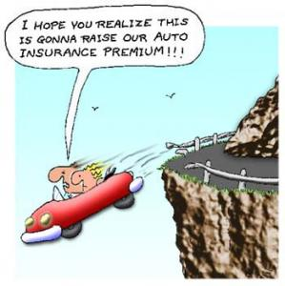
Examples of types of insurance
- Car
- Health
- Home and contents
- Life
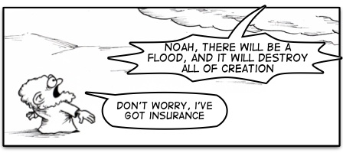
- Travel

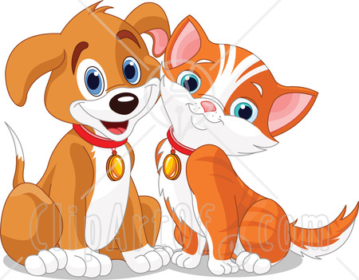
Pet Insurance Task

You and your group will be starting a pet insurance business. You sell insurance to pet owners to help pay for medical expenses and death expenses. People love their furry friends and are willing to pay money to make sure they get the best treatment and life possible. Make sure to advertise your insurance so that you stand out from your competition. You must decide the following:
- What will your premium be for five ​different animals?
- What type of guidelines have to be met in order to qualify for insurance? (create at least two)
- What type of exclusions will you have? (create at least two)
- How much will your coverage include?
- What is the deductible?
- What type of discounts will you offer?

Create a poster to advertise your pet insurance.

