Year 9 Chemistry: Types of Chemical Reactions

Name:_________________________

Acid and Base Neutralisation Reaction
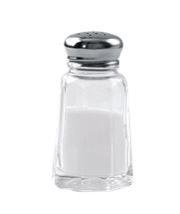
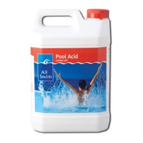
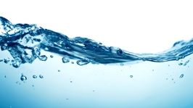
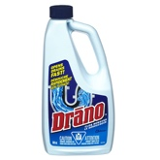

Acid + Base Salt + Water
e.g: HCl + NaOH NaCl + H₂O

Acid and a Reactive Metal
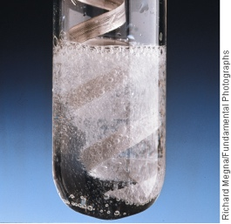
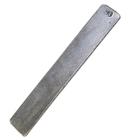

Acid + Metal Hydrogen Gas + Salt
e.g: H₂SO₄ + Mg H₂ + MgSO₄

Acid and a Metal Carbonate
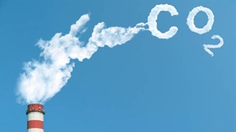
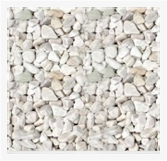
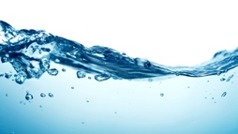

Acid + Metal Carbonate Carbon Dioxide + Salt + Water
e.g: 2HNO₃ + CaCO₃ CO₂ + Ca(NO₃)₂ + H₂O

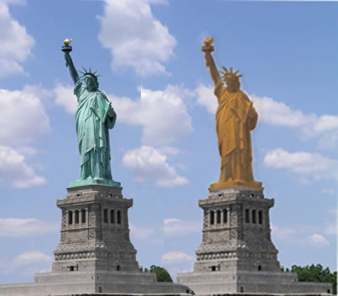
Metal and Oxygen (Oxidation of Metal)

Metal + Oxygen Metal Oxide
e.g: 2Cu + O₂ 2CuO

Non- Metal and Oxygen (Non-Metal Oxide)
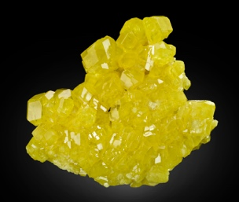
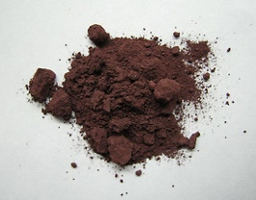

Non- Metal + Oxygen Non-Metal Oxide
e.g: C + O₂ CO₂

Hydrocarbon and Oxygen (Combustion)
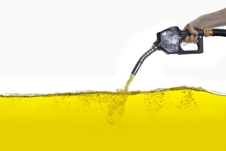

Hydrocarbon + Oxygen Carbon Dioxide + Water
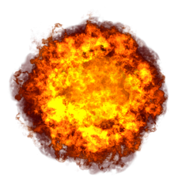
and releases Energy!

e.g C₅H₁₂ + 8O₂ 5CO₂ + 6H₂O

