~ THE MUSCULAR SYSTEM ~ Chapter 11
General functions & Properties:

~ MUSCLE TISSUE TYPES ~

Functions
& Control

Appearance

Location/s

Muscle  Type | Skeletal | Cardiac | Smooth
~ SKELETAL MUSCLE STRUCTURE ~

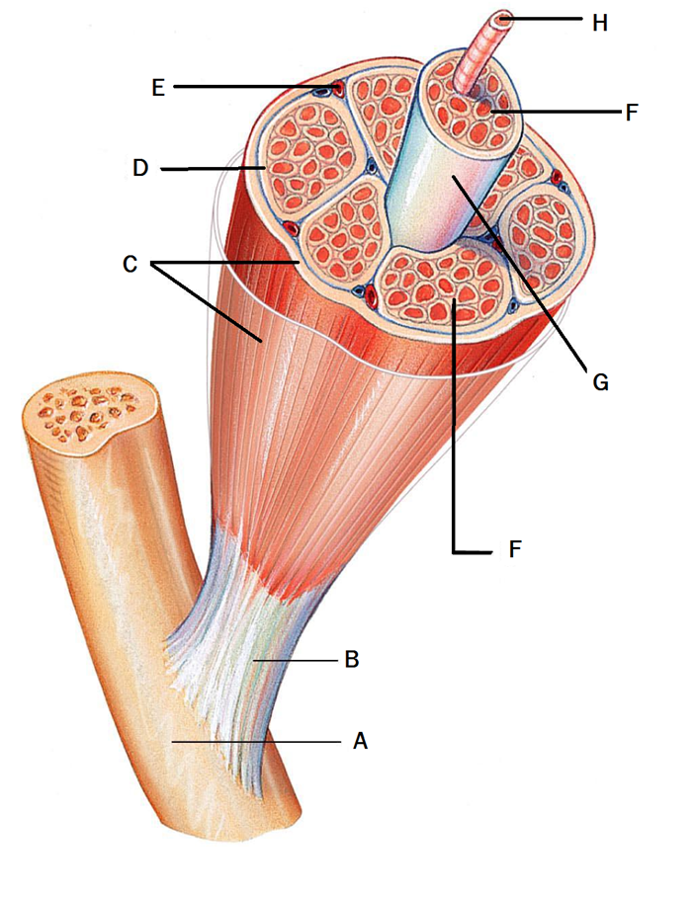

https://www.studyblue.com/notes/note/n/chapter-7/deck/12388264
Letter | Name of structure | Description / Function
A
B
C
D
E
F
G

H

MUSCLE FIBER (MICROSCOPIC) STRUCTURE

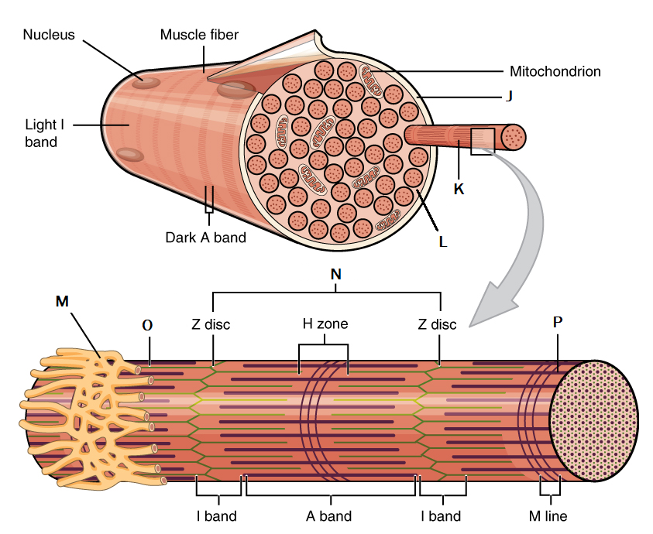

https://opentextbc.ca/anatomyandphysiology/chapter/10-2-skeletal-muscle/
Letter | Name of structure | Description / Function
J
K
L
M
N
O
P

SARCOMERE STRUCTURE

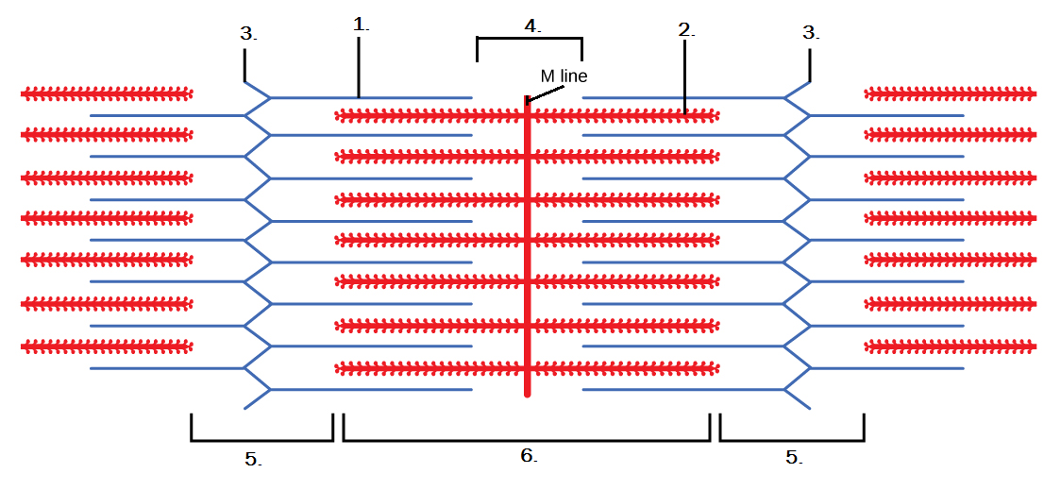

http://archive.cnx.org/contents/b7c9b702-b46c-435e-bea3-eee85ed940b4@6/muscle-contraction-and-locomotion
RELAXED:

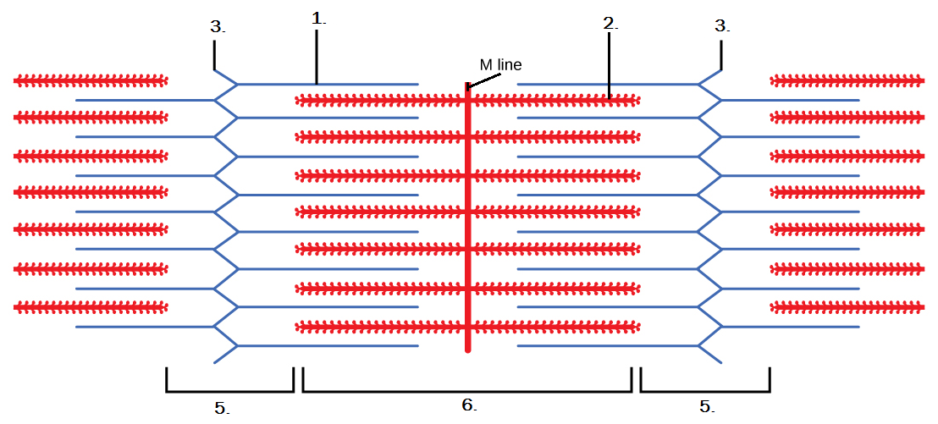

CONTRACTED:

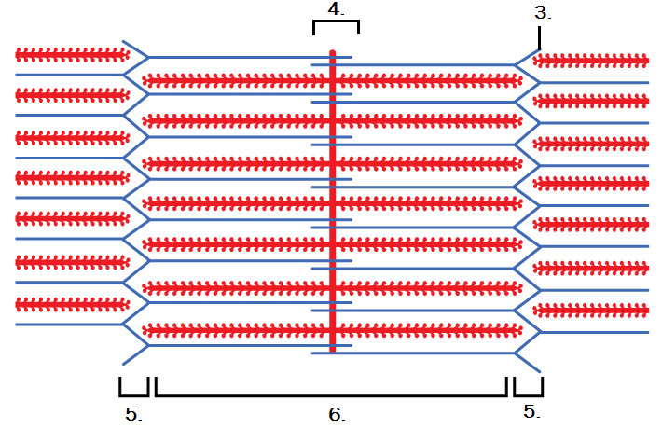

SLIDING FILAMENT MODEL

1.

2.

3.

4.

5.

NOTE:

~ WORKING MUSCLES ~
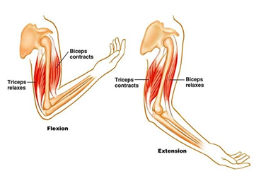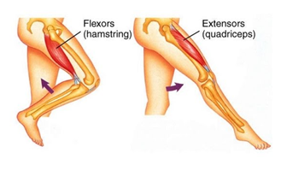
Describe how muscles work in pairs.

Define the following terms:
Antagonist
Agonist / Prime Mover
Origin
Insertion
Tendon
Synergist
Fixator
Muscle Tone

