Human Perspectives ATAR Units 3 & 4

Worksheet 5.3 Homeostasis of body temperature

Using Chapter 5 of Human Perspectives ATAR Units 3 & 4, complete the following activities.

1 Define the term ‘thermoregulation’.
2 List the body’s heat inputs and outputs.
3 Explain, using diagrams, the following types of heat transfer:
a conduction

b convection

c radiation.

4 Explain why people shiver when they get cold.
5 Compare and contrast vasodilation and vasoconstriction.
6 Draw a feedback system to demonstrate the mechanisms involved in thermoregulation when the environmental temperature drops.

7 Explain how shivering can increase heat loss.

8 Name the structures shown in the diagram that are involved in the regulation of body temperature. For each of the structures you have named, explain how it is involved in temperature regulation.
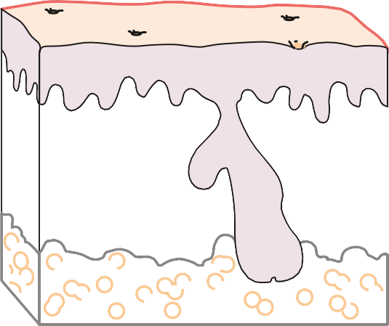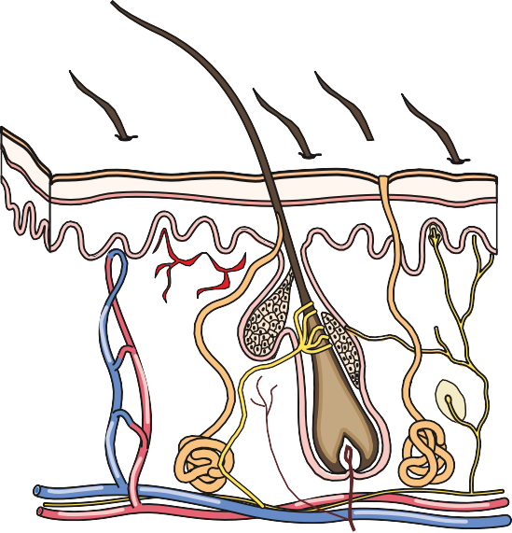
9 Describe how, in hot conditions, the body can decrease heat production.
10 Describe how, in hot conditions, the body can increase heat loss.

11 Draw a steady state control system to demonstrate the mechanisms involved in thermoregulation when the environmental temperature rises.

12 What is the difference between hyperthermia and hypothermia? Why are both of these conditions dangerous?

