7.5 The respiratory system exchanges gases

Student worksheet answers (pages 124–125)

The respiratory system
1 What is the function of the respiratory system?
To give the cells in your body the oxygen they need, and to remove carbon dioxide
2 What is cellular respiration and why is it important?
The process that releases energy from glucose, and requires oxygen; most of the food we eat is broken down to glucose, so the energy must be released from the glucose via cellular respiration
3 Describe the path that oxygen takes through the mouth and into the blood.
Through the mouth/nose to the pharynx, then through the oesophagus, trachea, lungs and alveoli, then into the blood
4 What is the structure and function of alveoli?
They are air sacs within the lungs that are covered in capillaries and transport oxygen into the blood
5 Why do capillaries cover each alveolus?
Capillaries are very small and are able to wrap closely around the alveolus, allowing for better gas exchange
6 Why do some capillaries appear to be red and others appear to be blue?
Red = oxygenated blood; blue = deoxygenated (carbon dioxide-rich) blood
7 What is the structure and function of the diaphragm?
A dome-shaped muscle that lifts the rib cage to allow the lungs to fill with air and deflate
8 Explain the movement of the diaphragm when inhaling and exhaling.
While inhaling, the diaphragm relaxes up to allow lungs to inflate
While exhaling, the diaphragm contracts down to squeeze air out of the lungs, allowing deflation
9 What is the function of the ring of cartilage that surrounds the trachea (windpipe)?
It acts as structural support to keep the windpipe open and protect it against damage
10 Label the following diagram of the respiratory system.
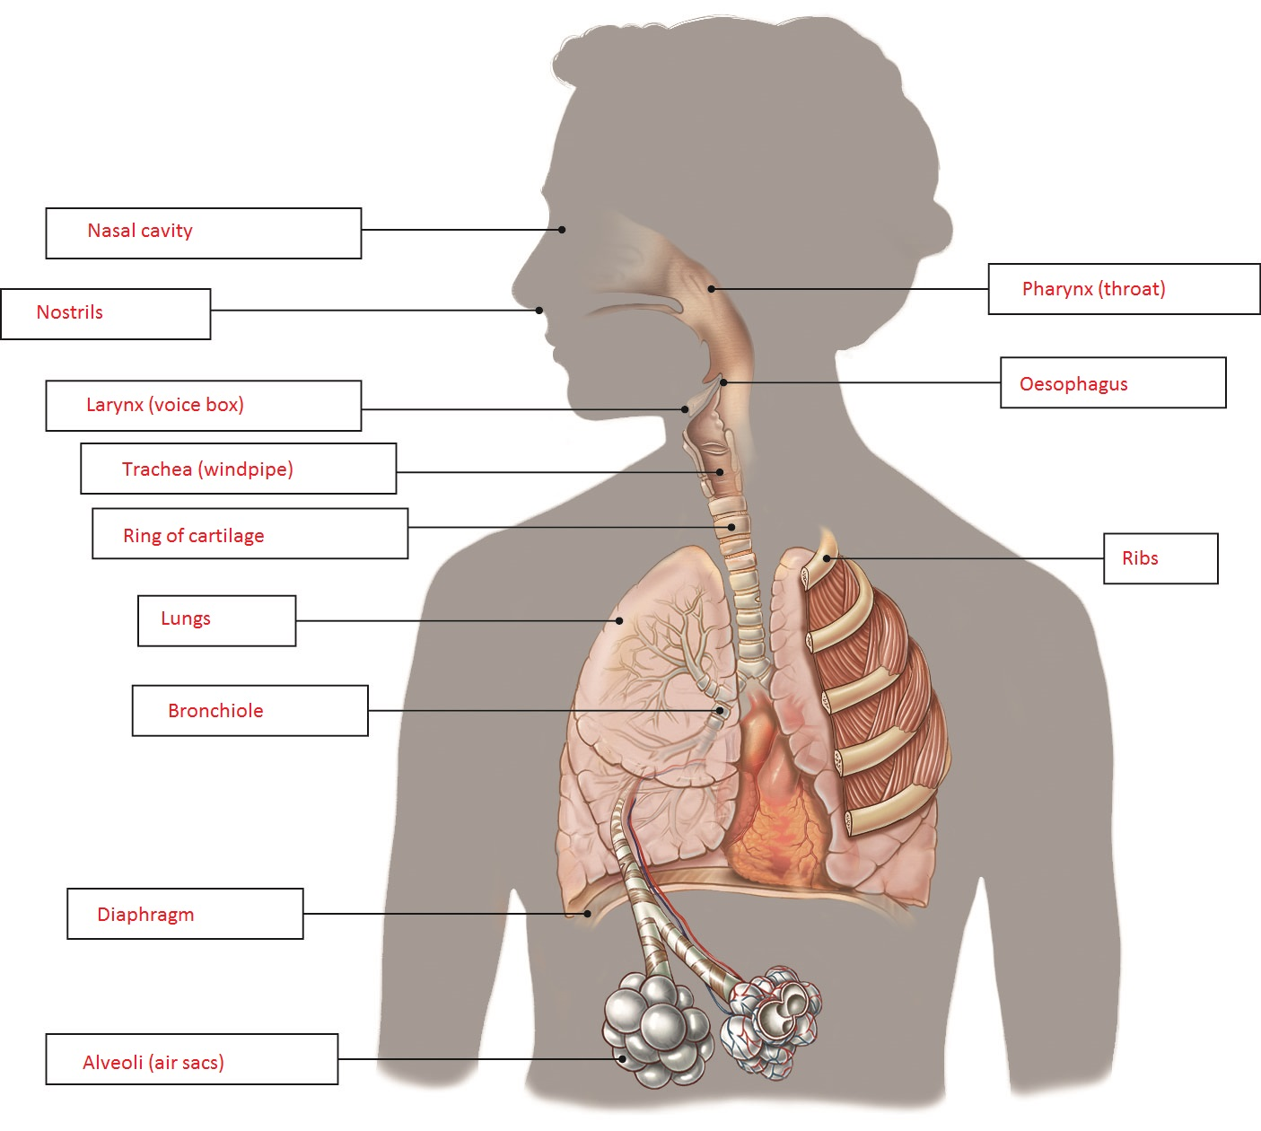

Extend your understanding
Plants have an alternative system of exchanging gases.
11 Why is the plant exchange of gases called respiration rather than breathing?
The term ‘breathing’ is used for respiration with lungs; respiration refers to an exchange of gases

12 What is the name of the process that plants use to convert carbon dioxide into sugars? Write an equation for this process.
Photosynthesis
CO₂ + H₂O → C₆H₁₂O₆ + O₂
13 Which gas do plants use in this reaction, and which gas is released as waste?
Carbon dioxide is used in photosynthesis; oxygen is released as waste
14 What is the name of the organ within a leaf where this process occurs?
Chloroplast
15 What is the name of the pigment that is necessary for this process and what colour is it?
Chlorophyll; green
16 Why are plants green?
They are green due to the chlorophyll in chloroplasts where photosynthesis occurs

