Year 11 Human Biology: Chapter 13 Review

1. The following diagram represents a short segment of DNA.
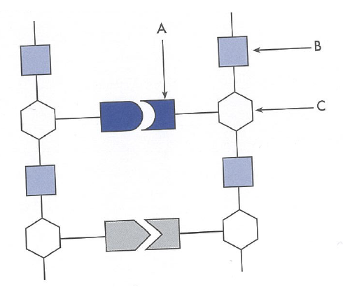
Name the substances labelled A, B and C.

A:

B:

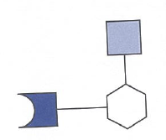
C:

2. Nucleic acids are broken down into these smaller units called: _________________________

3. Using the following diagram:
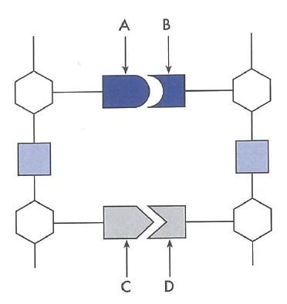

If A is cytosine, then B is ___________________________

If C is thymine, then D is ___________________________
4. If there are 30 adenine bases in the sequence how many thymine bases would there be? ____________________

5. Briefly explain why the sequence of nitrogenous bases in DNA is important.

6. Earlier this term you identified that a function of the nucleus is to control the functioning of the cell. Using your knowledge of DNA, explain this more in detail.

7. Use diagrams in the box below that show clearly the difference between the following terms: DNA, Gene, Chromatin, Histone, Chromosome and Centromere.

8. DNA is also found in the mitochondria. Complete the table below for the two types of DNA.
 | Nuclear DNA | Mitochondrial DNA
Location
Structure/Shape
Bound by proteins? Yes/no
Function/importance
Inheritance

9. Why is nuclear DNA bound by histones?

10. When cells reproduce (mitosis and meisosis) the DNA in the nucleus replicates.

(a) Outline why it replicates.

(b) describe the process of DNA replication (you may wish to use images to assist)

11. The other type of rucleic acid is Ribonucleic Acid, use the table below to outline the similarities and difference between DNA and RNA.

 | DNA | RNA
Differences
Similarties

12. RNA is involved in the production of proteins, which play important roles in the body. Give five examples of proteins found in the body.

13. There are three types of RNA are listed below. Distinguish between them.

Messenger RNA (mRNA)

Transfer RNA (tRNA)

Ribosomal RNA (rRNA)

13. Define the following the terms (you may wish to use images to assist)

(a) Codon

(b) Anticodon

(c) Amino acid

(d) peptide bond:

(e) Protein:

14. Protein synthesis is the process that builds proteins from small amino acids and requires energy (ATP).

(a) Outline the site for protein synthesis: ______________________________

(b) This process occurs two steps. These are Transcription and Translation. Describe in detail what occurs in each of these steps.

Transcription:
Translation:

15. If the DNA in the nucleus has the following sequence, outline the mRNA codons that are made and the tRNA anticodons:

DNA sequence: A T T – C G A – T A G – C T C – G G A

mRNA codons:

tRNA anticodons:

16. Although protein synthesis seems complicated it occurs very quickly. How quickly does it take a ribosome to make a protein, consisting of 400 amino acids? ___________________

17. The following table is used to determine the specific amino acids based on the mRNA codon. Determine the amino acid for the following mRNA codons:
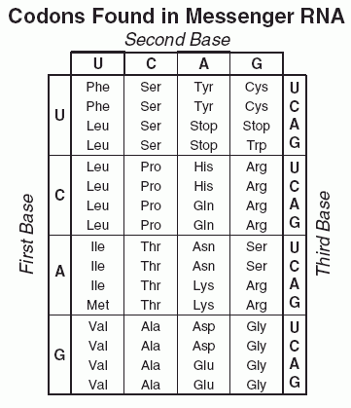
(a) A U G: ____________

(b) G G C: ____________

(c) U U A: ______________

(d) C A G: ____________

18. Identify the structures/processes shown in the diagram below:

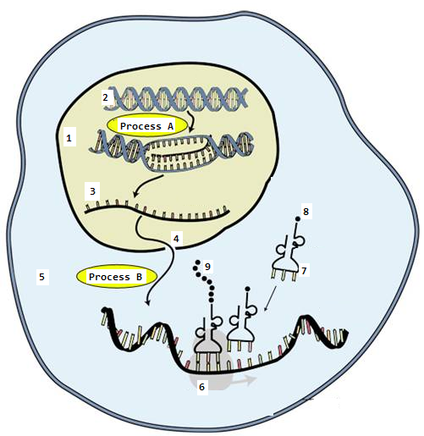

19. What determines how long an amino acid chain will be?

20. Are lipids and carbohydrates made in the same way? Describe why or why not.

21. Gene expression is the process of copying information from DNA onto mRNA and then translating the message into a series of amino acids to form a protein. Thus the genes contain instructions for making mRNA.

The specific genes that are used to make mRNA are said to be ‘switched on’ and a gene that is not used is said to be ‘switched off’. There are many factors that determine whether a gene is expressed (whether it is on or off).

(a) Outline some examples of factors that can affect gene expression:

(b) Why is gene regulation/expression usually ‘turned off’ most of the time? What advantage does this have?

22. Define Epigenetics

23. What is the difference between a person’s Genome and Epigenome?

24. Two epigenetic factors that can affect gene expression are Acetylation and Methylation. These factors do not change the DNA, they interfere with transcription and/ or translation, which changes the way proteins are produced by the cell.

Complete the table below for these factors.

 | Histone modification / Acetylation | Methylation
Description of what is happening
(you may wish to use an image to assist)
The effect on gene expression

25. A person’s epigenome can be influenced or changed by exposure to certain environmental stimuli. Provide two examples to show how this is so.

26. Why are identical twins often used to study/explain epigenetic differences?

