Student worksheet answers

7.9 Energy is always conserved
Pages 172–173

Conservation of energy
1 What is the law of conservation of energy?
Energy is always conserved.
2 Which two types of energy are harnessed by a pendulum?
Gravitational potential energy and kinetic energy
A student of mass 60.0 kg went bungee jumping during her holidays. The bridge from which she jumped was 250 m above a river. She was attached to a bungee cord that had an unstretched length of 150 m. You can assume that the student and the bungee cord are part of an ideal energy-conversion system. This means that no energy is 'lost' to the environment as heat or sound.
Figure A shows the student just before she jumps off the bridge.
Figure B shows the student a short time later when she has fallen a distance equal to the unstretched length of the bungee cord.
And Figure C shows the student when the bungee cord has reached its maximum length and the student is momentarily stationary.
 | 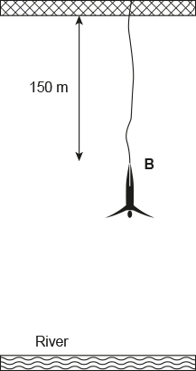 | 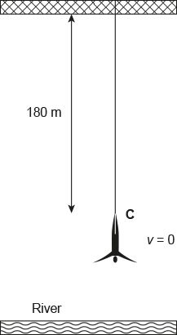
A | B | C
3 At which point is the bungee jumper likely to experience the most kinetic energy?
B
4 At which point is the bungee jumper likely to experience the most elastic energy?
C

5 What was the student’s gravitational potential energy at point A as shown in Figure 1? Provide your answer in joules. (Remember: GPE = mass × gravity × height)
m$=60.0 kg$, $g=9.80 m s^{-2}$, $h=250 m$
$$GPE=mgh$$
$$=60.0×9.80×250$$
$$=147 000 J$$
Note: At point A, the bungee cord is not stretched, so there is no elastic potential energy and because the bungee jumper is not moving, there is no kinetic energy. So the bungee jumper’s total energy will be 147 000 J.
6 How much elastic potential energy is stored in the bungee cord when the student has fallen 180 m and reached point C as shown in Figure 3? Give your answer in joules.
At point C, the bungee jumper’s total energy will still be 147 000 J. As the bungee cord has now stretched and the bungee jumper is stationary, the bungee jumper has gravitational potential energy and elastic potential energy.
$m=60.0 kg$, $g=9.80 m s^{-2}$, $h=250-180=70 m$, $v=0 m s^{-1}$
$$E_{\text{TOTAL}}=\text{KGPE}+\text{EPE}$$
$$147 000=60.0×9.80×70+EPE$$
$$147 000=41 160+\text{EPE}$$
$$EPE=105 840 J$$

Extend your understanding
A pendulum, as shown in Figure 1, is known to have an efficiency of 95% on each swing.
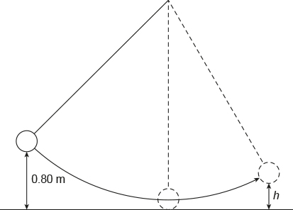
Figure 1
7 To what height, h, would the pendulum bob rise after a single swing if it was being released from a height of 0.80 m as shown? Give your answer in metres.
$$\text{Efficiency (\%)}=\frac{\text{useful energy out}}{\text{energy in}}×\frac{100}{1}$$
$$95=\frac{m×g×h}{m×g×0.80}×\frac{100}{1}$$
$$0.95=\frac{h}{0.80}$$
$$h=0.95×0.80$$
$=0.76 m$
8 How far below its release height of 0.80 m would the pendulum bob be after its return swing? Give your answer in metres.
$$E\text{fficiency (\%)}=\frac{\text{useful energy out}}{\text{energy in}}×\frac{100}{1}$$
$$95=\frac{m×g×h}{m×g×0.76}×\frac{100}{1}$$
$$0.95=\frac{h}{0.760}$$
$$h=0.95×0.76$$
$$=0.72 m$$

