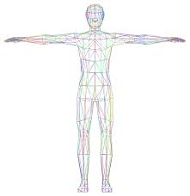
Year 11 Human Biology
Study Checklist
Please note: This checklist is to be used as a guide only. The information in this checklist does not reflect the full syllabus.

Topic 3: Cellular Metabolism
- Define metabolism, catabolism and anabolism. Provide examples of catabolic and anabolic reactions
- Describe cellular respiration, include defining the balanced chemical equation that represents it
- Describe the synthesis and role of ATP and how it acts as the energy currency of a cell
- Describe the ways in which cells utilise energy
- Compare and contrast aerobic and anaerobic metabolism, including:
  - Reactants
  - Products
  - Location
  - ATP yield
  - Oxygen debt

