Ancient Egypt
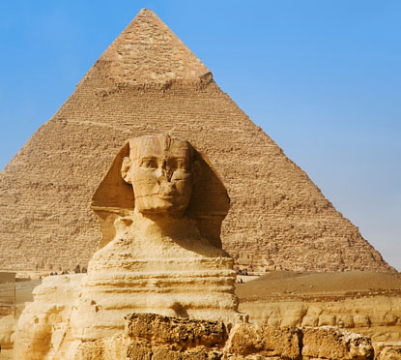

Today,
You become the Egyptologist

Egyptologist are people who have chosen to strictly study Egypt and its history. One of the most interesting parts of their job is the archaeological digs that have uncovered many great artifacts of Ancient Egypt. Also, the fact that there so many discoveries still yet to be made. Click on the link and go to the section titled "Lost Souls." Read through this section with your partner and come up with 3 questions based on what you read related to the content.

http://www.pbs.org/wgbh/nova/ancient/missing-tombs-pharaohs.html

Question 1:

Question 2:

Question 3:

When I was in Berlin this summer I had the privilege of viewing the "Bust of Nefertiti" in the Museum of Natural History along with a number of other artifacts from Ancient Egypt. Here are a couple of photos. Describe 2 things that stand out to you below each photo (these are considered your initial observations) and one possible conclusion you might reach based on the photo.

1.
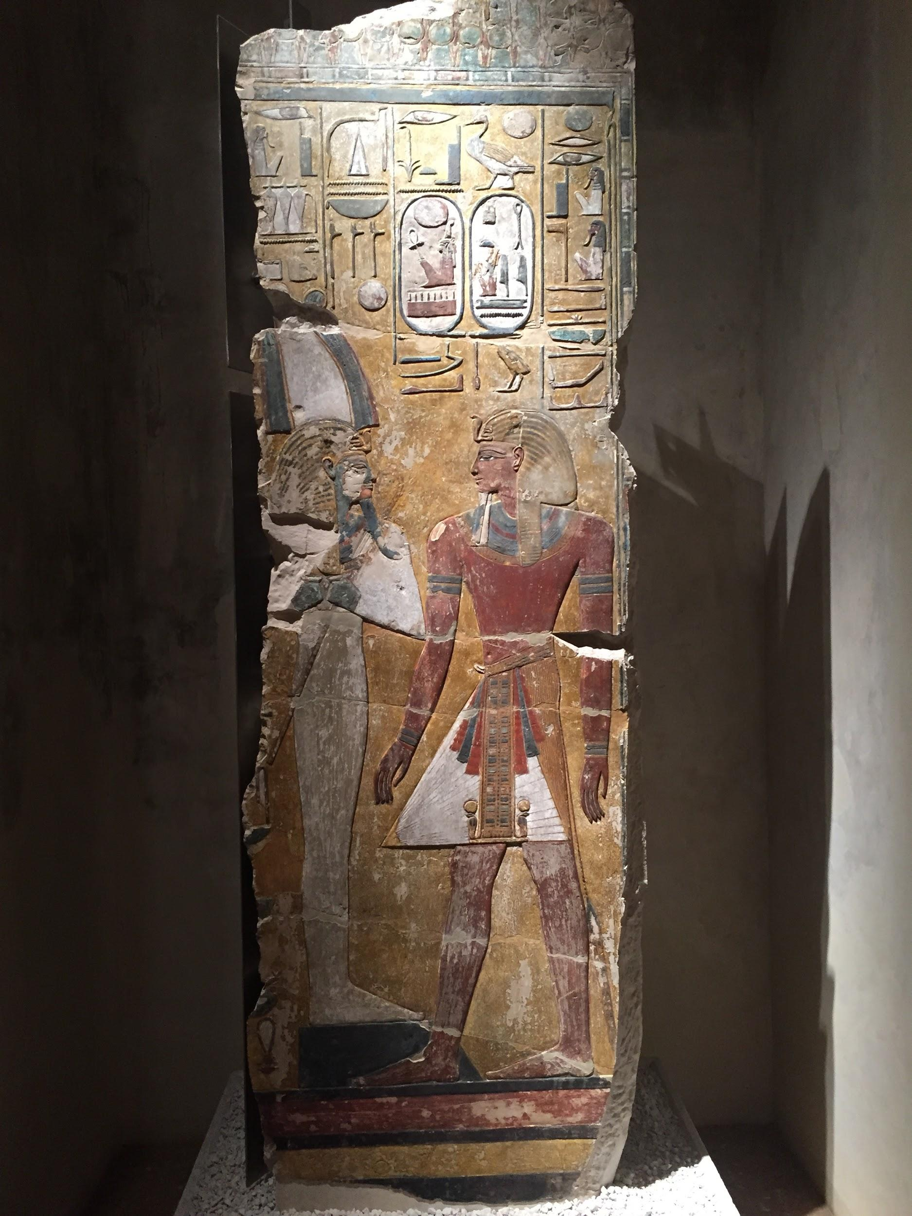
Observation 1:

Observation 2:

Possible Conclusion:

2.
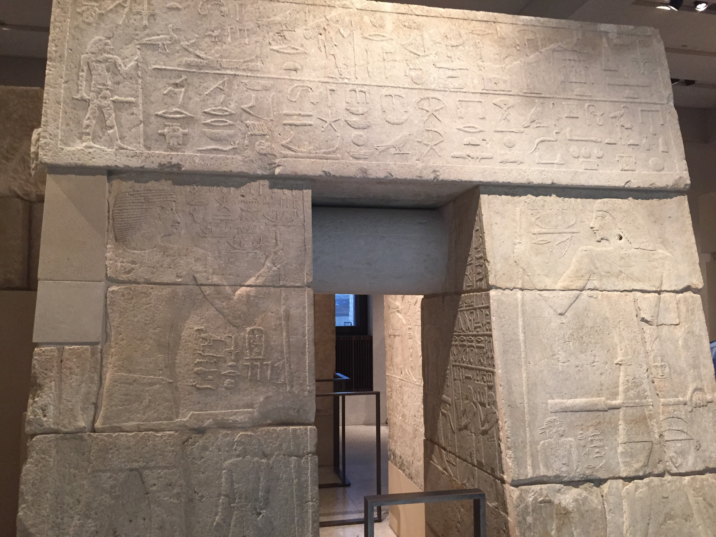
(look at the hieroglyphs)

Observation 1:

Observation 2:

Possible Conclusion:

3.
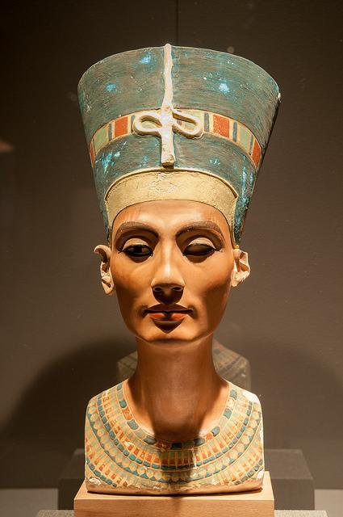

Observation 1:

Observation 2:

Possible Conclusion:

BONUS VIDEO (no questions, just for your knowledge - return to this after you complete your work)
The Tomb of Nefertiti: Or Is It? https://m.youtube.com/watch?v=-1GULSVk5dc

For extra credit: Describe whether or not you believe this to be Nefertiti given the evidence from the video (provide specific evidence from the video to support your case) **Must be 5-7 sentences and excellently supported using the evidence in order to receive extra credit**

Evidence for:
-

Evidence against:
-Uncovering Ancient Egypt (Pt. 2)

Use the link to gather information about Ancient Egypt: http://www.history.com/topics/ancient-history/ancient-egypt

1. What type of evidence exists today that has helped and continues to help historians and other researchers uncover Ancient Egypt's past (copy and paste the sentence from the introduction paragraph that provides the best answer)?

PREDYNASTIC PERIOD (C. 5000-3100 B.C.)
2. Why is it hard to figure out the details of the Predynastic Period?

3. Who was Nefertiti and what makes the role of women in Egyptian civilization unique?

4. Explain what happened between the early kingdoms of the Red Land and the White Land and include who eventually would become the first king of the United Kingdom of Egypt?

ARCHAIC (EARLY DYNASTIC) PERIOD (C. 3100-2686 B.C.)

5. Read through this section and provide important developments that were made for each of the following guiding historical topics:

POLITICAL -

INTELLECTUAL -

ECONOMIC -

OLD KINGDOM: AGE OF THE PYRAMID BUILDERS (C. 2686-2181 B.C.)

6. Why was the world’s first major stone building, the Step-Pyramid at Saqqara, built?

7. Who was the Great Pyramid at Giza built for?

8. Describe two major differences the show why the 3rd and 4th dynasties were so different than the 5th and 6th dynasties.

VIDEO QUESTIONS: use headphones with your partner
http://www.history.com/topics/ancient-history/ancient-egypt/videos/mankind-the-story-of-all-of-us-building-the-pyramids

9. Dr. Kari Cooney says that "a pyramid is a simple thing, it is a ------" but the actual pyramids would have had the steps filled in with white limestone that would "encapsulate (capture) the light" and this would do what for the Pharoah buried within that pyramid?

10. Where does Dr. Patrick Hunt teach at? Why would he chosen for this video as opposed to another professor (your opinion supported by facts)?

How many "blocks of stone" does he suggest it would have taken to build the pyramids?

11. What do the angles and exact measurements suggest about the knowledge of the Egyptian architects?

YOUR TURN: Choose a second video from the list of videos at the bottom of the page to explore with your partner.

Record the title here:

12. Write a 2-3 sentence summary about what the video was about.

13. Create a basic question about the video that gets at the main topic of the video.

14. Create an intermediate Question to help someone understand the video better who has never seen it?

15. Create an expert Question related to the content of the video?

MORE BONUS CONTENT: The study of hieroglyphics
http://discoveringegypt.com/egyptian-hieroglyphic-writing/egyptian-hieroglyphic-alphabet/

