Literacy support worksheet
3.10 The immune system protects our body in an organised way
Pages 62–63 and 193

The immune system
1 Briefly state the role of the immune system.

2 What is the body’s first line of defence? Give two examples.

3 What are the two approaches for the body’s second line of defence? Complete the sentences.

a First, _______________________________________________________________________

b Second, ______________________________________________________________________

4 Name the three key parts of a non-specific immune response.

5 Why are white blood cells produced? How do more white blood cells get to the area in need?

6 What is a phagocyte? Why is it sometimes compared to Pacman?

7 What is the body’s third line of defence? i.e. What is a specific immune response?

8 What is phagocytosis? Label the diagram below.

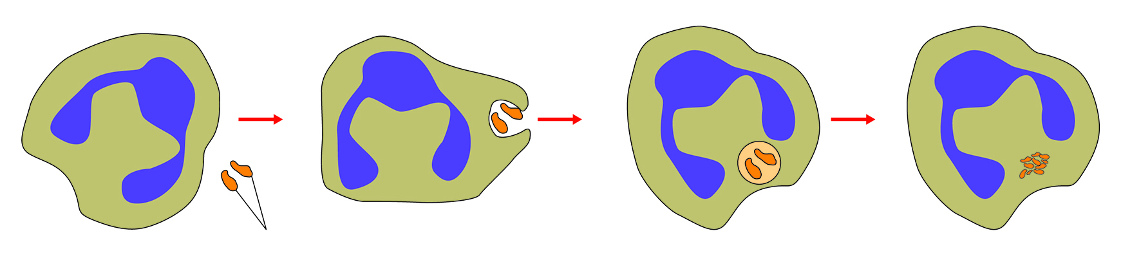

9 There are three kinds of vaccine. What are they?

WORD DETECTIVE
10 Matching meaning
Match the following words to their definitions:

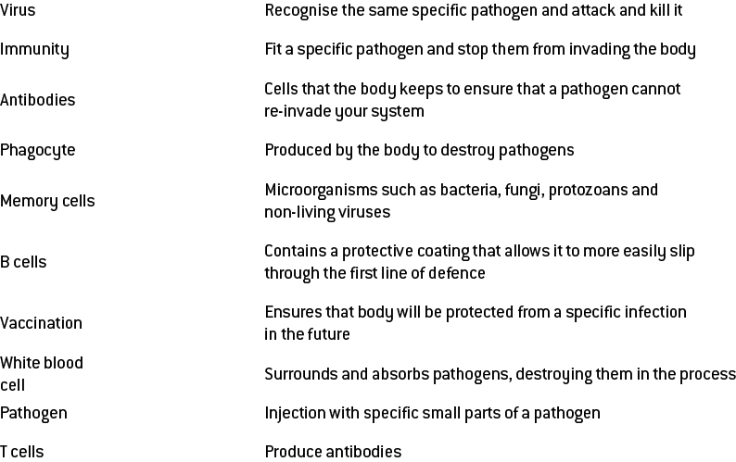

Literacy support worksheet
3.11 Things can go wrong with the immune system
Pages 64–65

Problems in the immune system
1 What does the immune system coordinate?

2 How do the following afflictions cause the immune system to go wrong?

a allergies

b autoimmune diseases

c HIV

3 What are two symptoms of anaphylaxis?

4 What is an autoimmune disease?

5 What do HIV and AIDS stand for?

6 Draw and label how a hay fever attack happens.

