Graphing
Criteria |  | Demonstrated or not?
Independent variable on the x-axis (ie. horizontal) and dependent on the y-axis (ie. vertical) | 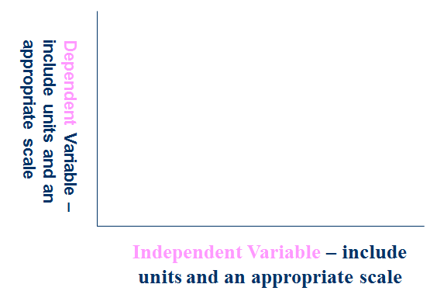
Appropriate type of graph:  - Line (or histogram) for continuous data “numbers derived from a scale  (ie. continuum) on both axes”  - Column (or bar) for discrete data (ie. in categories) “words on one axis and numbers on the other”. Note: usually column graphs have vertical (ie. up and down) bars whereas bar graphs have horizontal (ie. sideways) bars. | 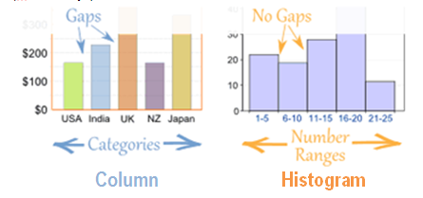
Both axes are labelled with an appropriate heading | 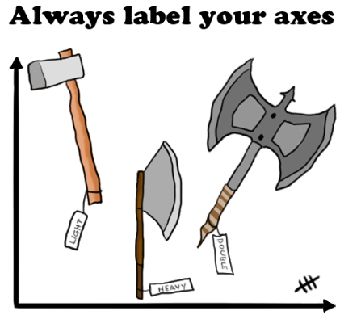
Both axes are labelled with units of measurement in brackets (only if required) | 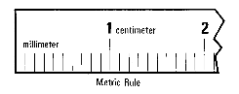
Title includes both the independent and… | Title: The Effect of the independent variable on the dependent variable
dependent variables

Criteria |  | Demonstrated or not?
The x-axis goes up by even intervals  eg. every 10 squares goes up by a value of 2 | Do both scales go up by even intervals?  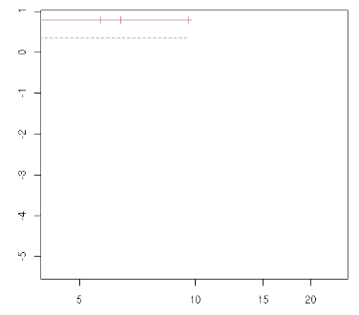
The y-axis goes up by even intervals

Plots data accurately | Note: Jagged line close to the origin represents a broken scale, when values close to zero are not required.  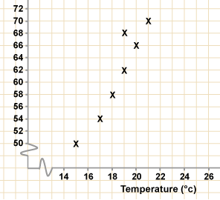  Which point may have been plotted incorrectly? Circle the point.
Lead pencil and ruler | 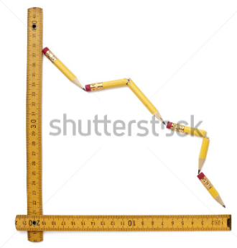
Total marks allocated |  | /10

