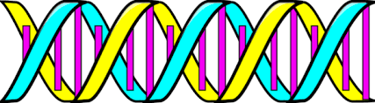
Recap….
DNA is in shape of a:
__________________ _______________. This structure allows for large amounts of genetic information to be stored in a small amount of space.
DNA is found in the _______________ and is important for controlling the _______________________ of the cell.
Nucleotides are made of the following structures:

Phosphate Sugar Nitrogen Base (One of a pair)
Draw a nucleotide in the space below:

There are four different types of nitrogen bases. Each base has a complementary base which it partners with.
Name the nitrogen bases and their partners below:
A_________________ bonds with T _________________
C_________________ bonds with G _________________

The bond that connects the base pairs together is a relatively weak ______bond.

Complete the DNA strand below by adding in the complimentary bases:
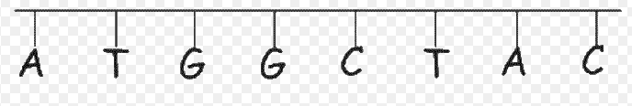

Relationship between DNA, Chromosomes and Genes
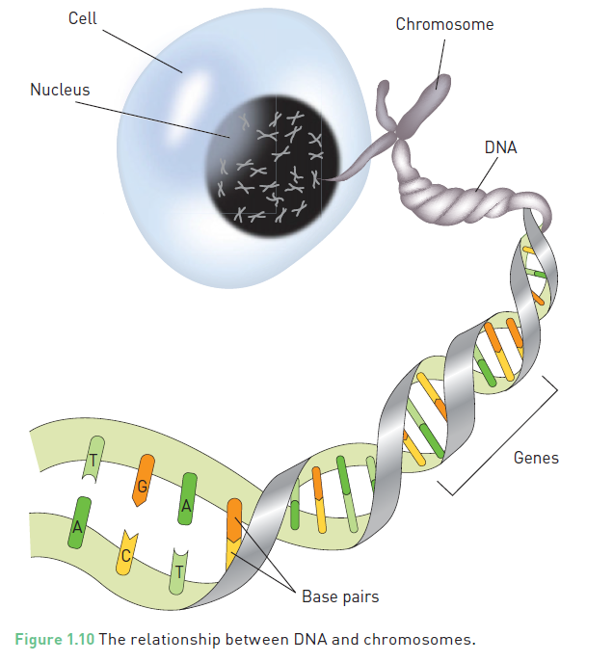
Human cells have between 2 – 3 metres of DNA in their nucleus. In order to fit this much genetic material in a small space the DNA is in the form of a double helix. The DNA strands are coiled around proteins called histones. This coiled DNA is called chromatin.

Chromosomes are DNA molecules carrying genetic information in the form of genes. Chromosomes are condensed ‘super coiled’ structures which become visible during cell division.
We have 23 pairs of chromosomes (46) in total.
The first 22 pairs (44) of chromosomes are called autosomal chromosomes. These are also called body/non-sex chromosomes.
The last pair of chromosomes (2) are called sex chromosomes. These determine the sex of the individual.
A Karyotype is a picture which shows all the chromosome pairs matched up from largest to smallest.

Sections of chromosomes (or DNA) contain specific instructions (genetic code) for structure and activities coordinated by the cell. These sections are called genes. We all have genes which code for the same traits, however our specific genetic codes vary. For example: We all have the gene for eye colour, however people have blue, brown or green eyes. These differences in genes of a population contribute to genetic variation.

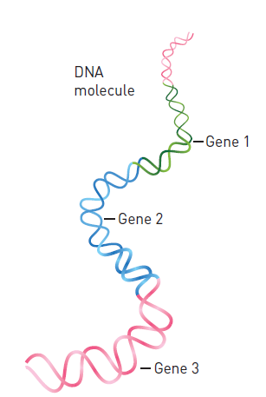

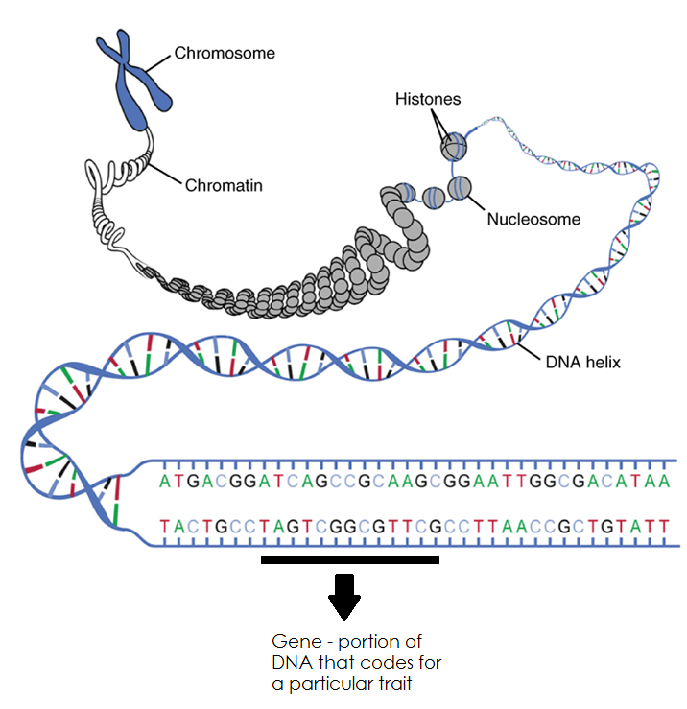
DNA Replication
In order for our body to grow and repair damaged cells we need to undergo DNA replication. DNA replication is required for mitosis to occur. In Mitosis we need an identical copy of the original DNA so that the new cell (daughter) can be exactly the same as the original (parent).

The complimentary base pairs make this process easy. The DNA first unzips (separates at the nucleotides) by breaking the weak hydrogen bonds between the bases. Each strand is then matched with complimentary bases to make a new double stranded DNA molecule.

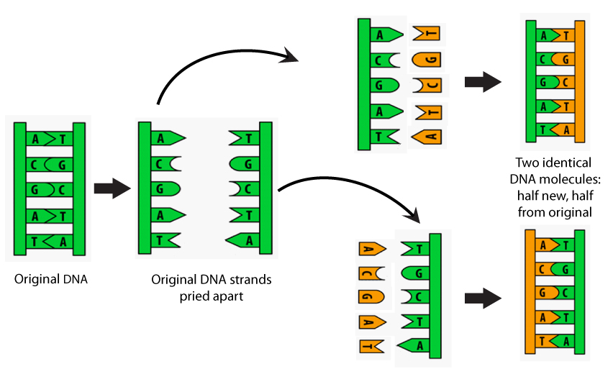

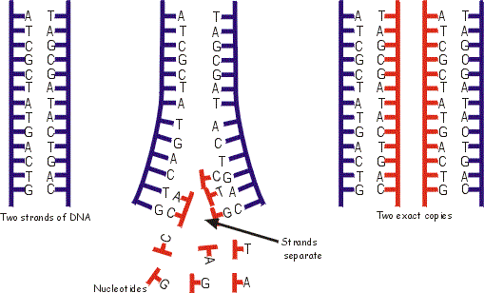
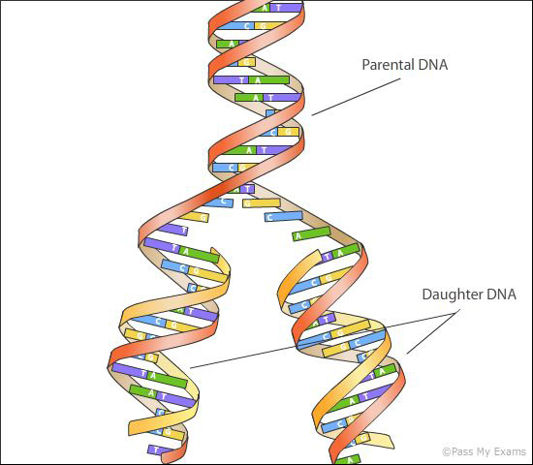

Genes are needed to make proteins….
Proteins are chemical substances that play a vital role in the functioning of the body. Enzymes, hormones and antibodies are all types of proteins. To make proteins the body needs to reads the genetic code found on genes of the DNA. This genetic code is like a recipe for making the correct proteins.
Proteins are made in the cytoplasm of the cell by ribosomes. You may recall that DNA is found in the nucleus and is too large to fit through the pores in the nuclear membrane. The cell makes templates of sections of the DNA needed to make proteins which is capable of leaving the nucleus and finding its way to the ribosome. This template is called RNA (Ribonucleic acid).
To make RNA, a section of the DNA is unzipped and the RNA is made with bases that are complimentary to one side of the DNA stand (template strand) that was unzipped. This RNA molecule can then leave the nucleus and enter the cytoplasm where it will find a ribosome.
DNA RNA PROTEIN

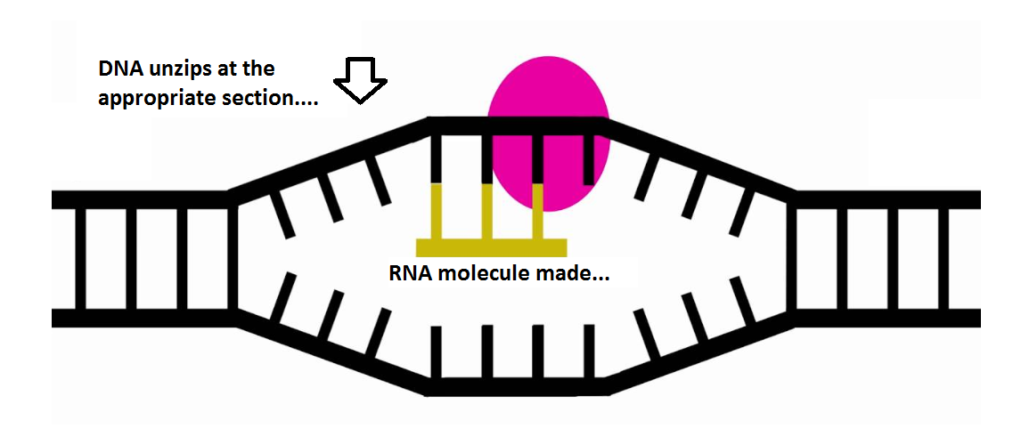

DNA RNA Comparison
 | DNA | RNA
Double/Single Stranded?
Bases Present
(appropriate partners identified)
Type of Sugar on Backbone
Function
Location in the Cell
