Year 8 Geology Revision

- Complete the Rock cycle below:
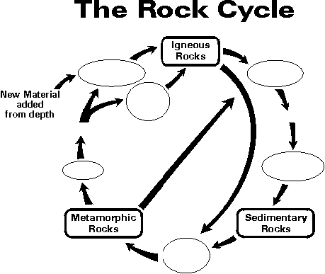

- What is it called when new material is pushed up from the Earth’s mantle?
____________________________________________________________
- In what types of rocks are fossils formed?
___________________________________________________________
- Sometimes, the presence of certain chemicals can cause a rock to be a certain colour. What mineral may be present in a red rock?
_______________________________________________________
- What is the Mohs scale used to measure?
___________________________________________________
- What does it mean for a mineral to measure 1 on the Mohs scale?
_____________________________________________________
- What is the name of an ore containing aluminium?
_________________________________________________
- What metal do chalcopyrite, malachite and azurite all contain?
________________________________________________

- What are the 2 types of igneous rock, and how do they form?
________________________________________________________________________________________________________________________________________________________________________________________________________________________________________________________
- What is the difference between a stalagmite and a stalactite?
__________________________________________________________________________________________________________________________________________________________________________________________
- A student claims that because a rock contains quartz it must be igneous. Do you agree? Explain your reasoning.
_______________________________________________________________________________________________________________________________________________________________________________________________________________________________________________________

- Sometimes the crystals in a metamorphic rock will be twisted, showing an uneven banded pattern. This is called foliation. How does foliation occur?
__________________________________________________________________________________________________________________________________________________________________________________________
- Match the words in the first column to the best available answer in the second column.
_____ | The crust | 1) The type of fault where the Earth’s crust in lengthened as plates are pulled apart.
_____ | The mantle | 2) A fold which bends downward to form a "∩ " shape.
_____ | continental drift | 3) The thin outer layer of the Earth.
_____ | convection | 4) The layer of the Earth underneath the crust.
_____ | mid ocean ridges | 5) The name given to lines of weakness in rocks.
_____ | seven | 6) Where you will find most volcanoes.
_____ | subduction zone | 7) The name given to areas where one plate is pushed underneath another.
_____ | plate boundaries | 8) The type of fault where one side of a fault moves up and over the other side.
_____ | joint | 9) The geological feature formed when a large block of crust moves downward, and the sides remain where they were.
_____ | fault | 10) These types of currents cause hot mama to move upward.
_____ | pressure or tension | 11) The theory that explains how continents move together and apart.
_____ | reverse fault | 12) The place where plates move apart under the ocean.
_____ | normal fault | 13) this occurs when rocks move on either side of a joint.
_____ | Rift valley | 14) When rocks bend after pressure has been applied to them.
_____ | folding | 15) A fold which forms a step shape.
_____ | syncline | 16) A fold which bends upward to form a "U" shape.
_____ | anticline | 17) The number of major plates on the Earth’s surface.
_____ | monocline | 18) What fault lines can be subjected to.

- How do geologists determine the age of rocks? Are their different methods?
________________________________________________________________________________________________________________________________________________________________________________________________________________________________________________________
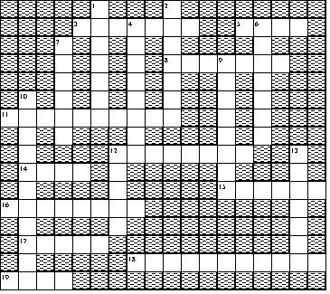
ACROSS  3 The process that moves soil from one place to another.  5 A black flaky mineral  8 The hardest mineral.  11 The process that breaks down rocks into smaller particles  12 A mineral that is pinkish in colour  14 The hardness of minerals is measured on this scale.  15 The colour a mineral will leave behind on a white tile is called the ....  16 Minerals are substances that always form ....  17 The rotting animal and plant matter that is found in soil.  18 Rocks that are made up of particles of other rocks that form layers  19 This type of rain can cause chemical weathering. | DOWN  1 An igneous rock that is made up of the minerals: quartz, mica and feldspar.  2 The process where rocks "bend".  4 A "U" shaped fold.  6 A type of rock formed from molten earth materials  7 A mineral that is white in colour and hard to scratch  9 What rocks are made up of.  10 The type of rocks that formed by heat and pressure changing other rocks  12 This will form when a line of weakness in rocks can allow the one side to "slip" past another.  13 A river of ice.

Objectives
- Can order the layers that are found within the Earth
- Can give properties of each layer (state of matter, composition and thickness)
- Describe the concept of a tectonic plate.
- Give evidence of tectonic plate movement (fossils and coast lines fitting like a jigsaw).
- Explain how convection currents are responsible for tectonic plate movement.
Define convergent and divergent plate boundaries
- Label the main vent, dike, sill, magma chamber, lava flow, crater and ash cloud on a volcano diagram
- Describe the difference between lava and magma
- Describe causes of volcanoes (both convergent and divergent boundaries)
- Explain why the majority of volcanoes are found around the ring of fire.
- Explain what causes an Earthquake
Name the device used to measure earthquakes (seismometer) and briefly describe how it works.
- Use diagrams to help explain the difference between syncline, anticline and monocline folds.
- Describe the difference between a normal fault, a reverse fault and a slip fault.
Identify, from diagrams, what type of fault or fold has occurred in the crust.
- Define a mineral
- Describe common minerals including quartz, mica, feldspar.
- Describe the ways minerals are classified; colour, streak, Mohs hardness, lustre, cleavage and polarising light
Explain the role of rate of change in temperature in determining crystal size
- Define a rock
- Describe common features of igneous, sedimentary and metamorphic rocks
- Describe the formation process for igneous rocks; intrusive and extrusive types.
- Can name the common igneous rocks; pumice, basalt and granite.
- Describe the formation process for metamorphic rocks; requirements for heat and pressure and how the amount of each will affect which rock is formed.
- Can name common metamorphic rocks and where they come from; marble from limestone, quartzite from sandstone, slate from mudstone.
- Describe each stage of the formation process for sedimentary rocks; weathering, erosion, deposition and cementation
- Can identify the relative age of rock layers within a core sample through application of the law of superposition.
- Can draw a flow diagram and describe the rock cycle
- Use a classification key describing physical and chemical properties to help identify rock types
- Define an ore
- Can name the important minerals in the following ores:
  - Iron ore: hematite and magnetite
  - Aluminium ore: bauxite
  - Uranium ore: uraninite
- Describe environmental concerns of mining and how certain techniques and practices can mitigate the damage (assessing environmental conditions before operations, minimising water and energy use, recycling products rather than mining more).

